Tianyang li

24833444

Content-addressable search engine

FIT5174 Assignment 2 Part B II

# Introduction

Nowadays, search engine technology had a great development with the popular of Internet, search engines becoming more accurate and effective, also they can accept search material in different format other than text. For example, people can upload images or audios to search engines and get the information about those uploaded multi-media files.

To achieve this function, a distributed associative memory scheme is required, and Hierarchical Graph Neuron is one of the distributed associative memory techniques that can applicate on distributed systems.

# Hierarchical Graph Neuron

“The hierarchical graph neuron (HGN) implements a single cycle memorization and recall operation through a novel algorithmic design. The HGN is an improvement on the already published original graph neuron (GN) algorithm.”(A.L Khan, 2008)

It is composed of layers of GN networks arranged in a pyramid composition. A GN network can be view as a kind of 2-D array, and HGN algorithm is similar to the simple GN algorithm. The base layer corresponds to the size of the pattern to be used in the pattern-recognition application. The size of the pattern is equal to the number of elements in the pattern. Each element may be assigned a fixed number of possible values from the pattern domain. With HGN, the top graph neuron can provide an overview of base GN to reduce cross-talk.

# HGN Communication Scheme

“The communication overheads may be minimised by adopting a scheme based upon Geometric Parallelism. While adopting a scheme based upon Geometric Parallelism the physical shape of the domain is replicated over the parallel processor network.” (A. I. Khan and B.H.V. Topping)

From this we can see if a banded matrix storage scheme is adopted, change the communication scheme to pipeline, each processors works paralleled, it will reduce the time of communication and refer to Geometric Parallelism. The communication within HGN can be speed up if we using Geometric parallel scheme to exchange data concurrently.

Geometric parallel scheme simply is to mapping a banded stiffness matrix to a pipeline of processors. Each process take a part of the banded matrix.

From this graph we can see the parallel inter-communication occurred mostly in lower layers.

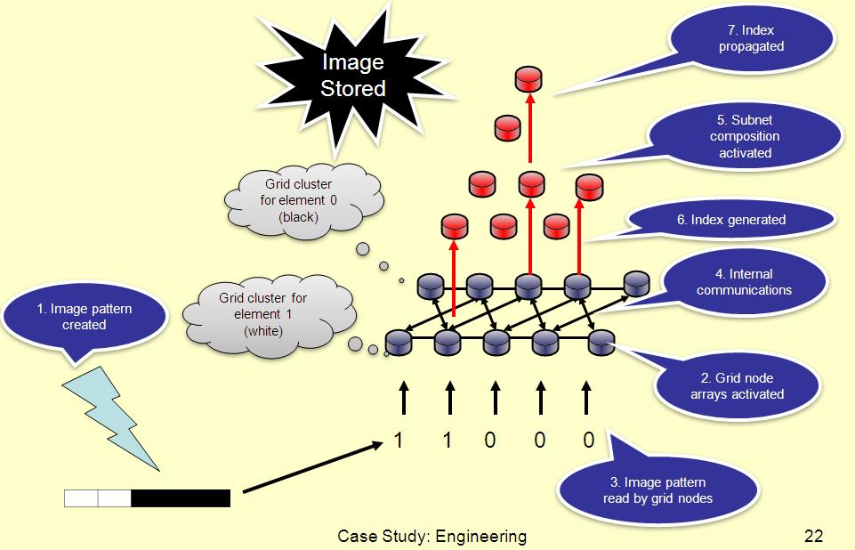

And this graph shows how a banded matrix mapped to a multi-processors pipeline.

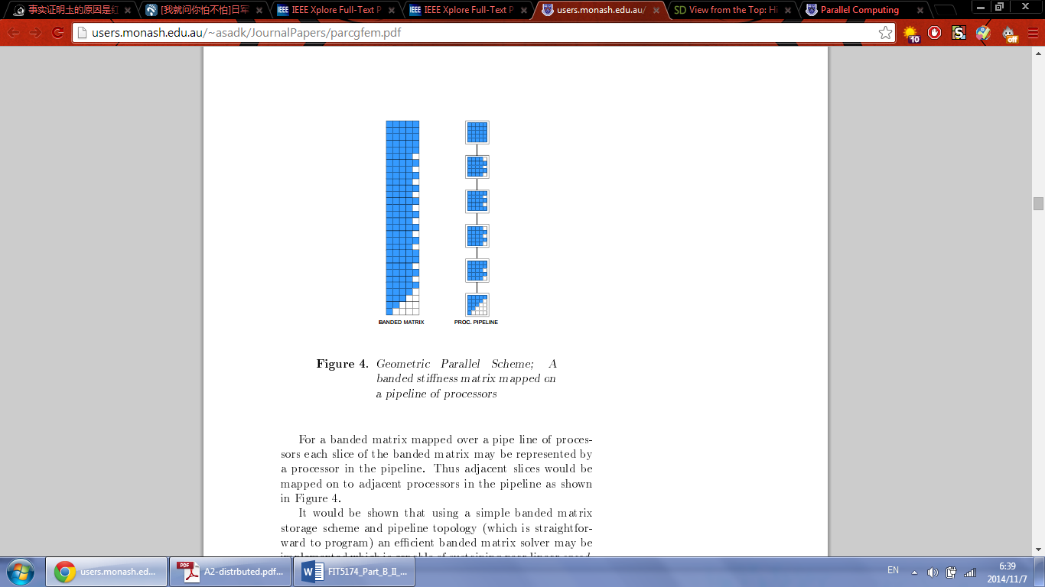

# References

Benny B. Nasution and Asad I. Khan, FEBRUARY 2008, *A Hierarchical Graph Neuron Scheme for Real-Time Pattern Recognition,* IEEE TRANSACTIONS ON NEURAL NETWORKS, VOL. 19, NO. 2.

Klaus-Robert Müller, Sebastian Mika, Gunnar Rätsch, Koji Tsuda, and Bernhard Schölkopf, MARCH 2001, *An Introduction to Kernel-Based Learning Algorithms,* IEEE TRANSACTIONS ON NEURAL NETWORKS, VOL. 12, NO. 2.

A. I. Khan and B.H.V. Topping, *Parallel Finite Element Analysis Using Jacobi-Conditioned Conjugate Gradient Algorithm*