<Assigment1 >

Analysis and Design Document

Student:Cimpan Roxana

**Group:30233**

Table of Contents

1. Requirements Analysis 3

1.1 Assignment Specification 3

1.2 Functional Requirements 3

1.3 Non-functional Requirements 3

2. Use-Case Model 3

3. System Architectural Design 3

4. UML Sequence Diagrams 3

5. Class Design 3

6. Data Model 3

7. System Testing 3

8. Bibliography 3

1. Requirements Analysis

# Assignment Specification

Use JAVA/C# API to design and implement an application for the front desk employees of a bank. The application should have two types of users (a regular user represented by the front desk employee and an administrator user) which have to provide a username and a password in order to use the application.

# Functional Requirements

The regular user can perform the following operations:

* Add/update/view client information (name, identity card number, personal numerical code, address, etc.).
* Create/update/delete/view client account (account information: identification number, type, amount of money, date of creation).
* Transfer money between accounts.
* Process utilities bills.

The administrator user can perform the following operations:

* CRUD on employees’ information.
* Generate reports for a particular period containing the activities performed by an employee.

# Non-functional Requirements

-conectare baza de date

2. Use-Case Model

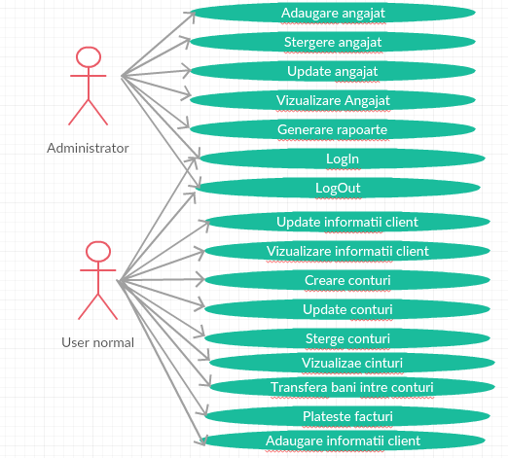

**Use case:**Log In

**Level:**user

**Primary actor:**Administratorul se logheaza

**Main success scenario:** Se completeaza field-urile corespunzatoare pentru logare: nume si parola. Ca urmare a acestei actiuni se va deschide o fereastra prin intermediul careia administratorul va putea sa-si realizeze operatiile specifice.

Extensions: Trebuie introduse corect, atat numele, cat si parola, altfel se va afisa un mesaj de eroare si nu va putea fi accesata acea fereastra.

3. System Architectural Design

**3.1 Architectural Pattern Description**

1. *table module*

-avem business logic- pentru fiecare tabela din baza de date (Client, Cont, Logare).

- o singură instanță a unei clase conține diverse proceduri care vor acționa asupra datelor.(ClientMap, ContMap, LogareMap).

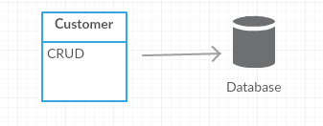

1. *table data gateway*

-se fac accesari ale bazei de date: stergere, inserare,update, select, precum si alte metode care solicita interactiunea cu baza de date

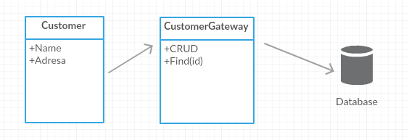

Pachete:

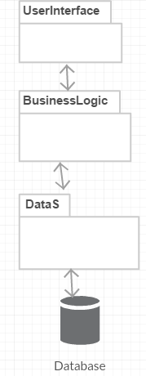

4. UML Sequence Diagrams

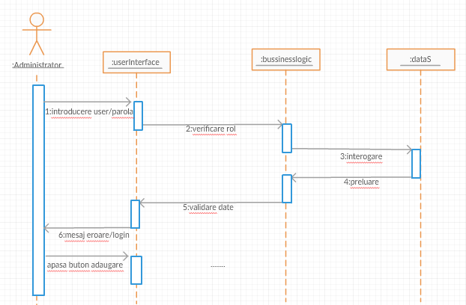

5. Class Design

**5.1 Design Patterns Description**

**-**table module

**-**table data gateway

**5.2 UML Class Diagram**

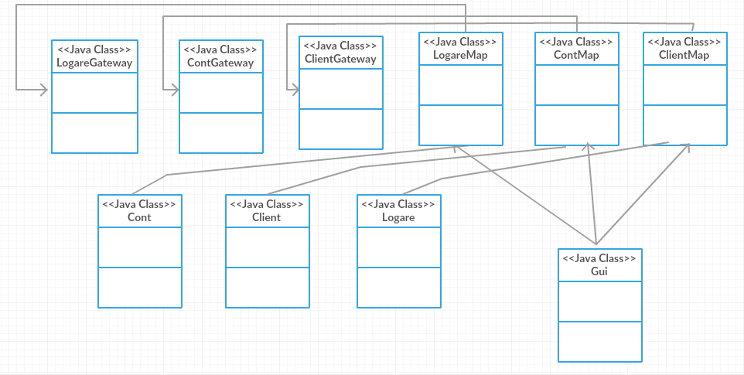

6. Data Model

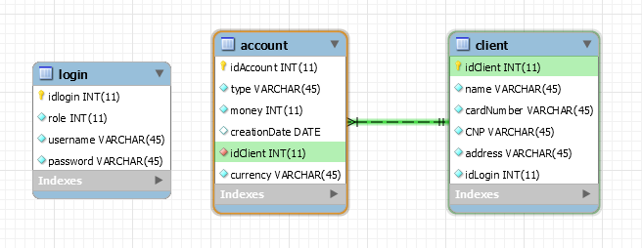

7. System Testing

-apar mesaje de confirmare in cazul in care s-a efectuat opertia cu success sau nu;

-de exemplu, in cazul in care introducem username-ul si parola gresite:

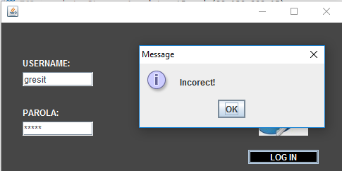

-daca introducem corect se realizeaza logarea in functie de rol(1 sau 2)

* 1=administrator
* 2=user normal

-administrator:

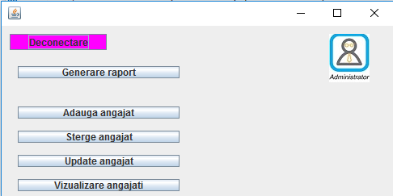

-adaugare angajat:

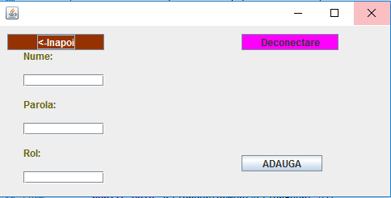

-user normal

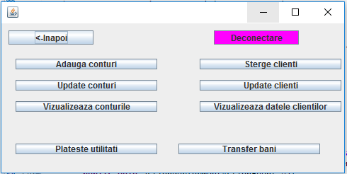

-update client

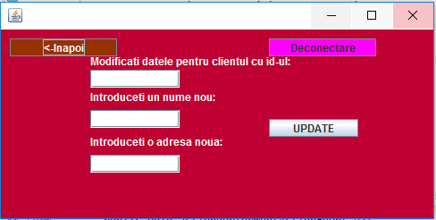

-update cont

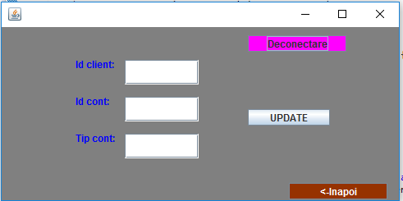

*-*vizualizare conturi

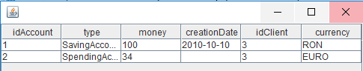

8. Bibliography

<https://en.wikipedia.org/wiki/Table_(database)>

<http://stackoverflow.com/questions/6072087/table-module-and-table-data-gateway-patterns>

<https://www.martinfowler.com/eaaCatalog/tableDataGateway.html>

<http://ramj2ee.blogspot.ro/2013/08/table-module-design-pattern-vs.html#.WNxB-sDyjIU>

<http://www.codejava.net/java-se/jdbc/jdbc-tutorial-sql-insert-select-update-and-delete-examples>

<http://www.codejava.net/java-se/jdbc/jdbc-tutorial-sql-insert-select-update-and-delete-examples>

<https://www.tutorialspoint.com/jdbc/jdbc-db-connections.htm>

<https://www.youtube.com/watch?v=BCqW5XwtJxY>

<https://www.w3schools.com/sql/sql_select.asp>

<http://stackoverflow.com/questions/14039062/how-to-convert-date-in-to-yyyy-mm-dd-format>

<https://www.youtube.com/watch?v=Huel7vbrLXY>

<https://docs.oracle.com/javase/tutorial/uiswing/components/table.html>

<http://stackoverflow.com/questions/19415170/what-is-setbounds-and-how-do-i-use-it>

<http://stackoverflow.com/questions/1081486/setting-background-color-for-the-jframe>

<https://www.youtube.com/watch?v=v_bYm091w3g>

<http://stackoverflow.com/questions/9698359/setbackgroundnew-color-in-java-does-not-understand-the-given-rgb-value>

<http://stackoverflow.com/questions/34262447/java-applet-setforeground-what-exactly-it-does-and-how-to-see-its-effect>

<http://richard.jp.leguen.ca/tutoring/soen343-f2010/tutorials/implementing-table-data-gateway/>