Student: Cotet Eusebio Calin

**Group:30233**

Table of Contents

1. Requirements Analysis 3

1.1 Assignment Specification 3

1.2 Functional Requirements 3

1.3 Non-functional Requirements 3

2. Use-Case Model 3

3. System Architectural Design 3

4. UML Sequence Diagrams 3

5. Class Design 3

6. Data Model 3

7. System Testing 3

8. Bibliography 3

1. Requirements Analysis

# Assignment Specification

The application is designed for the front-desk employees of a bank. In this way, they will manage the clients and their accounts. Also there will be an administrator which will manage the employees.

# Functional Requirements

The regular user can do the following: Create, Read and Update client info, Create, Read, Update and Delete client account information, transfer money between accounts, process utilities bills (these are processed when a transfer is done).

The admin user can do the following: CRUD on employee’s info, generate reports for a particular employee.

# Non-functional Requirements

The application data is stored in a database (PostgreSQL) and the application is developed in an OOP IDE. A three tier structure will be user and two patterns for accessing the data from the database.

2. Use-Case Model

Use-Case description format:

Use case: transfer money between accounts

Level: user-goal level

Primary actor: regular user (employee)

Main success scenario: the user successfully logins, and then transfers the money between accounts

Extensions: the user wrongly introduce his credentials, after that he finally login, but the amount he wants to transfer is smaller the the amount of the account. An error message is displayed

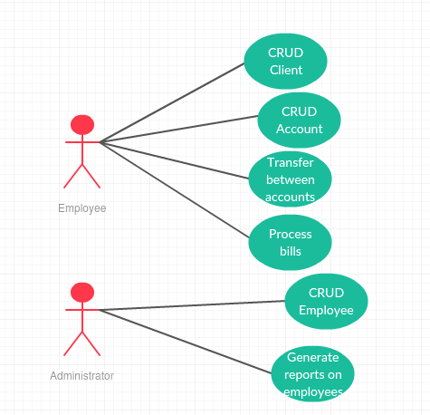

3. System Architectural Design

**3.1 Architectural Pattern Description**

The Three Principal Layers of an architecture are three primary layers: presentation (Provision of services, display of information), business (Logic that is the real point of the system) and persistence (Communication with databases).

Presentation logic is about how to handle the interaction between the user and the software. This can be as simple as a command-line or text-based menu

Data source logic is about communicating with other systems that carry out tasks on behalf of the application. These can be transaction monitors, other applications, messaging systems, and so forth. For most enterprise applications the biggest piece of data source logic is a database that is primarily responsible for storing persistent data.

The remaining piece is the domain logic, also referred to as business logic. This is the work that this application needs to do for the domain you’re working with. It involves calculations based on inputs and stored data, validation of any data that comes in from the presentation, and figuring out exactly what data source logic to dispatch, depending on commands received from the presentation.

**3.2 Diagrams**

Package Diagram. Component Diagram.

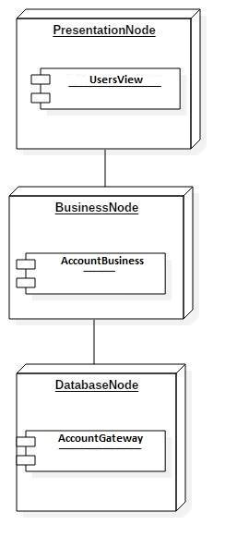

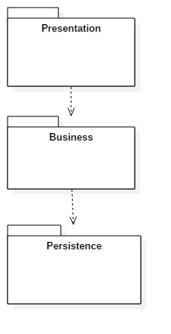

4. UML Sequence Diagrams

Scenario for creating a new Client.

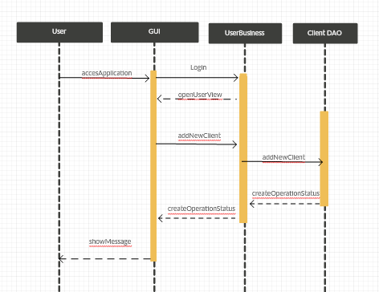

5. Class Design

**5.1 Design Patterns Description**

Design patterns:

1. Table Data Gateway: A Table Data Gateway holds all the SQL for accessing a single table or view: selects, inserts, updates, and deletes. Other code calls its methods for all interaction with the database
2. Active Record Pattern: An object carries both data and behavior. Much of this data is persistent and needs to be stored in a database. Active Record uses the most obvious approach, putting data access logic in the domain object. This way all people know how to read and write their data to and from the database.

**5.2 UML Class Diagram**

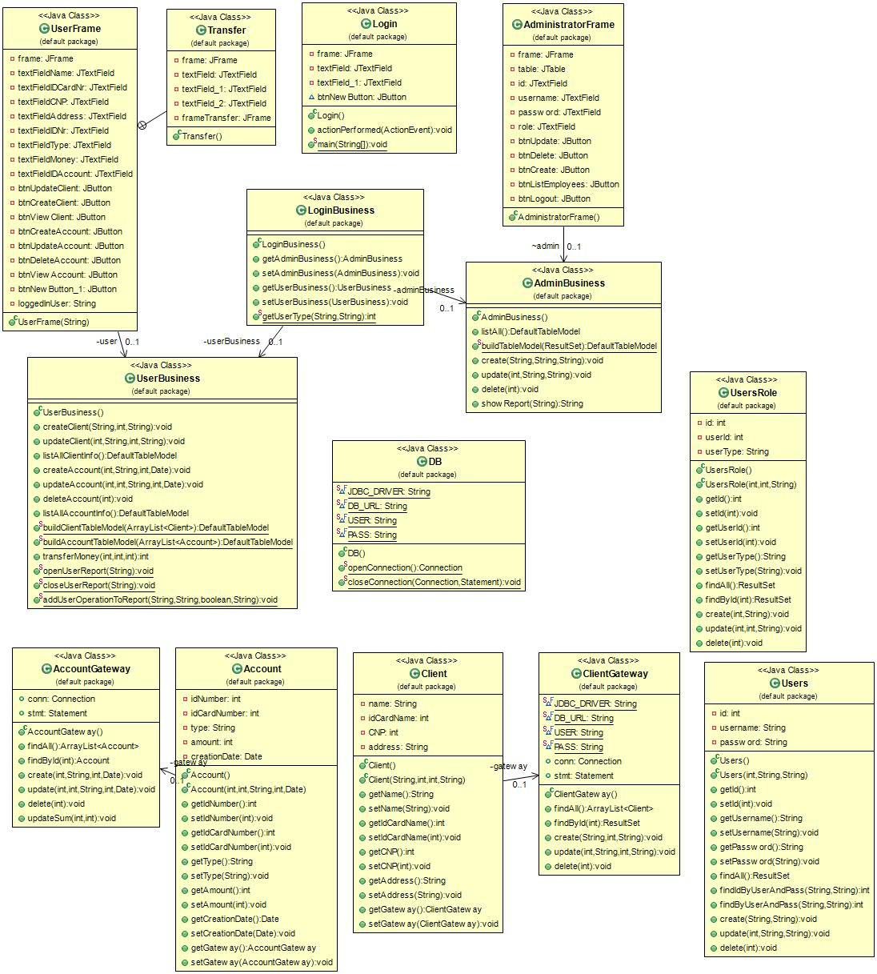

6. Data Model

I chose four entities to describe the functionality of my application: Client, Account, Users and UsersRole. These entities are described in SQL Language as in the next image, which represents the database diagram.

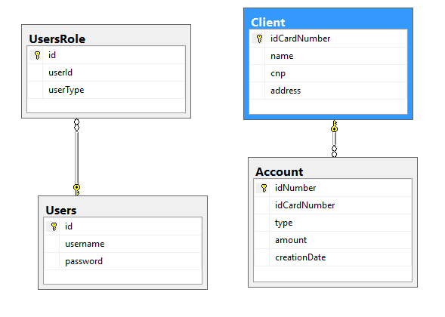

7. System Testing

For the main operations the system supports tests: delete, update, create, retrieve etc. If something is going wrong the application send an error message to inform the user.

8. Bibliography

* https://www.martinfowler.com/eaaCatalog/activeRecord.html
* https://www.martinfowler.com/eaaCatalog/tableDataGateway.html
* https://github.com/bhukailas/Books/tree/master/Fowler,%20Martin/Patterns%20of%20Enterprise%20Application%20Architecture
* http://tutorialspoint.com/
* https://www.w3schools.com/