README

Install:

1. You need to download and install Java on your computer.
2. You need a program that can be used to quickly run multiple SQL scripts against a database.
3. Take the dataSource.sql file from the res folder in te application folder and run execute it.
4. Simply run Bank file from the main folder, which is an Executable Jar File.

Use:

In order to access the application, one may firstly select on the main window wheter he is an Employee or Administrator.

Actual valid data for Employee:

1. Username: Anamaria ; Password : anamaria
2. Username: Matei ; Password: mateia
3. Username: Andreea; Password: popovicia

Actual valid data for Administrator:

1. Username: alexandruadmin; Password: admin
2. Username: mariaadmin; Password: admin

Several use cases and scenarios:

First window, after you run the .jar file, should look like below:

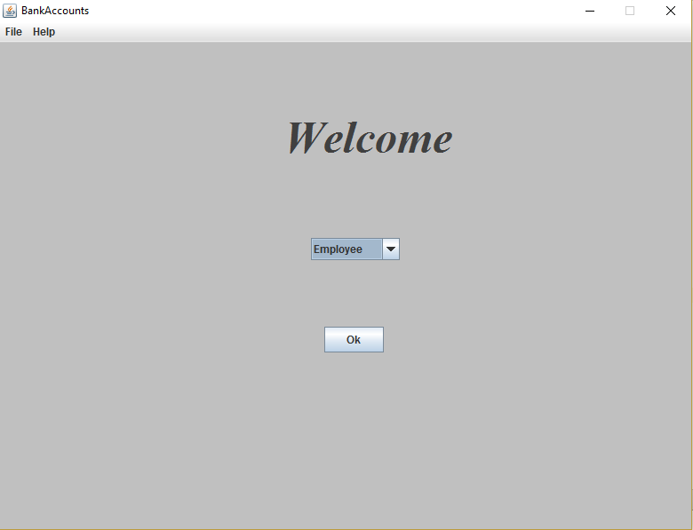

After that, you have to Sign in:

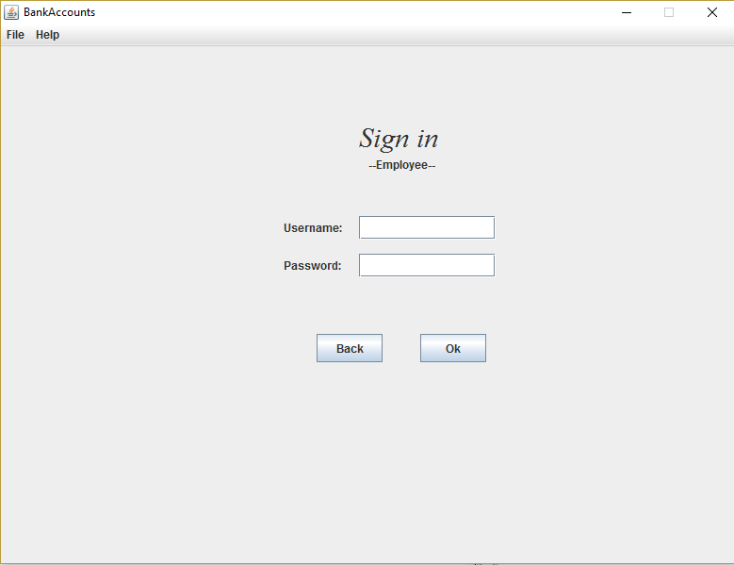

If you choose Employee, several options will pop up:

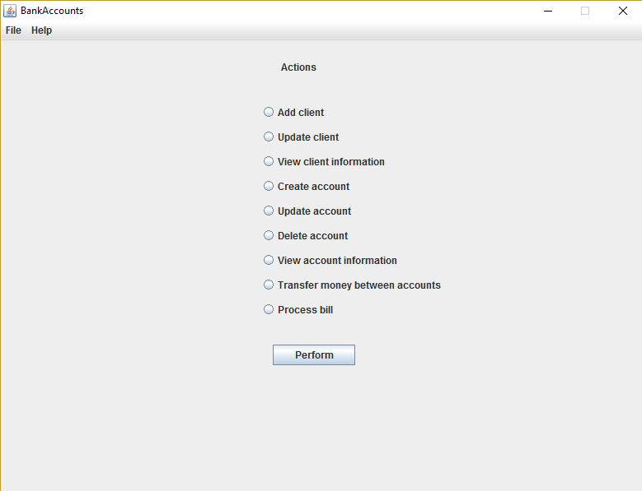

Same for the Administrator:

