Bank Application

In order to start the application, you have to download the Executable Jar and the SQL files from this folder. Before executing the Jar file you have to execute the SQL file on a SQL platform. After that you can execute the Jar file and the application will open and will look like in the following image.

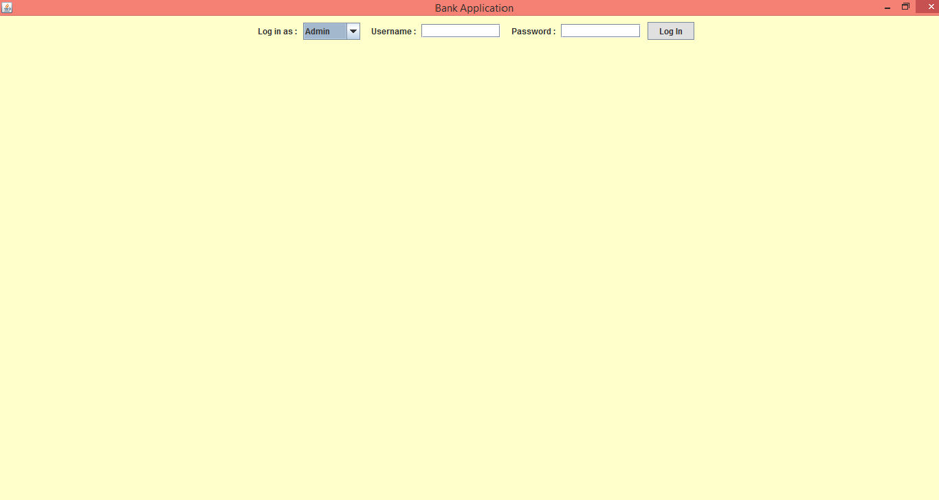

You can choose from the combo box to log in as an admin or as an employee. The admin that we will work with has the username “**admin1**” and the password “**1234**” and the employee has the username “**radu_paul**” and the password “**1234**”. If you press the button before completing the fields or if the username or the password are not correct the will appear error messages like in the pictures below.

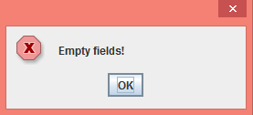 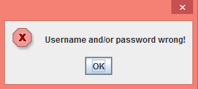

Firstly, we will log in as an admin. We choose the “Admin” field from the combo box, we write the corresponding username and password and then we press the button. There will appear the fields corresponding to the operations that an admin can perform like in the following image.

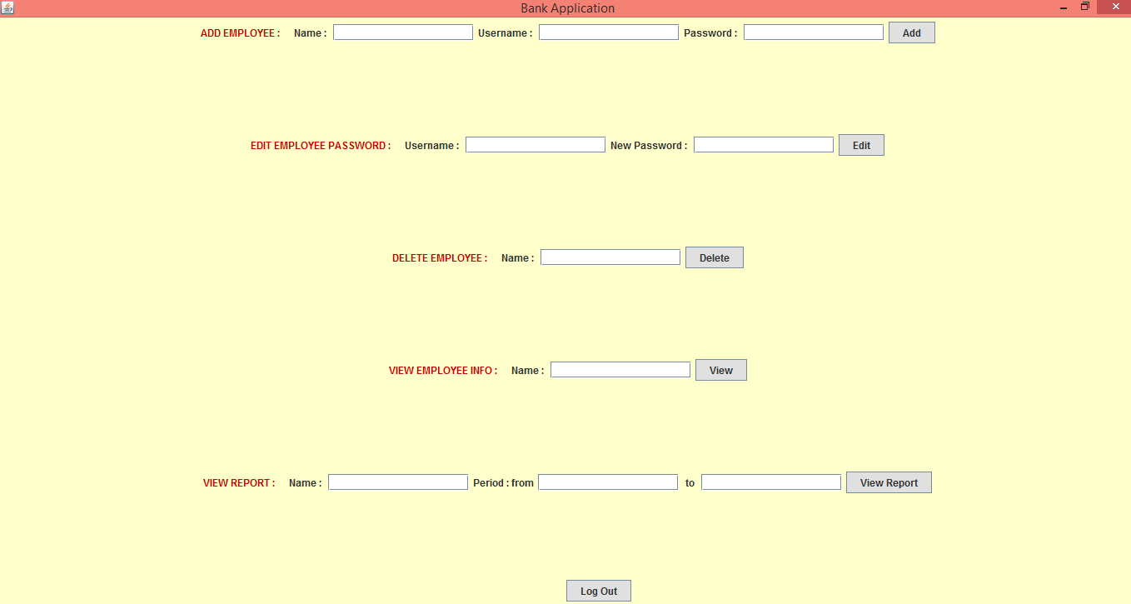

Exactly like at the log in operation, for all the other operations if we do not complete all the fields we will get an error message. For adding a new employee we have to provide all the information required. If the name or username introduces already exists in the database there will appear an error message and if not, we will get a message that informs us that the operation was successful.

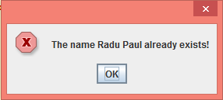 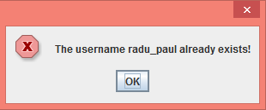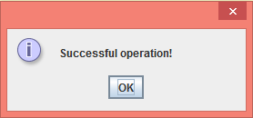

For all operations except the “view” ones, if all the information provided is alright there will appear this “Successful operation!” message. For the next operations existing for admin, edit, delete or view, we will get error messages if the name or username does not exist in the database.

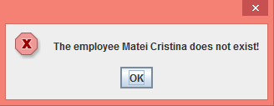 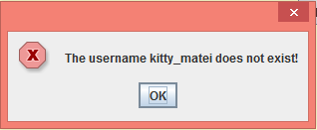

For the “VIEW EMPLOYEE INFO” operation we will receive the information about a particular employee it he exists in the database. For the employee with the name “Radu Paul” we will get:

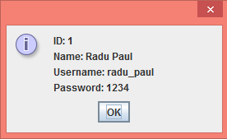

For the “VIEW REPORT” operation we will receive all the information about the activity of a particular employee in the specified period of time. Dates have to be introduced like “yyyy-mm-dd” or else we will not get the information. For the employee “Radu Paul” and the period from “2017-01-01” to “2017-03-29” we will get:

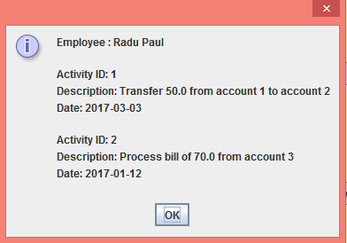

We can log out by pressing “Log Out” button and we will get back to the start page. Now we will select the “Employee” field, provide the corresponding username and password and there will appear the fields corresponding to the operations that an employee can perform like in the following image.

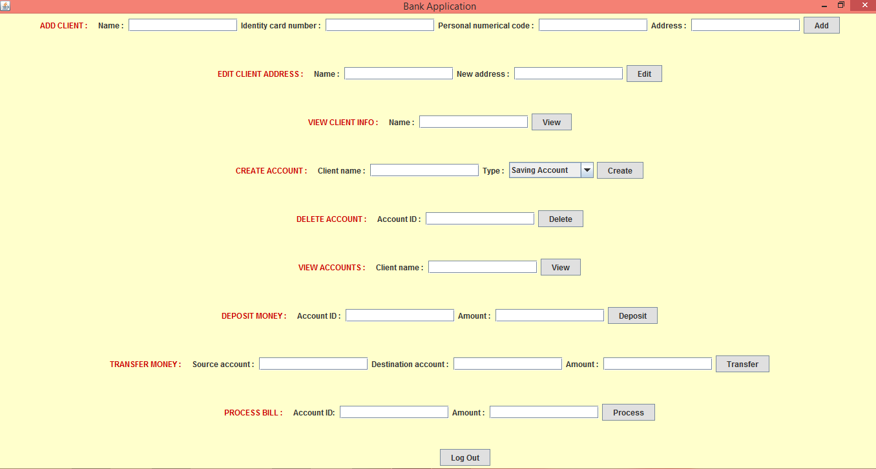

Exactly like at the operations of admin, there will appear an error message if the fields corresponding to the chosen operation are not completed and a “Successful operation!” message if the information provided is alright. Also, there will appear an error message for adding a new client if there already exists the client with the name provided and for the other operations if the names or ids provided do not exists in the database. The following pictures describe the error messages for adding a new client with the name “Matei Cristina” that already exists in the datadase, for deleting the account with the id 12 that does not exists and for editing the address of the client “Deac Dan” that does not exist.

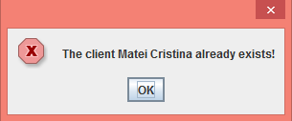 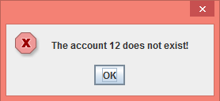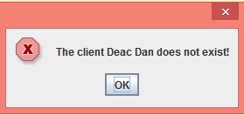

For the operation of deposit, transfer money and process bills where we have to introduce account ids and amount of money we have to introduce integers and reals respectively or else we will receive some error messages.

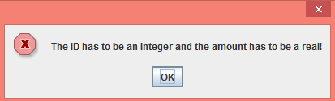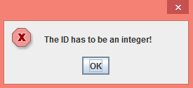

For creating a new account we have to provide the name of the client and to choose from the combo box the field “Saving Account” or “Spending Account”.

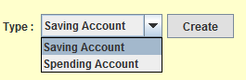

The operation “VIEW CLIENT INFO” show us all the information about a particular client and the operation “VIEW ACCOUNTS” show us all the accounts of a client with all their information. The images below describe the information of the client “Matei Cristina” and the account of the client “Sechel Raluca”.

