Bookstore

Student:Pop Laura-Maria

**Group:30233**

Table of Contents

1. Requirements Analysis 3

1.1 Assignment Specification 3

1.2 Functional Requirements 3

1.3 Non-functional Requirements 3

2. Use-Case Model 3

3. System Architectural Design 3

4. UML Sequence Diagrams 3

5. Class Design 3

6. Data Model 3

7. System Testing 3

8. Bibliography 3

1. Requirements Analysis

# Assignment Specification

Use Java/C# API to design and implement an application for the employees of a book store. The application should have two types of users (a regular user represented by the book store employee and an administrator user) which have to provide a username and a password in order to use the application.

# Functional Requirements

The regular user can perform the following operations:

-Search books by genre, title, author.

-Sell books.

The administrator can perform the following operations:

-CRUD on books (book information: title, author, genre, quantity, and price).

-CRUD on regular users’ information.

-Generate two types of reports files, one in pdf format and one in csv format, with the books out of stock.

# Non-functional Requirements

The application has to be accessible and secure because of the clients information. It also should be extensible (like to add new features and upgrades) and easy to use.

2. Use-Case Model

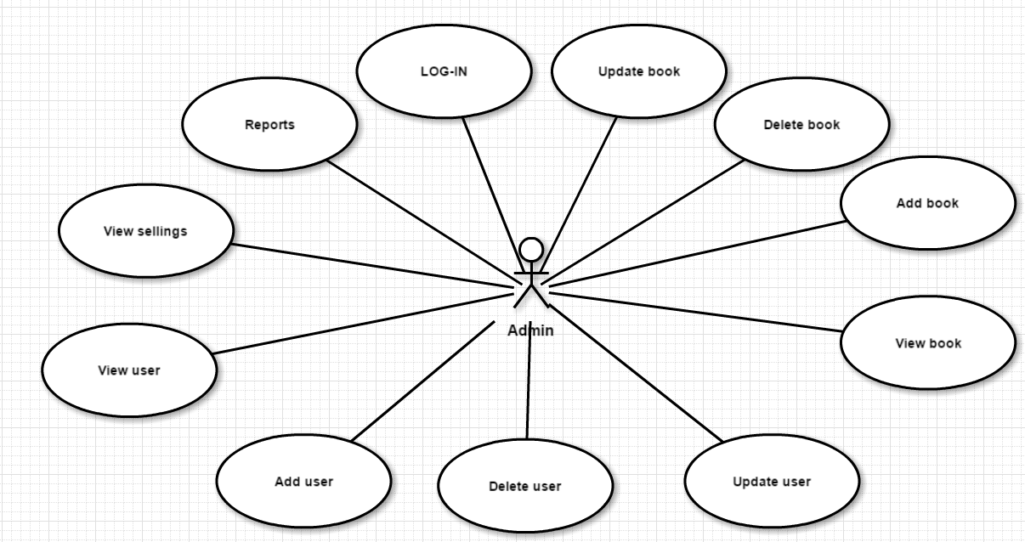

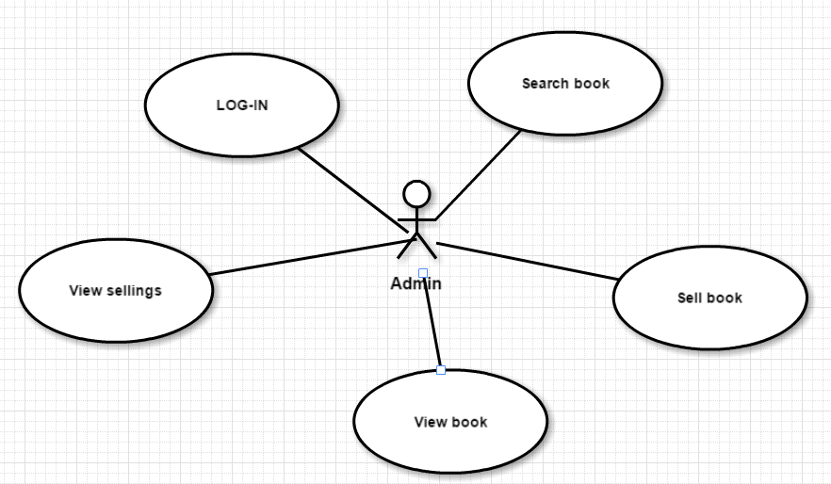

***Use case: LOG-IN***

***Level: user-goal***

***Primary actor: both Regular User and Admin***

***Main success scenario: the actor fills in the email and the password fields and if these are correct then the actor will see a menu of actions he/she can perform***

***Extensions: if the actor does not have an account, he will receive one from the Admin (only for Regular User)***

3. System Architectural Design

**3.1 Architectural Pattern Description**

MVC pattern-> MODEL-VIEW-CONTROLLER

Model-carrying data for objects

View-visualization for data from Model

Controller

* 1. –acts on both Model and View
  2. -controls the data flows into Model and updates the View
  3. -keeps Model and View separate

**3.2 Diagrams**

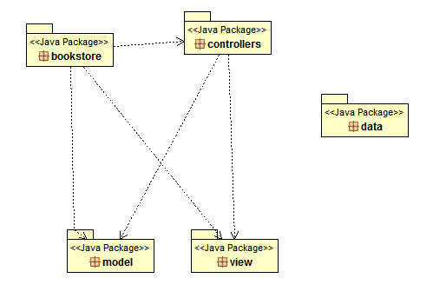

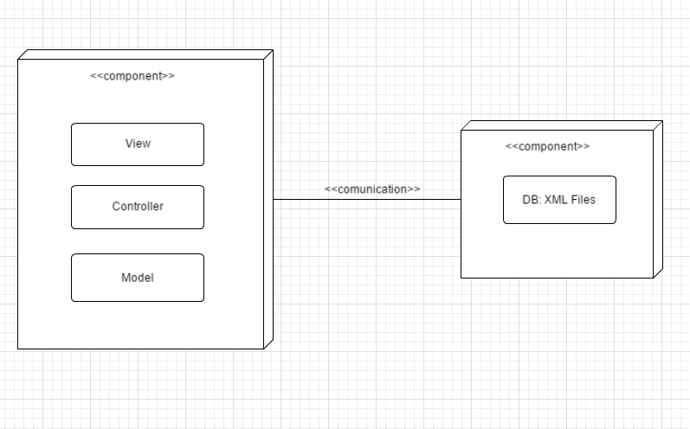

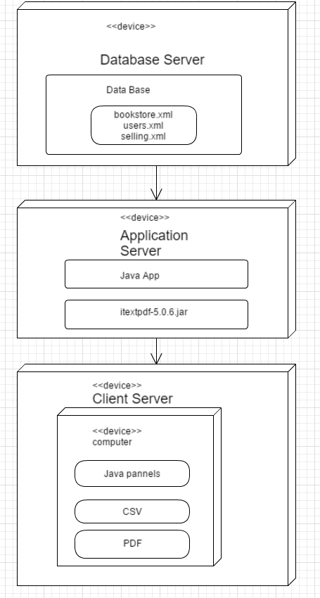

4. UML Sequence Diagrams

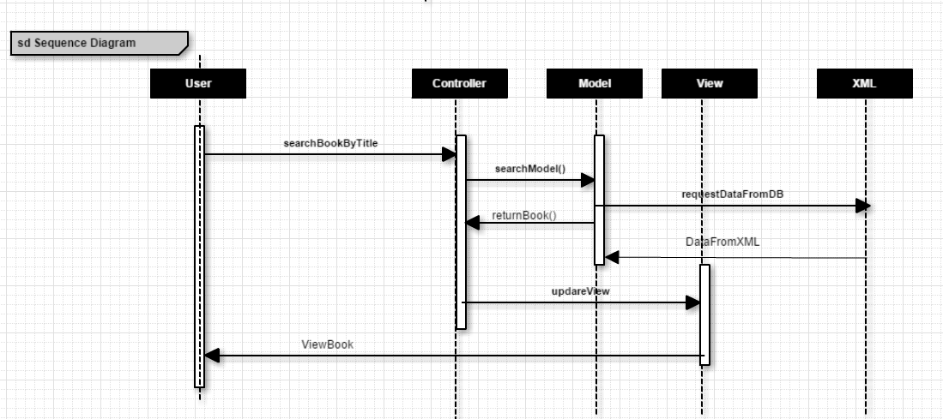

5. Class Design

**5.1 Design Patterns Description**

Factory pattern-used to create an object without exposing the creation logic

Here, I used the Factory pattern to generate reports in CSV and PDF. Classes PDF and CSV implements the Report interface. And class ReportFactory generates the reports based on a String.

**5.2 UML Class Diagram**

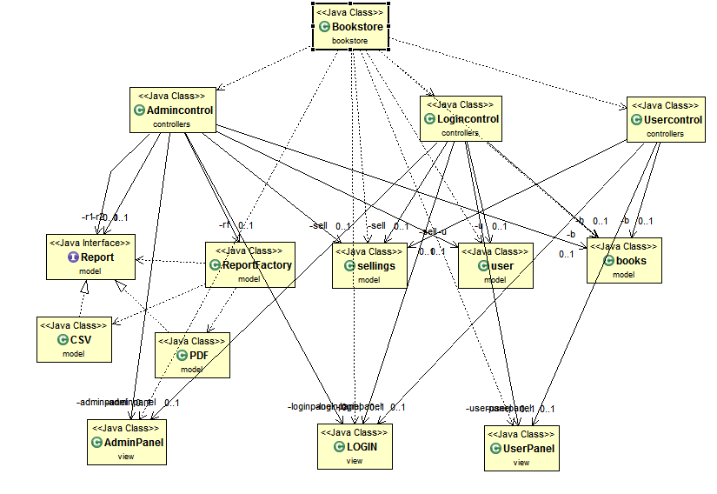

6. Data Model

My database is stored in XML files and I used XPath and DOM parsing to get my information.

XML files are based on a tree structure. XML stands for eXtensible Markup Languge and it was designed to store and transport data.

In my project I have 3 XML files:

1. bookstore.xml-information about books: title, author, genre, year, price, amount
2. selling.xml-email of the seller, amount, title of the book, date
3. users.xml-name, email, admin (yes if he/she is or no if he/she isn’t), password

7. System Testing

The application was tested manually for all operation.

8. Bibliography

1. Software Design Course, Prof. Dr. Eng. Mihaela Dinsoreanu
2. <https://www.w3schools.com/xml/default.asp>
3. <https://www.tutorialspoint.com/design_pattern/mvc_pattern.htm>
4. <https://www.tutorialspoint.com/design_pattern/factory_pattern.htm>
5. <https://www.w3.org/XML/Datamodel.html>
6. <http://stackoverflow.com/questions/25001921/how-to-remove-a-node-in-xml-using-java>
7. <http://stackoverflow.com/questions/7646607/how-to-modify-xml-tag-specific-value-in-java>
8. <https://www.mkyong.com/java/how-to-modify-xml-file-in-java-dom-parser/>
9. <http://stackoverflow.com/questions/20984323/how-to-add-an-element-in-this-xml-file-using-dom-parser>
10. <https://www.daniweb.com/programming/software-development/threads/255757/inserting-a-new-node-using-xpath-in-an-xml-document>
11. <http://stackoverflow.com/questions/3247577/how-can-i-insert-element-into-xml-after-before-certain-element-in-java>
12. <http://stackoverflow.com/questions/2811001/how-to-read-xml-using-xpath-in-java>