Debate website

Analysis and Design Document

Student:Tuluc Adelina

**Group:30643**

Revision History

|  |  |  |  |
| --- | --- | --- | --- |
| **Date** | **Version** | **Description** | **Author** |
| <dd/mmm/yy> | <x.x> | <details> | <name> |
|  |  |  |  |
|  |  |  |  |
|  |  |  |  |

Table of Contents

I. Project Specification 4

II. Elaboration – Iteration 1.1 4

1. Domain Model 4

2. Architectural Design 4

2.1 Conceptual Architecture 4

2.2 Package Design 4

2.3 Component and Deployment Diagrams 4

III. Elaboration – Iteration 1.2 4

1. Design Model 4

1.1 Dynamic Behavior 4

1.2 Class Design 4

2. Data Model 4

3. Unit Testing 4

IV. Elaboration – Iteration 2 4

1. Architectural Design Refinement 4

2. Design Model Refinement 4

V. Construction and Transition 5

1. System Testing 5

2. Future improvements 5

VI. Bibliography 5

# Project Specification

*[Present the project specification]*

Scopul de baza al acestui proiect e de a reusi sa ne conectam online la un site care ofera posibilitatea de dezbatere pe baza unui subiect. Subiectul de baza va fi incalzirea globala. Este nevoie de un astfel de site deoarece multi oameni azi sunt ingrijorati cu privire la acest subiect si e nevoie de un site in care acestia sa isi exprime parerile pro si contra vizavi de aceasta problema care direct sau indirect ne afecteaza pe fiecare. Obiectivul acestui site web e de a oferii o zona de desfacere online in care fiecare care doreste sa isi exprime opinia vizavi de subiectul cu incalzirea globala este liber sa faca lucrul acesta, iar in acelasi timp sa poata vizualiza si raspunsurile/ comentariile celorlati vizavi de acest subiect.

Pentru acest web site o sa fie 3 tipuri de utilizatori care vor interactiona cu acest site. cel care viziteaza si poate vizualiza comentariile, cel care participa la discutie , sic el care poate scoate statistici si actualiza sau sterge comentarii irelevante sau care au un limbaj neportivit.

# Elaboration – Iteration 1.1

# Domain Model

*[Define the domain model and create the conceptual class diagrams]*

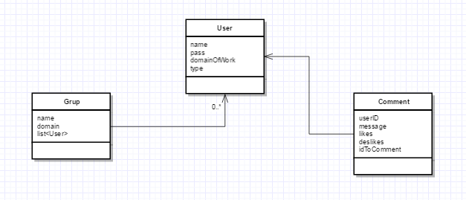

# Architectural Design

## Conceptual Architecture

*[Define the system’s conceptual architecture; use an architectural style and pattern - highlight its use and motivate your choice.]*

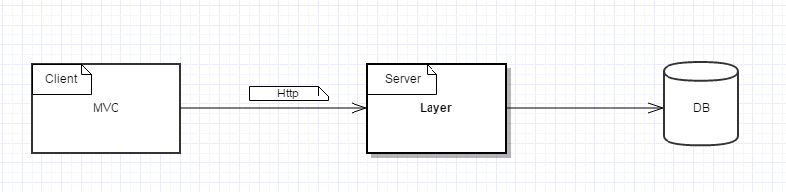

Voi folosi 2 arhitecturi. Una va fi pe parte de client si un ape parte de server. Pe client voi folosi MVC architecture iar pe partea de server Layer architecture. Am ales aceste 2 deoarece pe parte a de client trebuie sa fie un flow inspre baza de date, iar pe partea de client se bazeaza mult pe partea de afisare si de controller care mai apoi face legatura cu Servicess.

## Package Design

*[Create a package diagram]*

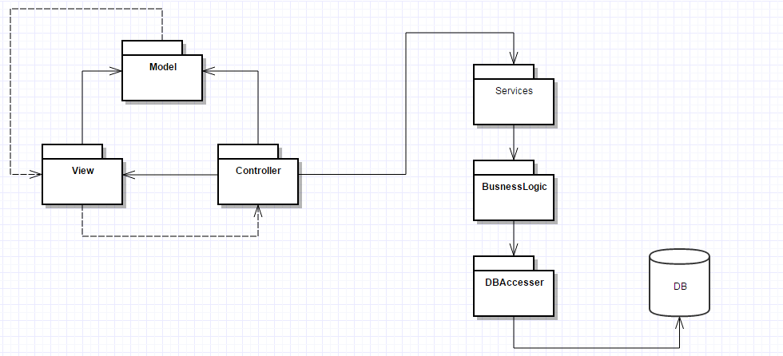

CLIENT

SERVER

## Component and Deployment Diagrams

*[Create the component and deployment diagrams.]*

# Elaboration – Iteration 1.2

# Design Model

## Dynamic Behavior

*[Create the interaction diagrams (1 sequence, 1 communication diagrams) for 2 relevant scenarios]*

For a regular user

The Communication Diagram :

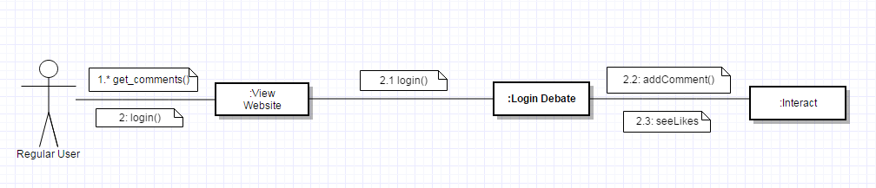

For admin user

The communication diagram:

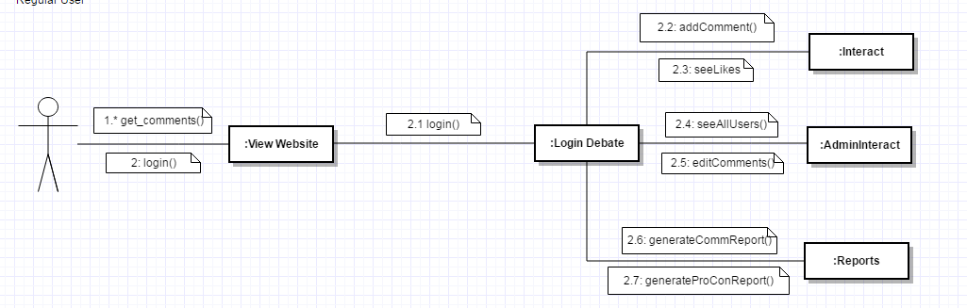

The sequence diagram:

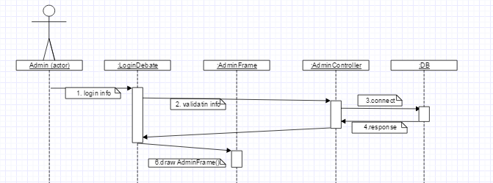

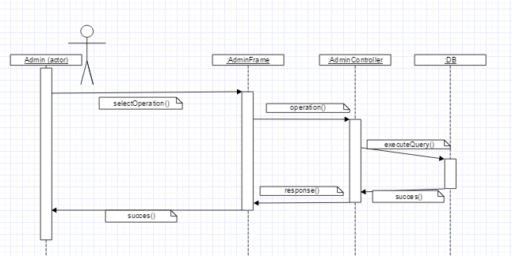

## Class Design

*[Create the UML class diagram; apply GoF patterns and motivate your choice]*

# Data Model

*[Create the data model for the system.]*



# Unit Testing

*[Present the used testing methods and the associated test case scenarios.]*

# Elaboration – Iteration 2

# Architectural Design Refinement

*[Refine the architectural design: conceptual architecture, package design (consider package design principles), component and deployment diagrams. Motivate the changes that have been made.]*

# Design Model Refinement

## *[Refine the UML class diagram by applying class design principles and GRASP; motivate your choices. Deliver the updated class diagrams.]*

# Construction and Transition

# System Testing

*[Describe how you applied integration testing and present the associated test case scenarios.]*

# Future improvements

*[Present future improvements for the system]*

# Bibliography