Sports Club Management Application

Analysis and Design Document

Student:Ilies Alina Denisa

**Group:30233**

Revision History

|  |  |  |  |
| --- | --- | --- | --- |
| **Date** | **Version** | **Description** | **Author** |
| 05/04/2017 | 1.0 | Domain Model, Architectural Design (architectural patterns and styles, package design), Component and Deployment diagrams | Ilies Alina Denisa |
|  |  |  |  |
|  |  |  |  |
|  |  |  |  |

Table of Contents

I. Project Specification 4

II. Elaboration – Iteration 1.1 4

1. Domain Model 4

2. Architectural Design 4

2.1 Conceptual Architecture 4

2.2 Package Design 4

2.3 Component and Deployment Diagrams 4

III. Elaboration – Iteration 1.2 4

1. Design Model 4

1.1 Dynamic Behavior 4

1.2 Class Design 4

2. Data Model 4

3. Unit Testing 4

IV. Elaboration – Iteration 2 4

1. Architectural Design Refinement 4

2. Design Model Refinement 4

V. Construction and Transition 5

1. System Testing 5

2. Future improvements 5

VI. Bibliography 5

# Project Specification

*[Present the project specification]*

# Elaboration – Iteration 1.1

# Domain Model

# Architectural Design

## Conceptual Architecture

The system will use a Model-View-Controller architecture. This is a client-server one and the system functionallity is totally separated.

1. View

This component represents the top level of the application. Using this, it will possible to display some data like events, participant, and a calendar in which are displayed the events. The user, by a web page, communicate directly with this . If we connect the presentation layer with others, it will be possibile to display all the modification from other sub-levels.

2.Controller

This component control the application and with its help, all the modification in the model side can be display in view component.

3. Model

This part is responsible for information persistence and all the methods that access data.

## Package Design

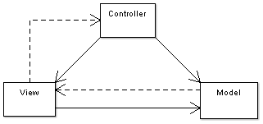

## Component and Deployment Diagrams

Deployment Diagram

**

# Elaboration – Iteration 1.2

# Design Model

## Dynamic Behavior

Sequence Diagram

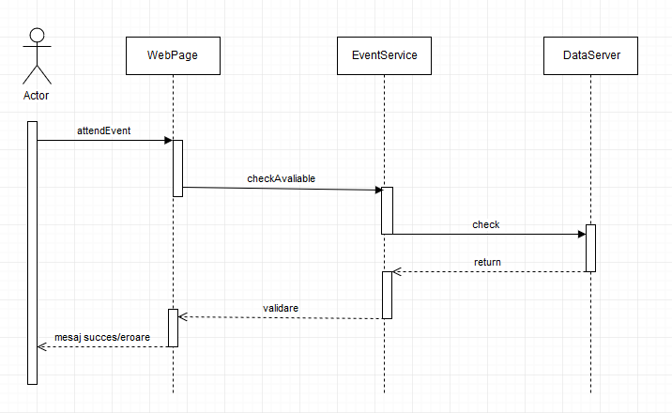

Communication Diagram

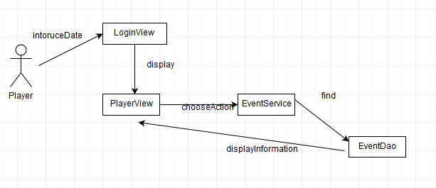

## Class Design

*[Create the UML class diagram; apply GoF patterns and motivate your choice]*

# Data Model

*[Create the data model for the system.]*

# Unit Testing

*[Present the used testing methods and the associated test case scenarios.]*

# Elaboration – Iteration 2

# Architectural Design Refinement

*[Refine the architectural design: conceptual architecture, package design (consider package design principles), component and deployment diagrams. Motivate the changes that have been made.]*

# Design Model Refinement

## *[Refine the UML class diagram by applying class design principles and GRASP; motivate your choices. Deliver the updated class diagrams.]*

# Construction and Transition

# System Testing

*[Describe how you applied integration testing and present the associated test case scenarios.]*

# Future improvements

*[Present future improvements for the system]*

# Bibliography