Insurance Broking Management System

Analysis and Design Document

Student: Cozma Andreea

**Group: 30233**

Revision History

|  |  |  |  |
| --- | --- | --- | --- |
| **Date** | **Version** | **Description** | **Author** |
| 05/04/2017 | 1.0 | I,II | Cozma Andreea |
|  |  |  |  |
|  |  |  |  |
|  |  |  |  |

Table of Contents

I. Project Specification 4

II. Elaboration – Iteration 1.1 4

1. Domain Model 4

2. Architectural Design 4

2.1 Conceptual Architecture 4

2.2 Package Design 4

2.3 Component and Deployment Diagrams 4

III. Elaboration – Iteration 1.2 4

1. Design Model 4

1.1 Dynamic Behavior 4

1.2 Class Design 4

2. Data Model 4

3. Unit Testing 4

IV. Elaboration – Iteration 2 4

1. Architectural Design Refinement 4

2. Design Model Refinement 4

V. Construction and Transition 5

1. System Testing 5

2. Future improvements 5

VI. Bibliography 5

# Project Specification

Aplicatia online pentru managementul asigurarilor furnizeaza acces usor si rapid la informatiile legate de polite, clienti, companii de asigurare, brokeri, precum si daune si plati.

Companiile de asigurari vor putea:

* adauga/sterge/modifca client
* adauga/sterge/modifca broker
* vizualiza clientii, brokerii
* tine evidenta detaliilor tutoror politelor
* avertiza si sanctiona clientii neplatitori
* vedea daunele corespunzatoare care atrag majorarea primei de asigurare
* atribui comisione brokerilor
* valida politele
* trimite mesaje clientilor si brokerilor

Clientii vor putea:

* vizualiza informatiile personale
* vizualiza statusul politelor
* realiza o polita/modifca (cu acordul companiei de asigurari)
* achita online suma datorata prin intermediul contului bancar
* adauga/sterge cont

Angajatul bancii:

* valida plata

Brokerul va putea:

* crea polite
* adauga/sterge/modifca client
* incasa commission
* adauga/sterge cont
* vizualizarea politelor realizate de el

Asigurarile vor putea fi realizate de catre un client, dar si prin intermediul unui broker, care astfel va obtine un anumit comision pentru fiecare polita realizata.

Datele vor fi validate inainte stocarii lor, iar companiile de asigurari vor trebui sa valideze o polita creata de un client sau un broker pentru ca aceasta sa intre in vigoare. Angajatul bancii de asemenea va aproba plata in cazul platii online.

# Elaboration – Iteration 1.1

# Domain Model

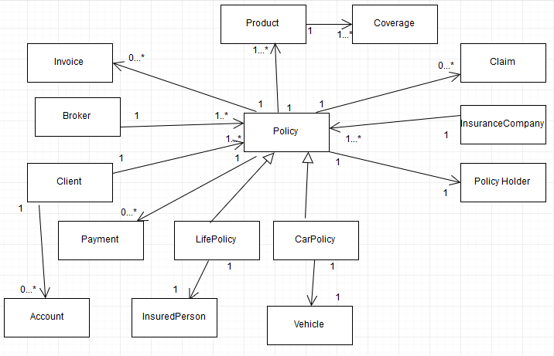

# Architectural Design

## Conceptual Architecture

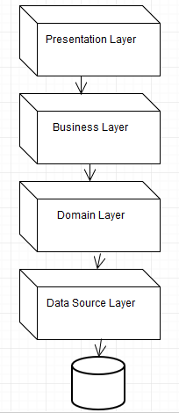

## Package Design

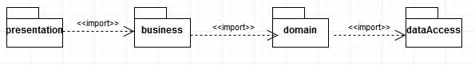

## Component and Deployment Diagrams

### Deployment Diagram

# 

### Component Diagram

# Elaboration – Iteration 1.2

# Design Model

## Dynamic Behavior

*[Create the interaction diagrams (1 sequence, 1 communication diagrams) for 2 relevant scenarios]*

## Class Design

*[Create the UML class diagram; apply GoF patterns and motivate your choice]*

# Data Model

*[Create the data model for the system.]*

# Unit Testing

*[Present the used testing methods and the associated test case scenarios.]*

# Elaboration – Iteration 2

# Architectural Design Refinement

*[Refine the architectural design: conceptual architecture, package design (consider package design principles), component and deployment diagrams. Motivate the changes that have been made.]*

# Design Model Refinement

## *[Refine the UML class diagram by applying class design principles and GRASP; motivate your choices. Deliver the updated class diagrams.]*

# Construction and Transition

# System Testing

*[Describe how you applied integration testing and present the associated test case scenarios.]*

# Future improvements

*[Present future improvements for the system]*

# Bibliography