Cinema

Analysis and Design Document

Student:Muresan Andreea Ioana

**Group:30233**

Revision History

|  |  |  |  |
| --- | --- | --- | --- |
| **Date** | **Version** | **Description** | **Author** |
| 06/04/2017 | <1.0 > |  | Muresan Andreea Ioana |
|  |  |  |  |
|  |  |  |  |
|  |  |  |  |

Table of Contents

I. Project Specification 4

II. Elaboration – Iteration 1.1 4

1. Domain Model 4

2. Architectural Design 4

2.1 Conceptual Architecture 4

2.2 Package Design 4

2.3 Component and Deployment Diagrams 4

III. Elaboration – Iteration 1.2 4

1. Design Model 4

1.1 Dynamic Behavior 4

1.2 Class Design 4

2. Data Model 4

3. Unit Testing 4

IV. Elaboration – Iteration 2 4

1. Architectural Design Refinement 4

2. Design Model Refinement 4

V. Construction and Transition 5

1. System Testing 5

2. Future improvements 5

VI. Bibliography 5

# Project Specification

This project wants to resolve the problem of saving time and energy for someone who is interested in going to see a movie by making the process of viewing the movies available at the moment and the process of reserving/buying tickets a more pleasant one. In order to do that, there will be 4 types of users with different roles.

Visitor - someone who can just see the movies and the theaters where they are available at.

Regular User - someone who can view the schedule, reserve and buy tickets.

Theater Company User - an employee of the theater who can organize the theater's schedule, and perform the CRUD operations for the movies.

Administrator - someone who can organize the schedule, perform the CRUD operations for the movies and is also in charge of troubleshooting.

# Elaboration – Iteration 1.1

# Domain Model

The classes Visitor, User, Administrator and Manager get their data from the database. The VisitorBusiness, UserBusiness, AdministratorBusiness and ManagerBusiness are the classes where all the function abilities of the Users are kept and the information from them are being send forward to the GUI class, which is in charge of displaying the information.

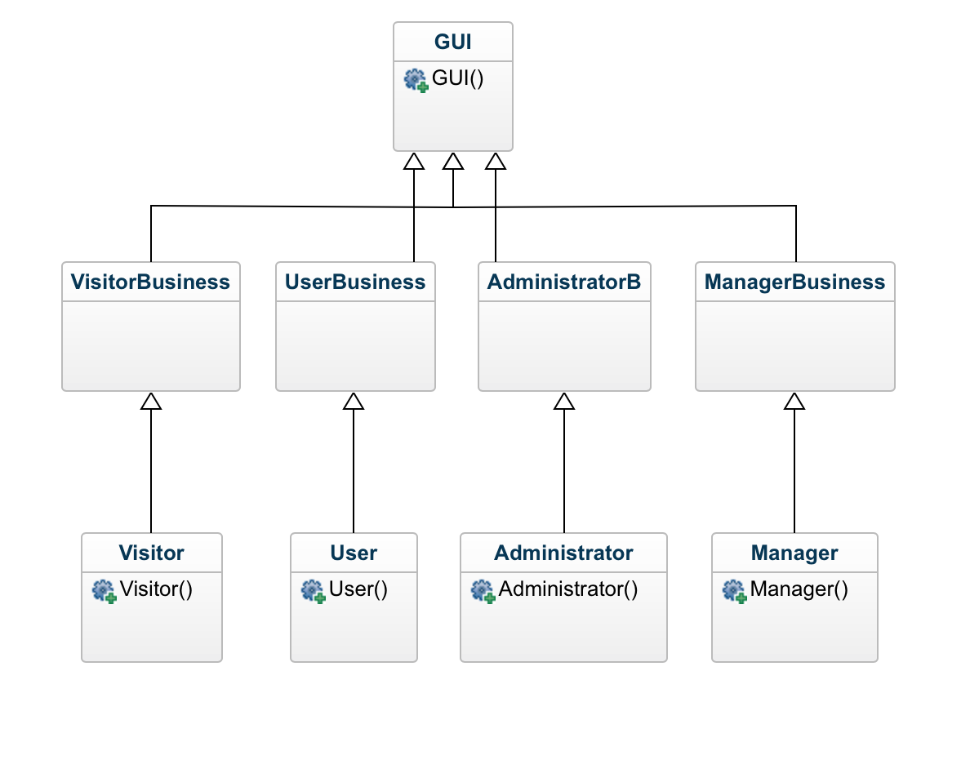

# Architectural Design

## Conceptual Architecture

I chose to organize the application by using the Layered Architecture Design model and organize the application on 3 main levels.

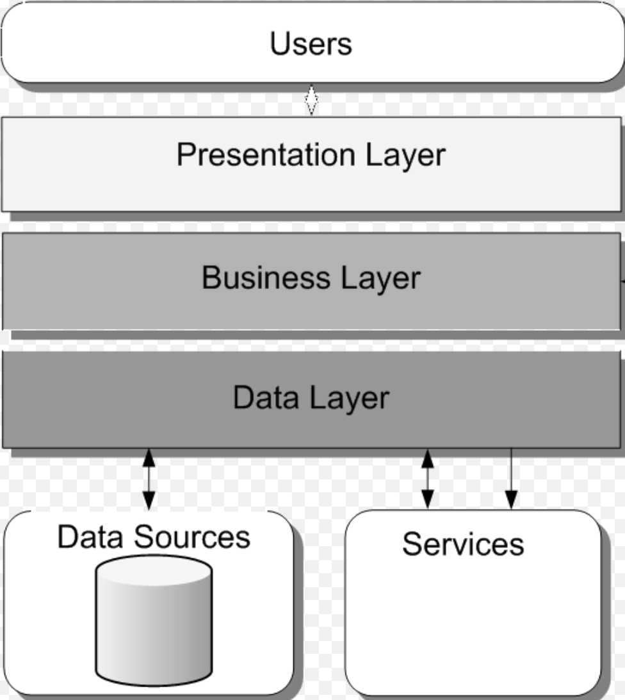

## Package Design

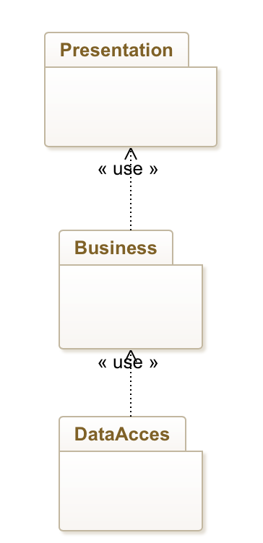

## Component and Deployment Diagrams

# Elaboration – Iteration 1.2

# Design Model

## Dynamic Behavior

*[Create the interaction diagrams (1 sequence, 1 communication diagrams) for 2 relevant scenarios]*

## Class Design

*[Create the UML class diagram; apply GoF patterns and motivate your choice]*

# Data Model

# Unit Testing

*[Present the used testing methods and the associated test case scenarios.]*

# Elaboration – Iteration 2

# Architectural Design Refinement

*[Refine the architectural design: conceptual architecture, package design (consider package design principles), component and deployment diagrams. Motivate the changes that have been made.]*

# Design Model Refinement

# Construction and Transition

# System Testing

*[Describe how you applied integration testing and present the associated test case scenarios.]*

# Future improvements

*[Present future improvements for the system]*

# Bibliography