Book Club Application

Analysis and Design Document

Student:Toader Daiana

**Group:30233**

Revision History

|  |  |  |  |
| --- | --- | --- | --- |
| **Date** | **Version** | **Description** | **Author** |
| 05/04/17 | 1.0 | - | Toader Daiana |
|  |  |  |  |
|  |  |  |  |
|  |  |  |  |

Table of Contents

I. Project Specification 4

II. Elaboration – Iteration 1.1 4

1. Domain Model 4

2. Architectural Design 4

2.1 Conceptual Architecture 4

2.2 Package Design 4

2.3 Component and Deployment Diagrams 4

III. Elaboration – Iteration 1.2 4

1. Design Model 4

1.1 Dynamic Behavior 4

1.2 Class Design 4

2. Data Model 4

3. Unit Testing 4

IV. Elaboration – Iteration 2 4

1. Architectural Design Refinement 4

2. Design Model Refinement 4

V. Construction and Transition 5

1. System Testing 5

2. Future improvements 5

VI. Bibliography 5

# Project Specification

The application that I will develop will be a sort of social network for people that want to find out more information about certain books, to store favorite books, and also to update information for a specific book or to add a new book. The application will be visible to visitors, users and admin. A visitor can view all information about a book, but can’t update or add anything, but he can sign up for registration.

An user can view, update or add a book/author and the admin can make CRUD operations on users/books/authors.

# Elaboration – Iteration 1.1

# Domain Model

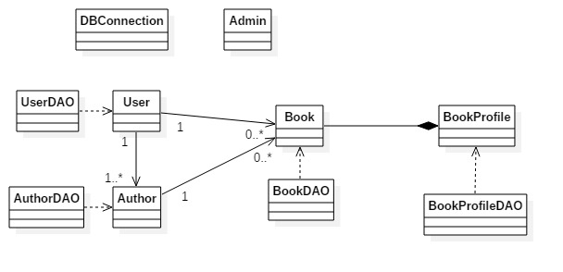

# Architectural Design

## Conceptual Architecture

For this project I choose to use Layered Architectural Pattern, because it separates very well the data access part from the business part and the presentation part where is the application’s GUI.

This architecture contains three layers:

* Data access: Here are the are the models from DB and DAO classes for the models, where I implement the CRUD operations.
* Business: Specific operations and functionalities.
* Presentation: This layer contains the application’s GUI.

## Package Design

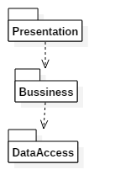

## Component and Deployment Diagrams

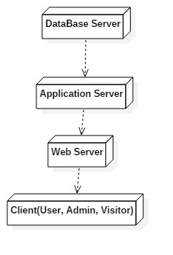

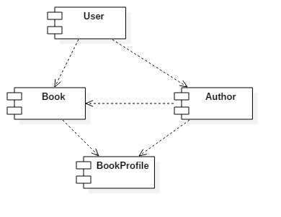

# Elaboration – Iteration 1.2

# Design Model

## Dynamic Behavior

*[Create the interaction diagrams (1 sequence, 1 communication diagrams) for 2 relevant scenarios]*

## Class Design

*[Create the UML class diagram; apply GoF patterns and motivate your choice]*

# Data Model

*[Create the data model for the system.]*

# Unit Testing

*[Present the used testing methods and the associated test case scenarios.]*

# Elaboration – Iteration 2

# Architectural Design Refinement

*[Refine the architectural design: conceptual architecture, package design (consider package design principles), component and deployment diagrams. Motivate the changes that have been made.]*

# Design Model Refinement

## *[Refine the UML class diagram by applying class design principles and GRASP; motivate your choices. Deliver the updated class diagrams.]*

# Construction and Transition

# System Testing

*[Describe how you applied integration testing and present the associated test case scenarios.]*

# Future improvements

*[Present future improvements for the system]*

# Bibliography