Cinema Application

Analysis and Design Document

Student:Deac Dan

**Group:30233**

Revision History

|  |  |  |  |
| --- | --- | --- | --- |
| **Date** | **Version** | **Description** | **Author** |
| <5/04/2017> | <1.0> |  | Deac Dan |
|  |  |  |  |
|  |  |  |  |
|  |  |  |  |

Table of Contents

I. Project Specification 4

II. Elaboration – Iteration 1.1 4

1. Domain Model 4

2. Architectural Design 4

2.1 Conceptual Architecture 4

2.2 Package Design 4

2.3 Component and Deployment Diagrams 4

III. Elaboration – Iteration 1.2 4

1. Design Model 4

1.1 Dynamic Behavior 4

1.2 Class Design 4

2. Data Model 4

3. Unit Testing 4

IV. Elaboration – Iteration 2 4

1. Architectural Design Refinement 4

2. Design Model Refinement 4

V. Construction and Transition 5

1. System Testing 5

2. Future improvements 5

VI. Bibliography 5

# Project Specification

My project will be about a cinema application. There will be two main actors: the administrator and the regular user. The administrator will be able to make CRUD operations on movies and halls. The regular user could be any movie enthusiastic. He will be able to login with Facebook, watch trailers and make reservations.

# Elaboration – Iteration 1.1

# Domain Model

*[Define the domain model and create the conceptual class diagrams]*

# Architectural Design

## Conceptual Architecture

The architectural design will be composed of two main patterns: Client-Server and Layered Architectural Pattern. The Layered Architectural Pattern will be divided into three layers: Presentation, Business and Data Source. The Presentation Layer will contain the GUI, the Business Layer will be the linker layer between Presentation and Data Source. Here the information will be transformed and passed forward to another layer. The Data Source Layer will be the part of the project that will be directly linked to the database and will execute queries.

## Package Design

The package diagram:

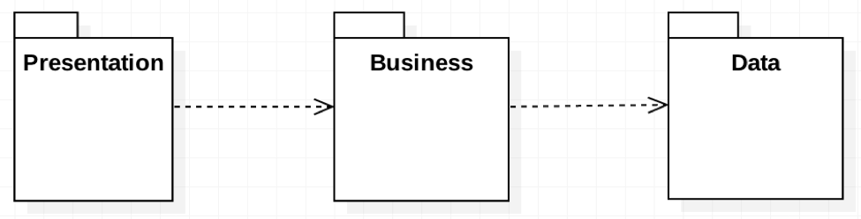

## Component and Deployment Diagrams

The deployment diagram:

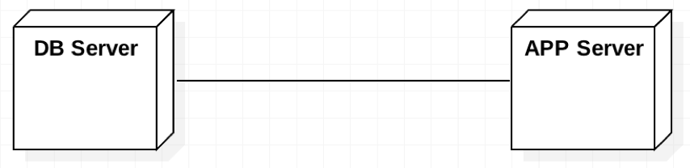

# 

# Elaboration – Iteration 1.2

# Design Model

## Dynamic Behavior

*[Create the interaction diagrams (1 sequence, 1 communication diagrams) for 2 relevant scenarios]*

## Class Design

*[Create the UML class diagram; apply GoF patterns and motivate your choice]*

# Data Model

*[Create the data model for the system.]*

# Unit Testing

*[Present the used testing methods and the associated test case scenarios.]*

# Elaboration – Iteration 2

# Architectural Design Refinement

*[Refine the architectural design: conceptual architecture, package design (consider package design principles), component and deployment diagrams. Motivate the changes that have been made.]*

# Design Model Refinement

## *[Refine the UML class diagram by applying class design principles and GRASP; motivate your choices. Deliver the updated class diagrams.]*

# Construction and Transition

# System Testing

*[Describe how you applied integration testing and present the associated test case scenarios.]*

# Future improvements

*[Present future improvements for the system]*

# Bibliography