Insurance Application

Analysis and Design Document

Student:Suciu Vlad

**Group: 30233**

Revision History

|  |  |  |  |
| --- | --- | --- | --- |
| **Date** | **Version** | **Description** | **Author** |
| <dd/mmm/yy> | <x.x> | No details | Suciu Vlad |
|  |  |  |  |
|  |  |  |  |
|  |  |  |  |

Table of Contents

I. Project Specification 4

II. Elaboration – Iteration 1.1 4

1. Domain Model 4

2. Architectural Design 4

2.1 Conceptual Architecture 4

2.2 Package Design 4

2.3 Component and Deployment Diagrams 4

III. Elaboration – Iteration 1.2 4

1. Design Model 4

1.1 Dynamic Behavior 4

1.2 Class Design 4

2. Data Model 4

3. Unit Testing 4

IV. Elaboration – Iteration 2 4

1. Architectural Design Refinement 4

2. Design Model Refinement 4

V. Construction and Transition 5

1. System Testing 5

2. Future improvements 5

VI. Bibliography 5

# Project Specification

*The application brings togheter all offers from available companies. This fact is very useful for customers that have not enough time to go to agency.*

# - 3types of registration as companie or customer or admin.

- authentification process.

- all flow sell-view-buy insurances will be implemented in this application

The admin can make CRUD operations (create/update/delete) on insurance and customers or:

--validate insurances

--send massages to customers or companies

Customers can:

--View personal information

--View history

--Buy an insurance

--Do payments

--Add as recomandation another customer etc.

# Elaboration – Iteration 1.1

# Domain Model

Will APPEAR AS PRELIMINARY CLASS DIAGRAM:

# Architectural Design

# Aici am primit putin mai down dar voi reveni cu o privire mai de ansamblu.

## Conceptual Architecture

I choose to use Layered Architectural Pattern, because it separates the data access part from the business part and the presentation part where is the application’s GUI.

This architecture contains three layers:

* Data access: Here are the are the models from DB and DAO classes for the models, where I implement the CRUD operations.
* Business: logic behind the app an functionalities.
* Presentation: GUI.

## Package Design

*My package diagram :*

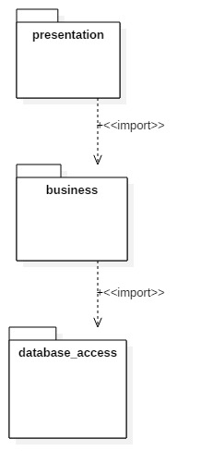

## Component and Deployment Diagrams

**Component**

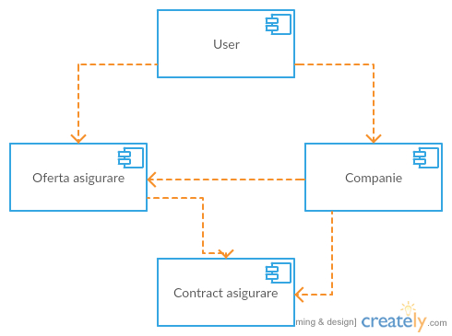

***deployment diagram***

# 

# Elaboration – Iteration 1.2

# Design Model

## Dynamic Behavior

*[Create the interaction diagrams (1 sequence, 1 communication diagrams) for 2 relevant scenarios]*

## Class Design

*[Create the UML class diagram; apply GoF patterns and motivate your choice]*

# Data Model

For this project is the same as domain domain model.

# Unit Testing

*[Present the used testing methods and the associated test case scenarios.]*

# Elaboration – Iteration 2

# Architectural Design Refinement

*[Refine the architectural design: conceptual architecture, package design (consider package design principles), component and deployment diagrams. Motivate the changes that have been made.]*

# Design Model Refinement

## *[Refine the UML class diagram by applying class design principles and GRASP; motivate your choices. Deliver the updated class diagrams.]*

# Construction and Transition

# System Testing

*[Describe how you applied integration testing and present the associated test case scenarios.]*

# Future improvements

*[Present future improvements for the system]*

# Bibliography