A3: Your Books Everywhere!

Analysis and Design Document

Student: Adrian Moldovan

**Group:** 30238

Table of Contents

1. Requirements Analysis 3

1.1 Assignment Specification 3

1.2 Functional Requirements 3

1.3 Non-functional Requirements 3

2. Use-Case Model 4

3. System Architectural Design 4

4. UML Sequence Diagrams 8

5. Class Design 9

6. Data Model 9

7. System Testing 11

8. Bibliography 11

1. Requirements Analysis

# Assignment Specification

Book management service:

A user should be able to create an account, choose a payment plan and login to search the book library.

Payments can be done via a cash only policy and need to be validated by library staff.

The library is managed by staff and can be filtered by release date, author, title, genre.

If a book is available a user can add it to your library. If not the user can join a waiting list. Once a book has been read by a user it can be returned via the online library return function. This assigns the book to the next user in the waiting list after validation of the return by library staff.

The service also provides users with dynamic recommendations based on latest trends (popular borrowed books) or user defined interests by genre or topic.

# Functional Requirements

-User Registration

-Payment system

-Library management

-Dynamic recommendations

-Store data

-Input data has to be validated

# Non-functional Requirements

-Payments:cash only polcy

-Waiting list for unavailable book

-Library is managed by staff.

-Transactions validated by staff

-Recommendations based on latest trends or user defined Interests by genre or topic

-Observer DP

-Factory method for building user recommendations

-Use Database for storage

2. Use-Case Model

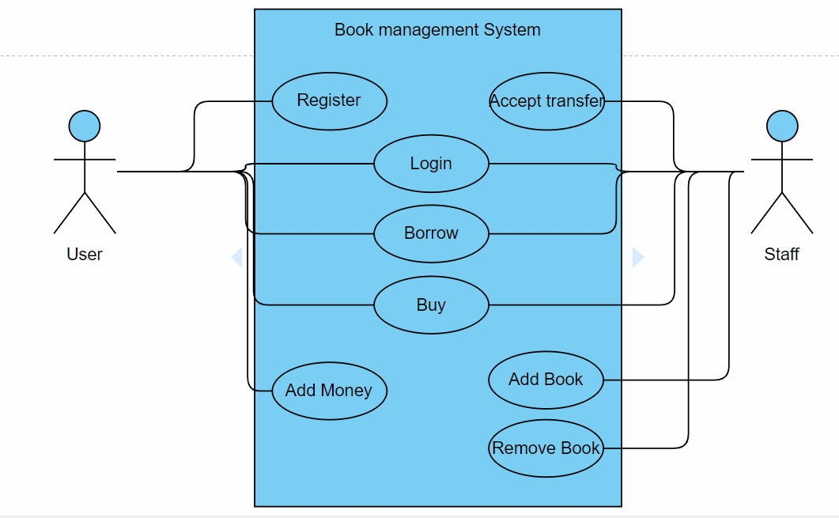

3. System Architectural Design

**3.1 Architectural Pattern Description**

**CQRS:**

Segregate operations that read data from operations that update data by using separate interfaces. This can maximize performance, scalability, and security. Supports the evolution of the system over time through higher flexibility, and prevents update commands from causing merge conflicts at the domain level.

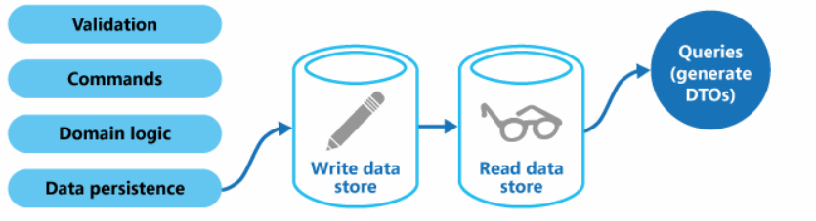

The read store can be a read-only replica of the write store, or the read and write stores can have a different structure altogether. Using multiple read-only replicas can increase query performance, especially in distributed scenarios where read-only replicas are located close to the application instances.

Separation of the read and write stores also allows each to be scaled appropriately to match the load. For example, read stores typically encounter a much higher load than write stores.

Benefits of CQRS include:

* **Independent scaling**. CQRS allows the read and write workloads to scale independently, and may result in fewer lock contentions.
* **Optimized data schemas**. The read side can use a schema that is optimized for queries, while the write side uses a schema that is optimized for updates.
* **Security**. It's easier to ensure that only the right domain entities are performing writes on the data.
* **Separation of concerns**. Segregating the read and write sides can result in models that are more maintainable and flexible. Most of the complex business logic goes into the write model. The read model can be relatively simple.
* **Simpler queries**. By storing a materialized view in the read database, the application can avoid complex joins when querying.

**Observer Design Pattern:**

* Define a one-to-many dependency between objects so that when one object changes state, all its dependents are notified and updated automatically.
* Encapsulate the core (or common or engine) components in a Subject abstraction, and the variable (or optional or user interface) components in an Observer hierarchy.
* The "View" part of Model-View-Controller.
* Define an object that is the "keeper" of the data model and/or business logic (the Subject). Delegate all "view" functionality to decoupled and distinct Observer objects. Observers register themselves with the Subject as they are created. Whenever the Subject changes, it broadcasts to all registered Observers that it has changed, and each Observer queries the Subject for that subset of the Subject's state that it is responsible for monitoring.
* This allows the number and "type" of "view" objects to be configured dynamically, instead of being statically specified at compile-time.
* The protocol described above specifies a "pull" interaction model. Instead of the Subject "pushing" what has changed to all Observers, each Observer is responsible for "pulling" its particular "window of interest" from the Subject. The "push" model compromises reuse, while the "pull" model is less efficient.
* Issues that are discussed, but left to the discretion of the designer, include: implementing event compression (only sending a single change broadcast after a series of consecutive changes has occurred), having a single Observer monitoring multiple Subjects, and ensuring that a Subject notify its Observers when it is about to go away.
* The Observer pattern captures the lion's share of the Model-View-Controller architecture that has been a part of the Smalltalk community for years.

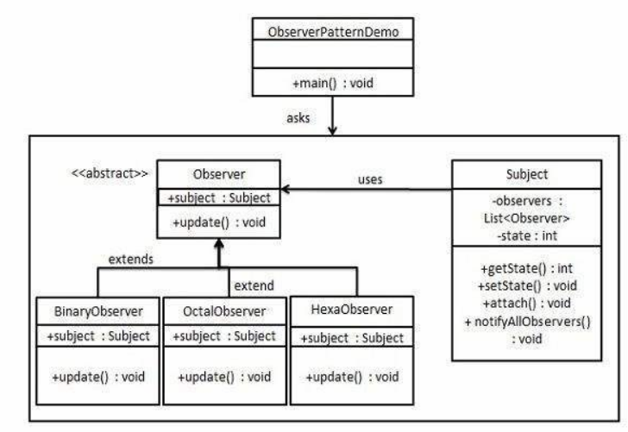

**Mediator:**

Mediator pattern is used to reduce communication complexity between multiple objects or classes. This pattern provides a mediator class which normally handles all the communications between different classes and supports easy maintenance of the code by loose coupling. Mediator pattern falls under behavioral pattern category.

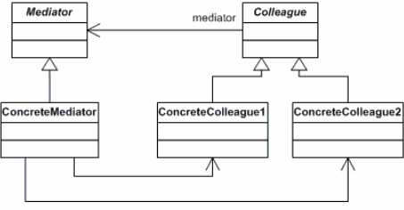

**Decorator:**

Decorator pattern allows a user to add new functionality to an existing object without altering its structure. This type of design pattern comes under structural pattern as this pattern acts as a wrapper to existing class.

This pattern creates a decorator class which wraps the original class and provides additional functionality keeping class methods signature intact.

We are demonstrating the use of decorator pattern via following example in which we will decorate a shape with some color without alter shape class.

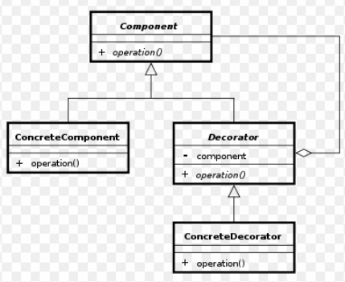

**3.2 Diagrams**

**Package Diagram:**

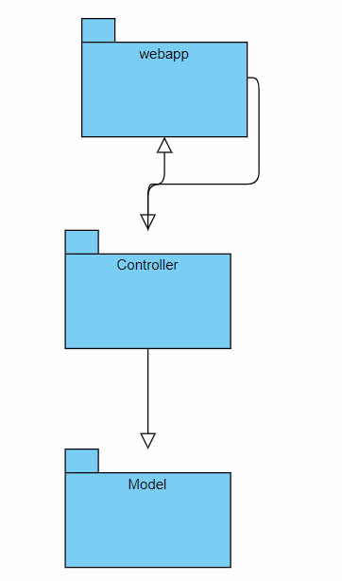

4. UML Sequence Diagrams

5. Class Design

**5.1 Design Patterns Description**

**Factory method pattern:**

The **factory method pattern** is a [creational](https://en.wikipedia.org/wiki/Creational_pattern) pattern that uses factory methods to deal with the problem of creating objects without having to specify the exact class of the object that will be created. This is done by creating objects by calling a factory method—either specified in an interface and implemented by child classes, or implemented in a base class and optionally overridden by derived classes rather than by calling a constructor.

**5.2 UML Class Diagram**

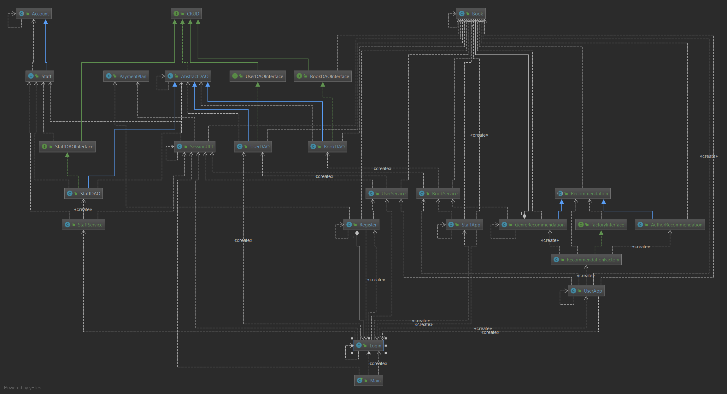

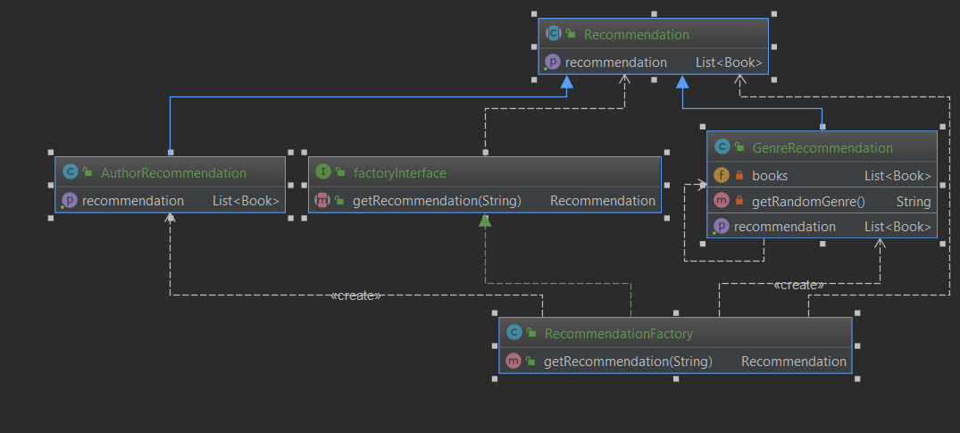

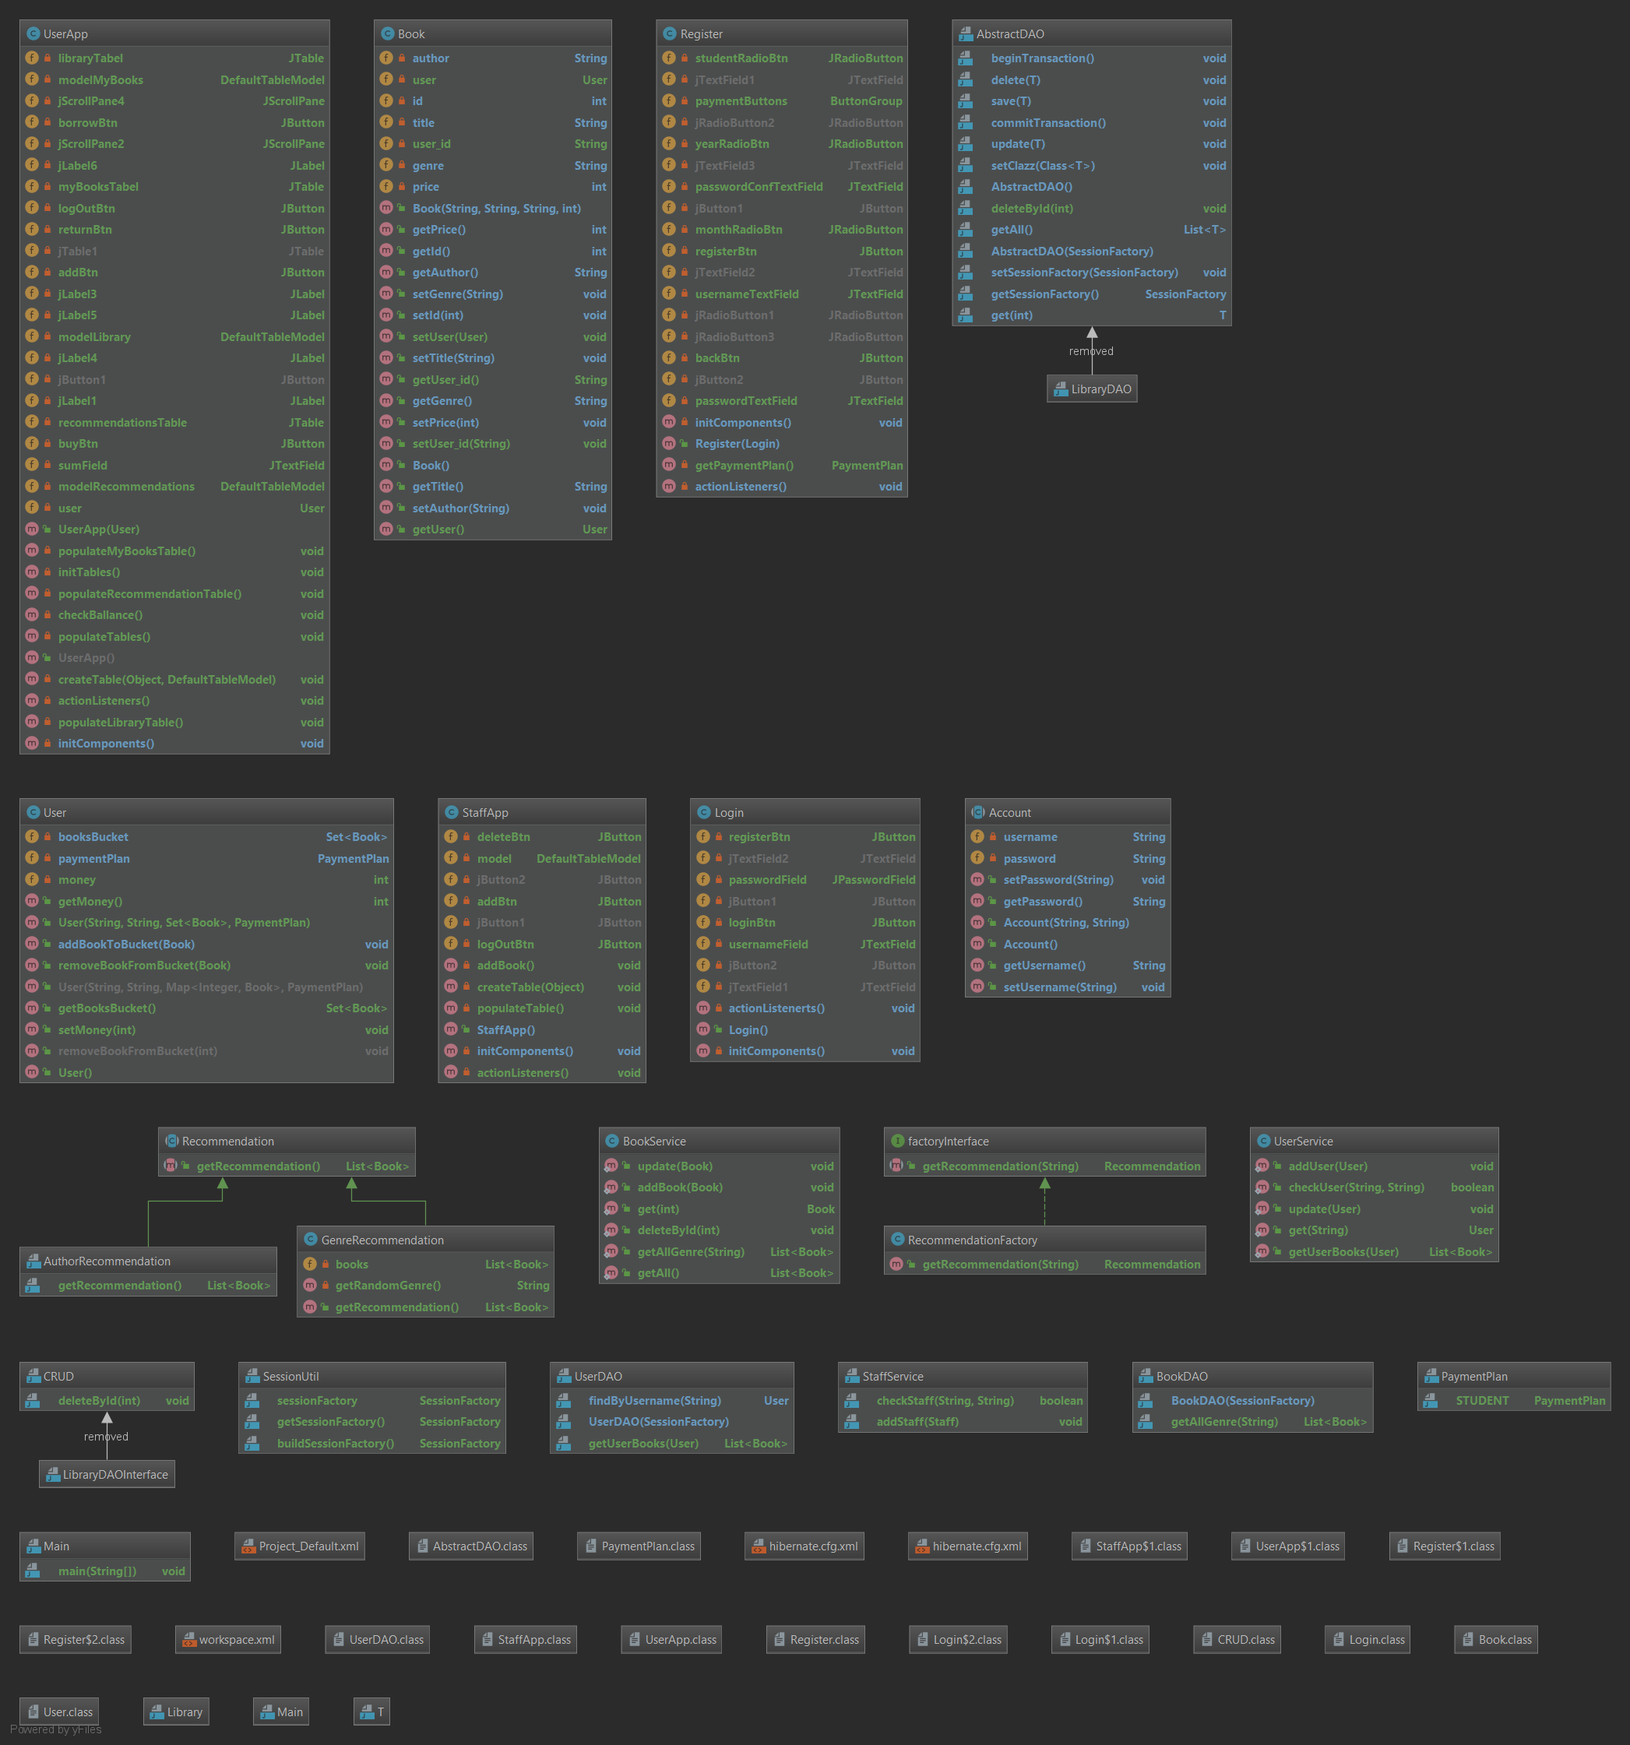

6. Data Model

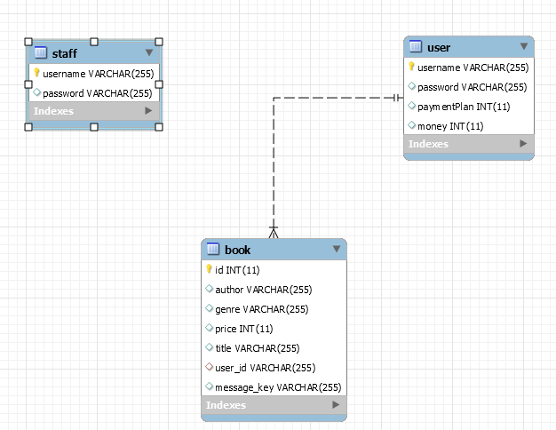

7. System Testing

8. Bibliography

<https://www.baeldung.com/simplifying-the-data-access-layer-with-spring-and-java-generics>

<https://en.wikipedia.org/wiki/Model%E2%80%93view%E2%80%93controller>

<https://www.tutorialspoint.com/design_pattern/observer_pattern.htm>