Best Furniture Deals

Student: Păcurar Aralda

**Group: 30238**

Table of Contents

1. Requirements Analysis 3

1.1 Assignment Specification 3

1.2 Functional Requirements 3

1.3 Non-functional Requirements 3

2. Use-Case Model 3

3. System Architectural Design 4

4. UML Sequence Diagrams 5

5. Class Design 5

6. Data Model 6

7. System Testing 7

8. Bibliography 7

1. Requirements Analysis

# Assignment Specification

The application is a search engine for furniture products. A user is able to create an account and login to search for various provided deals. Deals are managed by staff and can be filtered by price, name and type. Payments can be done via a cash only policy and need to be validated by staff. This creates an order in the system that can be tracked by the user from the Order History section. The state of an order is updated by staff. Once an order is delivered the user can provide feedback in a form on the specific Order History entry details.

# Functional Requirements

In order to use the application, every user is supposed to create an account and login. The application has three types of users, each one of them having a specific set of rights. The administrator has the rights to perform any operation, employees can manage products, discounts and orders as well as view and order items while customers can view and order products, check their order history and give feedback on the products they bought.

The application allows hireing and fireing employees which implies inserting and removing them from the database. Users, roles and the furniture can also be listed. Furniture can be added and removed from the system. Discounts can also be managed by adding or removing a 10% or 20% price change. This also modifies the product’s price in the database. Every type of user can place orders and view their order history as well as leave feedback to the products they bought and received. Staff members can view and manage the orders, updating their tracking information.

# Non-functional Requirements

The “Best Furniture Deals” application has a good response time, it’s a maintainable application that can be updated and upgraded any time. The information provided by the users is safely stored in a database, passwords are hashed using the SHA-256 algorithm.

2. Use-Case Model

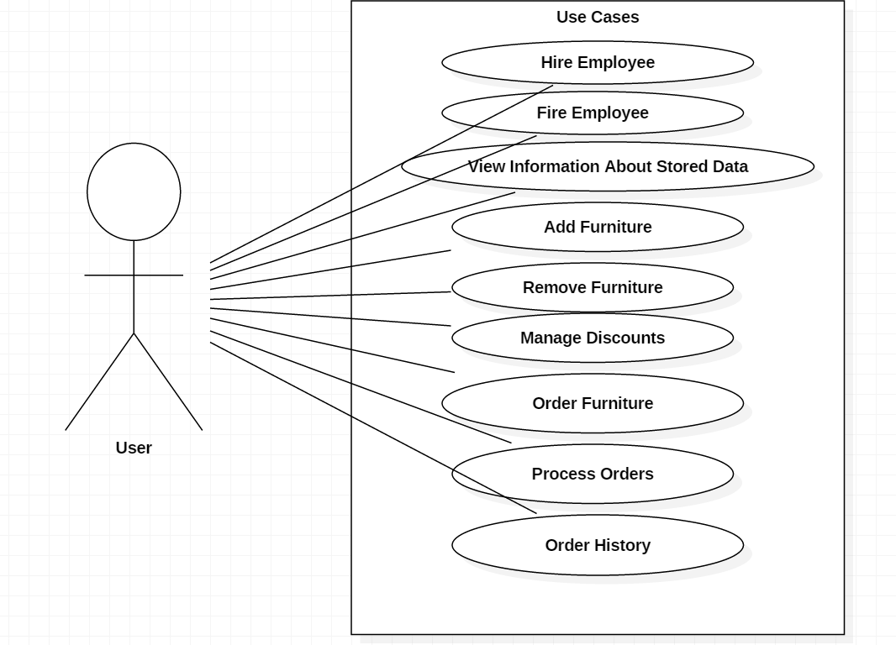

Use case: Hire Employee

Level: sub-function

Primary actor: admin

Main success scenario:

* Admin clicks Hire Employee from the menu
* Admin enters the new employee’s information
* Admin clicks Hire Employee
* The entered data is valid and the new employee is registered and saved in the database

Extensions:

* The data entered by the admin is not valid and the new employee isn’t registered or saved in the database

3. System Architectural Design

**3.1 Architectural Pattern Description**

The layered architectural pattern can be used to structure programs that can be decomposed into groups of subtasks, each of which is at a particular level of abstraction. Each layer provides services to the next higher level.

**3.2 Diagrams**

* Package diagram

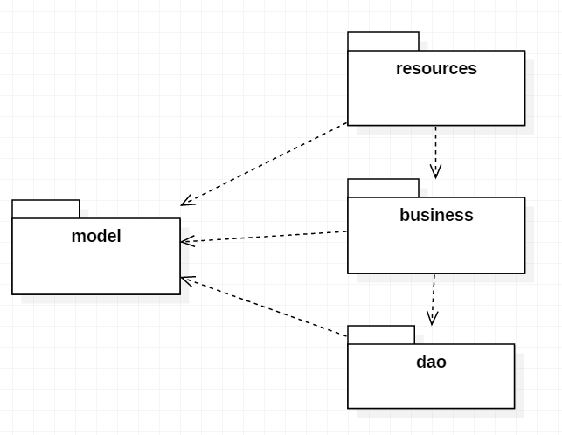

4. UML Sequence Diagrams

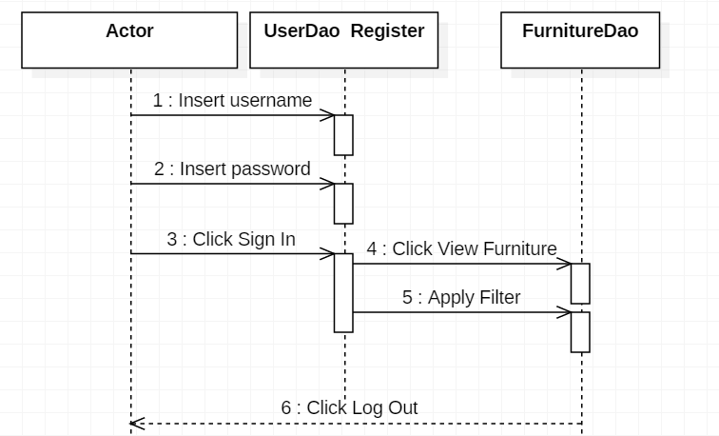

5. Class Design

**5.1 Design Patterns Description**

* **Factory Method**

Factory Method is a creational design pattern that provides an interface for creating objects in a superclass, but allows subclasses to alter the type of objects that will be created. The Factory Method pattern suggests that you replace direct object construction calls (using new operator) with calls to a special factory method. The objects are still created via the new operator, but it is being called from within the factory method. Objects returned by a factory method are often referred to as “products”.

* **Builder**

Builder is a creational design pattern that lets you construct complex objects step by step. The pattern allows you to produce different types and representations of an object using the same construction code. The builder pattern suggests that you extract the object construction code out of its own class and move it to separate objects called builders.

**5.2 UML Class Diagram**

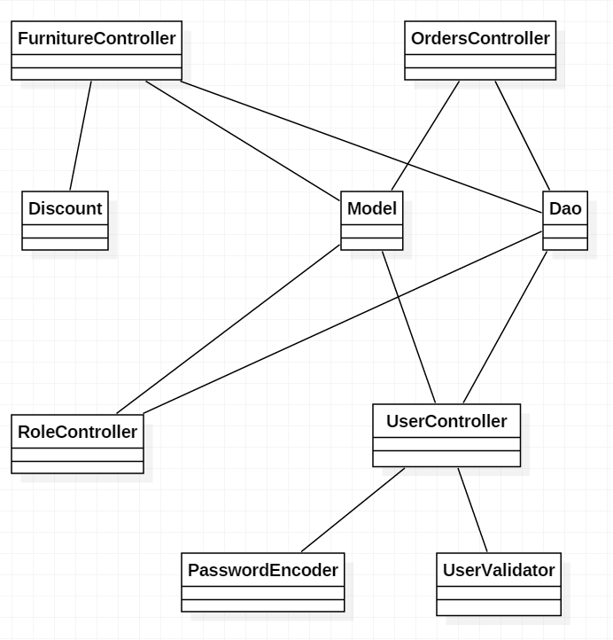

6. Data Model

The data models used in the system’s implementation are:

* Furniture
* Id
* Description
* Name
* Original_price
* Price
* Furniture_type_id
* Furniture_type
* Id
* Name
* Orders
* Id
* Feedback
* Furniture_name
* Status
* Username
* Furniture_id
* User_id
* Rights
* Id
* My_right
* Role
* Id
* Role
* Role_rights
* Roles_id
* Rights_id
* User
* Id
* Address
* Email
* Password
* Username
* Role_id

7. System Testing

The system has been tested by trying out the application’s various features and comparing the obtained results with the desired results. The tests have been successful.

8. Bibliography

<https://towardsdatascience.com/10-common-software-architectural-patterns-in-a-nutshell-a0b47a1e9013>

<https://refactoring.guru/design-patterns/factory-method>

<https://refactoring.guru/design-patterns/builder>