Student : Catargiu Andreea - Alexandra
Group : 30238

Table of Contents
1
1
Student: 1
Table of Contents 2
1. Requirements Analysis 3
1.1Assignment Specification 3
1.2Functional Requirements 3
1.3Non-functional Requirements 3
2. Use-Case Model 3
Use case: <use case goal> 3
Level: <one of: summary level, user-goal level, sub-function> 3
Primary actor: <a role name for the actor who initiates the use case> 3
Main success scenario: <the steps of the main success scenario from trigger to goal delivery> 3
Extensions: <alternate scenarios of success or failure> 3
] 3
3. System Architectural Design 3
4. UML Sequence Diagrams 3
5. Class Design 3
6. Data Model 3
7. System Testing 4
8. Bibliography 4

1. Requirements Analysis

Assignment Specification
The assignment is about building a book management service. A user will be able to create an account, choose a payment plan and login to search the book library.
Payments can be done via cash only policy and need to be validated by library staff.
The library is managed by staff and can be filtered by release date, author, title and genre.
If a book is available a user can add it to your library. If not, the user can join a waiting list. Once a book has been read by a user, it can be returned via the online library return function. The assigns the book to the next user in the waiting list after validation of the return by library staff.
The service also provides users with dynamic recommendations based on latest trends – popular borrowed books – or user defined interests by genre or topic.

Functional Requirements
The functional requirements of the assignment:
    - create an account
    - choose a payment plan
    - login
    - the books can be filtered by release date, author, title and genre
    - add a book to library
    - return a book
    - book recommendations

Non-functional Requirements
- The staff will manage the library. They will have to validate the payments of the users, the return of a book.
  - If a user wants a book that is not available, he can join a waiting list. When the list will be returned, it will be assigned to the first person in the waiting list.

2. Use-Case Model
[Create the use-case diagrams and provide one use-case description (according to the format below).
Use-Case description format:

Use case: <use case goal>

Level: <one of: summary level, user-goal level, sub-function>

Primary actor: <a role name for the actor who initiates the use case>

Main success scenario: <the steps of the main success scenario from trigger to goal delivery>

Extensions: <alternate scenarios of success or failure>

]

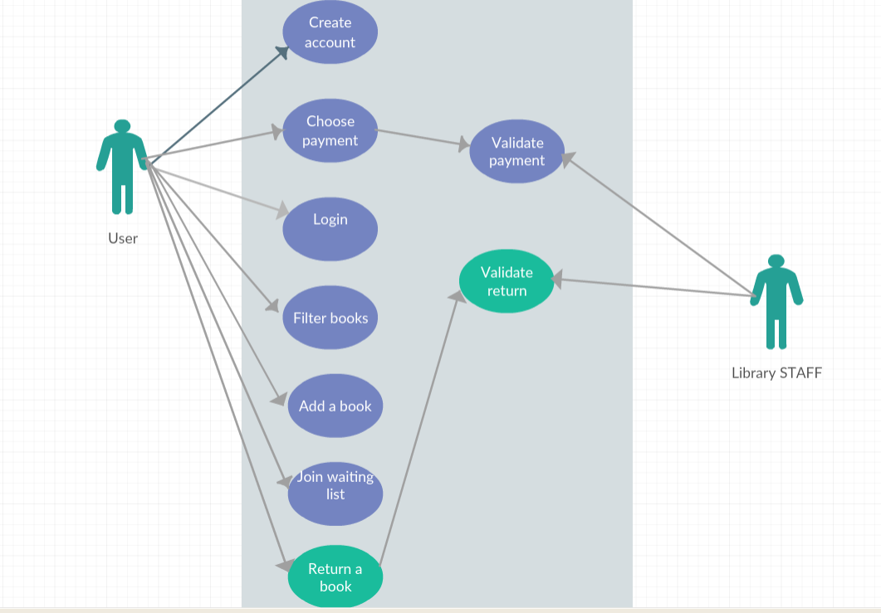

3. System Architectural Design

3.1 Architectural Pattern Description
Client-server model is a distributed application structure that partitions tasks or workloads between the providers of a resource or service, called servers, and service requesters, called clients. Often clients and servers communicate over a computer network on separate hardware, but both client and server may reside in the same system. In out case, the client will be the normal users, and the server will be the library staff, who have to accept the return of books, and the payments.

3.2 Diagrams
[Create the system’s conceptual architecture; use architectural patterns and describe how they are applied. Create package, component and deployment diagrams]

4. UML Sequence Diagrams
[Create a sequence diagram for a relevant scenario.]

5. Class Design

5.1 Design Patterns Description
[Describe briefly the used design patterns.]

5.2 UML Class Diagram
[Create the UML Class Diagram and highlight and motivate how the design patterns are used.]

6. Data Model
[Present the data models used in the system’s implementation.]

7. System Testing
[Present the used testing strategies (unit testing, integration testing, validation testing) and testing methods (data-flow, partitioning, boundary analysis, etc.).]

8. Bibliography
- https://en.wikipedia.org/wiki/Client%E2%80%93server_model

