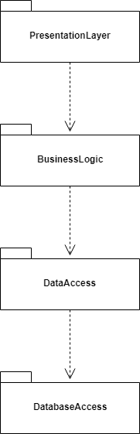
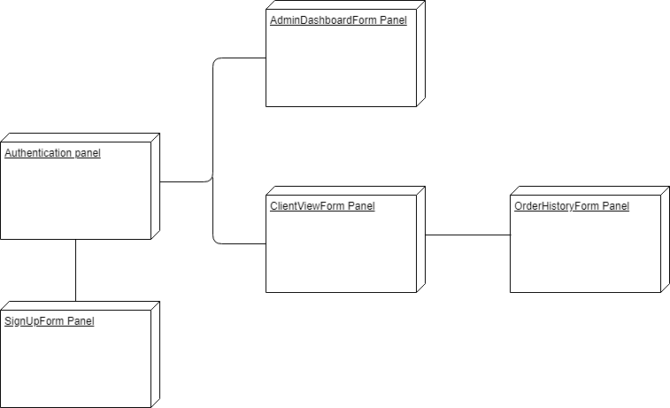
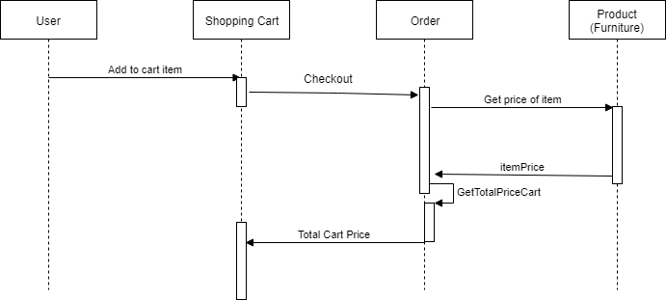
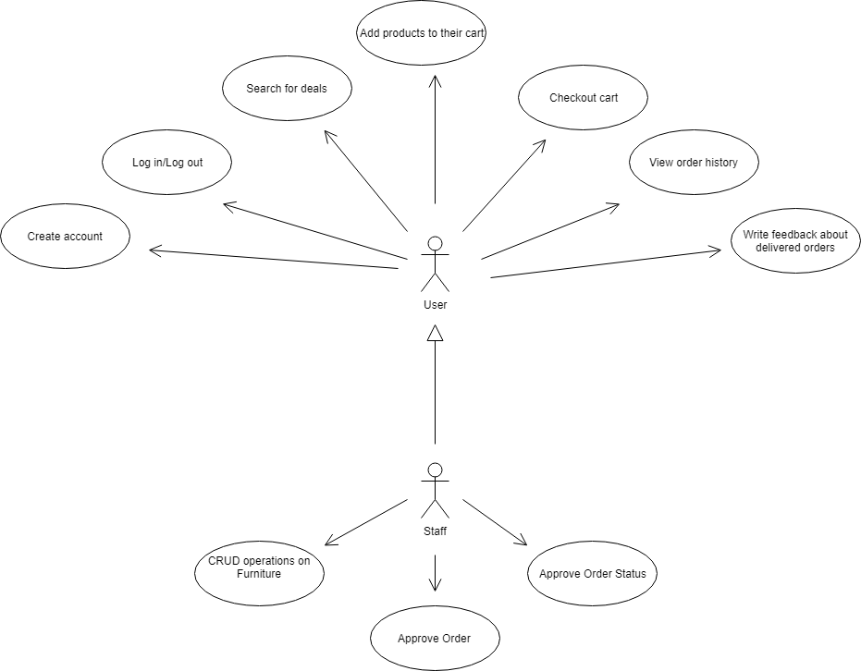
Best Furniture Deals

Student: Tothazan Dragos Tudor
Group: 30238

Table of Contents
Best Furniture Deals 1
1
Student: Tothazan Dragos Tudor 1
Table of Contents 2
1. Requirements Analysis 3
1.1Assignment Specification 3
1.2Functional Requirements 3
1.3Non-functional Requirements 3
2. Use-Case Model 3
Use case: <use case goal> 3
Level: <one of: summary level, user-goal level, sub-function> 3
Primary actor: <a role name for the actor who initiates the use case> 3
Main success scenario: <the steps of the main success scenario from trigger to goal delivery> 3
Extensions: <alternate scenarios of success or failure> 3
] 3
3. System Architectural Design 4
4. UML Sequence Diagrams 6
5. Class Design 6
6. Data Model 7
7. System Testing 7
8. Bibliography 7

1. Requirements Analysis

Assignment Specification
[Application description]
We are tasked to implement an application that users can use to search for furniture deals (same concept as Amazon where costumers are able to find deals from different vendors). Users should be able to filter their query by price, name and type. If a deal is available, users can add that deal to their cart and proceed to checkout. Another feature that the application offers is tracking the order status.
For our second assignment, our task is to use a client-server architecture. The client (or the users) will be able to do CRUD operations (Create, Retrieve all data, Update and Delete Furniture). Also, the data about the Furniture in the database can be accessed by http requests using Postman. Postman will return this data in a JSON format.

Functional Requirements
[Present the functional requirements]
The application will be designed and implemented in C# offering a graphical user interface.
The users should be able to:
- Create their account
- Login
- Search for deals
- Add products to their cart and checkout
- Provide feedback to an order
The staff / admin should be able to:
- Manage products
- Make discounts
- Update order status

Non-functional Requirements
[Discuss the non-functional requirements for the system]
First requirement is to implement and test the application. Another requirement is to use any OOP language (Java, C#, Python etc.). Another requirement is to use layered architecture. Other non-functional requirement is to use a factory method in order to build and apply discounts on existing which change the order quantity and overall price accordingly.

2. Use-Case Model
[Create the use-case diagrams and provide one use-case description (according to the format below).
Use-Case description format:

Use case: <use case goal>

Level: <one of: summary level, user-goal level, sub-function>

Primary actor: <a role name for the actor who initiates the use case>

Main success scenario: <the steps of the main success scenario from trigger to goal delivery>

Extensions: <alternate scenarios of success or failure>

]

3. System Architectural Design

3.1 Architectural Pattern Description
[Describe briefly the used architectural patterns.]
In our application, I structured the application using layered architecture. The layered architecture’s components are organized into horizontal layers, each layer performing a specific role within application (presentation layer, business logic and database access layer) each layer communicates with the layer below and above it. The layers of my application are: DataAccess, BusinessLogic and PresentationLayer.
3.2 Diagrams
[Create the system’s conceptual architecture; use architectural patterns and describe how they are applied. Create package, component and deployment diagrams]

Component diagram:

Package diagram:

Deployment diagram:

Client – Server Architecture:

Package Diagram:

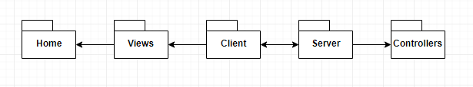
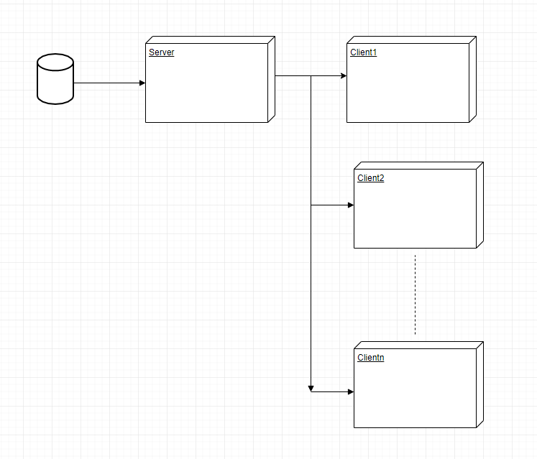

4. UML Sequence Diagrams
[Create a sequence diagram for a relevant scenario.]
Shopping Cart scenario:

5. Class Design

5.1 Design Patterns Description
[Describe briefly the used design patterns.]
The main design pattern that is used in this application is the Factory Method Design Pattern. This is a creational pattern uses factory methods to deal with the problem of creating objects, but without the need to specify the exact class of the object that will be created. This is done by calling a factory method, usually specified by an interface and implemented by child classes or implemented by a base class and optionally overridden by derived classes, instead of calling a constructor.
This enables writing of subclasses to change the way an object is created (to redefine which class to instantiate).
Another design pattern that I used is Layered architecture. I organized my application in different layers: DataAccess(DataAccessObjects and DatabaseConnection), BussinessLogic and PresentationLayer.

5.2 Observer Design Pattern

Observer pattern uses three actor classes. Subject, Observer and Client. Subject is an object having methods to attach and detach observers to a client object. We have created an abstract class Observer and a concrete class Subject that is extending class Observer.
ObserverPatternDemo, our demo class, will use Subject and concrete class object to show observer pattern in action.

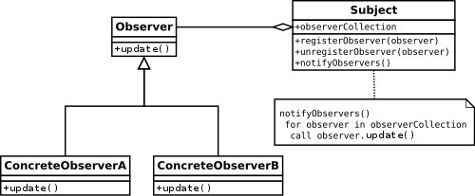

5.2 UML Class Diagram
[Create the UML Class Diagram and highlight and motivate how the design patterns are used.]

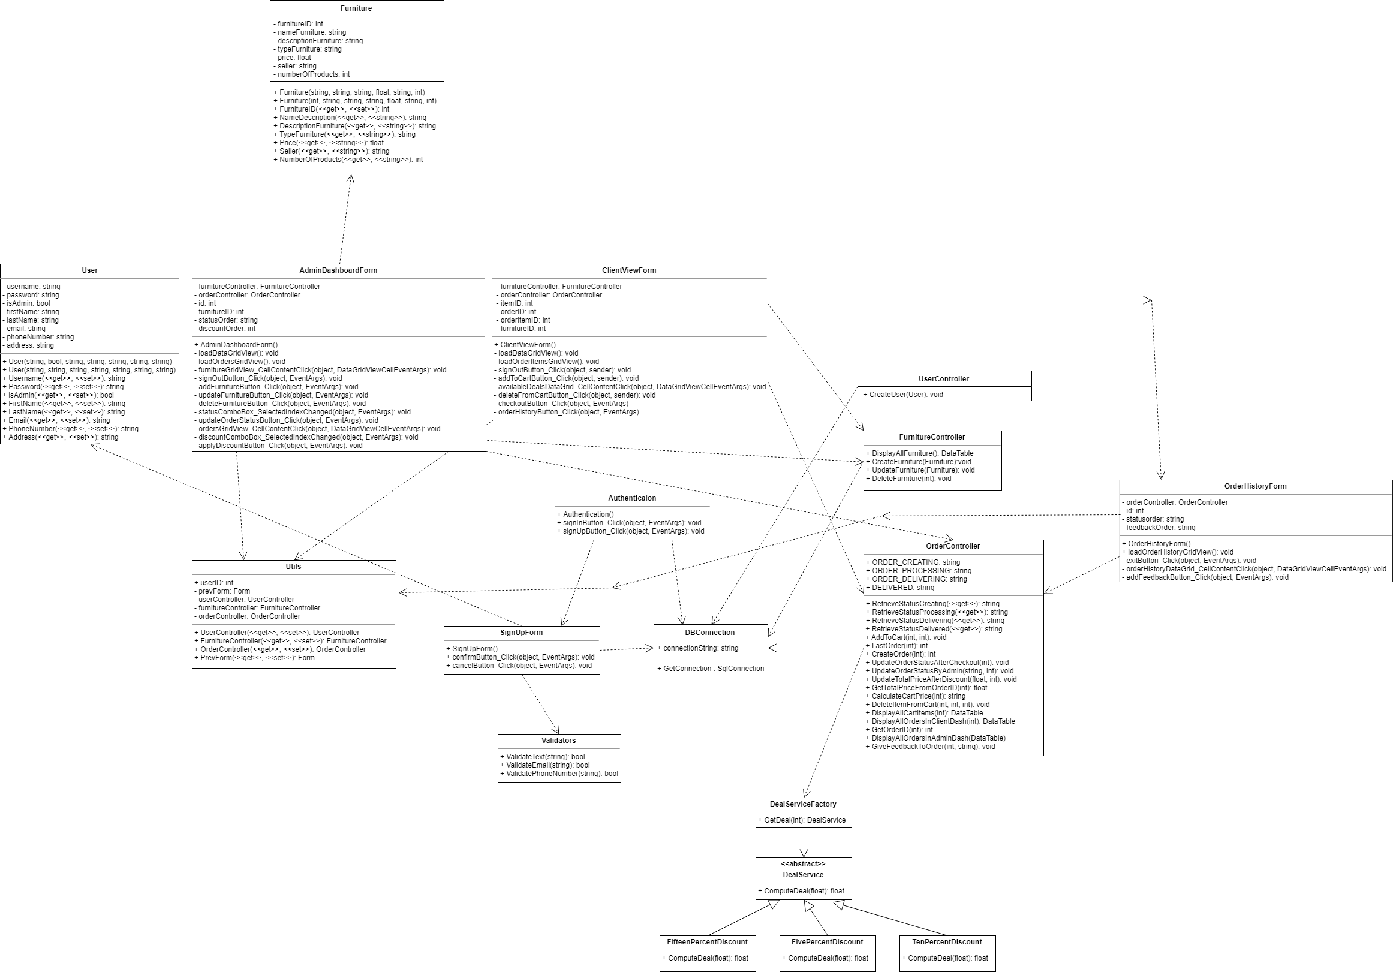

6. Data Model
[Present the data models used in the system’s implementation.]
In this application, the data model is represented as C# classes and as database tables. The business logic of the system is done by C# objects, while the database provides storage for those objects.
The classess that form the data model for this application are: User and Furniture. In the database they are represented as Users and Furnitures while Orders and OrdersItems are objects for business logic.
For the second assignment, I have used Entity Framework to access the data about Furniture from our database (SQL Server). Our data model looks like this after the connection with ADO .NET:

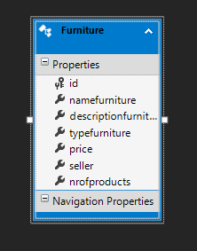

7. System Testing
[Present the used testing strategies (unit testing, integration testing, validation testing) and testing methods (data-flow, partitioning, boundary analysis, etc.).]

8. Bibliography
https://stackoverflow.com/questions/13786549/how-to-implement-3-tiers-architecture-in-c-sharp
https://www.codeproject.com/Articles/36847/Three-Layer-Architecture-in-C-NET-2
https://code-maze.com/factory-method/
https://exceptionnotfound.net/the-daily-design-pattern-factory-method/
https://www.c-sharpcorner.com/blogs/crud-operation-in-c-sharp-application
https://www.guru99.com/c-sharp-access-database.html
https://www.tutorialspoint.com/design_pattern/observer_pattern.htm
https://www.youtube.com/watch?v=iublAXAm8HQ
https://docs.microsoft.com/en-us/aspnet/web-api/overview/older-versions/build-restful-apis-with-aspnet-web-api

