Student:Serban Raluca

**Group:30238**

Table of Contents

1. Requirements Analysis 3

1.1 Assignment Specification 3

1.2 Functional Requirements 3

1.3 Non-functional Requirements 3

2. Use-Case Model 3

3. System Architectural Design 3

4. UML Sequence Diagrams 3

5. Class Design 3

6. Data Model 3

7. System Testing 3

8. Bibliography 3

1. Requirements Analysis

# Assignment Specification

The task for this application was to build a deal search engine for furniture products ,using an OOP language. For this application I used Java. Data used in the application is stored in a database , from where it is retrieved later in the application logic. The application lets the users to make an account , login , browse for product and make orders. The administrator maintains the site , manages product operations like adding , deleting or updating products , updates the database when orders are placed .The users can just view the items but cannot modify them .The items selected by an user are kept in a cart , from where the user can make the order .The site provides information about the cost of the products and also about their availability .The users can add as well as remove products from the cart.

# Functional Requirements

The functional requirements of the application are:

* **Register**-users of the application can create an account that they can later use to get access to the application’s provided services
* **Login**-users can access the application based on the username and the password that they provide when they create the account
* **Logout-** this function allows the users to leave their account
* **Search for deals in the product list-**users can search for various provided deals in the application interface
* **Filter deals**-the deals provided can be filtered by name , type and price
* **Add products to cart-**users can add the products they want to buy to a virtual cart
* **Checkout/Order-**after the products had been added to cart , the users can proceed to checkout and specify the order details
* **View order history-**from their account users can see their orders , as well as their state
* **Update order state-**the staff can update the state of an order
* **Feedback-**when an order is delivered the users can provide feedback
* **Add/Remove product-**the admin can add or remove products
* **Add discount-**the admin can apply different discounts to the existing products , changing in this way their price

# Non-functional Requirements

Non-functional requirements describe user visibility aspects of the system that are not directly related to the functional behavior of the system:

* **User interface –**the system should provide a graphical user interface with different forms of presentation and should be easy to use ; a web browser is an interface between the clients and the software system
* **Documentation-**information about how to use the system should be provided to the users
* **Error handling-**the system handles exception in different situations that mightoccur and notifies the user when they happen(ex. If an order cannot be completed)
* **Reliability-**the system is reliable as it efficiently interacts with the user and secures access to user’s confidential information through user authentication.
* **Robustness-**in case of failures the system cannot lose data and it handles exceptions such as invalid data or incomplete fields
* **Flexibility-**the system is flexible to changes
* **Security-**the system provides secure registration and management facilities for users , so that no other unauthorized user can use their account
* **Validation of data-**all data inputs of the application are validated against invalid before being saved in the database

2. Use-Case Model

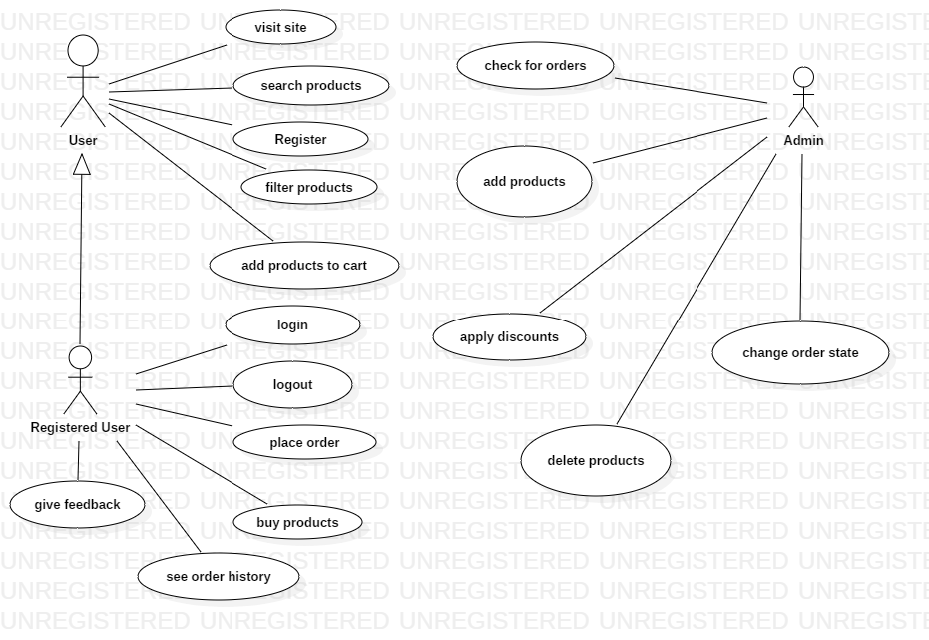

**Use case description:**

**Login**:

**Use case goal:**

This use case describes how a user logs into the Furniture Deals System.

#### **Main success scenario**

Primary actor for this use case is the user.This use case starts when an user wants to log into the Furniture Deals System.

1. The system requests that the user to enter his/her username and password.
2. The actor enters his/her username and password.
3. The system validates the entered name and password and searches in the database for the data introduced .
4. The user can choose to check the option **Remember me** for the system to remember him for the next login operation.
5. The user can use the button **Reset** to clear all the text boxes.
6. If the username and password are found in the database and are correct then the system lets the user in and redirects him to the home page.

#### **Alternate scenarios**

**Invalid Name / Password**:

If in the *Basic Flow*the user enters an invalid name or password, the system displays an error message(Invalid creditentials).

If the user doesn’t specify all the required fields ,some alert messages will alert him of that.

**Pre-Conditions**

None

#### **Post-Conditions**

If the use case was successful, the actor is now logged into the system. If not the system state is unchanged.

3. System Architectural Design

**3.1 Architectural Pattern Description**

For this application the Layered Architecture Pattern was used.In this pattern component of the system are organized into horizontal layers,each layer performing a specific role in the application:presentation,business logic,persistence,data access.In some cases the business and persistance layers are combined into a single business layer,usually in cases where persistence logic (SQL) is embedded in the business layer component.

The presentation layer is responsible with handling all user interface and browser communication logic .

The business logic layer is responsible with executing certain tasks associated with the requests.

Each layer forms an abstarction and doesn’t need to know about the other ayes responsabilities.

This type of classification makes it easy to build effective roles and responsibility models into the architecture of the system.Each of the layers are closed ,which means that a request goes from layer to layer,it goes to the layer right bellow it to get to the next layer bellow that one.In this way changes in one of the layers don’t affect other layers.

**3.2 Diagrams**

**Package Diagram**

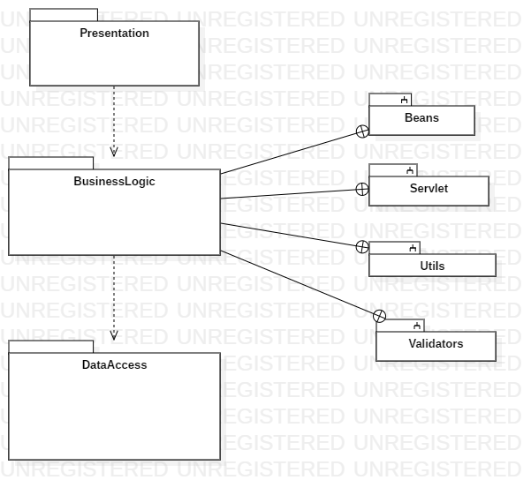

**Component diagram**

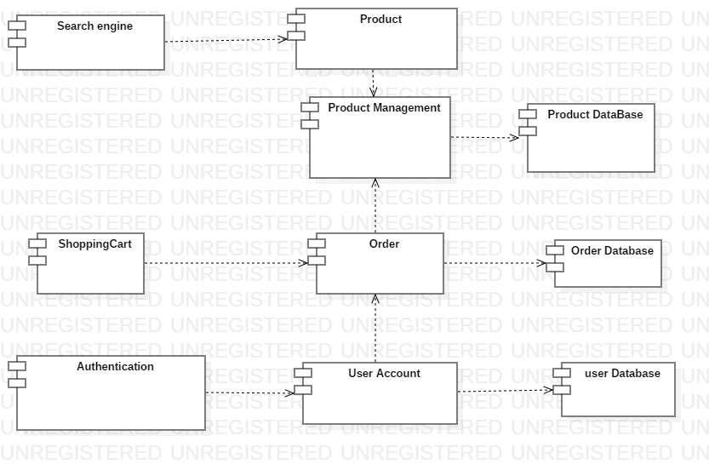

**Deployment Diagram**

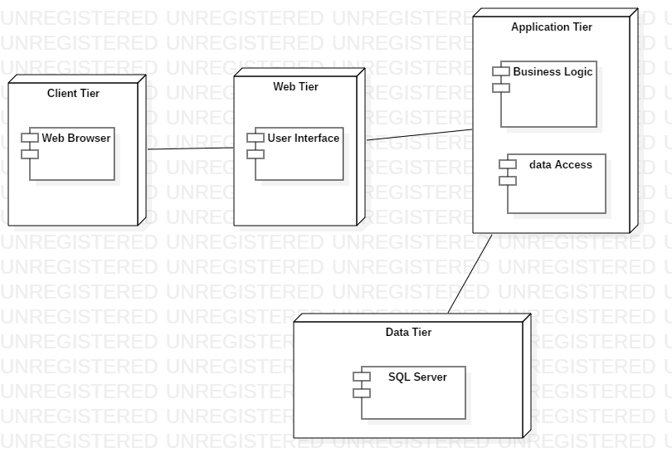

4. UML Sequence Diagrams

Shopping Cart scenario:

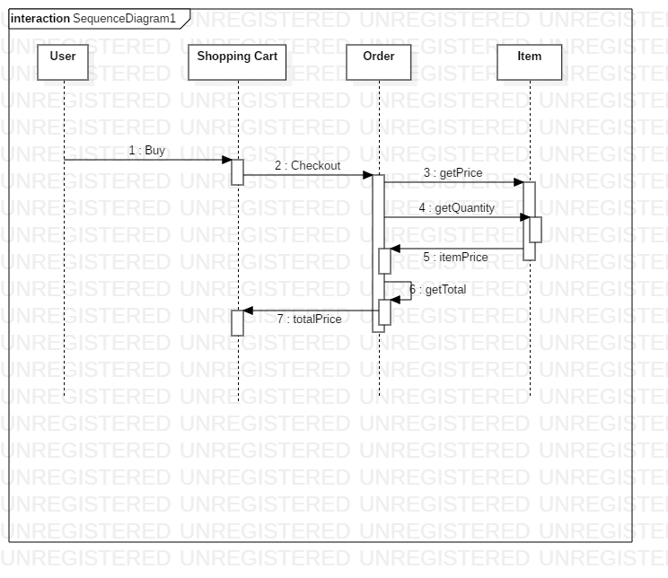

5. Class Design

**5.1 Design Patterns Description**

The design pattern used in this application is the factory method pattern .This is a creational pattern that uses factory methods to deal with the problem of creating objects ,but without the need to specify the exact class of the object that will be created .This is done by calling a factory method,usually specified by an interface and implemented by child classes or implemented by a base class and optionally overridden by derived classes,instead of calling a constructor.

This enables writing of subclasses to change the way an object is created (to redefine witch class to instantiate).

This pattern relies on inheritance ,as object creation is delegated to subclasses that implement the factory method to create objects.

In the context of this application the pattern is used for creating different types of discounts to apply on products ,in order to change their price .There are 3 types of discounts:10%,15%,20%.For creating the discounts the method **createDiscount** from the class **DiscountCreator** is use and this method returns an instance of the Discount class,instance of one of its subclasses depending on the type of discount wanted:Discount10,Discount15.Discount20.

**5.2 UML Class Diagram**

*[Create the UML Class Diagram and highlight and motivate how the design patterns are used.]*

6. Data Model

*[Present the data models used in the system’s implementation.]*

7. System Testing

*[Present the used testing strategies (unit testing, integration testing, validation testing) and testing methods (data-flow, partitioning, boundary analysis, etc.).]*

8. Bibliography