Furniture Deals

Analysis and Design Document

Student:Urcan Miruna - Stefania

**Group:30238**

Table of Contents

1. Requirements Analysis 3

1.1 Assignment Specification 3

1.2 Functional Requirements 3

1.3 Non-functional Requirements 3

2. Use-Case Model 3

3. System Architectural Design 3

4. UML Sequence Diagrams 3

5. Class Design 3

6. Data Model 3

7. System Testing 3

8. Bibliography 3

1. Requirements Analysis

# Assignment Specification

The task is about building a search engine for furniture products. The client ( or user) is able to login or create an account in case he does not have one. He can search for different products added by a staff member. For an easier search, he can filter the products by their type, price or name. In this case, the product list will change, in order to have a better vision for what the user is looking for.

A deal can be proceeded only if available, which means there are enough products to cover the order for user. The payment process is automatically requested when the user validate the order.

The payment is validated by the staff. In this case, the order will remain in the system until a staff member validate it. This process can be seen by the user via Invoice and Order History: if the payment is not validated yet, the order will be seen in the Invoice category. On the other hand, if the payment if validated, the order details will appear in the Order History section.

# Functional Requirements

There are two kinds of clients: users : which can make orders and search for deals - and staff - members who can add, delete or update a product and validate the orders.

Both categories of clients are able to logIn. The logout is made automatically when the client closes the window.

# Non-functional Requirements

We were asked to use an OOP language (Java), implement and test the application. Another requirement was to use a layered architecture and to use a database for storage. All the inputs of the application has to be validated. The next request was to build a feature for the staff member, in order to apply discounts. For this requirement, we were asked to use Factory Method. This feature can change the overall price.

2. Use-Case Model

*[Create the use-case diagrams and provide one use-case description (according to the format below).*

*Use-Case description format:*

*Use case: <use case goal>*

*Level: <one of: summary level, user-goal level, sub-function>*

*Primary actor: <a role name for the actor who initiates the use case>*

*Main success scenario: <the steps of the main success scenario from trigger to goal delivery>*

*Extensions: <alternate scenarios of success or failure>*

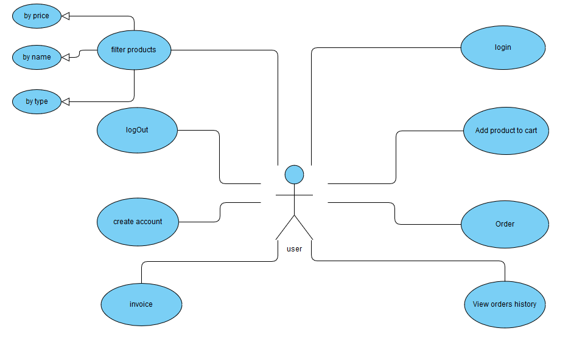

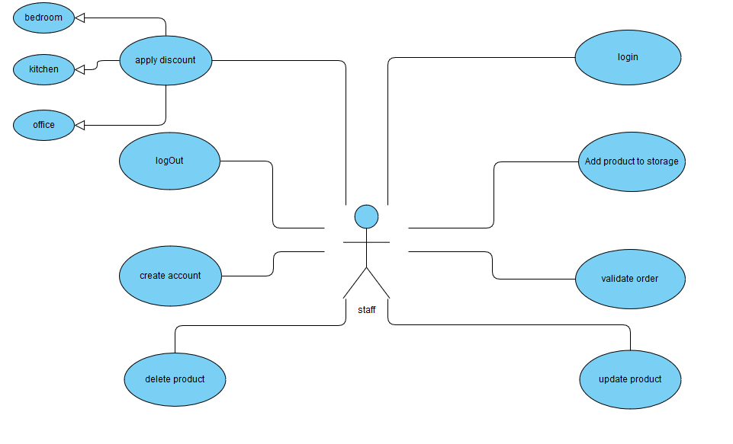

3. System Architectural Design

**3.1 Architectural Pattern Description**

*[Describe briefly the used architectural patterns.]*

**3.2 Diagrams**

*[Create the system’s conceptual architecture; use architectural patterns and describe how they are applied. Create package, component and deployment diagrams]*

4. UML Sequence Diagrams

*[Create a sequence diagram for a relevant scenario.]*

5. Class Design

**5.1 Design Patterns Description**

*[Describe briefly the used design patterns.]*

**5.2 UML Class Diagram**

*[Create the UML Class Diagram and highlight and motivate how the design patterns are used.]*

6. Data Model

*[Present the data models used in the system’s implementation.]*

7. System Testing

*[Present the used testing strategies (unit testing, integration testing, validation testing) and testing methods (data-flow, partitioning, boundary analysis, etc.).]*

8. Bibliography