Alliance vs Horde

Analysis and Design Document

Student:Alexandru-Horea Anisorac

**Group:30238**

Revision History

|  |  |  |  |
| --- | --- | --- | --- |
| **Date** | **Version** | **Description** | **Author** |
| <dd/mmm/yy> | <x.x> | <details> | <name> |
|  |  |  |  |
|  |  |  |  |
|  |  |  |  |

Table of Contents

I. Project Specification 4

II. Elaboration – Iteration 1.1 4

1. Domain Model 4

2. Architectural Design 4

2.1 Conceptual Architecture 4

2.2 Package Design 4

2.3 Component and Deployment Diagrams 4

III. Elaboration – Iteration 1.2 4

1. Design Model 4

1.1 Dynamic Behavior 4

1.2 Class Design 4

2. Data Model 4

3. Unit Testing 4

IV. Elaboration – Iteration 2 4

1. Architectural Design Refinement 4

2. Design Model Refinement 4

V. Construction and Transition 5

1. System Testing 5

2. Future improvements 5

VI. Bibliography 5

# Project Specification

# This project is a RPG(Role Playing Game).It is similar with WOW(World Of Warcraft),game where the player have two clans:Alliance and Horde.This game will have different types of races for each clan.For Alliance will be:Human,Centaur,Elf,Dwarf and Golem.Races that have joined to Horde clan are:Orc,Cyclop,Zombie,Naga and Minotaur.These races will fight each other and they will can control one of these classes: Paladin, Hunter, Warrior, Priest ,Mage , Demon and Overlord.For each class the player will have a set of skills that he can use them in combat.The goal of this game is to be the best in the world and beat all enemies.

# Elaboration – Iteration 1.1

# Domain Model

The first diagrams will be for classes,clans and races.They will be interconnected with each other.

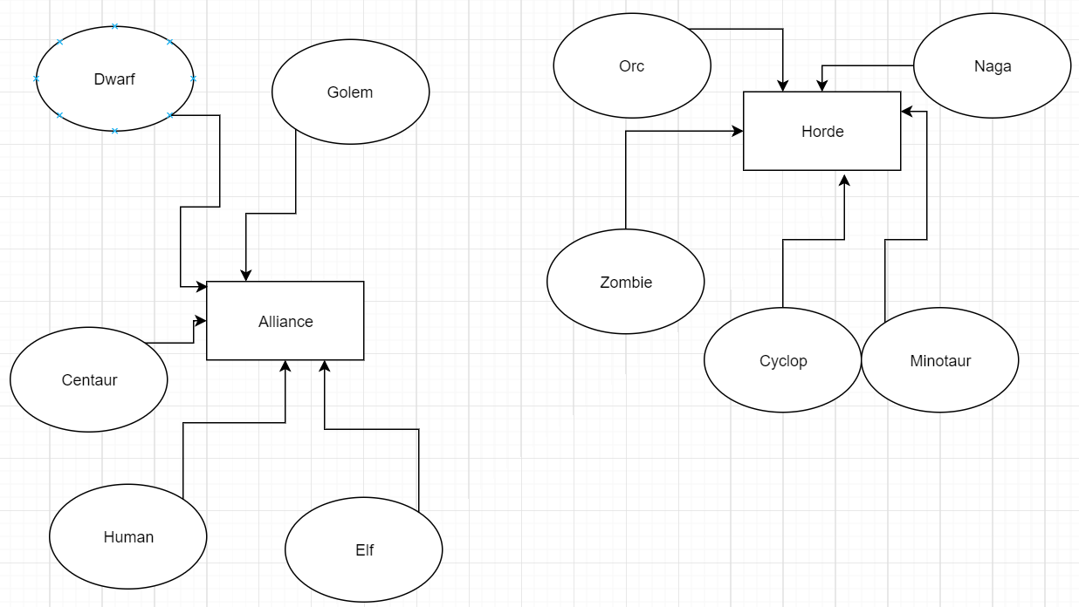

# Architectural Design

## Conceptual Architecture

This project’s architecture will be a client-server one.The client will be connected with other players and they will manage to enter in the same lobby.The lobby will be a server the is gonna be active meanwhile the players will play the game.

One of the design patterns that will be implemented is Observer because a class will be notify when is changed.

## Be Package Design

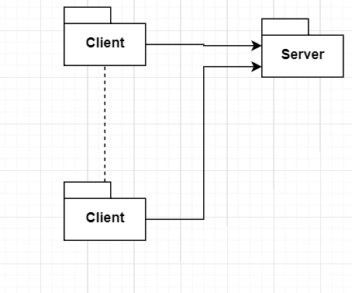

There are two packages.One is server and the other one is client.There are more dots because it can be more clients in a lobby to a maximum number of twenty.

## Component and Deployment Diagrams

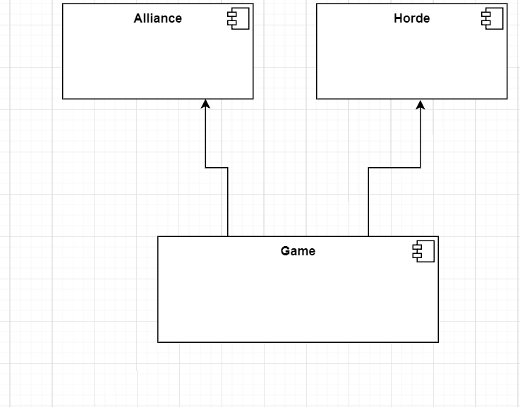

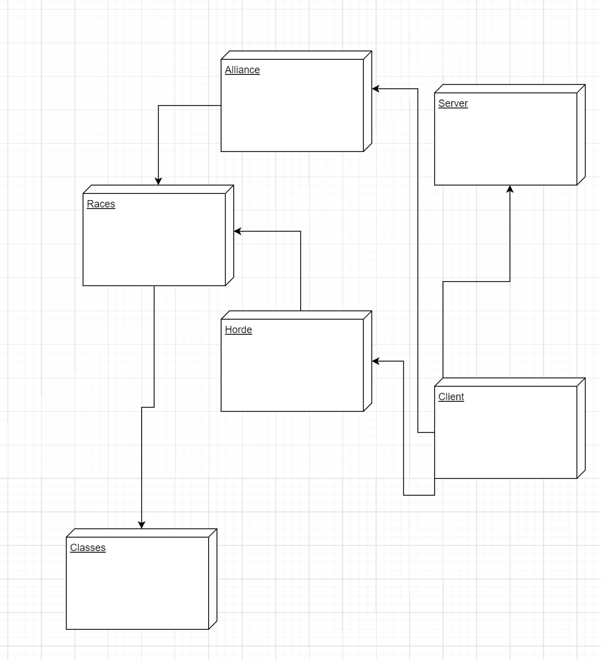

# Elaboration – Iteration 1.2

# Design Model

## Dynamic Behavior

*[Create the interaction diagrams (1 sequence, 1 communication diagrams) for 2 relevant scenarios]*

## Class Design

*[Create the UML class diagram; apply GoF patterns and motivate your choice]*

# Data Model

*[Create the data model for the system.]*

# Unit Testing

*[Present the used testing methods and the associated test case scenarios.]*

# Elaboration – Iteration 2

# Architectural Design Refinement

*[Refine the architectural design: conceptual architecture, package design (consider package design principles), component and deployment diagrams. Motivate the changes that have been made.]*

# Design Model Refinement

## *[Refine the UML class diagram by applying class design principles and GRASP; motivate your choices. Deliver the updated class diagrams.]*

# Construction and Transition

# System Testing

The testing part will be maid by testers,actually gamers that I hope that won’t find bugs and glitches.If these anomalies will be found they will be repaired thet the game will be playable.

# Future improvements

*[Present future improvements for the system]*

# Bibliography