Smart Exchange

Analysis and Design Document

Student:Bercea Ionut-Alexandru

**Group:30238**

Revision History

|  |  |  |  |
| --- | --- | --- | --- |
| **Date** | **Version** | **Description** | **Author** |
| 04/04/19 | 1.0 | <details> | Bercea Ionut Alexandru |
|  |  |  |  |
|  |  |  |  |
|  |  |  |  |

Table of Contents

I. Project Specification 4

II. Elaboration – Iteration 1.1 4

1. Domain Model 4

2. Architectural Design 4

2.1 Conceptual Architecture 4

2.2 Package Design 4

2.3 Component and Deployment Diagrams 4

III. Elaboration – Iteration 1.2 4

1. Design Model 4

1.1 Dynamic Behavior 4

1.2 Class Design 4

2. Data Model 4

3. Unit Testing 4

IV. Elaboration – Iteration 2 4

1. Architectural Design Refinement 4

2. Design Model Refinement 4

V. Construction and Transition 5

1. System Testing 5

2. Future improvements 5

VI. Bibliography 5

# Project Specification

Aplicatia are rolul de a imbunatati serivicile de schimb valutar. Aceasta ofera posibilitatea clientilor de a-si crea un cont personal pentru a utiliza aplicatia. Fiecare cont personal are atribuit un portofel in care se pot depune mai multe tipuri de monezi( ex. RON, $), iar utilizatorul poate vinde sau cumpara diferite monezi, vizualiza anumite statistici referitoare la moneda pe care vrea sa o vanda sau sa o cumpere astfel este influentat daca perioada aleasa este una buna.

Aplicatia este dezvoltata cu ajutorul limbajului Java, impreuna cu o baza de date SQL care ajuta la stocarea datelor necesare aplicatiei.

# Elaboration – Iteration 1.1

# Domain Model

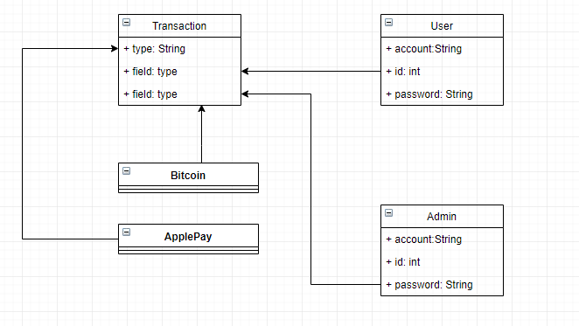

# Architectural Design

## Conceptual Architecture

*[Define the system’s conceptual architecture; use an architectural style and pattern - highlight its use and motivate your choice.]*

## Package Design

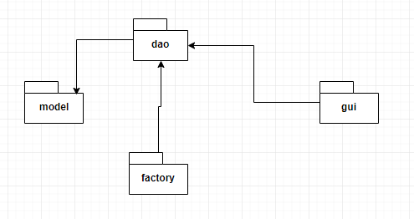

## Component and Deployment Diagrams

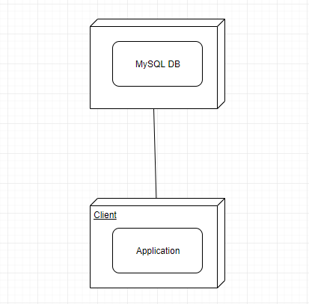

# Elaboration – Iteration 1.2

# Design Model

## Dynamic Behavior

Communication diagram:

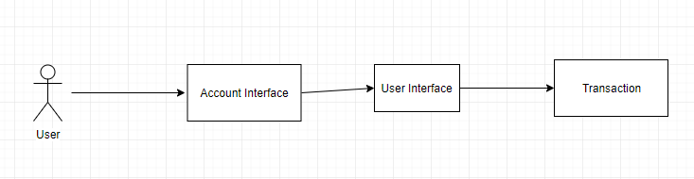

Sequence diagram:

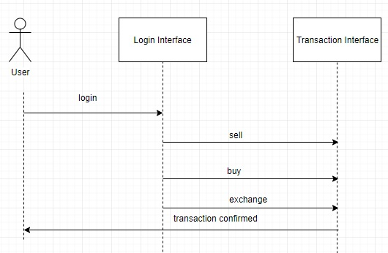

## Class Design

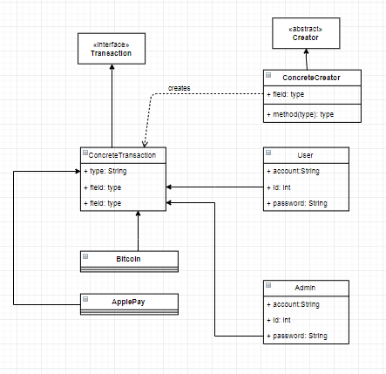

# Data Model

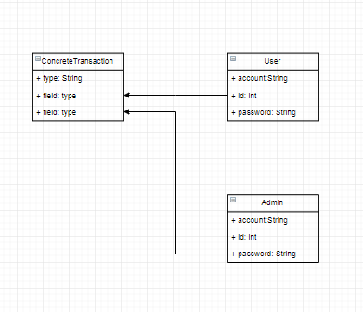

# Unit Testing

*[Present the used testing methods and the associated test case scenarios.]*

# Elaboration – Iteration 2

# Architectural Design Refinement

*[Refine the architectural design: conceptual architecture, package design (consider package design principles), component and deployment diagrams. Motivate the changes that have been made.]*

# Design Model Refinement

## *[Refine the UML class diagram by applying class design principles and GRASP; motivate your choices. Deliver the updated class diagrams.]*

# Construction and Transition

# System Testing

*[Describe how you applied integration testing and present the associated test case scenarios.]*

# Future improvements

*Aplicatia poate fi dezvoltata ulterior prin adaugarea unor licitatii. Aici client pot face licitatii pentru a vinde anumite sume in diferite monede.*

# Bibliography

<https://dzone.com/articles/solid-grasp-and-other-basic-principles-of-object-o>