Coach4Health

Use-Case Model

Version <1.0>

Revision History

|  |  |  |  |
| --- | --- | --- | --- |
| **Date** | **Version** | **Description** | **Author** |
| <dd/mmm/yy> | <x.x> | <details> | <name> |
|  |  |  |  |
|  |  |  |  |
|  |  |  |  |

Table of Contents

1. Use-Cases Identification 4

2. UML Use-Case Diagrams 6

Use-Case Model

# Use-Cases Identification

The main actors in case of this application are the people that use it. These users can be divided into two categories, based on their roles:

* **Regular users**: these are the users who choose workout and meal plans and pay for them
* **Fitness trainers**: there will be a few fitness trainers using the “Coach4Health” application as well. Their role is to create new workout and meal plans for the regular users and to also monitor their ongoing progress.

In order to define scenarios for an application a few potential clients should be asked to define their vision regarding the application and in this particular case, asked questions like*: “Should a user be able to see the fitness progress of other users?” , ”Should a fitness trainer be able to create more than one workout and meal plan?” , ”Should a regular user be able to be enrolled in more than one workout routine at a given time?” , ”Should a meal plan be chosen independently in respect to a workout plan?”* etc.

Possible scenarios regarding “Coach4Health” are: logging in, signing up for a new account, choosing a workout and/or meal plan, tracking personal progress and so on.

Next, three relevant use cases will be described according to the following format:

***Use case: <use case goal>***

***Level: <one of: summary level, user-goal level, sub-function>***

***Primary actor: <a role name for the actor who initiates the use case>***

***Main success scenario: <the steps of the main success scenario from trigger to goal deliverye following format:>***

***Extensions: <alternate scenarios of success or failure>***

]

**Use case:** A user logging in into his/her personal account

**Level:** user-goal level

**Primary actor:** a user of the application (this use case is valid for both a regular user and a fitness trainer)

**Main success scenario:** The goal of this use case is that the user can enter his/her personal account, from where he/she will be able to track own fitness progress and choose different workout and meal plans (in case of a regular user) or create new workout and meal plans (in case the user is a fitness trainer). The trigger of this use case is represented by introducing the username and password in the corresponding fields contained in the login form. If they are correct (this meaning that they exist in the database), the user will be logged into his/her personal account from where he/she will be able to do specific actions and benefit from different facilities offered by the application.

**Extensions:** In case of failing to provide the correct username and password, the login cannot be performed and the user will be notified about what he introduced in a wrong format in the login form (username and/or password).

**Use case:** Creating a new workout plan

**Level:** user-goal level

**Primary actor:** this use case can be initiated only by a fitness trainer

**Main success scenario:** when a fitness trainer want to offer the users a new workout plan, he/she must complete a form containing information such as exercises in the workout plan, duration of the workout plan, intensity (for example Beginner, Intermediate or Advanced). After completing the workout plan the fitness trainer must add a price to it and then make it available for the general public to purchase**.**

**Extensions:** Since this use case should not have failures, I will present an extended version in case of success. After a workout plan is published, if the fitness trainer who published it considers necessary, the plan can be updated by adding new exercises.

**Use case:** paying for a workout/meal plan

**Level:** user-goal level

**Primary actor:** the actor for this use case is a regular user

**Main success scenario:** once a user chose a workout and meal plan, he/she must pay for it. This payment can be done via card or bank transfer. In case the payment has been made without any errors, its amount will be transferred to the fitness trainer whose meal/workout plans have been chosen by the user.

**Extensions:** in case the user chooses to pay by card, if his/her bank account associated to the card do not contain enough money the payment will not be further processed by the application.

# UML Use-Case Diagrams

This subsection of the document will contain the use- case diagrams corresponding to the three relevant use cases described in the previous sub section:

* Login use-case diagram

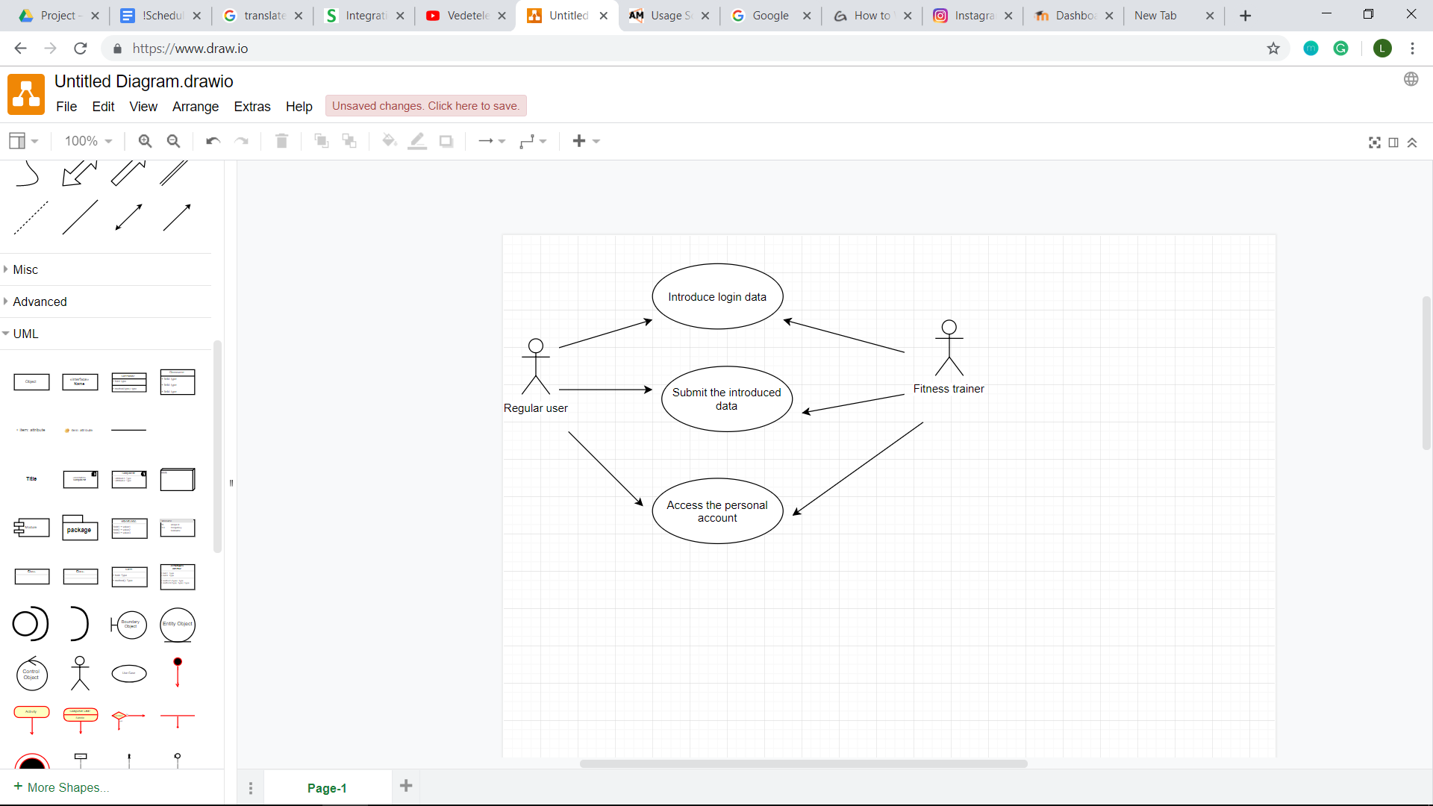

* Creating a new workout plan use-case diagram

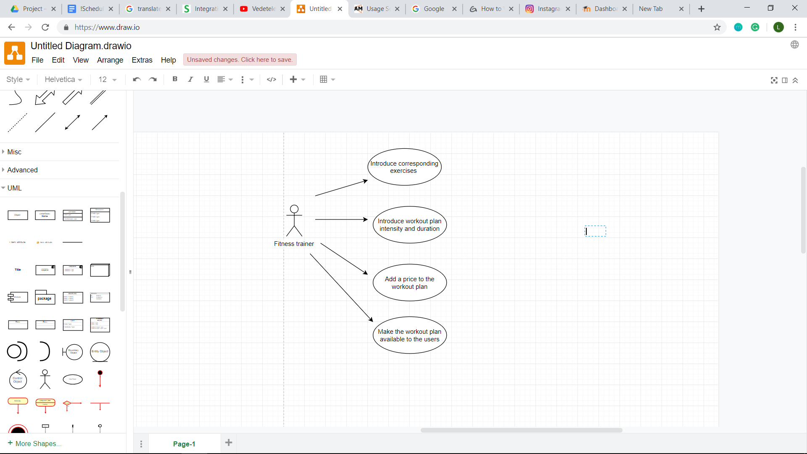

* Paying for a workout/meal plan use-case diagram

