CinemaGO

Use-Case Model

Version <1.0>

Revision History

|  |  |  |  |
| --- | --- | --- | --- |
| **Date** | **Version** | **Description** | **Author** |
| <01/Apr/19> | <1.0> | <details> | Ruști Maria |
| <03/June/19> | <1.0> |  | Ruști Maria |
|  |  |  |  |
|  |  |  |  |

Table of Contents

1. Use-Cases Identification 4

2. UML Use-Case Diagrams 4

Use-Case Model

# Use-Cases Identification

[Identify actors, scenarios and use cases. Describe the three most important use-cases according to the following format:

***Use case: <use case goal>***

***Level: <one of: summary level, user-goal level, sub-function>***

***Primary actor: <a role name for the actor who initiates the use case>***

***Main success scenario: <the steps of the main success scenario from trigger to goal deliverye following format:>***

***Extensions: <alternate scenarios of success or failure>***

]

Use case: create account

Level: user-goal level

Primary actor: customer

Main success scenario: the customer introduces his/her personal information by completing a form; the data is then validated and stored in the database; after this, an account will be created for the corresponding user so that he/she could then log in and use the functionalities the system provides

Extensions: the data the user introduces cannot be validated; the format of the fields is not respected

Use case: buy tickets for a movie

Level: user-goal level

Primary actor: customer

Main success scenario: the customer logs in, searches for the movie he/she wants to watch and adds it to the cart; after choosing the payment method and finalizing the order they will receive their ticket in electronic format

Extensions: there are no more seats available for the chosen movie

Use case: add movie program

Level: user-level

Primary actor: administrator

Main success scenario: the administrator logs into the system and chooses the option to add a new movie in the program; he/she introduces all the necessary information and clicks on the submit button in order to finalize the action

Extensions: the data introduced is not valid

# UML Use-Case Diagrams

[Create the UML Use-Case Diagrams.]

Customer Use - Case Diagram

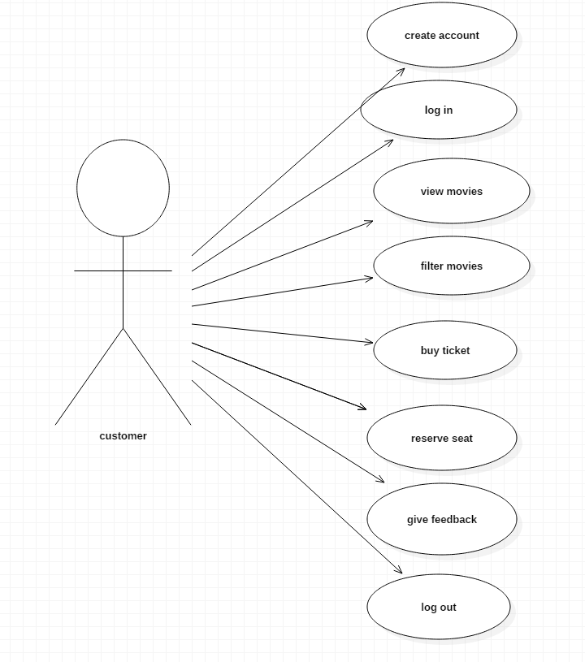

Administrator Use – Case Diagram

