Analysis and Design Document

Student:Serban Raluca

**Group:30238**

Revision History

|  |  |  |  |
| --- | --- | --- | --- |
| **Date** | **Version** | **Description** | **Author** |
| <dd/mmm/yy> | <x.x> | <details> | <name> |
|  |  |  |  |
|  |  |  |  |
|  |  |  |  |

Table of Contents

I. Project Specification 4

II. Elaboration – Iteration 1.1 4

1. Domain Model 4

2. Architectural Design 4

2.1 Conceptual Architecture 4

2.2 Package Design 4

2.3 Component and Deployment Diagrams 4

III. Elaboration – Iteration 1.2 4

1. Design Model 4

1.1 Dynamic Behavior 4

1.2 Class Design 4

2. Data Model 4

3. Unit Testing 4

IV. Elaboration – Iteration 2 4

1. Architectural Design Refinement 4

2. Design Model Refinement 4

V. Construction and Transition 5

1. System Testing 5

2. Future improvements 5

VI. Bibliography 5

# Project Specification

The Travel Management System is going to be a web application , designed for people who like to travel and want a to plan the details for their trip ,in order to have the best experience they can.

The objective of the project is to design and implement an application that provides services for tourists who want to find places to visit according to their choices .The application lets the users choose a destination they want to explore and search for places they want to visit , select the timing for each event in their trip .The user should be able to find details about places ,book flights and make rezervations to hotels ,buy tickets for bus, train or other means of transport for their trip or view information about different traveling packages from travel agencies. They can search for places based on different interests such as: art ,culture ,beaches ,festivals ,food ,nature ,road trips.The user needs to create an account in order to use the application.The administrator will be able to add places information,bus information,train information,flights details ,and basicaly update information about places,the travels of the users ,bookings hotel detailsetc.Users can make plans and pay online for the expenses of the planned trip and also to give feedback and complaints for the offered services.

# Elaboration – Iteration 1.1

# Domain Model

The domain model for the application contains model classes like: Destination ,Place ,User ,Bus Reservation , Hotel Reservation ,Flight ,Route etc.

Conceptual class diagrams:

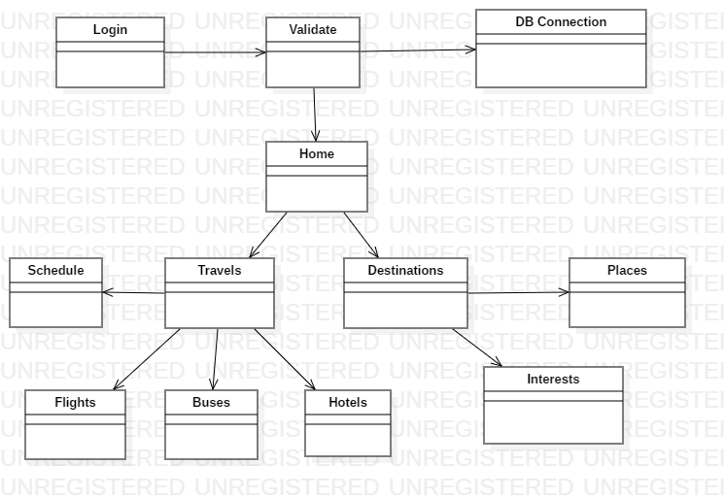

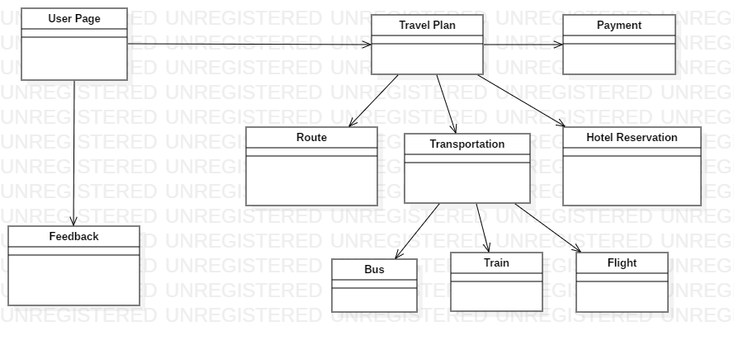

# Architectural Design

## Conceptual Architecture

The application architecture follows the layered architectural pattern, consisting of 3 main layers : presentation layer ,business logic layer and persistence layer. In this way the functionality of the application is separated based on the role that the components have within the system. A request will move from layer to layer, each layer using functionality from the layer below it, in order to perform a specific task. This isolation between the layers assures that changes in one layer won’t affect the other layers.

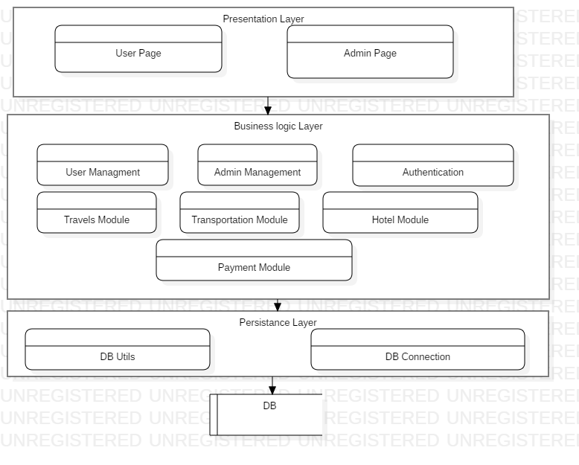

## Package Design

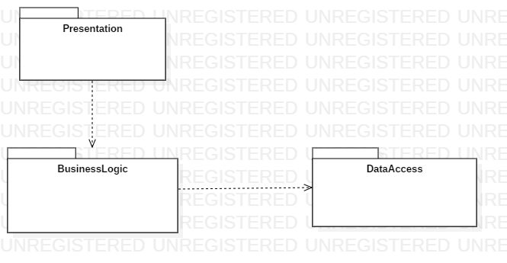

## Component and Deployment Diagrams

# Component Diagram:

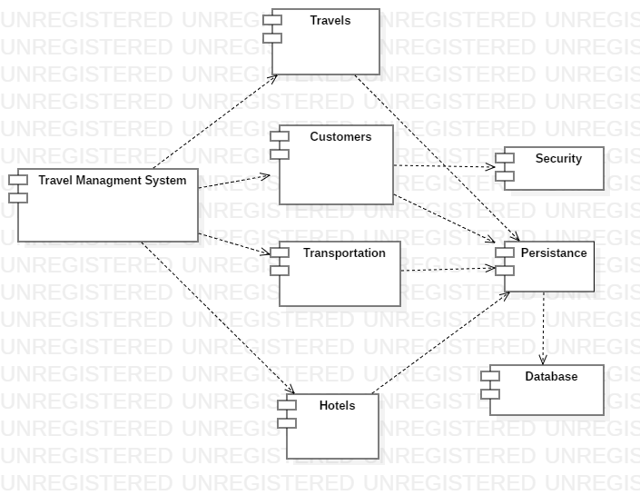

**Deployment Diagram:**

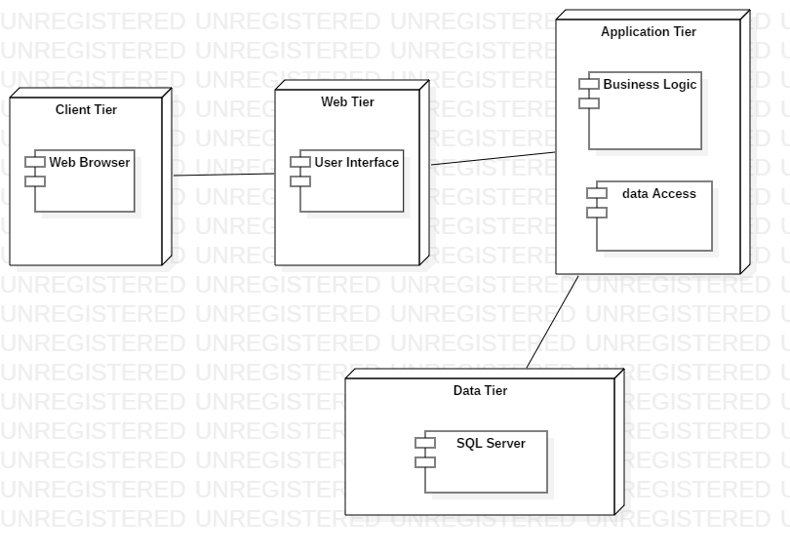

# Elaboration – Iteration 1.2

# Design Model

## Dynamic Behavior

**Login scenario sequance diagram:**

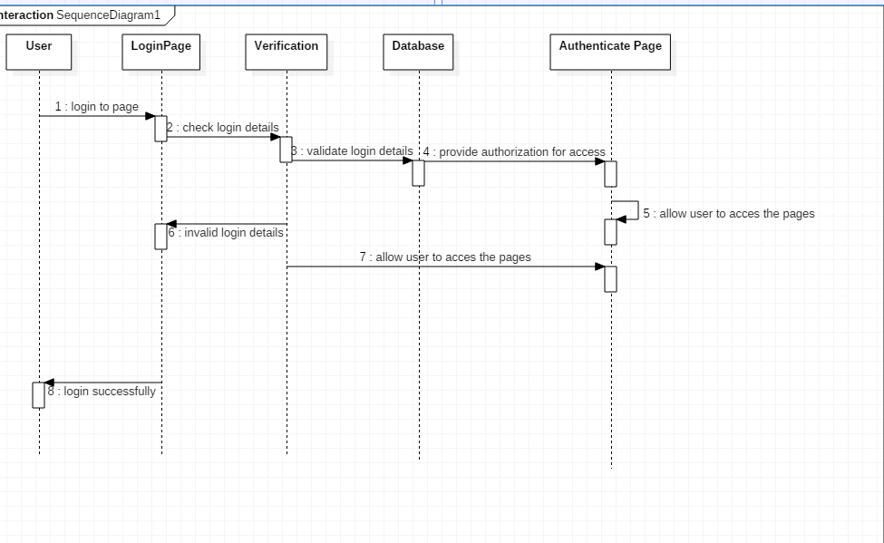

**Communication diagram**

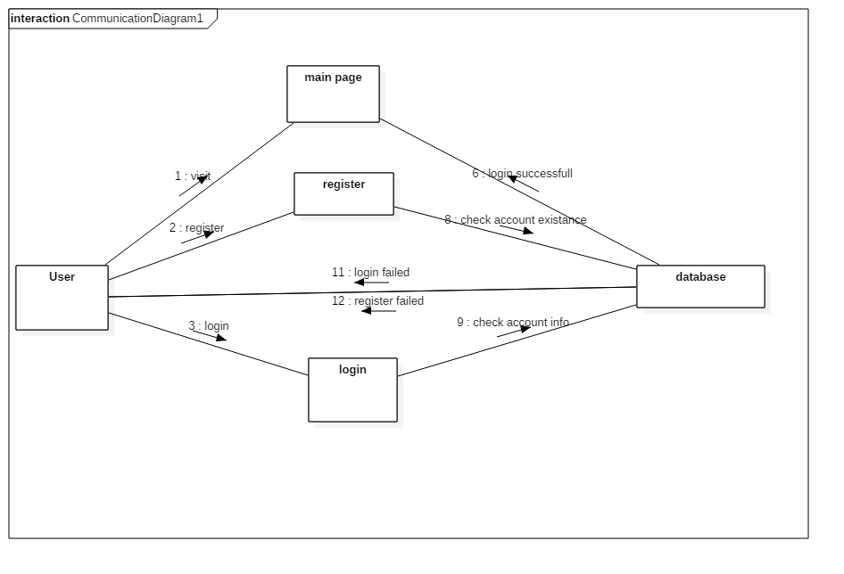

## Class Design

*[Create the UML class diagram; apply GoF patterns and motivate your choice]*

For this application there are a few GoF patterns that would be helpful:**Singleton**-because there will be a connection to the database ,and for security reasons there should be only one instance to this connection;**Observer** –because this would help to notify user system about the changes made by an administrator for example;**Factory method**-as there would be the need to create different type of objects that repersent a general thing:locations,hotels etc;

# Data Model

*[Create the data model for the system.]*

The data model for the Travel Management system consists of classes like: User , TravelPlan, Transportation,Location,Route,Hotel,Bus etc.The classes that represent the data model of the system have a corresponding table in the database.The representation in the database keeps information about the attributes of the corresponding classes.

# Unit Testing

*[Present the used testing methods and the associated test case scenarios.]*

# Elaboration – Iteration 2

# Architectural Design Refinement

*[Refine the architectural design: conceptual architecture, package design (consider package design principles), component and deployment diagrams. Motivate the changes that have been made.]*

# Design Model Refinement

## *[Refine the UML class diagram by applying class design principles and GRASP; motivate your choices. Deliver the updated class diagrams.]*

# Construction and Transition

# System Testing

*[Describe how you applied integration testing and present the associated test case scenarios.]*

# Future improvements

*[Present future improvements for the system]*

# Bibliography