Your Tickets

Use-Case Model

Version <1.0>

Revision History

|  |  |  |  |
| --- | --- | --- | --- |
| **Date** | **Version** | **Description** | **Author** |
| 04/apr/2019 | 1.0 | <details> | Bianca Dondas |
|  |  |  |  |
|  |  |  |  |
|  |  |  |  |

Table of Contents

1. Use-Cases Identification 4

2. UML Use-Case Diagrams 4

Use-Case Model

# Use-Cases Identification

An user will be able to create an account. His data will be validated and if it’s valid it will be introduced into a database. User will have to login in order to have accest to the app. After login user will be able to search bands or concerts, add a band to his favourites and buy tickets to concerts.

# UML Use-Case Diagrams

Use case diagram for user

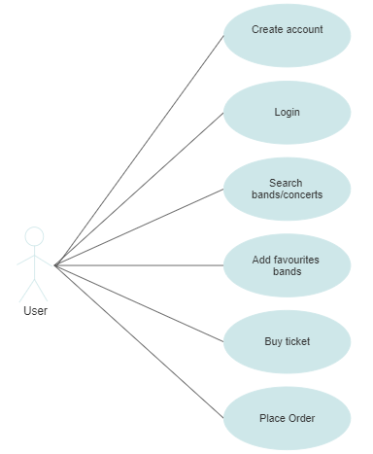

Use case diagram for manager

