Word Processor

Use-Case Model

Version 1.0

Revision History

|  |  |  |  |
| --- | --- | --- | --- |
| **Date** | **Version** | **Description** | **Author** |
| <dd/mmm/yy> | <x.x> | <details> | <name> |
|  |  |  |  |
|  |  |  |  |
|  |  |  |  |

Table of Contents

1. Use-Cases Identification 4

2. UML Use-Case Diagrams 5

Use-Case Model

# Use-Cases Identification

The first steps that an user is able to do are following (Figure 1.a):

* user can create an account by introducing account details (e.g. nickname, username, password, e-mail, phone). The system will verify if account details are correct, through some validators.
* user can login using his account. The system will verify if his account is valid.
* user can try as guest the entire system, but it will be restricted to watch just public documents.

After login, users can do following actions (Figure 1.b and Figure 1.c):

* users can save documents on cloud
* users can load documents from cloud
* users can modify documents on cloud
* users are able to search for documents on cloud
* users can set documents privacy to public or private
* users are able to modify documents privacy from public to private and from private to public

# UML Use-Case Diagrams

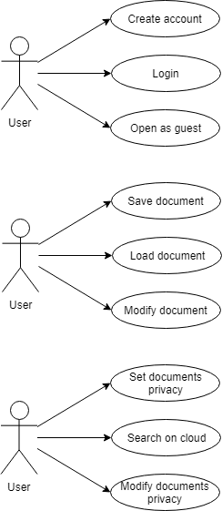

Figure 2.a - Use Case Diagram

Figure 2.b - Use Case Diagram

Figure 2.c - Use Case Diagram