Pet Hotel

Analysis and Design Document

Student: Campean Casiana Stefana

**Group: 30238**

Revision History

|  |  |  |  |
| --- | --- | --- | --- |
| **Date** | **Version** | **Description** | **Author** |
| <dd/mmm/yy> | <x.x> | <details> | <name> |
|  |  |  |  |
|  |  |  |  |
|  |  |  |  |

Table of Contents

I. Project Specification 4

II. Elaboration – Iteration 1.1 4

1. Domain Model 4

2. Architectural Design 4

2.1 Conceptual Architecture 4

2.2 Package Design 4

2.3 Component and Deployment Diagrams 4

III. Elaboration – Iteration 1.2 4

1. Design Model 4

1.1 Dynamic Behavior 4

1.2 Class Design 4

2. Data Model 4

3. Unit Testing 4

IV. Elaboration – Iteration 2 4

1. Architectural Design Refinement 4

2. Design Model Refinement 4

V. Construction and Transition 5

1. System Testing 5

2. Future improvements 5

VI. Bibliography 5

# Project Specification

Our animals are like family to us, but unfortunately we can’t bring them everywhere we go and we can’t let them home alone for a long time when we go somewhere far. So this project aims to solve this problem by implementing an hotel application for pets, where you can leave your animal there while you are away from home for a longer period of time.

This application will be used by every pet owner who wants to bring their animal at the hotel, and will also be used by the hotel manager and staff.

The client can choose from different services based on the type of their animal and they will get a report of the activities of their animal when they take their pet home.

The hotel staff will consist of different employees, like a vet, pet groomer, pet trainer, and other types of employees that are in charge of taking care of the animals, like playing with them, giving them food and putting them to sleep.

The manager user will be in charge of handling with staff, clients and animals, validate registrations and giving reports to the clients about theirs animal activity.

# Elaboration – Iteration 1.1

# Domain Model

*[Define the domain model and create the conceptual class diagrams]*

The domain for this project is the hotel. From the project specification we can determine some important classes, like Admin, Client, Animal, Service, staff and Hotel, and we can make the conceptual class diagram.

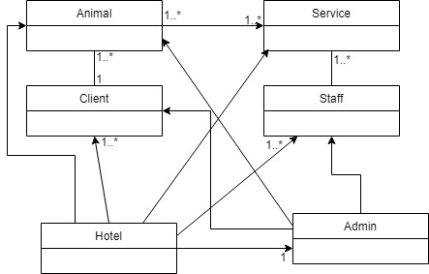

# Architectural Design

## Conceptual Architecture

*[Define the system’s conceptual architecture; use an architectural style and pattern - highlight its use and motivate your choice.]*

## Package Design

## Component and Deployment Diagrams

*[Create the component and deployment diagrams.]*

***Component Diagram***

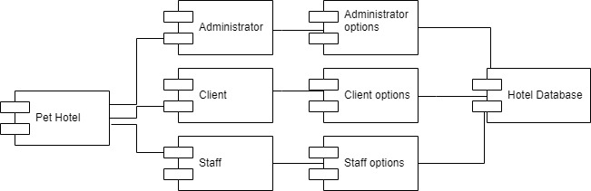

***Deployment Diagram***

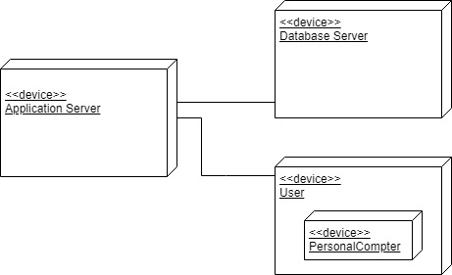

# Elaboration – Iteration 1.2

# Design Model

## Dynamic Behavior

*[Create the interaction diagrams (1 sequence, 1 communication diagrams) for 2 relevant scenarios]*

## Class Design

*[Create the UML class diagram; apply GoF patterns and motivate your choice]*

# Data Model

*[Create the data model for the system.]*

# Unit Testing

*[Present the used testing methods and the associated test case scenarios.]*

# Elaboration – Iteration 2

# Architectural Design Refinement

*[Refine the architectural design: conceptual architecture, package design (consider package design principles), component and deployment diagrams. Motivate the changes that have been made.]*

# Design Model Refinement

## *[Refine the UML class diagram by applying class design principles and GRASP; motivate your choices. Deliver the updated class diagrams.]*

# Construction and Transition

# System Testing

*[Describe how you applied integration testing and present the associated test case scenarios.]*

# Future improvements

*[Present future improvements for the system]*

# Bibliography