Pet Hotel

Use-Case Model

Version <1.0>

Revision History

|  |  |  |  |
| --- | --- | --- | --- |
| **Date** | **Version** | **Description** | **Author** |
| <dd/mmm/yy> | <x.x> | <details> | <name> |
|  |  |  |  |
|  |  |  |  |
|  |  |  |  |

Table of Contents

1. Use-Cases Identification 4

2. UML Use-Case Diagrams 5

Use-Case Model

# Use-Cases Identification

The actors of this application are: Client and Staff.

Use case: Add animal

Level: user-goal level

Primary actor: client

Main success scenario: Register, Login, press Add animal Button, introduce the details for their animal, add animal, success.

Extensions: when the client introduces the details of their animal, some input might be wrong, so an error message will appear.

Use case: add Animal

Level: user-goal level

Primary actor: manager

Main success scenario: Register as admin, login, press validate registrations, validate registration for chosen animal, add animal, success.

Extensions: <alternate scenarios of success or failure>

Use case: Add service

Level: user-goal level

Primary actor: staff

Main success scenario: Register as staff, login, press add service, choose animal, add service to that animal, success.

Extensions: when you introduce the input for the animal or for the service, the input might be wrong, or your staff account can’t make some services, so an error message will appear.

# 

# UML Use-Case Diagrams

**Client Use-Case:**

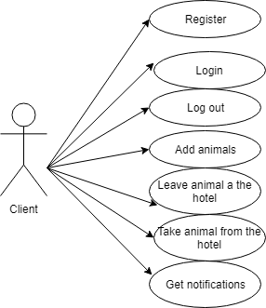

**Staff Use-Case:**

