Conta app

Analysis and Design Document

Student: Ban Erno Emmanuel

**Group: 30238**

Revision History

|  |  |  |  |
| --- | --- | --- | --- |
| **Date** | **Version** | **Description** | **Author** |
| 04/04/2019 | 1.0 | first and second deliverable | Ban Erno Emmanuel |
|  |  |  |  |
|  |  |  |  |
|  |  |  |  |

Table of Contents

I. Project Specification 4

II. Elaboration – Iteration 1.1 5

1. Domain Model 5

2. Architectural Design 5

2.1 Conceptual Architecture 5

2.2 Package Design 5

2.3 Component and Deployment Diagrams 5

III. Elaboration – Iteration 1.2 6

1. Design Model 6

1.1 Dynamic Behavior 6

1.2 Class Design 6

2. Data Model 6

3. Unit Testing 6

IV. Elaboration – Iteration 2 7

1. Architectural Design Refinement 7

2. Design Model Refinement 7

*[Refine the UML class diagram by applying class design principles and GRASP; motivate your choices. Deliver the updated class diagrams.]* 7

V. Construction and Transition 8

1. System Testing 8

2. Future improvements 8

VI. Bibliography 9

# Project Specification

*[Present the project specification]*

Nowadays websites are very popular, they became a trend. Should your business have a website, even if your business is small and sells products or services you don't think can be sold online? The answer is: Yes, if you have a business, you should have a website. Period. No question. Without a doubt. This is an accountancy company’s presentation website, where the clients can read information about the past of the company, contacts and ongoing projects and services. Also, it will have a blog application feature, where the company’s employees can add posts about the news in economy, legislation and marketing. The clients can leave comments at the end of the posts. Also, the clients will be able to leave messages to the employees online.

# Elaboration – Iteration 1.1

# Domain Model

*[Define the domain model and create the conceptual class diagrams]*

Since it’s a presentation website, anybody will be able to access and view the website

without logging in. The users who will have to log in are only the employees who want to modify the informations on the website and the administrator, who can manipulate the users. The project will be implemented in python, using the Flask framework, so it won’t contain too many classes.

# Architectural Design

## Conceptual Architecture

*[Define the system’s conceptual architecture; use an architectural style and pattern - highlight its use and motivate your choice.]*

The website’s architecture will be a client-server one. Since the visitors can perform many actions with afferent callbacks in the back-end, I think the client-server architecture is the best choice.

## Package Design

*[Create a package diagram]*

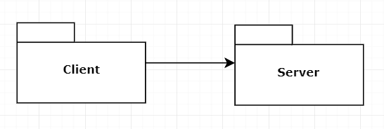

## Component and Deployment Diagrams

*[Create the component and deployment diagrams.]*

**Deployment diagram**

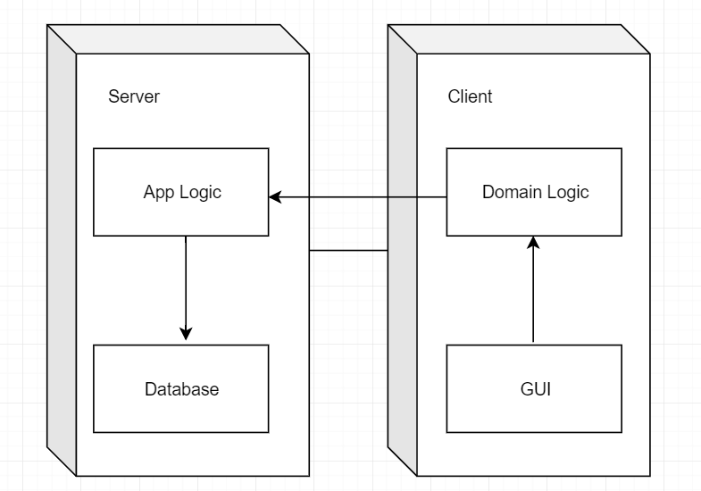

**Component diagram**

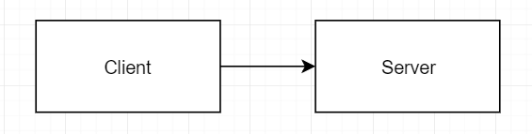

# Elaboration – Iteration 1.2

# Design Model

## Dynamic Behavior

*[Create the interaction diagrams (1 sequence, 1 communication diagrams) for 2 relevant scenarios]*

## Class Design

*[Create the UML class diagram; apply GoF patterns and motivate your choice]*

# Data Model

*[Create the data model for the system.]*

# Unit Testing

*[Present the used testing methods and the associated test case scenarios.]*

# Elaboration – Iteration 2

# Architectural Design Refinement

*[Refine the architectural design: conceptual architecture, package design (consider package design principles), component and deployment diagrams. Motivate the changes that have been made.]*

# Design Model Refinement

## *[Refine the UML class diagram by applying class design principles and GRASP; motivate your choices. Deliver the updated class diagrams.]*

# Construction and Transition

# System Testing

*[Describe how you applied integration testing and present the associated test case scenarios.]*

The project will be manually tested for the beginning at each added feature, but also recursively backwards.

# Future improvements

*[Present future improvements for the system]*

* Real time chat with an employee.

# Bibliography