Public transport tickets

Use-Case Model

Version <1.0>

Revision History

|  |  |  |  |
| --- | --- | --- | --- |
| **Date** | **Version** | **Description** | **Author** |
| <dd/mmm/yy> | <x.x> | <details> | <name> |
|  |  |  |  |
|  |  |  |  |
|  |  |  |  |

Table of Contents

1. Use-Cases Identification 4

2. UML Use-Case Diagrams 4

Use-Case Model

# Use-Cases Identification

[Identify actors, scenarios and use cases. Describe the three most important use-cases according to the following format:

***Use case: <use case goal>***

***Level: <one of: summary level, user-goal level, sub-function>***

***Primary actor: <a role name for the actor who initiates the use case>***

***Main success scenario: <the steps of the main success scenario from trigger to goal deliverye following format:>***

***Extensions: <alternate scenarios of success or failure>***

]

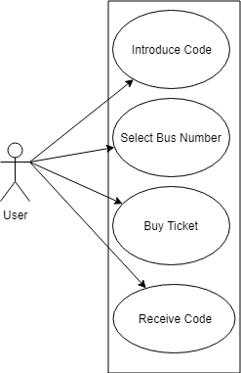

Use case: Buy ticket

Level: User-goal

Primary Actor: User

Main success scenario: After selecting an existing bus number and having enough amount to pay for the ticket the user would get the ticket code

Extension: The user might not have enough money to pay for the ticket

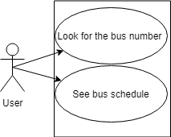

Use case: Search for a bus route and schedule

Level: User-goal

Primary Actor: User

Main success scenario: After selecting an existing bus number the user would get the bus schedule and the price for the ticket depending on the bus (buses that go out of the city might be a bit more expensive)

Extension: The user might not introduce an existing bus number, this would show him a specific message

# UML Use-Case Diagrams

[Create the UML Use-Case Diagrams.]