Student:Dragoteanu Bogdan
Group:30431

Table of Contents
1
1
Student: 1
Table of Contents 2
1. Requirements Analysis 3
1.1Assignment Specification 3
1.2Functional Requirements 3
1.3Non-functional Requirements 3
2. Use-Case Model 3
3. System Architectural Design 3
4. UML Sequence Diagrams 3
5. Class Design 3
6. Data Model 3
7. System Testing 4
8. Bibliography 4

1. Requirements Analysis

Assignment Specification

The assignment is an application that helps users manage food waste.

Authenticated users can input grocery lists and see reports of how much food is wasted weekly and monthly. An item in the grocery list has the following data:

Name,quantity, calorie value, purchase date, expiration date and consumption date

The system allows the users to track the goals and minimize waste by reminding them if the waste levels are too high based on ideal burn down rates.

The system gives the users options to donate excess food to various local food charities and soup kitchens.

If an item expiration is close to the current date the user is notified.

Functional Requirements
- Search → The user is able to find data about the grocery item by searching explicitly for it
- Reports → The system will generate a weekly and monthly report for the user
- Modify → The user is able to change a grocery item's information
- AddItem → Insert a new item

Non-functional Requirements
- Security → The system shall ensure that data is protected from unauthorized access
→ System data may be accessed only by users authenticated by means of a username and password
- Portability → The application works on both Windows and Linux machines
- Extendibility → Features can be further enriched

2. Use-Case Model
Use case: Log In
Level: user-goal
Primary actor: Registered User
Main success scenario: User log into the system
Extensions: On fail it notifies the user that something is wrong

Use case: Sign Up
Level: user-goal
Primary actor: User
Main success scenario:
Extensions:

Use case: Search
Level: user-goal
Primary actor: Registered User
Main success scenario: The system finds the item in the list and shows its data to the user
Extensions: On fail it notifies the user that the item doesn't exist or that they may have misspelled its name

Use case: Refresh
Level: user-goal
Primary actor: Registered User
Main success scenario: Refreshes the Grocery List
Extensions: -

Use case: Modify
Level: user-goal
Primary actor: Registered User
Main success scenario: Changes the data of a selected item in the List
Extensions: If some parameters are bad then the user is notified

Use case: Add Item to Grocery List
Level: user-goal
Primary actor: Registered User
Main success scenario: Adds the data of a new item to the List
Extensions: If some parameters are bad then the user is notified

Use case: Create Report
Level: user-goal
Primary actor: Registered User
Main success scenario: Creates report with the data from thegrocery list and shows it to the user.
Type depends on the chosen one (Weekly/Monthly).
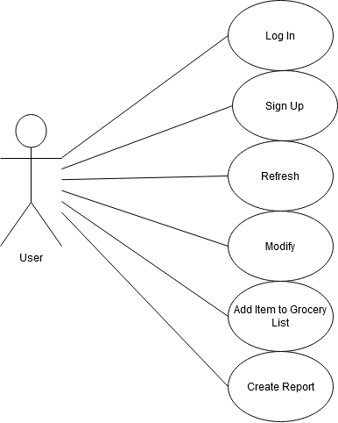
Extensions: If the list is empty the user is notified that nothing can be shown.

3. System Architectural Design
The system will be made using the layered architecture.
3.1 Architectural Pattern Description
Components in a layered architecture are organized into horizontal layers, each performing a specific role within the application. In our case we have four layers:
- Presentation → handles the user interface
- Business → handles requests
- Persistence (Data Access) → contains database tech
- Database
The layers are closed → requests move from layer to layer:
presentation → business → persistence → database
3.2 Diagrams
Package Diagram
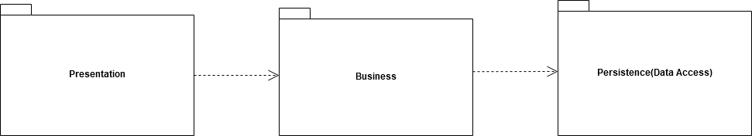
Deployment Diagram
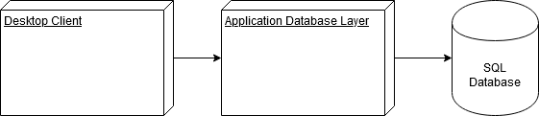
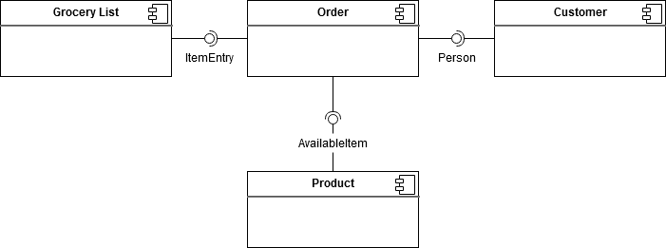
Component Diagram

Patterns used:
- layered → used to structure the program into groups of subtasks
→ each layer provides services to the next higher layer
- dependency injection pattern - Used to make the main class independent of its functions

4. UML Sequence Diagrams
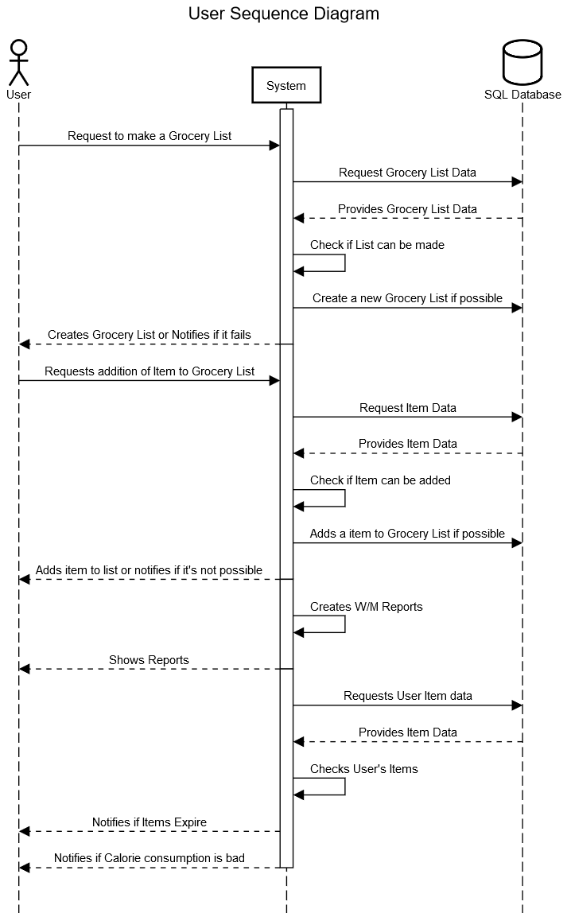

5. Class Design

5.1 Design Patterns Description
- Abstract Factory → Used in the creation of Weekly/Monthly Reports
→ Provides an interface for creating families of related or dependent
objects without specifying their concrete classes.
- ?Observer → Define a one-to-many dependency between objects so that when one object changes state, all its dependents are notified and updated automatically.
→ Used in the notification of the user (Bad Calorie Intake, Expiration Dates).

5.2 UML Class Diagram
[Create the UML Class Diagram and highlight and motivate how the design patterns are used.]

6. Data Model
Relational Model for Database information:
- This model is based on first-order predicate logic and defines a table as an n-ary relation.
- Data is stored in tables called relations.
- Each row in a relation contains a unique value.
- Each column in a relation contains values from a same domain.
Entity-Relationship Model in DatabaseMS:
- Entity – is a real-word entity having attributes
– attributes are defined by a domain
- Relationship – Mapped entities (in our case one to one (PrimaryUserKey to PrimaryGroceryListKey))

7. System Testing
Validation Testing
[Present the used testing strategies (unit testing, integration testing, validation testing) and testing methods (data-flow, partitioning, boundary analysis, etc.).]

8. Bibliography
[1] www. Stackoverflow.com → Used for explication of things such as:
- email checking
- abstract factory (?)

