WasteLess

Student: Andrei Tiberiu

**Group: 30431**

Table of Contents

1. Requirements Analysis 3

1.1 Assignment Specification 3

1.2 Functional Requirements 3

1.3 Non-functional Requirements 3

2. Use-Case Model 3

3. System Architectural Design 3

4. UML Sequence Diagrams 3

5. Class Design 3

6. Data Model 3

7. System Testing 3

8. Bibliography 3

1. Requirements Analysis

# Assignment Specification

The application helps users manage food waste. Once a user is authenticated he can input grocery lists and see reports of how much food is wasted weekly and monthly. A grocery list item has a name and a quantity as well as a calorie value, purchase date, expiration date and consumption date. The system also allows users to track goals and minimize waste by sending reminders if waste levels are too high based on ideal burndown rates. The reminders are send automatically by email, once a user has logged in, only if at least one day has passed since he has logged in last(this is used in order to avoid spamming)

The system also provides an option to donate excess food to various local food charities and soup kitchens and notifies the user of them prior to item expiration.

# Functional Requirements

# Non-functional Requirements

1. Implement and test the application
2. Use an ORM and a DI Container
3. Commit the work you do on your Git repository. Do it iteratively as you progress, not all at once (this will incur a penalty on your final mark)
4. Use any OOP language you like. Non-exhaustive: Python, C#, Java, Ruby, C/C++, JS+Typescript
5. Use a layered architecture
6. Use the abstract factory pattern for creating weekly/monthly reports
7. The data will be stored in a database
8. All the inputs of the application will be validated against invalid data before submitting

the data and saving it in the database.

2. Use-Case Model

*[Create the use-case diagrams and provide one use-case description (according to the format below).*

*Use-Case description format:*

*Use case: Log In*

*Level: sub-function*

*Primary actor: user*

*Main success scenario:*

*Enters correct credentials*

*Is redirected to the welcome page*

*Extensions:*

*Enters invalid credentials*

*Is redirected to the log in page again*

*Use case: Add Item*

*Level: user-goal*

*Primary actor: user*

*Main success scenario:*

*Enters valid data in the form*

*The item is added in the database and displayed on the main page*

*Extensions:*

*Enters invalid data*

*The item is not added and an error message is displayed, letting the user know the cause*

*of failure*

*Use case: Delete Item*

*Level: sub-function*

*Primary actor: user*

*Main success scenario:*

*The user deletes the item he wants from the databse*

*Extensions:*

*Impossible in this case because we assured the user can delete only existing items*

*Use case: Edit Consumption Date*

*Level: sub-function*

*Primary actor: user*

*Main success scenario:*

*The user enters the new date in a valid format*

*The user is then redirected to the main page*

*Extensions:*

*The user enters an invalid date*

*An error message is displayed*

*Use case: View Reports*

*Level: user-goal*

*Primary actor: user*

*Main success scenario:*

*The user is redirected to the reports page when he sees the resume of the data*

*Extensions:*

*Not possible in this case*

*Use case: Donate*

*Level: user-goal*

*Primary actor: user*

*Main success scenario:*

*The user is redirected to the page where the current available charity organisations are listed*

*Extensions: Not possible in this case*

*]*

3. System Architectural Design

**3.1 Architectural Pattern Description**

*I have used a three-layer architecture. The layers are :*

*Presentation layer: responsible for user interface and the navigation between pages*

*Business layer: responsible for the business logic and data validation*

*Data access layer: responsible for updating and retrieving data from a database*

*The Pressentatin layer and the Data access layer communicate trough the Business layer*

**3.2 Diagrams**

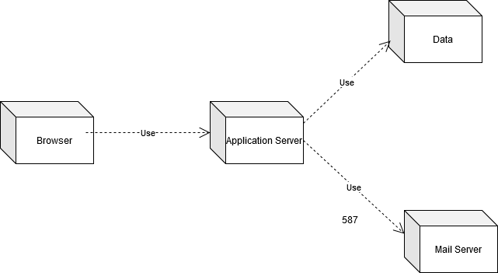

4. UML Sequence Diagrams

5. Class Design

**5.1 Design Patterns Description**

*Abstract factory design pattern has been used. We started by creating an AbstractReportFactory abstract class, containing the abstract methods createWeeklyReport and creatMonthlyReport. This class was extended by ConcreteReportFactory, which implemnts the abstract methods. The factorty products, in our case, will be the classes WeeklyReport and MonthlyReport, which extends the abstract classes AbstractWeeklyReport and AbstractMonthlyReport respectivly*

**5.2 UML Class Diagram**

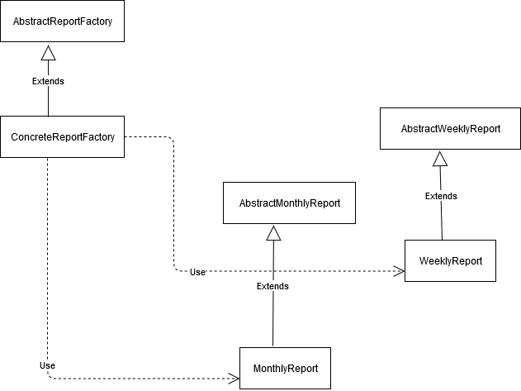

*The class diagram above is the same for UserManger, MailManager, NotificationManager and CharOrgManager*

6. Data Model

*The data models used in the implementation are:*

*User: store the log in credentials*

*FoodItem: Stores all the information about the food, which is needed for the creation of both the reports and the notifications*

*MailBot: Stores the credentials required to automatically send email notifications*

*CharOrg: Stores the address and the phone number of the current available charity organisations*

7. System Testing

*During development, each individual component has been tested individually, and then combined with the other modules already developed. Data flow testing has also been used used to assure the final product executes without bugs.*

8. Bibliography