<Assignment 1>

Analysis and Design Document

Student: Trif Marina Bianca

**Group: 30431**

Table of Contents

1. Requirements Analysis 3

1.1 Assignment Specification 3

1.2 Functional Requirements 3

1.3 Non-functional Requirements 3

2. Use-Case Model 3

3. System Architectural Design 3

4. UML Sequence Diagrams 3

5. Class Design 3

6. Data Model 3

7. System Testing 3

8. Bibliography 3

1. Requirements Analysis

# Assignment Specification

The application is called WasteLess and provides help for users in order to manage the food they buy. This is done by allowing them to create items from their groceries and add details about each of them:

* name of the product
* quantity in grams
* nr of calories
* the purchase date
* the expiration date
* the consumption date

The user must first login in order to have access to any of the feature, therefore a JWT login service is provided for this part.

The application generates a report by showing the user relevant numbers about the items that expired such that food waste management can be improved.

The user can also create lists by selecting items. All data is stored in a database.

# Functional Requirements

Functional requirements for users management:

* The system must provide a form for the users to register
* The system must register the user details and store them in the database
* The system must provide a form for the users to login
* The system must verify if the username and password provided match with the ones in the database

Functional requirements for items management:

* The system should provide users the possibility to add an item to the database, with their desired details
* The system must display all the items added on the dashboard alongside with their details
* The system must compute and analyze the data about items in order to notify the user about its conclusion on food waste
* The system must provide a report based on the ideal burndown rate and on the expiration details

# Non-functional Requirements

Performance

- The app’s response time is good and is able to register/log a user in less than 2s.

- The app should render the dashboard within 2 seconds from logging in

Security

- By using the JWT model of authentication, the user cannot access data that is not meant for them to be seen. It also keeps user data secure and only passes the necessary information to the frontend

- The app should display the personal details only for that user

- The app should end the session when the user opts to log out, so other users can’t access their personal data

Data integrity - The app generates exceptions if the data provided is not compatible with the type that it’s supposed to have

Availability - The app should render each request of the user within 2 seconds from the time of the request

-The app should immediately update the database after a new item/list is added in order for it to be available and displayed on the dashboard right after the user requests the addition of the item, without having to refresh the page to see the new content

Capacity – The user can create as many items/lists as they want, storage being locally limited since the application is not yet deployed

Portability - The app should be portable on each browser and the user must have the same/similar experience and the same access to all features

Maintainability - The app should be easily maintained on each of its layer by having components as separate as possible, such as controllers, services, models and context.

Scalability – Since the chosen architecture is a layered one, the division between the presentation layer, the business layer and the data access layer makes it fairly easily scalable. Therefore, other features can be added without changing much of the structure of the application, including big modifications such as adding another architectural layer or another design pattern.

2. Use-Case Model

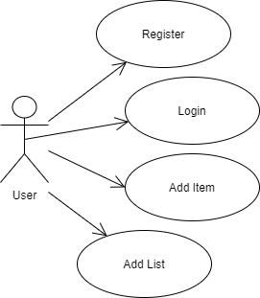

Use case: Register

Level: user-goal level

Primary actor: user

Main success scenario:

* User enters username
* User enters password
* User attempts to register
* Account is created
* User is redirected to the login page

Extensions:

* User enters username
* User enters no password
* User attempts to register
* User is not allowed since password is required
* User must add details again

3. System Architectural Design

**3.1 Architectural Pattern Description**

The main architectural pattern used is the layered architecture. The presentation layer is represented by the client side, which is built with Angular 9.

The backend is implemented with .NET Core and EF Core. The business layer is represented by the controllers which manage the data and retrieve information or send it to the persistence layer. The persistence layer consists of the models and the repositories which access the database context.

For storing the database SQL Server was used.

**3.2 Diagrams**

Layered Architecture diagram

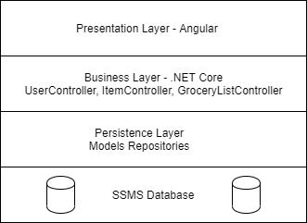

Package Diagram

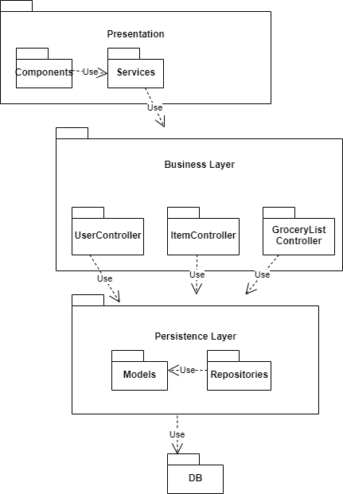

Component diagram

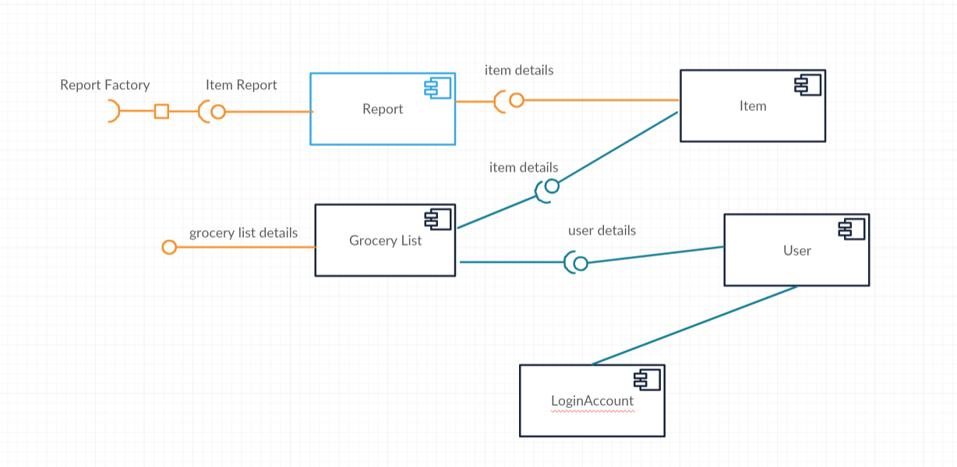

Deployment diagram

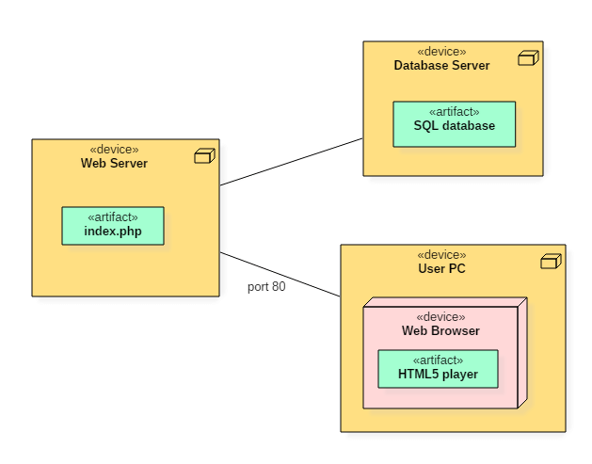

4. UML Sequence Diagrams

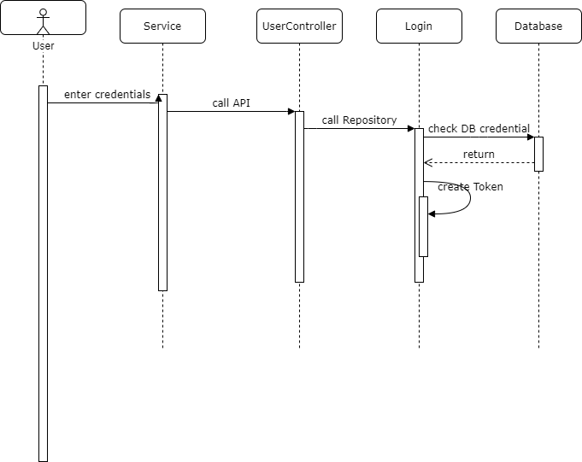

5. Class Design

**5.1 Design Patterns Description**

Since EF core implements the repository pattern, a layered approach was chosen. Therefore, the data access layer uses the context and LINQ to query the database and make changes to the tables. In this application, the Item repository, Grocery List Repository and User Repository deal with data access.

The next layer is given by the Controllers, which have no access to the database context, but receive HTTP requests and manage them by calling the methods in the data layer.

The requests come directly from the client by using REST API services. The client side implements these services and renders the presentation layer by the use of components.

Angular implements the Singleton pattern when declaring a service by using the @Injectable decorator and setting the provideIn property to ‘root’. For the service to be Singleton it is included in AppModule or in module that is only imported by AppModule.

For generating the report on the state of the items regarding their expiration date, the Abstract factory pattern is used. It is created by declaring an abstract factory called ReportFactory and a concrete factory called ItemReportFactory which implements it. The concrete factory implements the abstract methods defined in the ReportFactory and returns a concrete product ExpiredItemReport, which is a particular ItemReport. The property accessors are implemented in the derived classes.

The abstract factory pattern is useful because it allows creating similar and related objects (in this case different type of reports) without having to specify their actual implementation. This patterns enables dependency injection. In the end, the client (in this case repository) uses the abstract factory and the abstract product.

**5.2 UML Class Diagram**

Abstract factory diagram

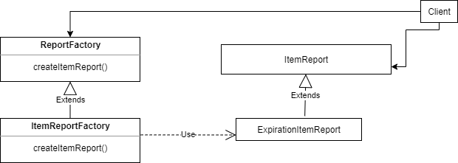

Class diagram

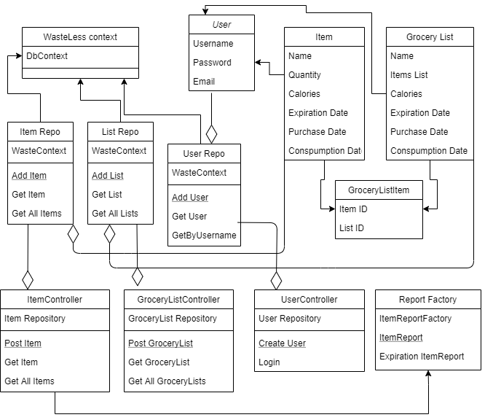

6. Data Model

The data models are the following:

User model:

public class User

{

[DatabaseGenerated(DatabaseGeneratedOption.Identity)]

public int UserId { get; set; }

public string Username { get; set; }

public string Email { get; set; }

public string Password { get; set; }

public ICollection<GroceryList> GroceryLists { get; set; }

}

Item model:

public class Item

{

[DatabaseGenerated(DatabaseGeneratedOption.Identity)]

public int ItemId { get; set; }

public string ItemName { get; set; }

public int Quantity { get; set; }

public int Calories { get; set; }

public DateTime PurchaseDate { get; set; }

public DateTime ExpirationDate { get; set; }

public DateTime ConsumptionDate { get; set; }

public IList<GroceryListItem> GroceryListItems { get; set; }

}

Grocery List Model

public class GroceryList

{

[DatabaseGenerated(DatabaseGeneratedOption.Identity)]

public int GroceryListId { get; set; }

public string GroceryListName { get; set; }

public IList<GroceryListItem> GroceryListItems { get; set; }

}

We use a Grocery List Item model in order to define the many to many relationship between Item and Grocery List, needed since it was a code first approach:

public class GroceryListItem

{

public int GroceryListId { get; set; }

public GroceryList GroceryList { get; set; }

public int ItemId { get; set; }

public Item Item { get; set; }

}

We define a Login model in order to only get the username and password from the database and send it to the front end:

public class LoginModel

{

public string Username { get; set; }

public string Password { get; set; }

}

The report factory model contains:

* The abstract class – Report factory
* The abstract product – Item Report
* The concrete product – Expiration Item Report
* The concrete factory – Item Report Factory

7. System Testing

Validation testing is done for every object/model sent through an HTTP post request to the controller. If the object sent was null the API method returns a BadRequest exception alongside with a significant message: for example, “Item is null”.

[HttpPost]

public ActionResult Post([FromBody] Item i)

{

if (i == null)

{

return BadRequest("Item is null");

}

_itemRepository.createItem(i);

return NoContent();

}

Field validation is done on Angular forms on the front end by specifying whether a certain field is required or not. If it is, the form cannot be submitted unless the user provides a valid input for each field.

<input class="form-control" #***UserName***="ngModel" name="UserName" [(ngModel)]="formModel.UserName" required>

8. Bibliography

[1] - <https://docs.microsoft.com/en-us/ef/core/>

[2] - <https://www.entityframeworktutorial.net/efcore/configure-many-to-many-relationship-in-ef-core.aspx>

[3] - <https://angular.io/guide/architecture>

[4] - <https://www.geeksforgeeks.org/abstract-factory-pattern/>

[5] - <https://refactoring.guru/design-patterns/abstract-factory>

[6] - <https://blog.angular-university.io/angular-jwt-authentication/>

[7] - <https://www.entityframeworktutorial.net/efcore/entity-framework-core-migration.aspx>