Student:Andreea Monea

**Group:30431**

Table of Contents

1. Requirements Analysis 3

1.1 Assignment Specification 3

1.2 Functional Requirements 3

1.3 Non-functional Requirements 3

2. Use-Case Model 3

3. System Architectural Design 3

4. UML Sequence Diagrams 3

5. Class Design 3

6. Data Model 3

7. System Testing 3

8. Bibliography 3

1. Requirements Analysis

# Assignment Specification

# Functional Requirements

Implement and test the application

● Commit the work you do on your Git repository. Do it iteratively as you progress, not

all at once (this will incur a penalty on your final mark)

● Use any OOP language you like. Non-exhaustive: Python, C#, Java, Ruby, C/C++,

JS+Typescript

● Use a CQRS architecture, use a mediator pattern to handle requests

● Use a decorator pattern for changing the color of the report (green for above the ideal

rate and red for under)

● The data will be stored in a database

● All the inputs of the application will be validated against invalid data before submitting

the data and saving it in the database.

# Non-functional Requirements

1. Design and implement an application that helps users manage food waste.
2. Once a user is authenticated he can input grocery lists and see reports of how much food is wasted weekly and monthly. A grocery list item has a name and a quantity as well as a calorie value, purchase date, expiration date and consumption date.
3. The system also allows users to track goals and minimize waste by sending reminders if waste levels are too high based on ideal burndown rates.
4. The ideal burndown rate for 100 calories worth of groceries due to expire in 5 days is 20 calories worth of groceries per day.
5. The system should provide you with options to donate excess food to various local food charities and soup kitchens and notify you of them prior to item expiration.

2. Use-Case Model

*Use case: register*

*Primary actor: user*

*Main success scenario: register successfully*

*Extensions: if the process fails, the user must follow the instruction and have the possibility to do the registration process again*

*Use case: login*

*Level: <one of: summary level, user-goal level, sub-function>*

*Primary actor: user*

*Main success scenario: login successfully*

*Use case: add food*

*Primary actor: user*

*Main success scenario: added item into the account*

*Extensions: if the process fails, the user must follow the instruction and have the possibility to do the process again*

*Use case: add goal*

*Primary actor: user*

*Main success scenario: added goal into the account*

*Extensions: if the process fails, the user must follow the instruction and have the possibility to do the process again*

*Use case: donate*

*Primary actor: user*

*Main success scenario: donation completed*

*Extensions: if the process fails, the user must follow the instruction and have the possibility to do the process again*

3. System Architectural Design

**3.1 Architectural Pattern Description**

The system is designed using CQRS so that the events are captured by the a mediater and then put in a queue. So there are operations that only read from the database, I named them queries in the project arhitecture and the other ones that can only write in the database that are named comands in this way the separation between write and read operation, required by the CQRS is made.

There is no decorator because i did not keep any reports.

**3.2 Diagrams**

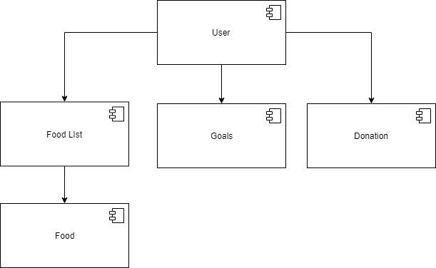

4. UML Sequence Diagrams

5. Class Design

**5.1 Design Patterns Description**

The mediator is used to differenciate when encautering queries or commands

**5.2 UML Class Diagram**

The only update to the project model are the commands and queries packages along with the class diagram for the CQRS design. The above diagram is left with empty fields intentionally as it does not want to focus on the inside of the classes all having one method and structure from their interfaces but on the communication of the classes.

6. Data Model

The data models used are the user, list of foods, food, donations and goals.

The center of all is the user which has a username and a password also a list of food assigned automatically through its id. The user can insert food which has a name, a quantity, calories and expire date which is measured in days until expire date(implementation decision). After the inserting a pop-up notification will show with the amount of calories that need to be consumed in order to not waste food, also the alternative with grams/day will show also as a pop-up notification. This numbers are computed by dividing the number of calories/quantity to the number of days. The user can also view its items in the list.

In case the food expired in less than 2 days, a flash notification will be shown. The user can set goals that can also have pop-up notifications implemented in the Flask App. He has donate options: for donating food waste to orphans or homeless organizations.

7. System Testing

The system testing is found in test.py where login, register and logout methods are being unit tested. Because of the database I have chosen(found too late it was a bad choice) I have not found configuration for MySQL Database just for SQL lite.

8. Bibliography

Flask tutorials on Youtube, ex:

[https://www.google.com/search?q=flask+tutorial&oq=flask+tur&aqs=chrome.1.69i57j0l7.3259j0j1&sourc eid=chrome&ie=UTF-8#kpvalbx=_0uuRXum9G-TmrgTMtJ-4Bg72](https://www.google.com/search?q=flask+tutorial&oq=flask+tur&aqs=chrome.1.69i57j0l7.3259j0j1&sourc%20%20%20eid=chrome&ie=UTF-8#kpvalbx=_0uuRXum9G-TmrgTMtJ-4Bg72)

9.Important info

*The application is a WEB Application made with Flask for the front-end part and python for backend.*

*The migration of the database is actually an export, I have a problem with migration in MySQL, do not know why, as I said bad decision to chose MySQL.*

*Even though all the CRUD operation for database are implemented just some of them are used(jus adding action where specified)*