<Assignment Name>

Analysis and Design Document

Student: Neagu Lorena

**Group: 30431**

Table of Contents

1. Requirements Analysis 3

1.1 Assignment Specification 3

1.2 Functional Requirements 3

1.3 Non-functional Requirements 3

2. Use-Case Model 3

3. System Architectural Design 3

4. UML Sequence Diagrams 3

5. Class Design 3

6. Data Model 3

7. System Testing 3

8. Bibliography 3

1. Requirements Analysis

# Assignment Specification

Wasteless is an application that helps users manage food waste.

Once a user is authenticated he can input grocery lists and see reports of how much food is wasted weekly and monthly. A grocery list item has a name and a quantity as well as a calorie value, purchase date, expiration date and consumption date.

The system also allows users to track goals and minimize waste by sending reminders if waste levels are too high based on ideal burndown rates.

The ideal burndown rate for 100 calories worth of groceries due to expire in 5 days is 20 calories worth of groceries per day.

The system should provide you with options to donate excess food to various local food charities and soup kitchens and notify you of them prior to item expiration.

# Functional Requirements

* Authenticate user and login
* Input and view grocery lists
* Input and view grocery list items
* Set goals
* Receive reminder for high waste levels
* Receive notification before items expire
* Generate reports

# Non-functional Requirements

* Use a client-server architecture
* Use an observer for sending notifications to users about donation options when item
* expiration is due
* Use the abstract factory pattern for creating weekly/monthly reports
* The data will be stored in a database
* All the inputs of the application will be validated against invalid data before submitting

the data and saving it in the database.

* Use an ORM and a DI Container

2. Use-Case Model

*Use case: Add Grocery List Item*

*Level: User-goal level*

*Primary actor: User*

*Main success scenario: First the authenticated user can input a new grocery item in an existing grocery list or in a newly created one. The data introduced is checked against validity constraints. He must not enter null fields, the purchase date must be only past or present and the dates must follow the date format specified in the text field. For the dates he can select the date from a drop-down calendar. If the user introduced the right item data, the item will be added to the database in the respective list and it can be seen in the list seen below.*

*Extensions: In case the data introduced is invalid or null, the page may display an error and the data won’t be added to the database. The user can the introduce a valid item.*

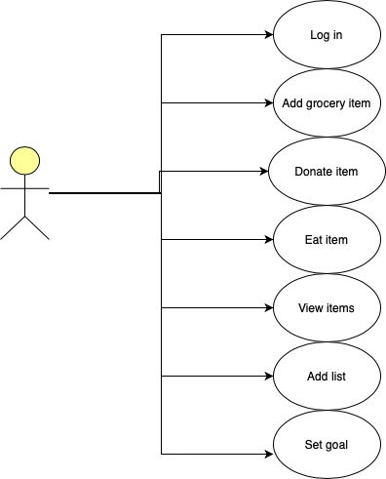

3. System Architectural Design

**3.1 Architectural Pattern Description**

This assignment introduces CQRS architecture to the design. Command Query Responsibility Segregation is an architectural pattern that separates reading and writing into two different models.This means that every method should either be a Command that performs an action or a Query that returns data. A Command cannot return data and a Query cannot change the data. By splitting the application into dedicated read and write models, we move the responsibility into dedicated objects. The write model does not need to be concerned with returning data and the read model can be specifically written to return the correct data to satisfy the application’s requirements.

Additionally, an architectural style for this project would be Client-Server architectural style because the Client will have to request data from the Server. Most of the services will be handled by the Server which also handles the data. The app uses [Spring Boot](https://www.baeldung.com/spring-boot) for implementing a RESTful backend, and [Angular](https://angular.io/) for creating a JavaScript-based frontend. The chosen architectural style is an n-tier architecture, more specifically a 3-tier architecture. This pattern is actually a client-server architecture in which presentation, application processing, and data management functions are physically separated, being in different layers.

The levels of the 3-tier architecture are data, business and presentation layer, which are subleveled into a Spring specific component layering: Repository, Web, Service.

The presentation layer contains the Web component of the app. It interacts with the end user. It shows data, takes user input or takes a command from it. The Business Layer contains the services and is based on the User command and the data captured from the user. It takes a domain-specific decision, like what to do with the data and how to manipulate the data which comes from the database, so it can be presented into the user interface. Data layer contains the repositories and captures the data and persists it, captures any change of the state of the data, so this layer is maintaining a state of the application data.

From the Spring point of view, the Web layer, which contains the Controllers and the Model classes, is the uppermost level and represents the entry point of the app. It is responsible of processing user’s input and returning the correct response back to the user.

The service layer resides below the web layer. It acts as a transaction boundary and contains both application and infrastructure services. The application services provide the public API of the service layer. They also act as a transaction boundary and are responsible of authorization. The infrastructure services contain the “plumbing code” that communicates with external resources such as file systems, databases, or email servers. Often these methods are used by more than a one application service.

The repository layer is the lowest layer of a web application. It is responsible of communicating with the database.

**3.2 Diagrams**

*Package Diagram*

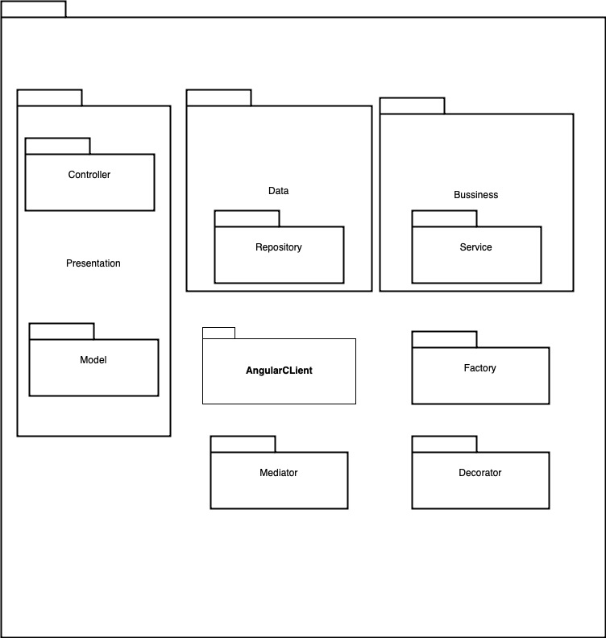

*Component Diagram*

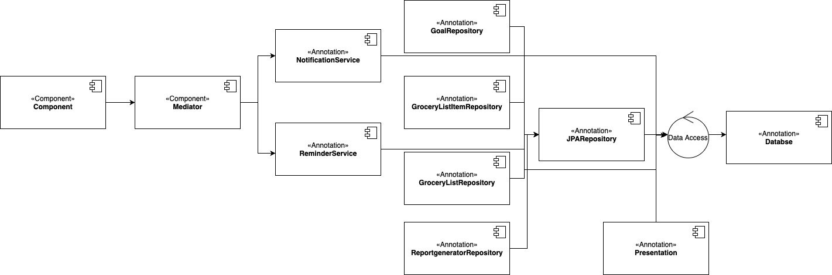

*Deployment Diagram*

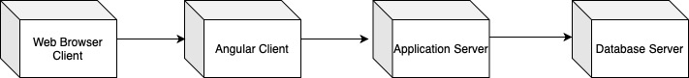

4. UML Sequence Diagrams

Scenario: insert a new Grocery List Item

5. Class Design

**5.1 Design Patterns Description**

Wasteless web application uses an Abstract Factory design pattern. It is one of the Creational pattern. Abstract Factory pattern works around a super-factory which creates other factories.

Abstract factory pattern implementation provides a framework that allows us to create objects that follow a general pattern. So, at runtime, abstract factory is coupled with a desired concrete factory which can create objects of desired type.

In this case the pattern is used for Monthly/Weekly type reports generation. Having two enums MONTHLY, WEEKLY, we will use a Report Factory as an abstract class that is inherited by the two factories WeeklyReportFactory and MonthlyReportFactory, which both need to implement the abstract method “getReport”. The factory producer will give the type of report chosen by the user and will be used in the report generator repository which will communicate with the database in order to extract the needed data and generate the report desired by the user, based on all the existing items that belong to the user logged in, which are bought last week or last month.

Also, the application implements the Mediator pattern in order to map and handle a request to a response. It allows loose coupling by encapsulating the way different sets of objects interact and communicate with each other, allowing the actions of each object set to vary independently of one another. The mediator is a good choice of pattern because here, the communication between objects is complicated, but well defined. When there are too many relationships between the objects it’s good to have such a central point of control, like a mediator.

Additionally, the assignment utilizes the Decorator Pattern for changing the color of an alert which will be shown on the screen. It will have the color red if the waste levels are too high and green otherwise. Decorator pattern allows a user to add new functionality to an existing object without altering its structure. This type of design pattern comes under structural pattern as this pattern acts as a wrapper to existing class.

This pattern creates a decorator class which wraps the original class and provides additional functionality keeping class methods signature intact.

The application also uses an Observer design pattern. An observer specifies communication between objects: observable and observers. An observable is an object which notifies observers about the changes in its state. The observer design pattern is used for sending a notification to the client any time items are about to expire the next day, so the user can know he has the option to donate them to charity or eat them right away. In my implementation the observable keeps a reference to the [PropertyChangeSupport](https://docs.oracle.com/javase/8/docs/api/java/beans/PropertyChangeSupport.html) instance. It sends the notifications to observers when the expiration message property of the notification class is changed. I have a Notification observable class which will have as observer NotificationObserver. So, when there are items about to expire, the notification will be set to a new message that will appear as a notification to the client in order to announce him prior to item expiration.

**5.2 UML Class Diagram**

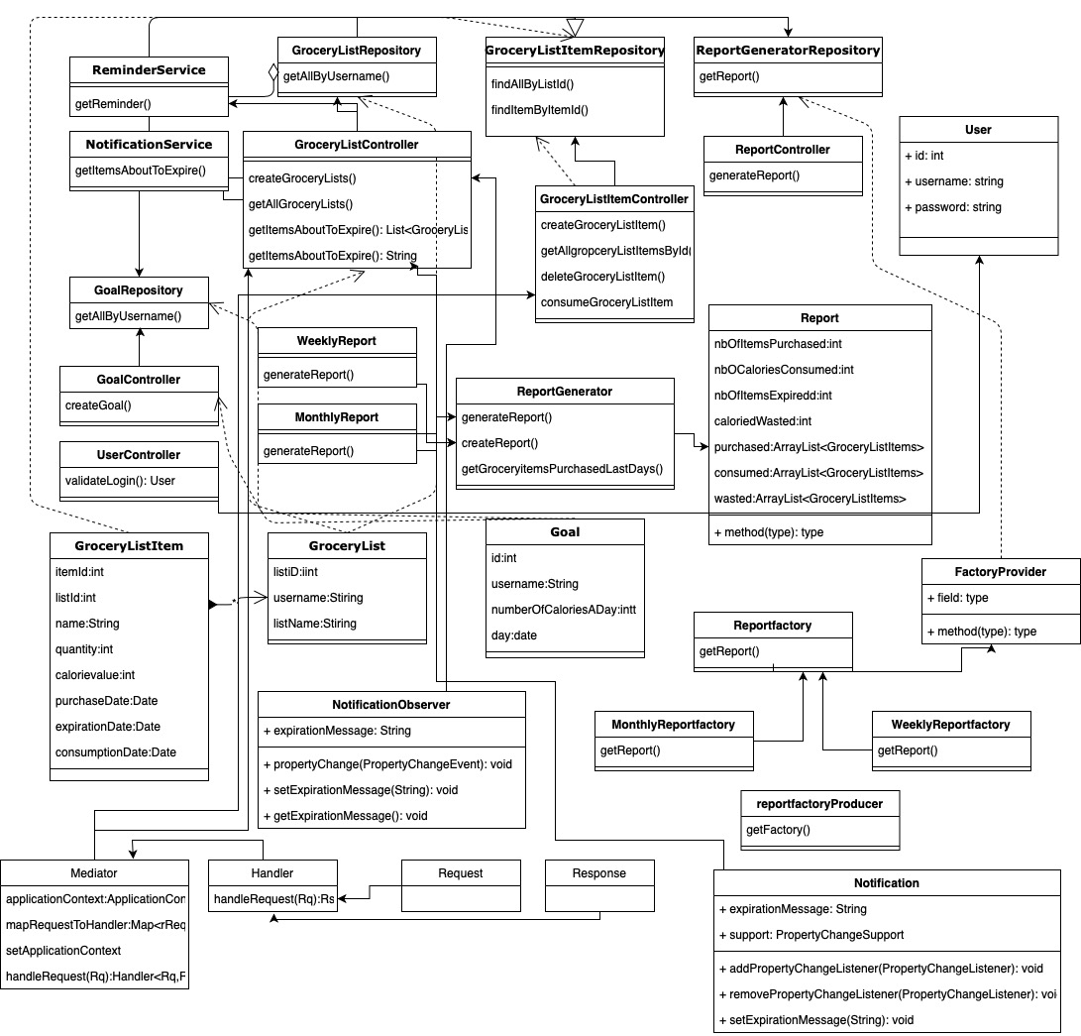

6. Data Model

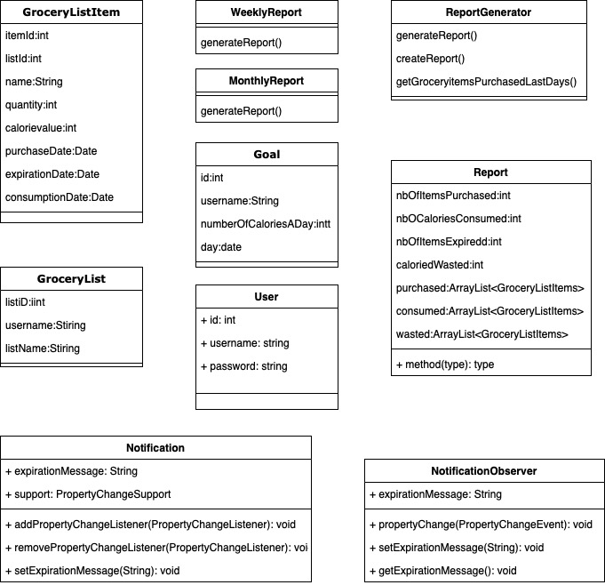

7. System Testing

The application uses Junit Framework for unit testing. Junit 5 is used for creating test cases to test the saving of the entities GroceryList, GroceryListItem and Goal in the H2 database and check the results are correct. The testing system contains 3 test cases for each main component of the system. Each case checks for the successful creation of a list, an item and a goal, which represent the three main objects used in the application, as well as checking if they were saved correctly in the database. The user entity doesn’t need to be checked because it is created by default by the Spring Security Framework, that uses the default schema.

8. Bibliography

<https://javabydeveloper.com/spring-boot-h2-in-memory-database-example/>

<https://www.javacodegeeks.com/2018/10/layered-architecture-running-just-5-minutes-spring-boot-part-1.html>

<https://www.tutorialspoint.com/design_pattern/abstract_factory_pattern.htm>

<https://www.javaguides.net/2018/06/guide-to-dependency-injection-in-spring.html>

<https://www.javaguides.net/2018/06/guide-to-dependency-injection-in-spring.html>

<https://www.baeldung.com/java-observer-pattern>

<https://www.baeldung.com/spring-boot-angular-web>

<https://www.tutorialspoint.com/design_pattern/decorator_pattern.htm>

<https://www.baeldung.com/cqrs-for-a-spring-rest-api>