Student:Dragoteanu Bogdan
Group:30431

Table of Contents
1
1
Student: 1
Table of Contents 2
1. Requirements Analysis 3
1.1Assignment Specification 3
1.2Functional Requirements 3
1.3Non-functional Requirements 3
2. Use-Case Model 3
Use case: <use case goal> 3
Level: <one of: summary level, user-goal level, sub-function> 3
Primary actor: <a role name for the actor who initiates the use case> 3
Main success scenario: <the steps of the main success scenario from trigger to goal delivery> 3
Extensions: <alternate scenarios of success or failure> 3
] 3
3. System Architectural Design 3
4. UML Sequence Diagrams 3
5. Class Design 3
6. Data Model 3
7. System Testing 4
8. Bibliography 4

1. Requirements Analysis

Assignment Specification

The assignment is an application that helps users manage food waste.

Authenticated users can input grocery lists and see reports of how much food is wasted weekly and monthly. An item in the grocery list has the following data:

Name,quantity, calorie value, purchase date, expiration date and consumption date

The system allows the users to track the goals and minimize waste by reminding them if the waste levels are too high based on ideal burn down rates.

The system gives the users options to donate excess food to various local food charities and soup kitchens.

If an item expiration is close to the current date the user is notified.

Functional Requirements
- Search → The user is able to find data about the grocery item by searching explicitly for it
- Reports → The system will generate a weekly and monthly report for the user

Non-functional Requirements
- Security → The system shall ensure that data is protected from unauthorized access
→ System data may be accessed only by users authenticated by means of a username and password
- Portability → The application works on both Windows and Linux machines
- Extendibility → Features can be further enriched

2. Use-Case Model

Use case: <use case goal>

Level: <one of: summary level, user-goal level, sub-function>

Primary actor: <a role name for the actor who initiates the use case>

Main success scenario: <the steps of the main success scenario from trigger to goal delivery>

Extensions: <alternate scenarios of success or failure>

]
Use case: User
Level: user-goal
Primary actor: Registered User
Main success scenario:
Extensions:

3. System Architectural Design
The system will be made using the layered architecture.
3.1 Architectural Pattern Description
Components in a layered architecture are organized into horizontal layers, each performing a specific role within the application. In our case we have four layers:
- Presentation → handles the user interface
- Business → handles requests
- Persistence (Data Access) → contains database tech
- Database
The layers are closed → requests move from layer to layer:
presentation → business → persistence → database
3.2 Diagrams
Package Diagram
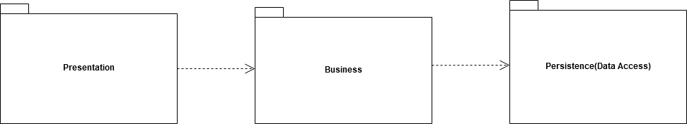
Deployment Diagram
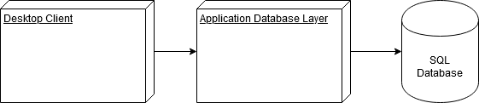
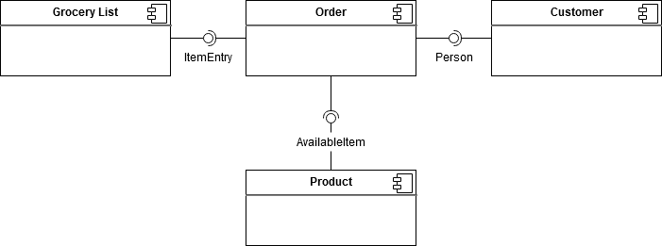
Component Diagram

Patterns used:
- layered → used to structure the program into groups of subtasks
→ each layer provides services to the next higher layer
- model-view-controller → model - contains the core functionality and data
→ view - displays the information to the user
→ controller - handles the input from the user
→ Used to separate internal representations of information from the ways information is presented to, and accepted from, the user

4. UML Sequence Diagrams
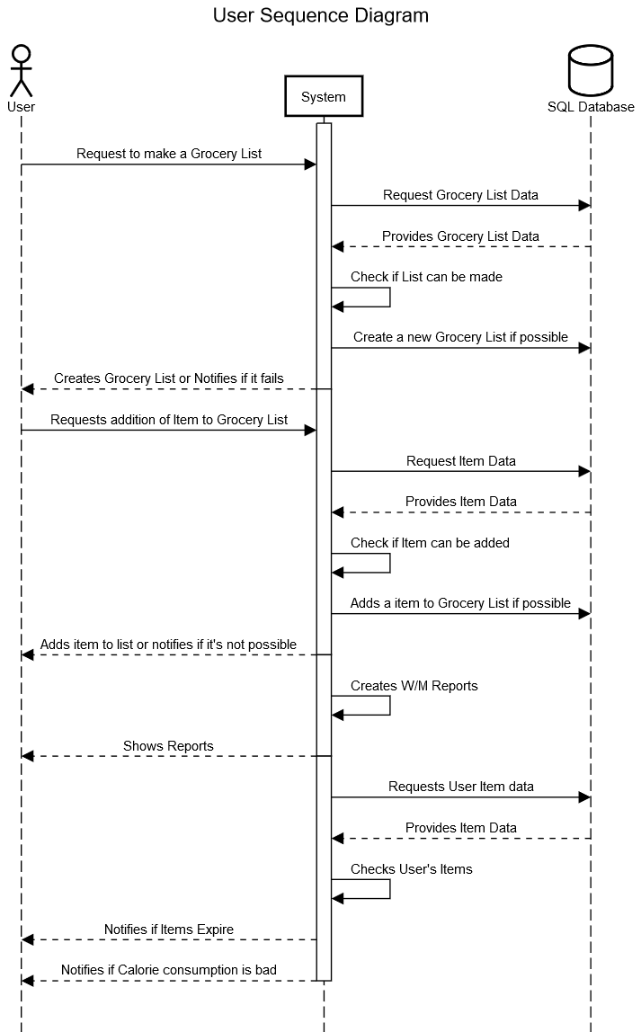

5. Class Design

5.1 Design Patterns Description
- Abstract Factory → Used in the creation of Weekly/Monthly Reports
→ Provides an interface for creating families of related or dependent
objects without specifying their concrete classes.
- ?Observer → Define a one-to-many dependency between objects so that when one object changes state, all its dependents are notified and updated automatically.
→ Used in the notification of the user (Bad Calorie Intake, Expiration Dates).

5.2 UML Class Diagram
[Create the UML Class Diagram and highlight and motivate how the design patterns are used.]

6. Data Model
[Present the data models used in the system’s implementation.]

7. System Testing
Validation Testing
[Present the used testing strategies (unit testing, integration testing, validation testing) and testing methods (data-flow, partitioning, boundary analysis, etc.).]

8. Bibliography

