Styx's Treasure Hunt

Use-Case Model

Version <1.0>

Revision History
Date | Version | Description | Author
<17/03/2020> | <1.0> | <First Iteration> | <Dragoteanu Bogdan>

Table of Contents
1.Use-Cases Identification 3
2.UML Use-Case Diagrams 3

Use-Case Model

Use-Cases Identification
Use case: Start Game
Level: user-goal level
Primary actor: User
Main success scenario: The user starts a game.
Extensions: -

Use case: Join Game
Level: user-goal level
Primary actor: User
Main success scenario: User joins another user's game
Extensions: Connection fails and the user is prompted to exit or try again.

Use case: Select Goblin and customize it
Level: user-goal
Primary actor: User
Main success scenario: The User creates the goblin with the chosen customization
Extensions: -

Use case: Take treasure/bag
Level: user-goal
Primary actor: User
Main success scenario: The User adds to its goblin inventory the treasure, the bag or both.
Extensions:
- If the inventory is full and there's no bag as reward the goblin can't take the treasure
- If there are already 8 bags in the goblin's inventory the bag can't be taken
- If there are no free spaces and there are 8 bags in the goblin's inventory neither a bag nor a treasure can be taken

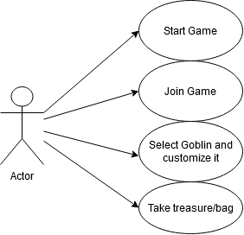
UML Use-Case Diagrams

