Styx's Treasure Hunt

Analysis and Design Document

Student: Dragoteanu Bogdan
Group: 30_431

Revision History

Date | Version | Description | Author
<17/3/2020> | <1.0> | <First Iteration> | <Dragoteanu Bogdan>

Table of Contents
I.Project Specification 4
II.Elaboration – Iteration 1.1 4
1.Domain Model 4
2.Architectural Design 4
2.1Conceptual Architecture 4
2.2Package Design 4
2.3Component and Deployment Diagrams 4
III.Elaboration – Iteration 1.2 4
1.Design Model 4
1.1Dynamic Behavior 4
1.2Class Design 4
2.Data Model 4
3.Unit Testing 4
IV.Elaboration – Iteration 2 4
1.Architectural Design Refinement 4
2.Design Model Refinement 4
[Refine the UML class diagram by applying class design principles and GRASP; motivate your choices. Deliver the updated class diagrams.] 4
V.Construction and Transition 5
1.System Testing 5
2.Future improvements 5
VI.Bibliography 5

Project Specification
The project is a java application, a game about treasure hunting. When starting a game the user can choose from a few goblin races. These come with racial bonuses and can be customized.
The players go through a series of events, 10 total, which vary in difficulty and size. Difficulty scales depending on the number of guards defending the treasure. Success depends on a series of dice throws simulated by the system, similar to how DnD (Dungeons and Dragons) works.
Once a goblin's inventory fills the user has to pick a bag or he has to progress to the next event without picking up the treasure.
At the end of the challenge goblins are ranked based on the value of the items in their inventory and the winner gets fame throughout the goblin kingdoms.

Elaboration – Iteration 1.1

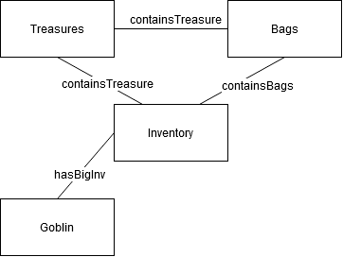
Domain Model

Architectural Design

Conceptual Architecture
- Layered Architecture:
Components in a layered architecture are organized into horizontal layers, each performing a specific role within the application. In our case we have four layers:
> Presentation → handles the user interface
> Business → handles requests
> Persistence (Data Access) → contains database tech
> Database
The layers are closed → requests move from layer to layer:
presentation → business → persistence → database
- MVC Pattern → model - contains the core functionality and data
→ view - displays the information to the user
→ controller - handles the input from the user
→ Sparates internal representations of information from the ways information is presented to, and accepted from, the user
- Observer Pattern → Used to notify the application that changes have been made
→ Updates the game GUI while the players customize their goblins
- Command Pattern → Used for request execution
- Peer to Peer Pattern → Used for the multiplayer aspect of the system
→ Partitions tasks or workloads between peers.

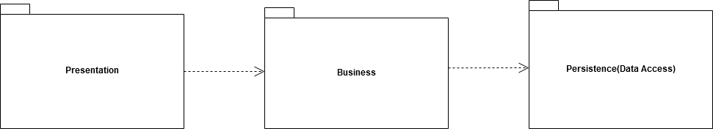
Package Design

Component and Deployment Diagrams
Deployment Diagram
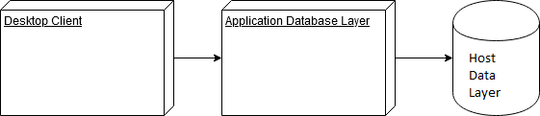
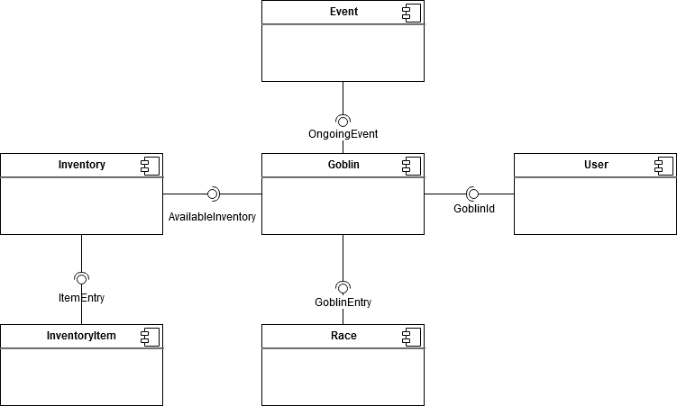
Component Diagram

Elaboration – Iteration 1.2

Design Model

Dynamic Behavior
[Create the interaction diagrams (1 sequence, 1 communication diagrams) for 2 relevant scenarios]

Class Design
[Create the UML class diagram; apply GoF patterns and motivate your choice]

Data Model
[Create the data model for the system.]

Unit Testing
[Present the used testing methods and the associated test case scenarios.]

Elaboration – Iteration 2

Architectural Design Refinement
[Refine the architectural design: conceptual architecture, package design (consider package design principles), component and deployment diagrams. Motivate the changes that have been made.]

Design Model Refinement

[Refine the UML class diagram by applying class design principles and GRASP; motivate your choices. Deliver the updated class diagrams.]

Construction and Transition

System Testing
The testing approach for the host is going to be a top down one. The functionality of the system will be tested from the upper layer to the lowest. For the data receiving, the host will be tested using a bottom up approach.
Using both these approaches → The main approach is something called Sandwich/Hybrid Approach. It's a mix between bottom up and top down approach.

Future improvements
> Better models used for the goblins
> New gamemodes
> Better GUI
> Connection Improvements

Bibliography
[1] Integration Testiong, http://softwaretestingfundamentals.com/integration-testing/
[2] Design Patterns, Alexander Shivets, https://sourcemaking.com/design_patterns

