Pandemic tracker

Analysis and Design Document

Student: Husman Andrei

**Group:30431**

Revision History

|  |  |  |  |
| --- | --- | --- | --- |
| **Date** | **Version** | **Description** | **Author** |
| <21/03/20> | <1.0> | <details> | Husman Andrei |
|  |  |  |  |
|  |  |  |  |
|  |  |  |  |

Table of Contents

I. Project Specification 4

II. Elaboration – Iteration 1.1 4

1. Domain Model 4

2. Architectural Design 4

2.1 Conceptual Architecture 4

2.2 Package Design 4

2.3 Component and Deployment Diagrams 4

III. Elaboration – Iteration 1.2 4

1. Design Model 4

1.1 Dynamic Behavior 4

1.2 Class Design 4

2. Data Model 4

3. Unit Testing 4

IV. Elaboration – Iteration 2 4

1. Architectural Design Refinement 4

2. Design Model Refinement 4

V. Construction and Transition 5

1. System Testing 5

2. Future improvements 5

VI. Bibliography 5

# Project Specification

# The goal of the project is to provide the users information about the COVID-19 virus in real time.

# Elaboration – Iteration 1.1

# Domain Model

The project uses one entity which is the Country entity.

# Architectural Design

## Conceptual Architecture

The architecture features on a client server basis, the backend being segregated from the frontend. The web app uses data which is independently collected and achieves a high degree of cohesion and a low coupling in the way the system behaves.

The backend uses a layered architectural pattern, using responsibility segregation and data independence.

## Package Design

## Component and Deployment Diagrams

*[Create the component and deployment diagrams.]*

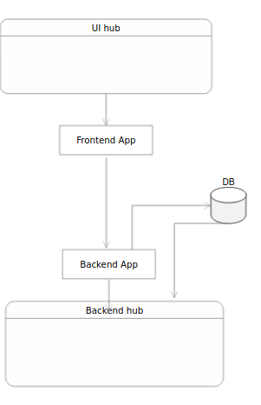

# Elaboration – Iteration 1.2

# Design Model

## Dynamic Behavior

*[Create the interaction diagrams (1 sequence, 1 communication diagrams) for 2 relevant scenarios]*

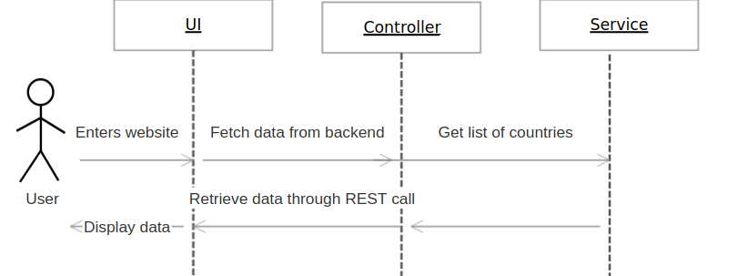

## Class Design

*[Create the UML class diagram; apply GoF patterns and motivate your choice]*

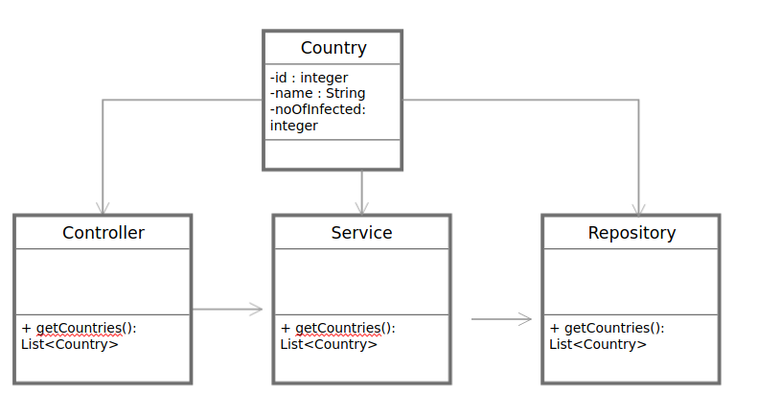

# Data Model

*[Create the data model for the system.]*

# Unit Testing

*[Present the used testing methods and the associated test case scenarios.]*

# Elaboration – Iteration 2

# Architectural Design Refinement

*[Refine the architectural design: conceptual architecture, package design (consider package design principles), component and deployment diagrams. Motivate the changes that have been made.]*

# Design Model Refinement

## *[Refine the UML class diagram by applying class design principles and GRASP; motivate your choices. Deliver the updated class diagrams.]*

# Construction and Transition

# System Testing

*[Describe how you applied integration testing and present the associated test case scenarios.]*

# Future improvements

*[Present future improvements for the system]*

# Bibliography