<Soul Song>

Analysis and Design Document

Student: Ioana Bozdog

**Group: 30431**

Revision History

|  |  |  |  |
| --- | --- | --- | --- |
| **Date** | **Version** | **Description** | **Author** |
| <18/3/20> | <1.0> | <the general view of the app> | <Ioana Bozdog> |
|  |  |  |  |
|  |  |  |  |
|  |  |  |  |

Table of Contents

I. Project Specification 4

II. Elaboration – Iteration 1.1 4

1. Domain Model 4

2. Architectural Design 4

2.1 Conceptual Architecture 4

2.2 Package Design 4

2.3 Component and Deployment Diagrams 4

III. Elaboration – Iteration 1.2 5

1. Design Model 5

1.1 Dynamic Behavior 5

1.2 Class Design 5

2. Data Model 5

3. Unit Testing 5

IV. Elaboration – Iteration 2 6

1. Architectural Design Refinement 6

2. Design Model Refinement 6

V. Construction and Transition 6

1. System Testing 6

2. Future improvements 6

VI. Bibliography 6

# Project Specification

*This project consists of a music application that can read people’s emotions in real time and suggest a playlist according to the mood they are in. The project will be implemented either in Android Studio using Java or in Visual Studio using C# and an API from Microsoft Azure called emotion API. The user could also search for a playlist or even only a song to play. The app will also use a database such as Firebase to store and retrieve songs. The user will also be capable to create an account and login.*

# Elaboration – Iteration 1.1

# Domain Model

*The domain model of the app can be seen below in the form of conceptual classes. Please keep in mind that this is the first version of the app.*

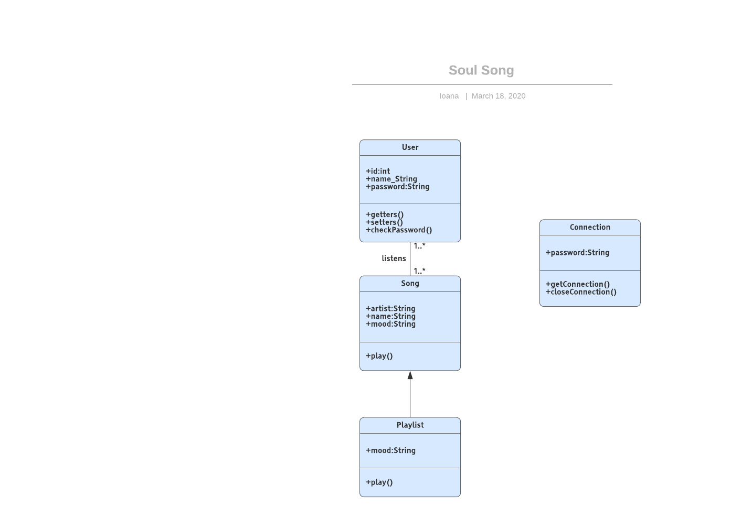

# Architectural Design

## Conceptual Architecture

*Since the application uses Firebase, I believe the best architecture would be Client-Server as the Client will have to request data.*

## Package Design

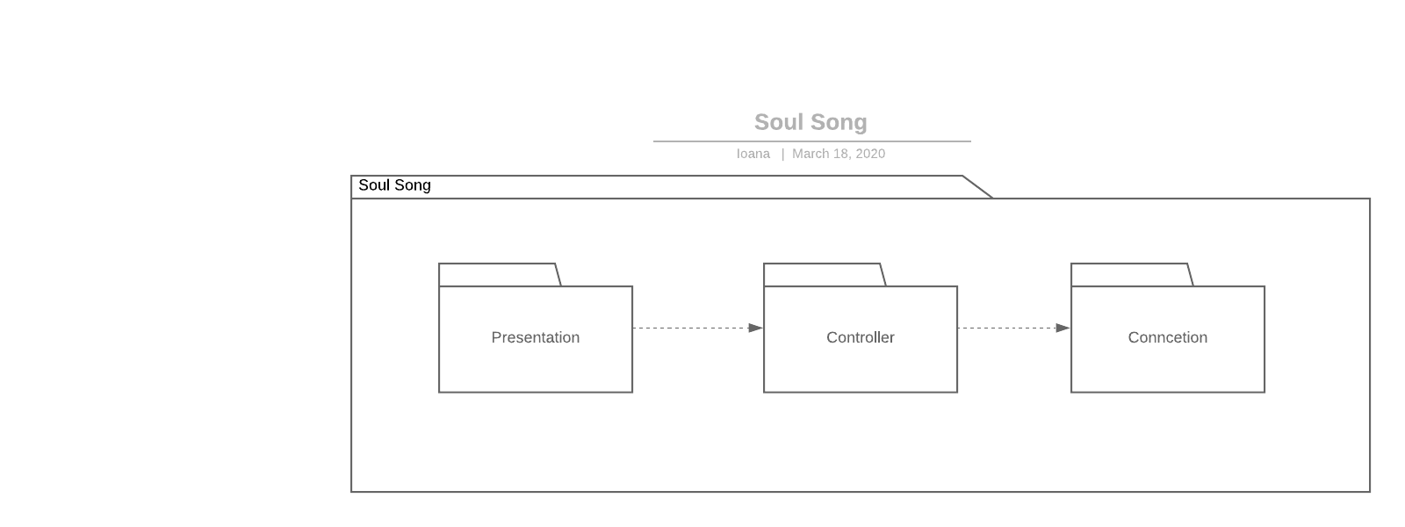

## Component and Deployment Diagrams

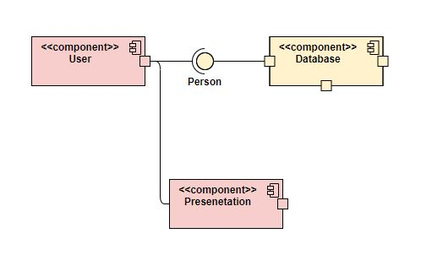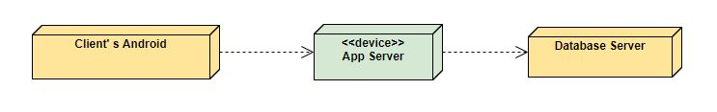

# Elaboration – Iteration 1.2

# Design Model

## Dynamic Behavior

*[Create the interaction diagrams (1 sequence, 1 communication diagrams) for 2 relevant scenarios]*

## Class Design

*[Create the UML class diagram; apply GoF patterns and motivate your choice]*

# Data Model

*[Create the data model for the system.]*

# Unit Testing

*[Present the used testing methods and the associated test case scenarios.]*

# Elaboration – Iteration 2

# Architectural Design Refinement

*[Refine the architectural design: conceptual architecture, package design (consider package design principles), component and deployment diagrams. Motivate the changes that have been made.]*

# Design Model Refinement

## *[Refine the UML class diagram by applying class design principles and GRASP; motivate your choices. Deliver the updated class diagrams.]*

# Construction and Transition

# System Testing

*The tests will provide an evaluation of the basic operations present in the application, such as login, create account, open camera, detect emotion, connect to database.*

# Future improvements

*I would really like to implement this to have multiple playlists for a single emotion, not just one.*

# Bibliography