< Patient Guided Assessment System >

Analysis and Design Document

Student:Iacob Andrei Ștefan

**Group:30431**

Revision History

|  |  |  |  |
| --- | --- | --- | --- |
| **Date** | **Version** | **Description** | **Author** |
| <dd/mmm/yy> | <x.x> | <details> | <name> |
|  |  |  |  |
|  |  |  |  |
|  |  |  |  |

Table of Contents

I. Project Specification 4

II. Elaboration – Iteration 1.1 4

1. Domain Model 4

2. Architectural Design 4

2.1 Conceptual Architecture 4

2.2 Package Design 4

2.3 Component and Deployment Diagrams 4

III. Elaboration – Iteration 1.2 4

1. Design Model 4

1.1 Dynamic Behavior 4

1.2 Class Design 4

2. Data Model 4

3. Unit Testing 4

IV. Elaboration – Iteration 2 4

1. Architectural Design Refinement 4

2. Design Model Refinement 4

V. Construction and Transition 5

1. System Testing 5

2. Future improvements 5

VI. Bibliography 5

# Project Specification

# The “Patient Guided Assessment System” is a project which aims at offering the users which enter a hospital / a clinic a better view about their condition. It asks for relevant data to be input (age, gender, pulse, most important symptoms, prior conditions) to determine the possible necessities of the patient and guide him towards a department.

# It brings utility to the user( in a lot of cases , people just go to the emergency room and wait there for hours before a nurse or a physician is able to help them ) , as well as to the medical stuff ( by giving them an idea about what the patient is experiencing in terms of symptoms , his medical background etc).

# Elaboration – Iteration 1.1

# Domain Model

The domain is used by 2 main actors: the patient which enters the hospital and the medical staff . Once a patient has entered the application , he will be required to fill in a form containing some basic informations(age, gender etc.). There will also be some fields (non-compulsory) which will ask for some more specific information, like the current pulse , number of hours slept . This is why it depends a little bit on whether a physician is able to assist the user (by calculating his pulse and so on). Anyhow, after filling the form , the patient will be able to choose the most predominant(and important) symptoms that he/she is feeling at the moment. This ranges from muscular pains to headaches to simply sneezing very often. More important is the output of the system : the patient will be able to see which department is the most suitable for his/her condition and make an appointment on an available spot right away , while the physician will receive a paper with the patient’s stats (being also able to verify the results of the system and have a better idea about the patient ).

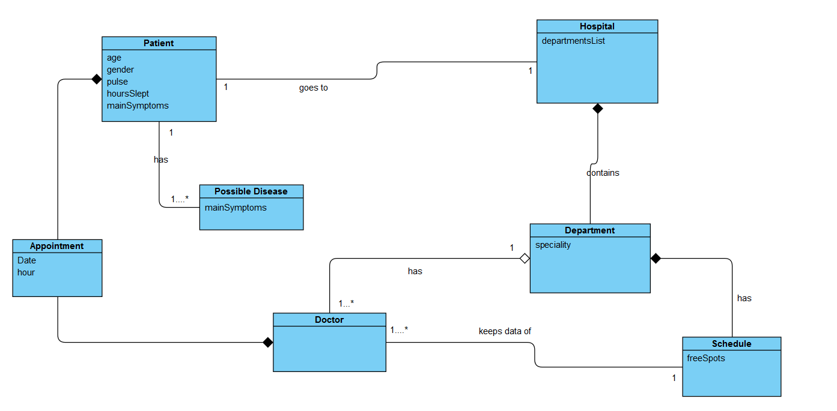

# Architectural Design

## Conceptual Architecture

*The intent of the conceptual architecture is to direct attention at an appropriate decomposition of the system without delving into the details of interface specification. It is a structural design that contains no implementation details.*

*The ”Patient Guided Assessment System”* *application will be web based. It will be hosted on a website to which the patients will have access once they enter the hospital/clinic ( maybe the website will continuously run on a device and remain ready to use for all the ‘ newcomers’). In order to have an organized structure , the project will be based on the layered architecture . Each layer will be performing a specific role within the application (presenation, logic etc.), so there will be a clear separation of concerns among components. The reasons for choosing so are , most importantly :the fact that it is easy to test, as components belong to specific layers ; it is easy to implement because naturally most applications work in layers. To sum up, it is easier to develop ,test , govern and maintain applications using this architectural pattern.*

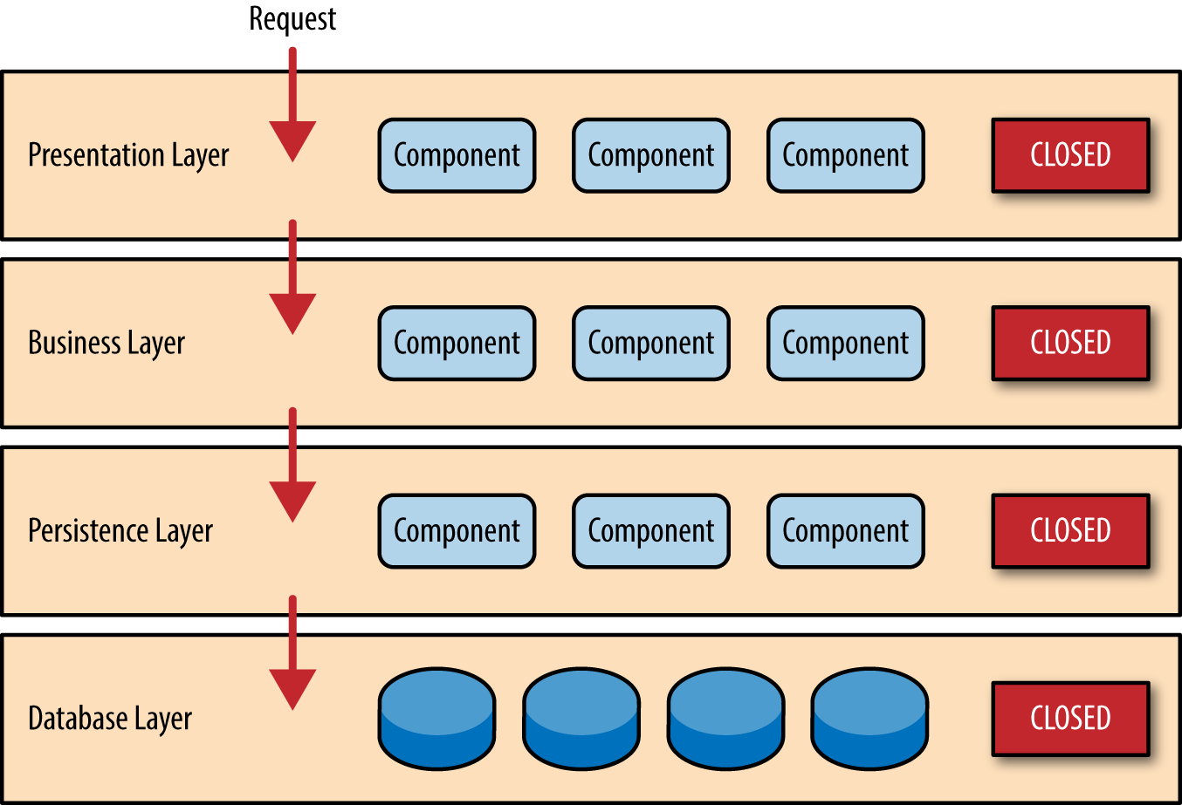

## Package Design

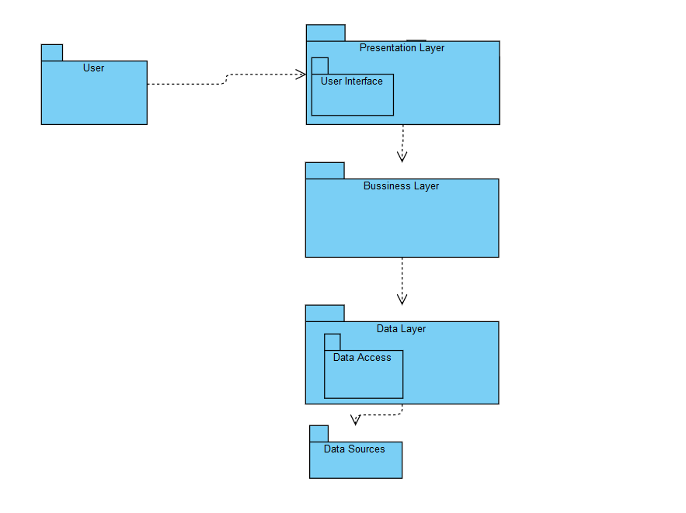

## Component and Deployment Diagrams

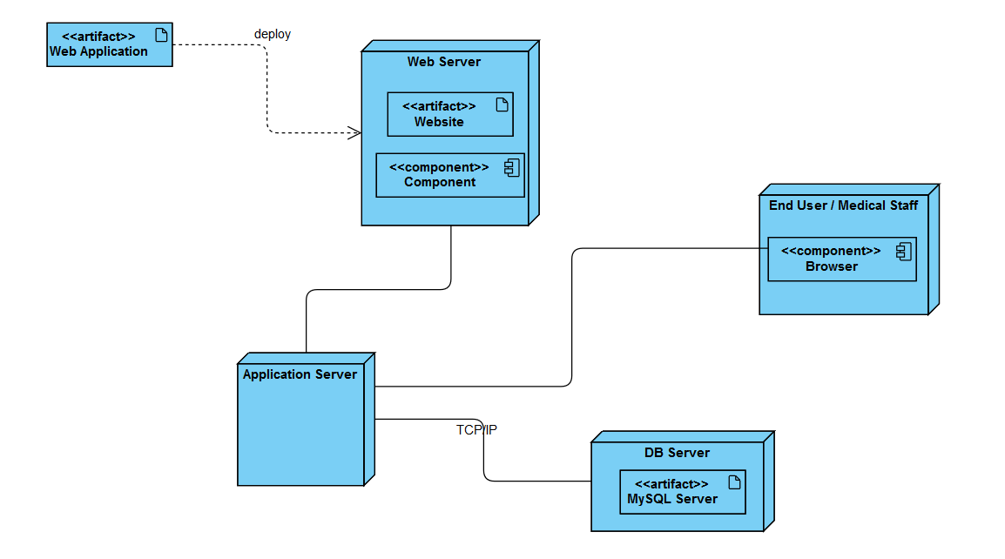

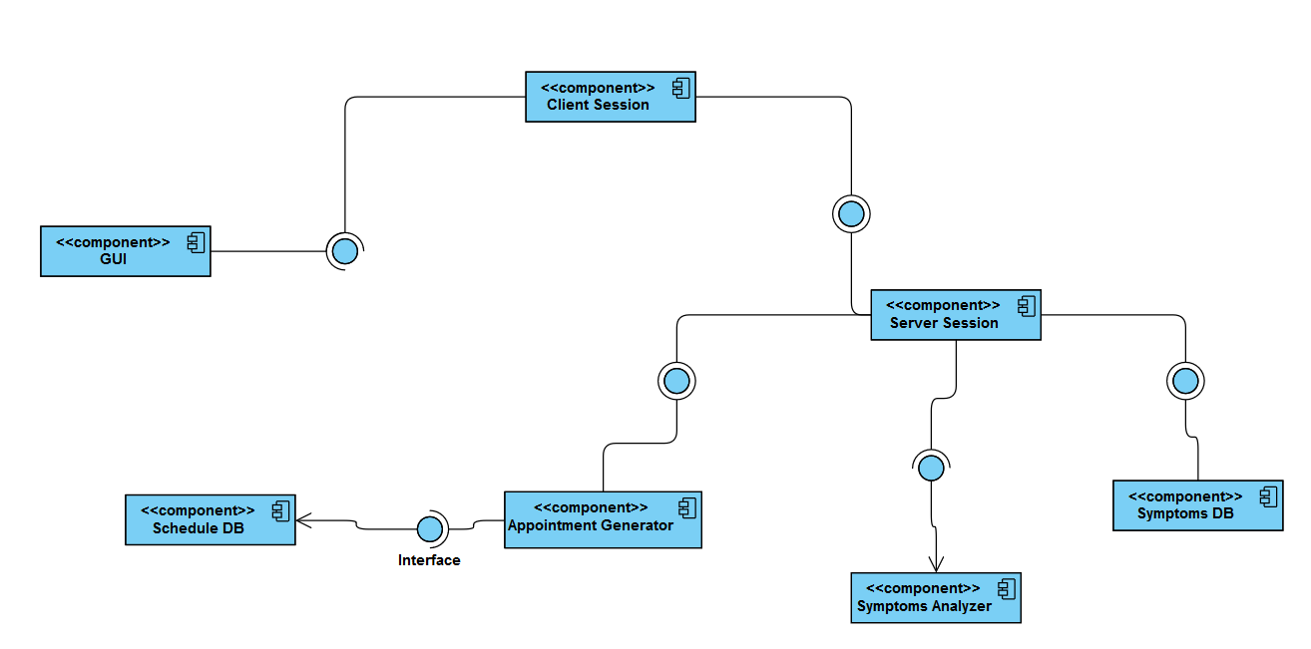

# Elaboration – Iteration 1.2

# Design Model

## Dynamic Behavior

*[Create the interaction diagrams (1 sequence, 1 communication diagrams) for 2 relevant scenarios]*

## Class Design

*[Create the UML class diagram; apply GoF patterns and motivate your choice]*

# Data Model

*[Create the data model for the system.]*

# Unit Testing

*[Present the used testing methods and the associated test case scenarios.]*

# Elaboration – Iteration 2

# Architectural Design Refinement

*[Refine the architectural design: conceptual architecture, package design (consider package design principles), component and deployment diagrams. Motivate the changes that have been made.]*

# Design Model Refinement

## *[Refine the UML class diagram by applying class design principles and GRASP; motivate your choices. Deliver the updated class diagrams.]*

# Construction and Transition

# System Testing

*[Describe how you applied integration testing and present the associated test case scenarios.]*

# Future improvements

*[Present future improvements for the system]*

# Bibliography