Analysis and Design Document

Student: Andrei Tosa

**Group: 30431**

Revision History

|  |  |  |  |
| --- | --- | --- | --- |
| **Date** | **Version** | **Description** | **Author** |
| 21/mar/20 | <x.x> | First edit | Andrei Tosa |
|  |  |  |  |
|  |  |  |  |
|  |  |  |  |

Table of Contents

I. Project Specification 4

II. Elaboration – Iteration 1.1 4

1. Domain Model 4

2. Architectural Design 4

2.1 Conceptual Architecture 4

2.2 Package Design 4

2.3 Component and Deployment Diagrams 4

III. Elaboration – Iteration 1.2 4

1. Design Model 4

1.1 Dynamic Behavior 4

1.2 Class Design 4

2. Data Model 4

3. Unit Testing 4

IV. Elaboration – Iteration 2 4

1. Architectural Design Refinement 4

2. Design Model Refinement 4

V. Construction and Transition 5

1. System Testing 5

2. Future improvements 5

VI. Bibliography 5

# Project Specification

This project will result in an application that will enable the user to create tests for competitive programming problems. The user will be able to interact with the graphical interface and without any code generate a set of tests and even run them on a solution.

# Elaboration – Iteration 1.1

# Domain Model

Below I will present the domain model regarding the application.

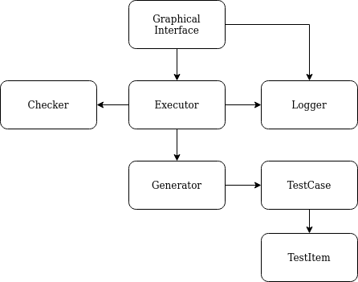

# Architectural Design

## Conceptual Architecture

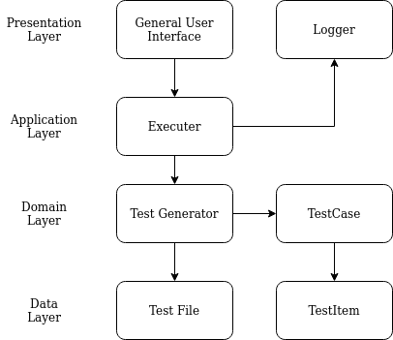

## Package Design

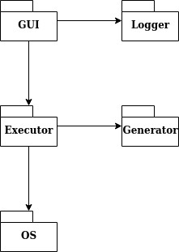

## Component and Deployment Diagrams

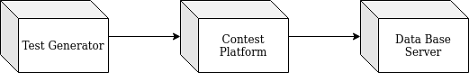

# Elaboration – Iteration 1.2

# Design Model

## Dynamic Behavior

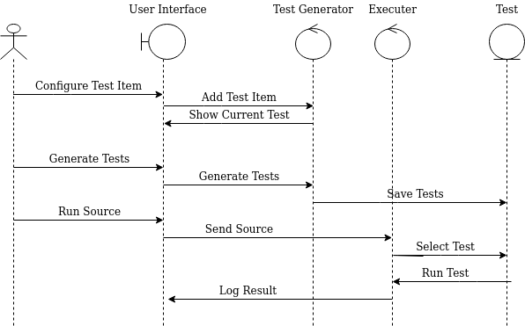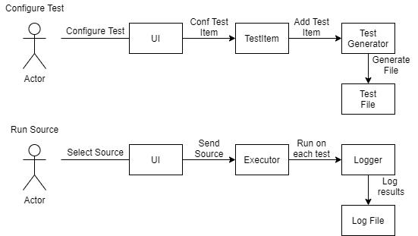

## Class Design

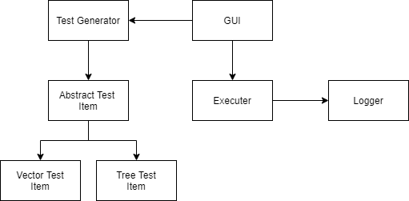

# Data Model

For this application the data model will consist of test items which will mostly be a set of numbers, generated by some rules configured by the user, and the result will be stored in text files.

# Unit Testing

I will test each test item generation method and look into the generated file. Then I will test running a source with the desired tests.

# Elaboration – Iteration 2

# Architectural Design Refinement

*[Refine the architectural design: conceptual architecture, package design (consider package design principles), component and deployment diagrams. Motivate the changes that have been made.]*

# Design Model Refinement

## *[Refine the UML class diagram by applying class design principles and GRASP; motivate your choices. Deliver the updated class diagrams.]*

# Construction and Transition

# System Testing

*[Describe how you applied integration testing and present the associated test case scenarios.]*

# Future improvements

*[Present future improvements for the system]*

# Bibliography