History Tinder

Analysis and Design Document

Student:Butuza Dan-Radu

**Group:30431**

Revision History

|  |  |  |  |
| --- | --- | --- | --- |
| **Date** | **Version** | **Description** | **Author** |
| 21/Mar/20 | 1.0 | Conceptual description of the application | Butuza Dan-Radu |
|  |  |  |  |
|  |  |  |  |
|  |  |  |  |

Table of Contents

I. Project Specification 4

II. Elaboration – Iteration 1.1 4

1. Domain Model 4

2. Architectural Design 4

2.1 Conceptual Architecture 4

2.2 Package Design 4

2.3 Component and Deployment Diagrams 4

III. Elaboration – Iteration 1.2 4

1. Design Model 4

1.1 Dynamic Behavior 4

1.2 Class Design 4

2. Data Model 4

3. Unit Testing 4

IV. Elaboration – Iteration 2 4

1. Architectural Design Refinement 4

2. Design Model Refinement 4

V. Construction and Transition 5

1. System Testing 5

2. Future improvements 5

VI. Bibliography 5

# Project Specification

*History Tinder will be an application similar to the Tinder application, but with historical characters. The user will be able to choose the area and based on that area, the application will show different historical figures with details and pictures about them. The application is aimed as a didactical tool to help teach history in a more modern take.*

# Elaboration – Iteration 1.1

# Domain Model

*[Define the domain model and create the conceptual class diagrams]*

Conceptual class diagram for the historical figures.

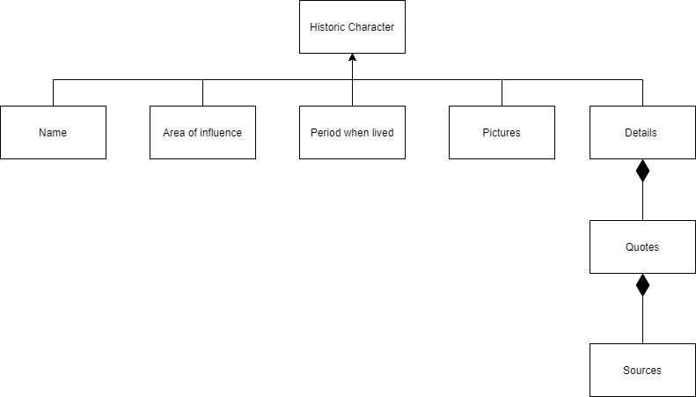

# Architectural Design

## Conceptual Architecture

*[Define the system’s conceptual architecture; use an architectural style and pattern - highlight its use and motivate your choice.]*

*TBD*

## Package Design

*[Create a package diagram]*

*TBD*

## Component and Deployment Diagrams

*[Create the component and deployment diagrams.]*

*Component Diagram*

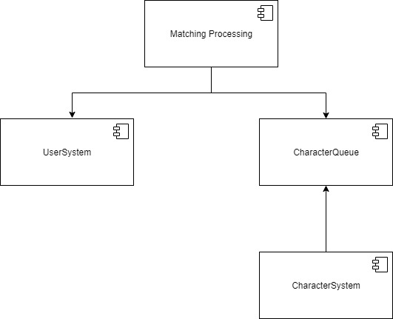

Deployment diagram

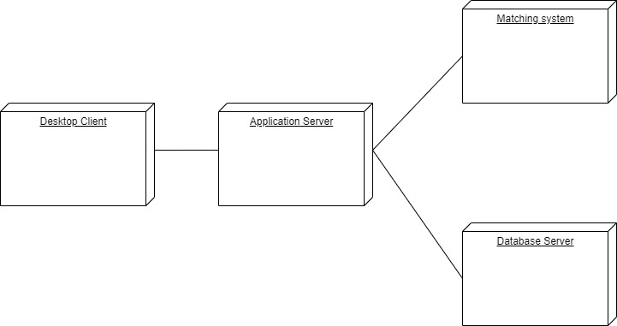

# Elaboration – Iteration 1.2

# Design Model

## Dynamic Behavior

*[Create the interaction diagrams (1 sequence, 1 communication diagrams) for 2 relevant scenarios]*

## Class Design

*[Create the UML class diagram; apply GoF patterns and motivate your choice]*

# Data Model

*[Create the data model for the system.]*

# Unit Testing

*[Present the used testing methods and the associated test case scenarios.]*

# Elaboration – Iteration 2

# Architectural Design Refinement

*[Refine the architectural design: conceptual architecture, package design (consider package design principles), component and deployment diagrams. Motivate the changes that have been made.]*

# Design Model Refinement

## *[Refine the UML class diagram by applying class design principles and GRASP; motivate your choices. Deliver the updated class diagrams.]*

# Construction and Transition

# System Testing

*[Describe how you applied integration testing and present the associated test case scenarios.]*

# Future improvements

*[Present future improvements for the system]*

# Bibliography