History Tinder

Use-Case Model

Version <1.0>

Revision History

|  |  |  |  |
| --- | --- | --- | --- |
| **Date** | **Version** | **Description** | **Author** |
| 21/Mar/20 | 1.0 | Conceptual description | Butuza Dan-Radu |
|  |  |  |  |
|  |  |  |  |
|  |  |  |  |

Table of Contents

1. Use-Cases Identification 4

2. UML Use-Case Diagrams 4

Use-Case Model

# Use-Cases Identification

Use Case models

|  |  |
| --- | --- |
| For User |  |
| Goal | Swipe left for one of the people |
| Actor | User |
| Success Scenario | The logged in User selects a person that is presented to them and decides whether of not they “like” them or not by swiping left to find out more about them |
| Error Scenario | The Chosen person is not displayed correctly (or not in the database ) and the information is either not displayed or poorly displayed. Pressing the button will result in an error |

|  |  |
| --- | --- |
| For Admin |  |
| Goal | Add personalities |
| Actor | Admin |
| Success Scenario | The logged in admin pressed “add” and introduces the information about the wanted personality, thus successfully creating a new entry in the database.  Admin presses the “remove” button and deletes chosen personality from the database, with all their info  Admin presses the edit button and is able to edit the information about the given character |
| Error Scenario | For add: some fields may be left blank, meaning that the database insertion fails  For remove: Failure in deleting the personality from the database  For Edit: failure in changing the information about the character |

# UML Use-Case Diagrams

For User

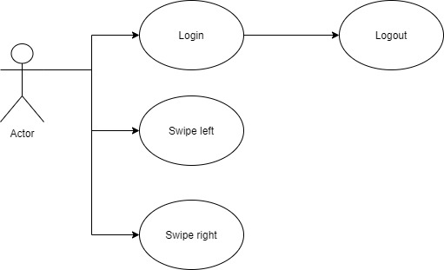

For the admin

