DreamCatch

Student:Bode Andreea-Nicoleta

**Group:30238**

Table of Contents

1. Requirements Analysis 3

1.1 Assignment Specification 3

1.2 Functional Requirements 3

1.3 Non-functional Requirements 3

2. Use-Case Model 4

3. System Architectural Design 5

4. UML Sequence Diagrams 8

5. Class Design 9

6. Data Model 10

7. System Testing 11

8. Bibliography 11

1. Requirements Analysis

# Assignment Specification

DreamCatch is a comprehensive sleep monitoring application that enables users to track the quality of their sleep over time. With DreamCatch, users can create custom categories and add entries with a short description and a set of tags that relate to their dreams. They can then evaluate the quality of their sleep based on three metrics: duration, energy level, and stress, which are scored on a scale of 1-5 for easy tracking.

The application allows users to aggregate these metrics across various categories and presents a daily chart for each quality metric when requested. In future implementations, the application will be able to monitor vitals via smart devices.

DreamCatch is designed with a layered architecture and uses an ORM and DI container. The data is stored in a database, and all user inputs are validated against invalid data before submission and saving in the database.

With its user-friendly interface, customizable categories, and comprehensive tracking metrics, DreamCatch is the perfect application for anyone looking to improve their sleep quality and track their dreams over time.

# Functional Requirements

Users can record their sleep by adding an entry with a short description and a set of tags that define the type of dream. Users can rate their sleep quality using three parameters: duration, energy level and stress. These values are recorded on a scale of 1 to 5 for easy tracking.

The app will allow users to select tag categories to better organize their sleep entries.

The application should be able to aggregate sleep quality values into different tag categories to present daily charts for each quality measure given that the user enters a requested category.

All application inputs will be validated against invalid data before submitting the data and saving it to the database.

The application will use the factory model for creating various reports/charts based on metrics. These reports should be easily accessible and easy to understand for the user.

The user interface should be intuitive and easy to navigate, providing a smooth and enjoyable user experience.

The application must ensure the privacy and security of user data, protecting against unauthorized access and data breaches.

# Non-functional Requirements

* Performance

The application should be able to handle a large volume of data efficiently and respond to user requests in a timely manner, even during peak usage times.

* Security

The application should protect user data from unauthorized access, both in transit and at rest. It should also follow industry-standard security practices for data storage and transmission.

* Scalability

The system should be able to handle increasing amounts of data and user traffic as the user base grows. It should be designed to be scalable without significant downtime or disruption to users.

* Usability

The application should be easy to use and navigate for all types of users, regardless of technical skill level. It should also be accessible to users with disabilities.

* Reliability

The application should be highly available and reliable, with minimal downtime or disruptions. It should also have a robust backup and recovery system in place in case of data loss or system failure.

* Maintainability

The application should be easy to maintain and update, with clear and well-documented code. It should also be easy to troubleshoot and fix issues that arise.

* Compatibility

The application should be compatible with different operating systems and devices, including mobile and desktop platforms.

* Data Integrity

The application should ensure the accuracy and integrity of user data, with appropriate measures in place to prevent data corruption or loss.

* Privacy

The application should be compliant with applicable privacy laws and regulations, with appropriate measures in place to protect user privacy and data confidentiality.

2. Use-Case Model

**Use**-**Case**: Create dream entry

**Level**: User-goal level

**Primary** **actor**: User website

The user can select a type of dreams from the dropbox, add a description, enter values from the range [1,5] for energy, duration and stress. By pressing the Submit button, the data will be saved in the database. By pressing the ViewUsers button, they can see a table with all the data saved in the database, and by pressing the Charts button, they can see the 3 diagrams according to date and stress, duration or energy.

3. System Architectural Design

**3.1 Architectural Pattern Description**

I used layer architecture. I have more packages than those captured in layer architecture, they can still be added to other packages to fully respect the architecture. I used Java and Spring, which is why my application is structured in packages: entity, controller, service, repository.

**3.2 Diagrams**

The conceptual architecture of the DreamCatch application is based on the layered architecture pattern, which separates the application into distinct layers, each with its own responsibilities and functionality. The layers in this architecture are: presentation layer( responsible for presenting the user interface to the user and handling user input. This layer communicates with the application layer to request and display data.), application layer (responsible for implementing the application's business logic, including processing user input and coordinating interactions between the presentation layer and the data access layer.), data access layer( responsible for accessing and manipulating data stored in the application's database.)

In addition to the layered architecture pattern, the DreamCatch application also utilizes the following architectural patterns:

Dependency injection: to manage dependencies between components and to enable modularity and testability.

Object-relational mapping (ORM): to facilitate the mapping of data between the application's object model and the database schema.

**Deployment Diagram**

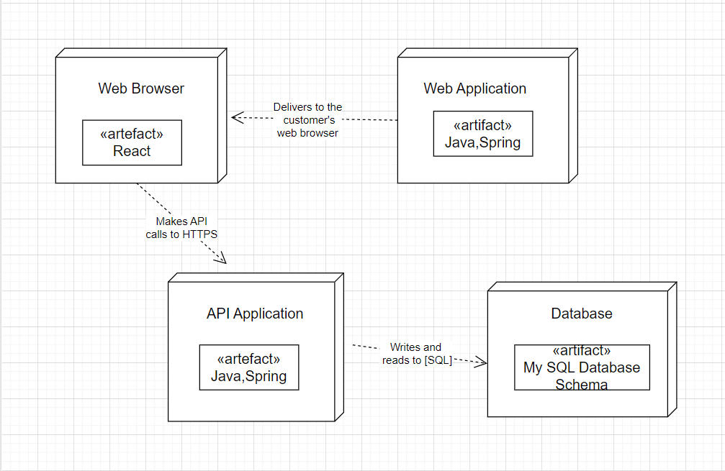

**Component Diagram**

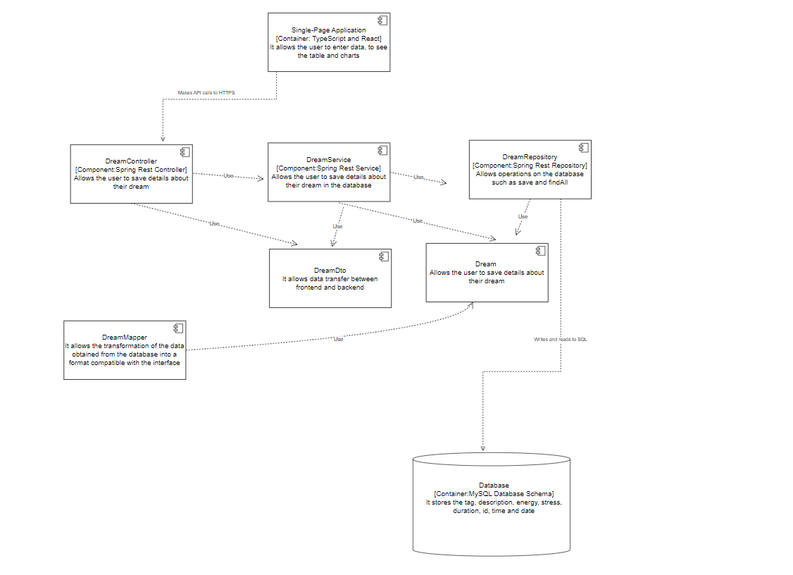

**Package diagram**

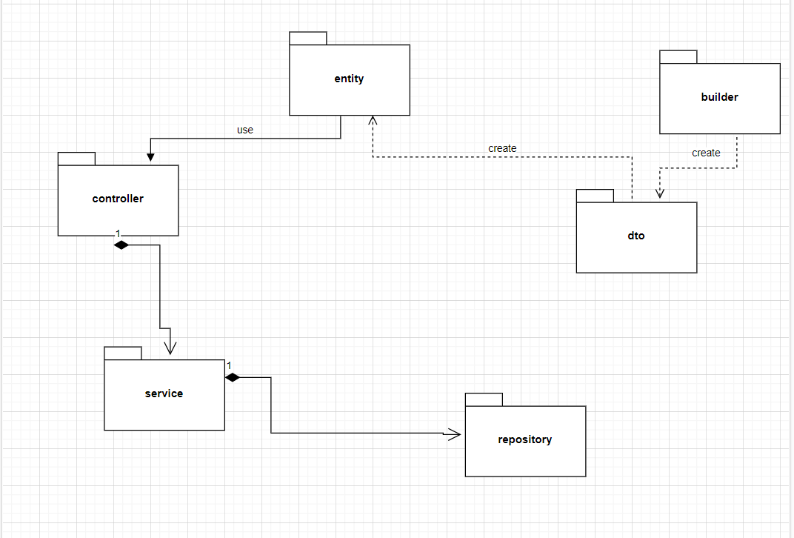

4. UML Sequence Diagrams

5. Class Design

**5.1 Design Patterns Description**

Object-Relational Mapping (ORM) is a model that is used to facilitate data mapping between an application's object model and a database schema. The idea is to provide an abstraction layer between the application and the database, which makes it easier to work with data in a more object-oriented way. I implemented this using the Sprng framework.

Dependency Injection is a pattern that is used to manage dependencies between different components of a software application. The idea is to allow components to be loosely coupled so that they can be easily replaced or modified without affecting the rest of the application.

Another design pattern that is used in the DreamCatch application is the Repository pattern. This pattern is used to abstract away the details of data storage and retrieval. The repository provides a way for the application to interact with data storage without being tightly coupled to the specific implementation of the storage mechanism. In the DreamCatch application, the Repository pattern is used to abstract away the details of data storage and retrieval from the application layer, making it easier to swap out different data storage mechanisms in the future

I used the Factory Design pattern to create chart components based on the type of data requested. The chartFactory function is responsible for creating the chart components based on the passed type parameter. It uses a switch statement to determine the type of chart to create and calls the createChart function with the appropriate parameters to create the chart. The createChart function is responsible for creating the actual chart component using the recharts library. By abstracting the chart creation logic to the chartFactory function, the code follows the Factory Design pattern, which separates the creation of objects from their use.

**5.2 UML Class Diagram**

Front-end

*Back-end*

Entity package: Contains the Dream class, which represents the domain object. The ORM design pattern is used to map the Dream class to a relational database table.

Controller package: Contains the DreamController class, which handles incoming HTTP requests and delegates the work to the service layer.

Service package: Contains the DreamService class, which implements the business logic of the application. The Dependency Injection pattern is used to inject an instance of DreamRepository into the DreamService class.

Repository package: Contains the DreamRepository interface and its implementation, DreamRepositoryImpl. The DreamRepository interface defines the methods for interacting with the database, while DreamRepositoryImpl provides the actual implementation. The ORM pattern is used to map the Dream class to the database and the Dependency Injection pattern is used to inject an instance of EntityManager into the DreamRepositoryImpl class.

DTO package: Contains the DreamDto class, which is used to transfer data between layers. In this example, it is not directly related to any design pattern, but it is a common practice to use DTOs in web applications to avoid exposing domain objects to the client.

6. Data Model

Dream Entity: This model represents a dream object and contains attributes such as dream id, title, description, date, and user id.

DreamDto: This model represents a data transfer object and contains fields such as dream id, title, description, date, and user id. It is used for data transfer between the frontend and backend of the application.

DreamRepository: This model represents the repository layer and contains methods for database operations such as insert, update, delete, and select.

DreamService: This model represents the service layer and contains methods for performing business logic on dream objects such as getting all dreams, getting dreams by user id, creating a new dream, updating an existing dream, and deleting a dream.

DreamController: This model represents the controller layer and contains RESTful endpoints for handling HTTP requests related to dreams such as getting all dreams, getting dreams by user id, creating a new dream, updating an existing dream, and deleting a dream.

7. System Testing

For the DreamCatch System, I did manual testing, I entered valid data to check if they are saved correctly in the database. With the help of the Stress, Duration and Energy buttons, you can see if the retrieved data are the same as those on the interface. Then, I entered invalid data, data validation was done both in the backend and in the frontend, and when invalid data is entered, a message will appear warning the user that they should enter a value between 1 and 5.

Link catre video: https://youtu.be/15OWZW8vtI8

8. Bibliography

1. <https://legacy.reactjs.org/>
2. <https://www.w3schools.com/java/>
3. <https://www.youtube.com/watch?v=vtPkZShrvXQ>
4. https://www.youtube.com/watch?v=4LZKnegAm4g&t=2270s