DreamCatch

Analysis and Design Document

Student: Bode Andreea-Nicoleta

**Group:30238**

Revision History

|  |  |  |  |
| --- | --- | --- | --- |
| **Date** | **Version** | **Description** | **Author** |
| 26/03/2023 | 1.0 | I have implemented most of the requirements. | Bode Andreea-Nicoleta |
|  |  |  |  |
|  |  |  |  |
|  |  |  |  |

Table of Contents

I. Project Specification 4

II. Elaboration – Iteration 1.1 4

1. Domain Model 4

2. Architectural Design 4

2.1 Conceptual Architecture 4

2.2 Package Design 4

2.3 Component and Deployment Diagrams 4

III. Elaboration – Iteration 1.2 4

1. Design Model 4

1.1 Dynamic Behavior 4

1.2 Class Design 4

2. Data Model 4

3. Unit Testing 4

IV. Elaboration – Iteration 2 4

1. Architectural Design Refinement 4

2. Design Model Refinement 4

V. Construction and Transition 5

1. System Testing 5

2. Future improvements 5

VI. Bibliography 5

# Project Specification

DreamCatch is an application that monitors the various topics we dream of and the quality levels of sleep over time. It allows users to input a short description together with a set of tags to add an entry to a user or application defined category. Once an entry is created, the user is able to evaluate the quality of his/her sleep with the following app metrics: duration, energy level, stress. These measurements are recorded on a scale of 1-5 for easy tracking. The application is capable of aggregating these metrics across various tag categories and is able to present a daily chart for each quality metric given the user inputs a requested category. Future implementations can include monitoring vitals via smart devices.

# Elaboration – Iteration 1.1

# Domain Model

The domain model for the DreamCatch includes the following entities: User, SleepEntry, Category, Tag, and Metric. The User entity represents the application users. The SleepEntry entity represents a sleep entry created by a user. Each sleep entry has one category and can have multiple tags associated with it. The Metric entity represents the three app metrics: duration, energy level, and stress. Each metric has a value between 1-5. The Category and Tag entities are used to categorize and tag the sleep entries.

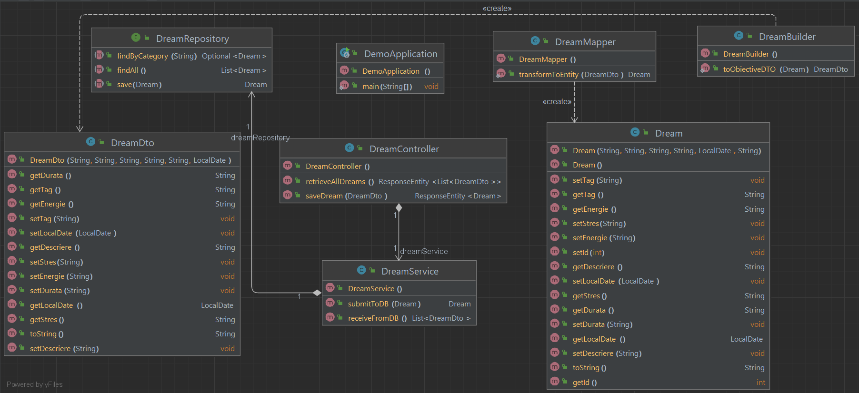

# Architectural Design

## Conceptual Architecture

*[Define the system’s conceptual architecture; use an architectural style and pattern - highlight its use and motivate your choice.]*

## Package Design

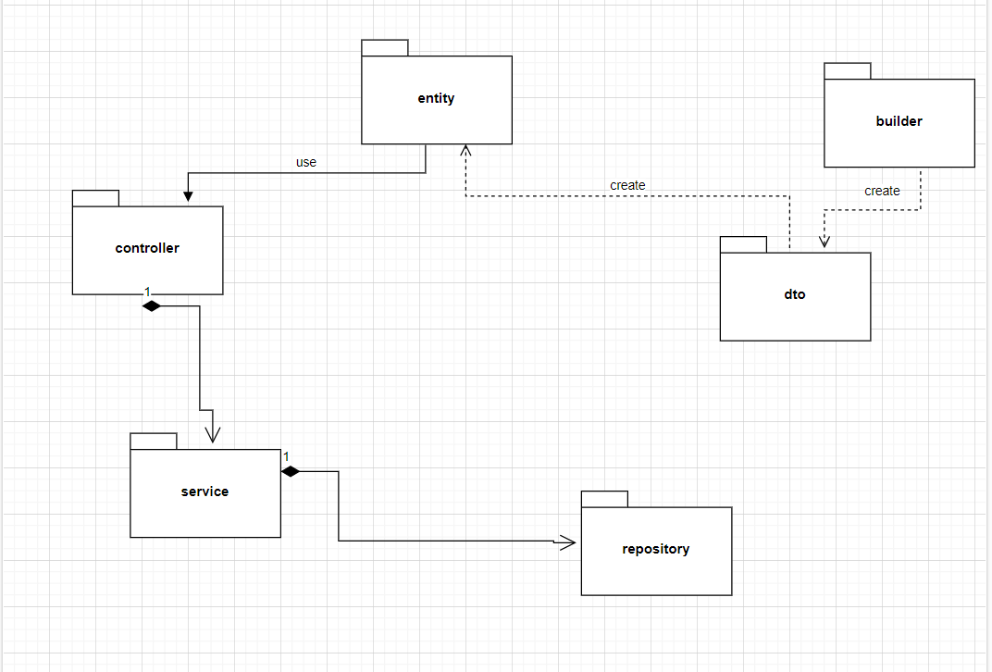

## Component and Deployment Diagrams

Deplyment Diagram

Component Diagram

# Elaboration – Iteration 1.2

# Design Model

## Dynamic Behavior

Sequence Diagram

*[Create the interaction diagrams (1 sequence, 1 communication diagrams) for 2 relevant scenarios]*

## Class Design

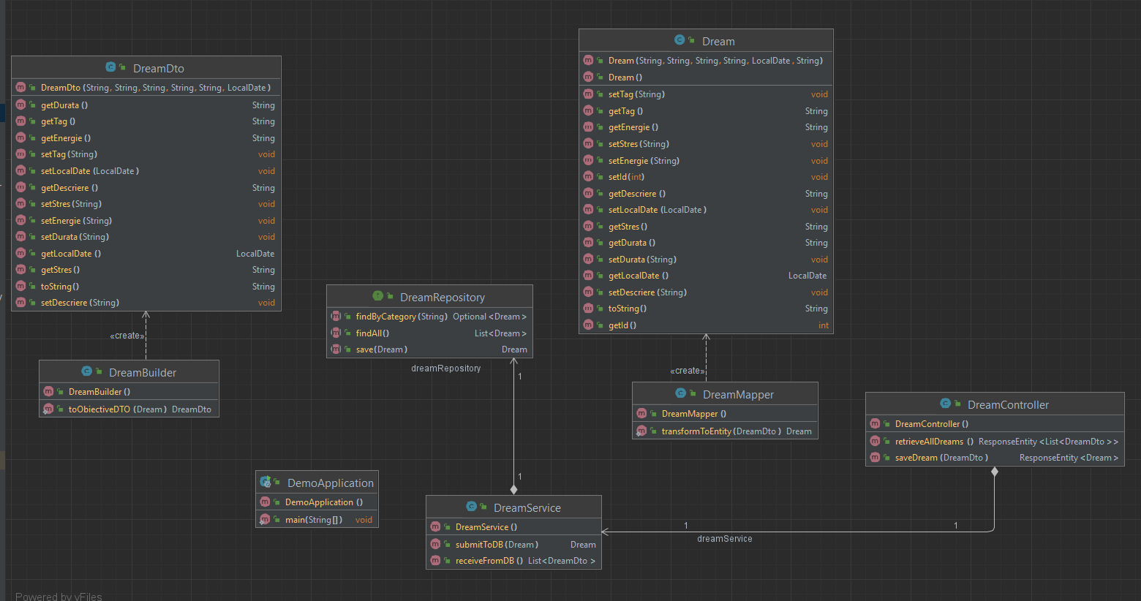

# Data Model

*[Create the data model for the system.]*

# Unit Testing

*[Present the used testing methods and the associated test case scenarios.]*

# Elaboration – Iteration 2

# Architectural Design Refinement

*[Refine the architectural design: conceptual architecture, package design (consider package design principles), component and deployment diagrams. Motivate the changes that have been made.]*

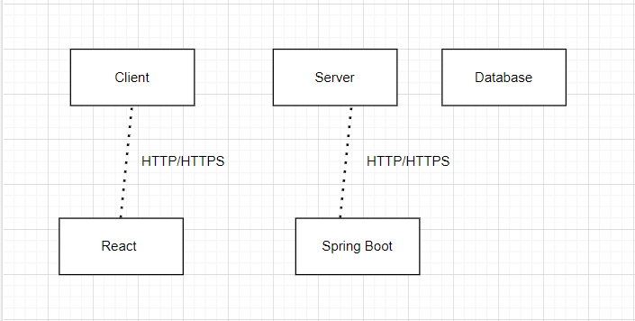

# Design Model Refinement

## *[Refine the UML class diagram by applying class design principles and GRASP; motivate your choices. Deliver the updated class diagrams.]*

# Construction and Transition

# System Testing

*[Describe how you applied integration testing and present the associated test case scenarios.]*

# Future improvements

The system could be enhanced by incorporating data from wearable devices like smartwatches and fitness trackers. This would enable more accurate tracking of sleep patterns and help users identify trends and correlations.

Implementing NLP algorithms could help to extract more information from the user’s descriptions of their dreams. This could include identifying specific themes or emotions, which could be useful for generating more detailed reports.

Machine Learning could be used to analyze sleep patterns and suggest personalized recommendations to improve the quality of sleep. For example, the system could suggest changes to the user’s sleep routine or environment to optimize their sleep quality.

Users could be given the option to share their sleep data and dream reports with friends or a community of other users. This could help to foster a sense of accountability and encourage users to make healthier sleep choices.

Implementing game-like features such as badges, leaderboards, and challenges could help to motivate users to consistently use the system and improve their sleep quality. This could also help to create a more engaging and fun user experience.

# Bibliography

1. <https://legacy.reactjs.org/>
2. <https://www.w3schools.com/java/>
3. <https://www.youtube.com/watch?v=vtPkZShrvXQ>
4. https://www.youtube.com/watch?v=4LZKnegAm4g&t=2270s