Travel
Diagrams

Student:Bode Andreea-Nicoleta
Group:30238

Cuprins
Domain Model 3
Architectural Design 4
Deployment Diagram 5
Component Diagram 6

Domain Model
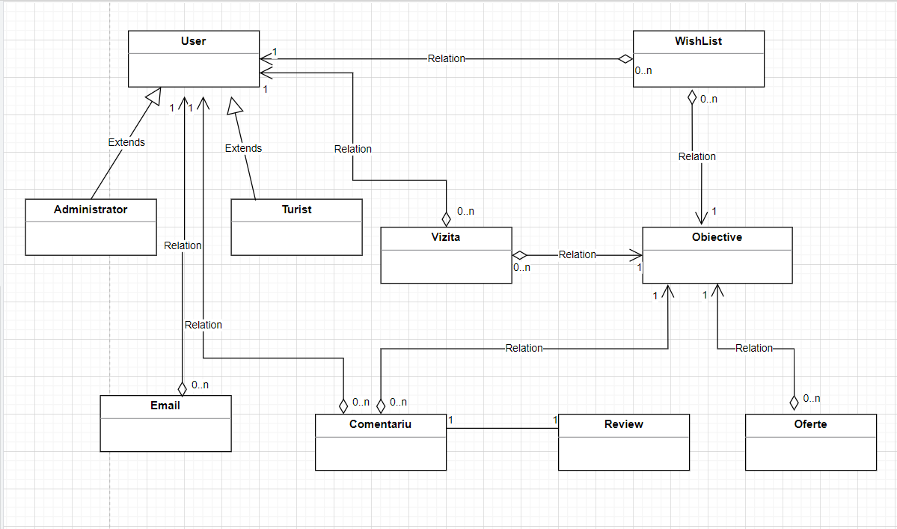

Architectural Design
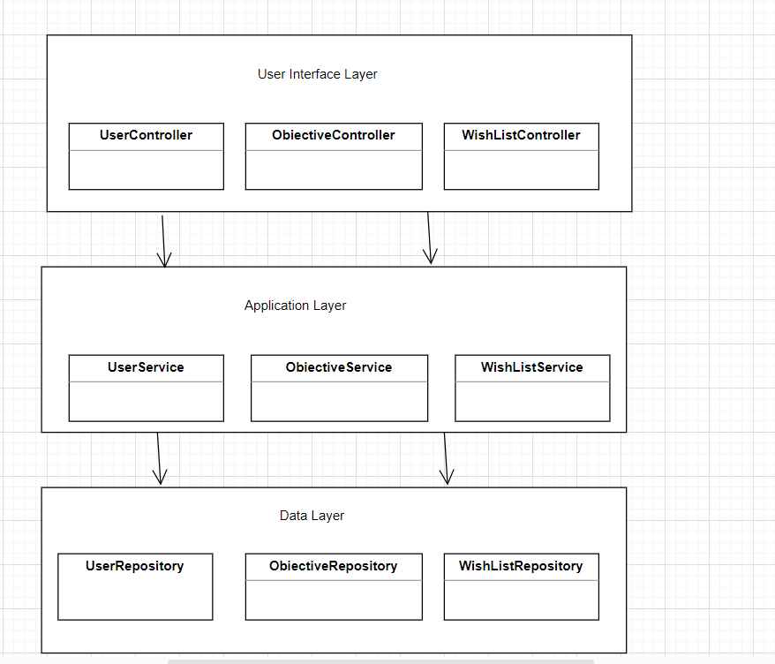
Deployment Diagram 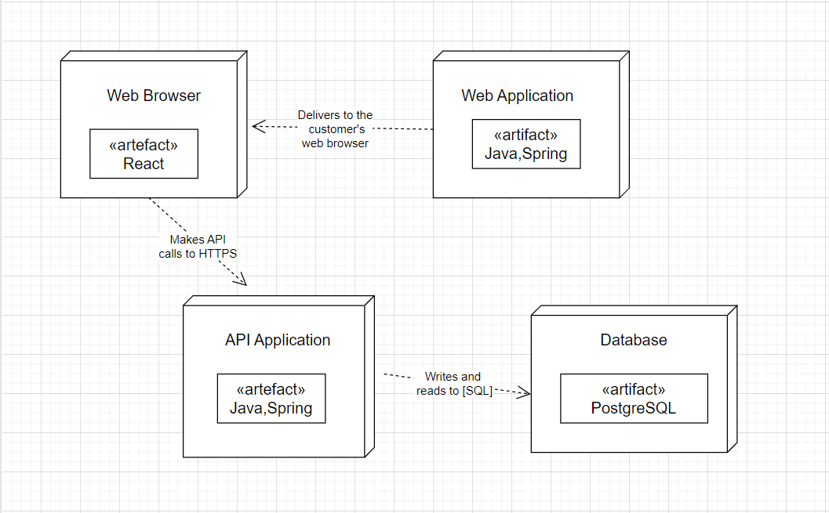

Component Diagram
