Bharatmata Bahuuddeshiya Sanstha, Barshi
Do this correction at Home Page
Bharat Mata ➡ Bharatmata
Bahuuddeshiy ➡ Bahuuddeshiya
Since 1,993 ➡ Since 1993
- Matimand Residential School ➡ Matimand Nivasi Shala Agalgaon
- Mukobadhir Residential School ➡ Mukbadhir Nivasi Shala Agalgaon
- Secondary School ➡ Madhyamik Vidyalay
- Swami Samarth English Medium School
- Swami Samarth Backward Class Boys Hostel ➡ Swami Samarth Magasvargiya Vidyarthi Vastigrah Agalgaon
- Swami Samarth Backward Class Boys Hostel ➡ Swami Samarth Magasvargiya Vidyarthi Vastigrah Barshi
- Swami Samarth English Medium School
- Swami Samarth Balkashram Child Care Center ➡ Swami Samarth Balkashram Balsangopan Kendra
- Swami Samarth Nursing School
10. Swami Samarth Semi-English School

Shri. Ramchandra Patil➡ Shri. Vitthal Ukirade
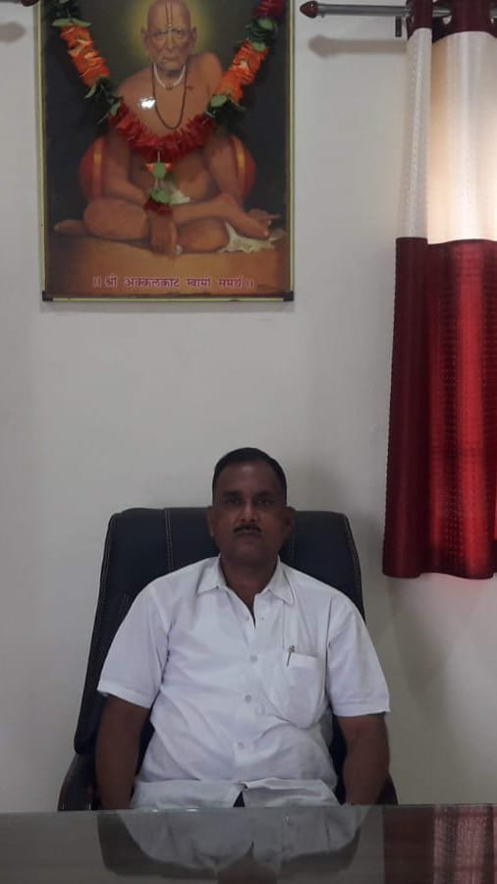
Shri.Sunil Jadhav ➡ Shri. Sharad Ukirade
Shri. Vikram Deshmukh➡ Shri. Samarth Ukirade
Shri.Manoj Kulkarni ➡ Shri. Siddhant Ukirade
Shri.Ajinkya Ukirade ➡ Shri. Ajinkya Ukirade

Address
Bharat Mata Bahuuddeshiy Sanstha, Barshi, Dist. Solapur, Maharashtra 413401

Phone
+91 9XXXXXXXXX

Email
info@bharatmatasanstha.org

Office Hours
Monday – Saturday: 9:00 AM – 5:00 PM
➡

Address
Bharatmata Bahuuddeshiy Sanstha Barshi, Vitthal Nagar, In front of ESSAR Petrol Pump, Tal. Barshi Dist. Solapur, Maharashtra 413401

Phone
+91 8888528452

Email
bharatmatabarshi@gmail.com

Office Hours
Monday – Saturday: 9:00 AM – 5:00 PM

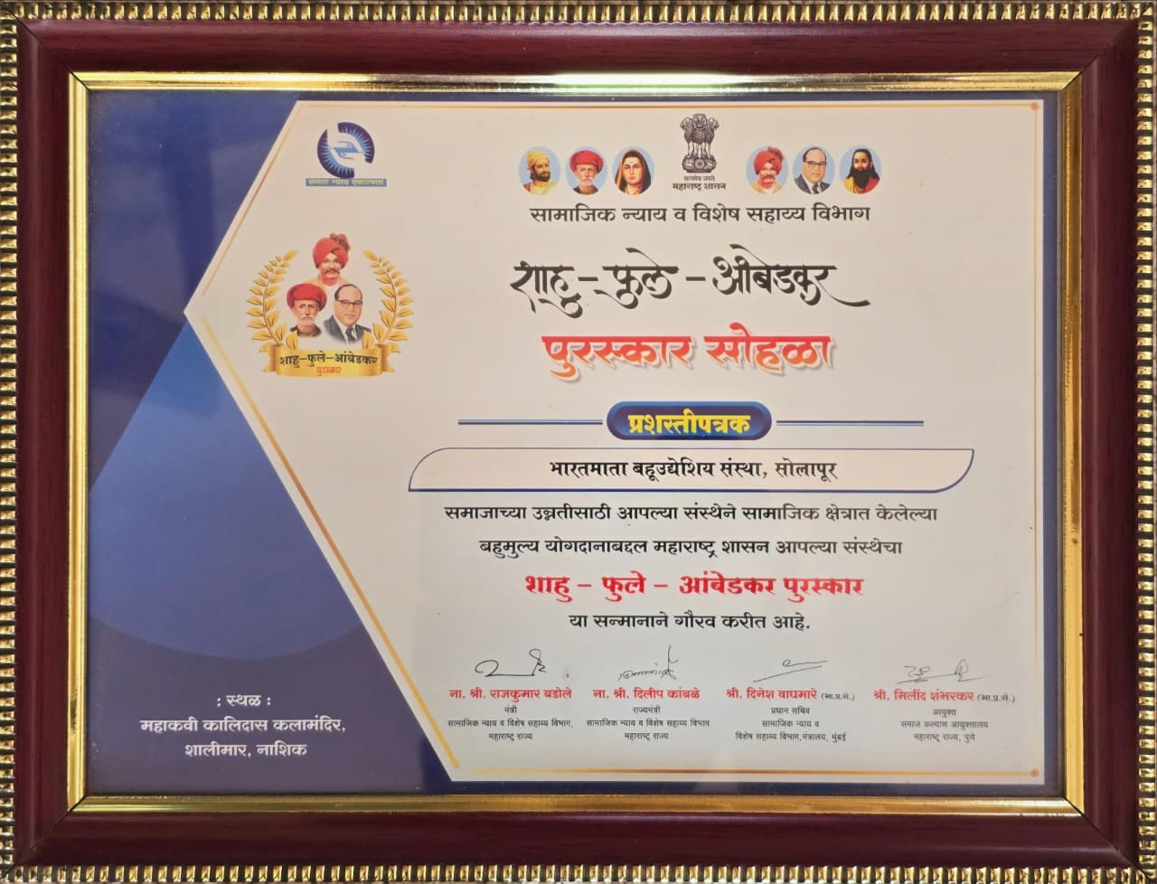

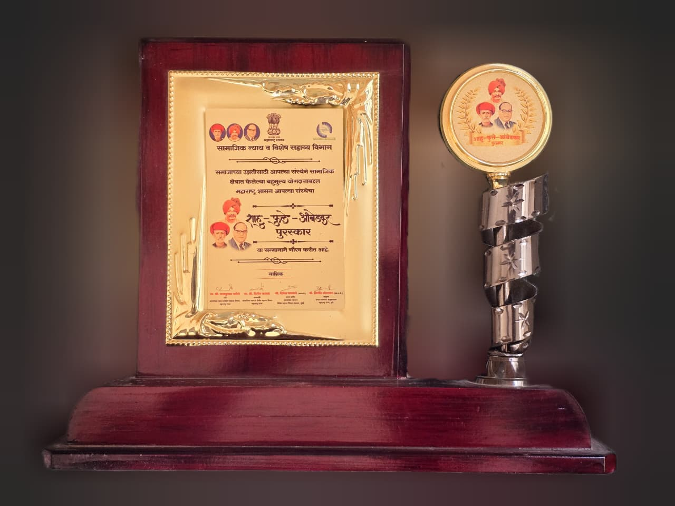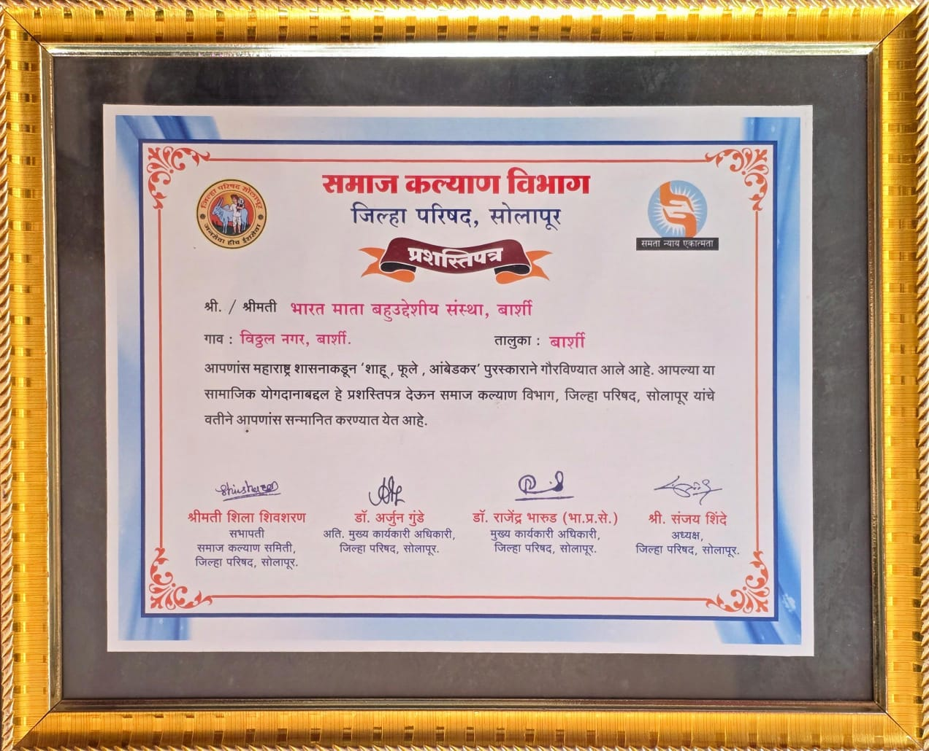

The organization was honored in Award distribution ceremony held in Nashik 2 March 2019 Department of Social Justice & Special Assistance, Government of Maharashtra. Shahū-Phule-Ambedkar Award (शाहू-फुले-आंबेडकर पुरस्कार) For Work has been Dun by the Sanstha.
This is a prestigious award instituted by the Government of Maharashtra. It’s given to organizations that have done outstanding work in social service, education, welfare, empowerment, health, rehabilitation, or community development for vulnerable and backward sections of society.
This award is often conferred during special state ceremonies with the presence of ministers and senior officials, and is one of the key awards in Maharashtra for social impact work.
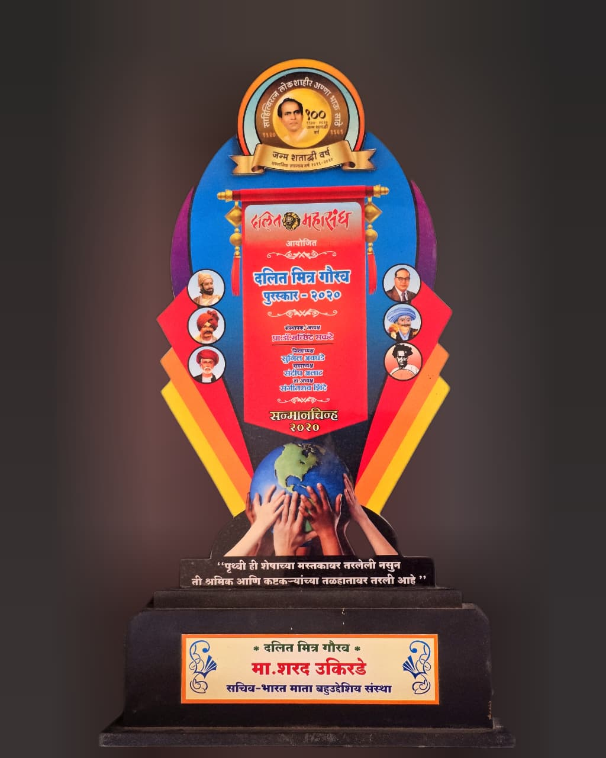
Our organization Secretary was also honored by The Dalit Mitra Gaurav Puraskar (or Dalit Mitra Award) 2020 is given to individuals who have made outstanding contributions to the upliftment, social awareness, and welfare of the underprivileged and backward classes. The Maharashtra government has been awarding this award since 1988. Formerly known as the Dr. Babasaheb Ambedkar Dalit Mitra Award, it is also presented on the birth anniversary of Sahitya Ratna Lokshahir Annabhau Sathe.
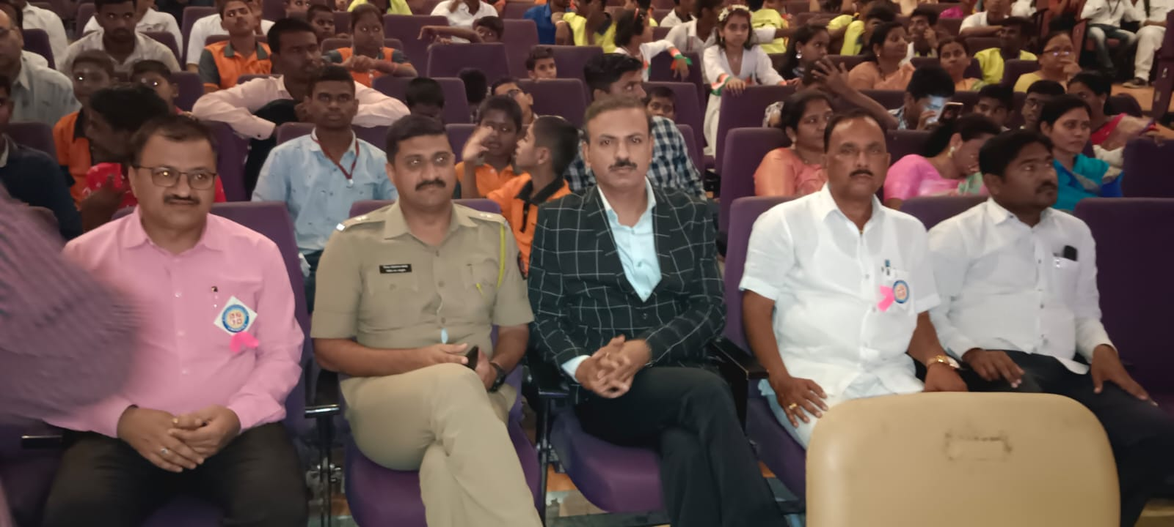
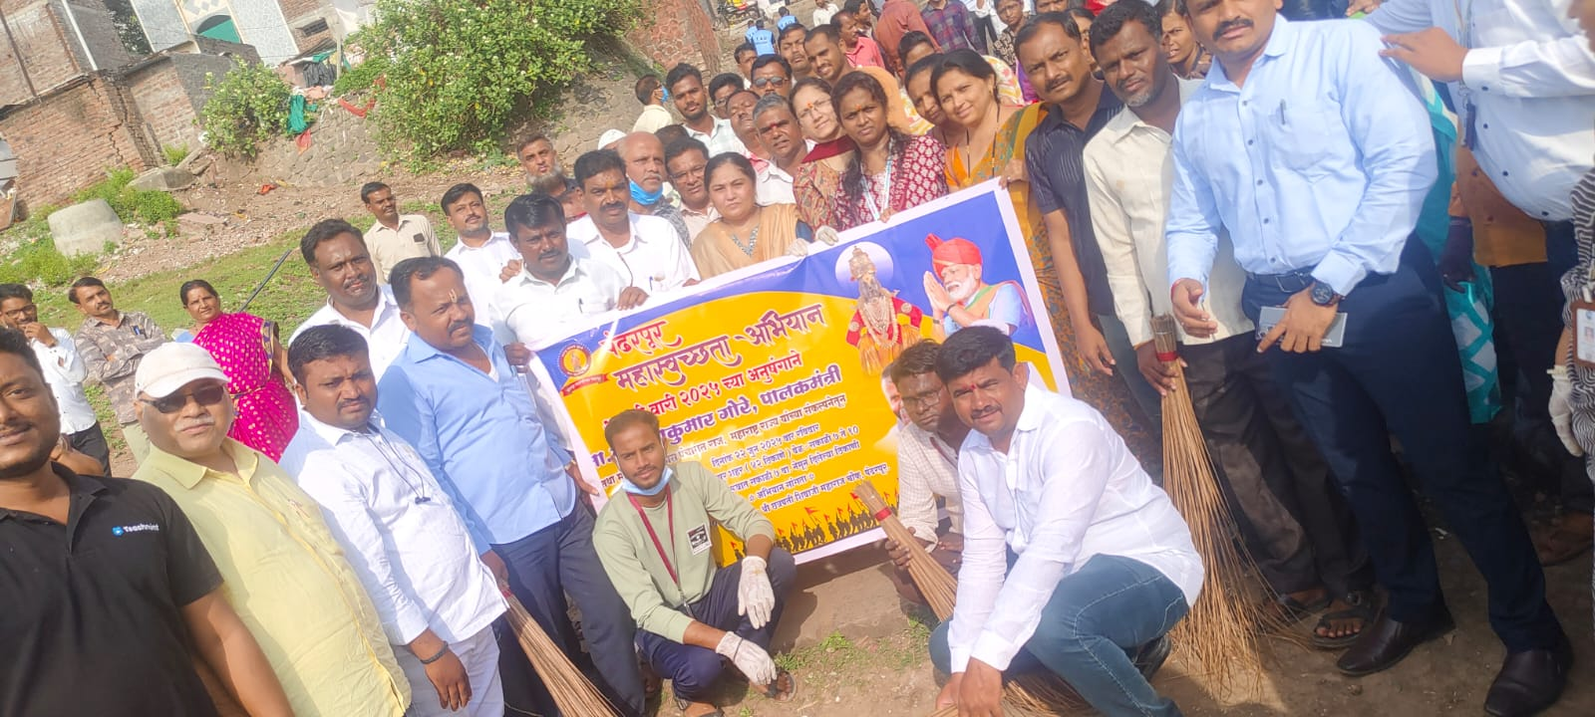
- Matimand Nivasi Shala Agalgaon :- Working for intellectual disabled students
Also work for early intervention for detected Special children's. 9 Time Solapur district general championship winner School.
Matimand Nivasi Shala Agalgaon, located in Agalgaon, Belgaon Road, is a prominent institution established in 1993 by the Bharatmata Bahuuddeshiya Sanstha, Barshi for the education, rehabilitation, and training of intellectually disabled children. The school provides a Marathi-medium education, focusing on empowering special needs children through vocational training and specialized support in an inclusive environment.
Target Group: Mentally challenged/intellectually disabled children, youth, and sometimes elderly.
Facilities & Services: The school features 9 classrooms, a library, playground, and offers residential (boarding) facilities for around 50 children, according to its website.
Management: It is a privately aided, co-educational institution operating under the Bharatmata Bahuuddeshiya Sanstha, Barshi.
Objective: To provide holistic education, early intervention, and rehabilitation to promote independent living.
Contact Information: Often listed with contact numbers like Office 9921213103 Hostel 9421361855 in local directories.
Email : manishaagalgaon@gmail.com
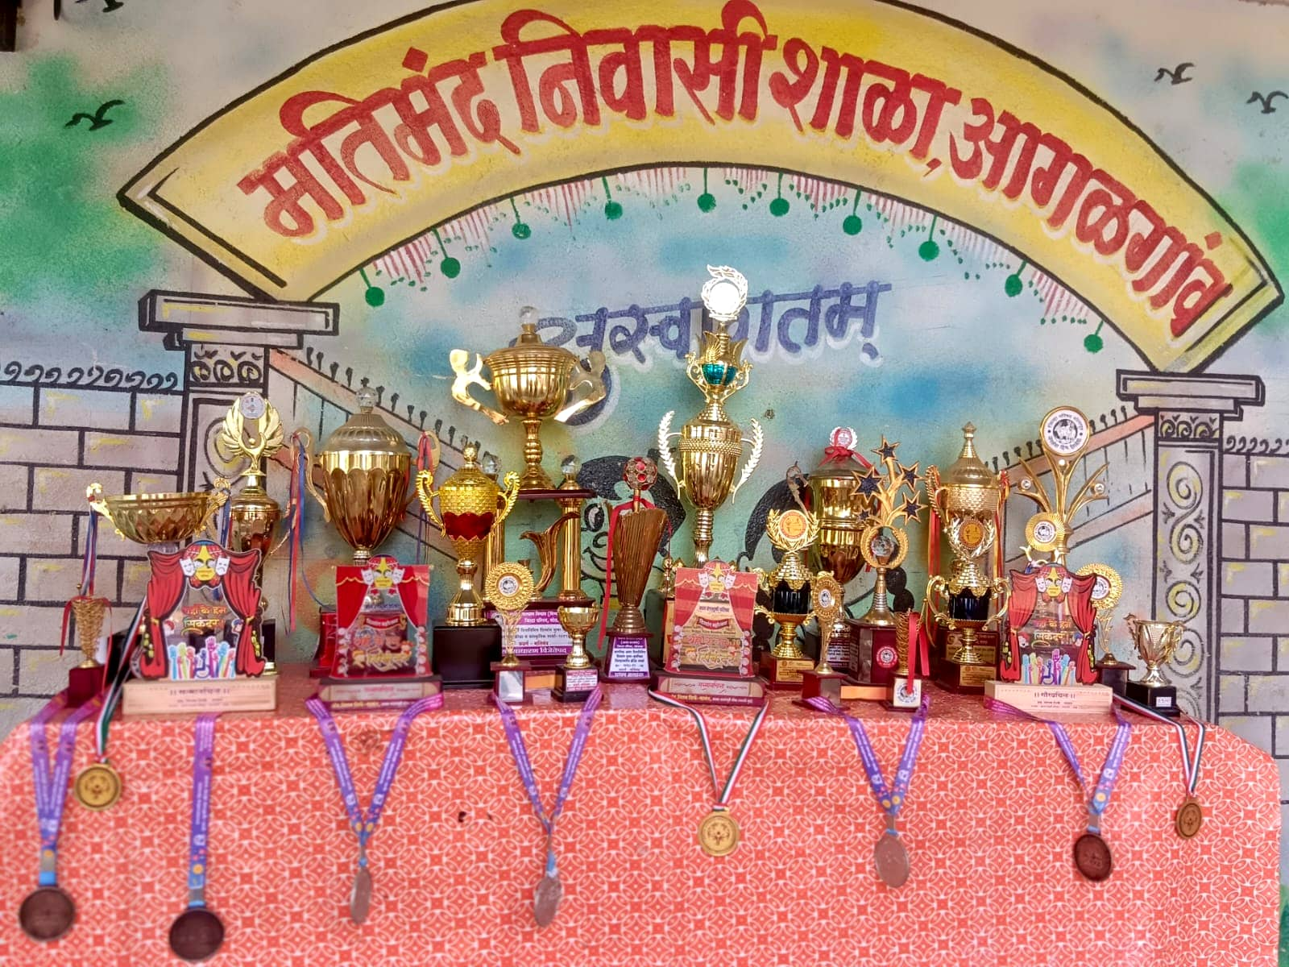

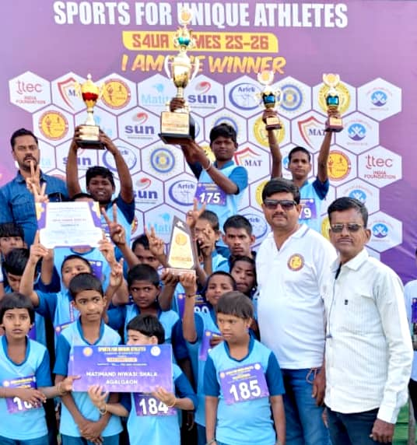

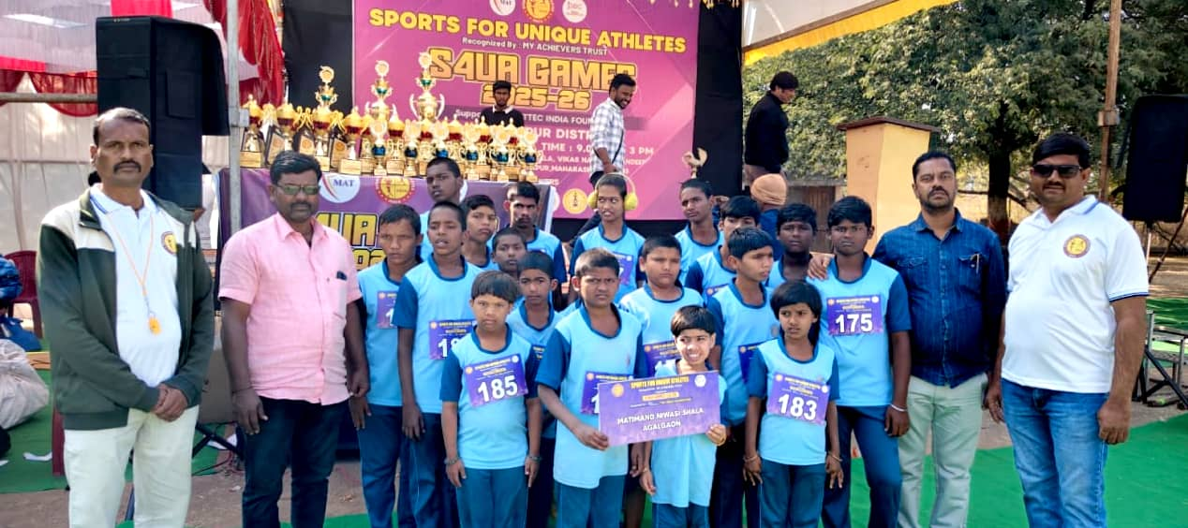

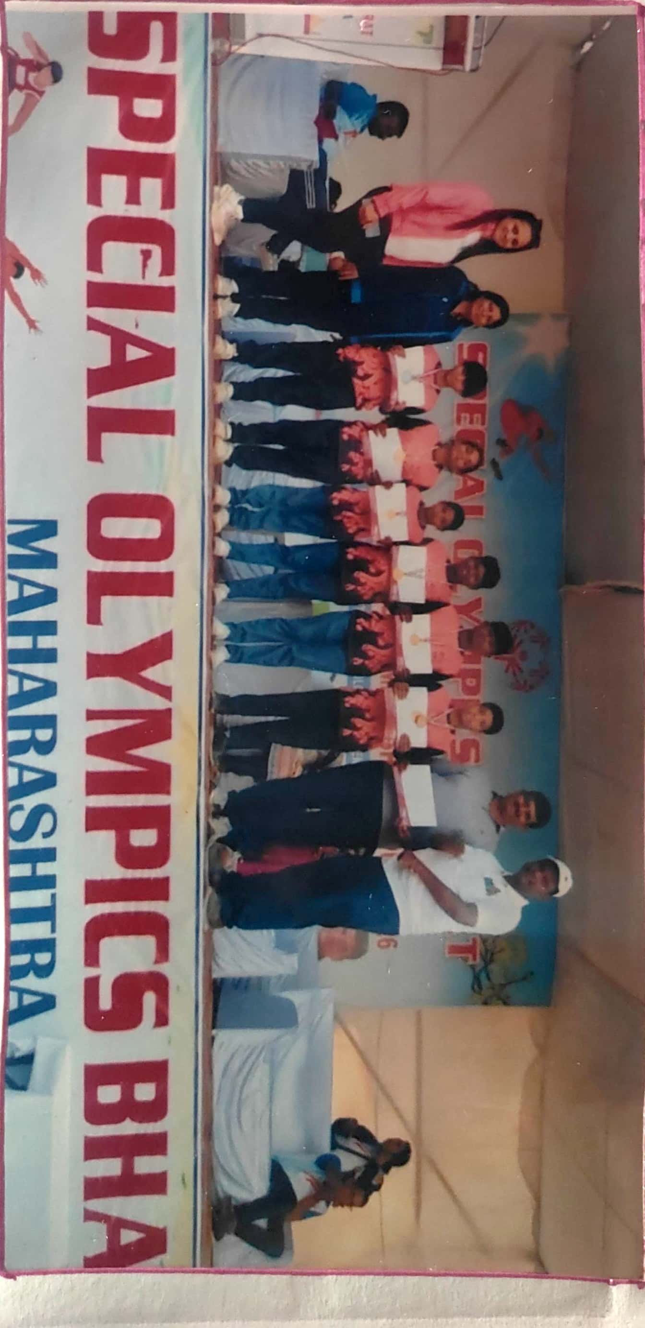
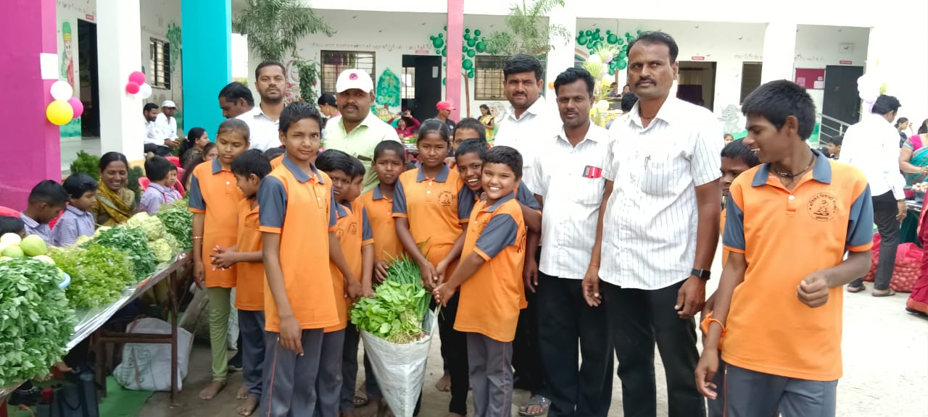

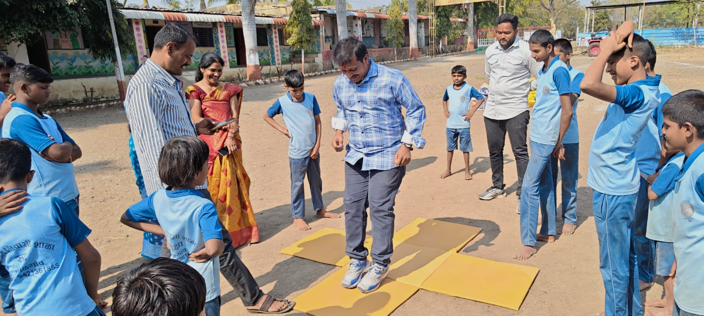
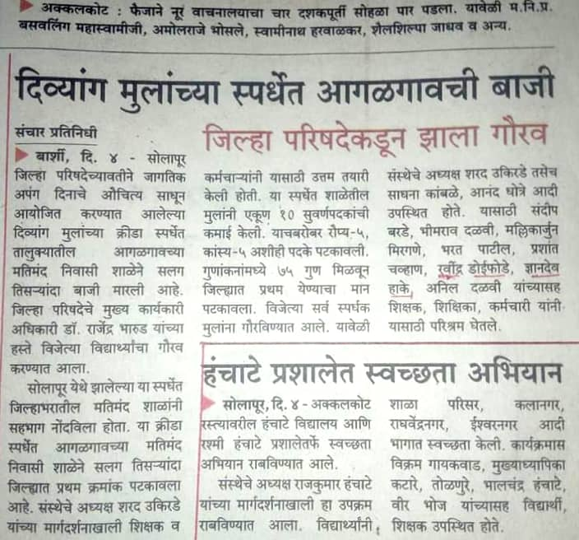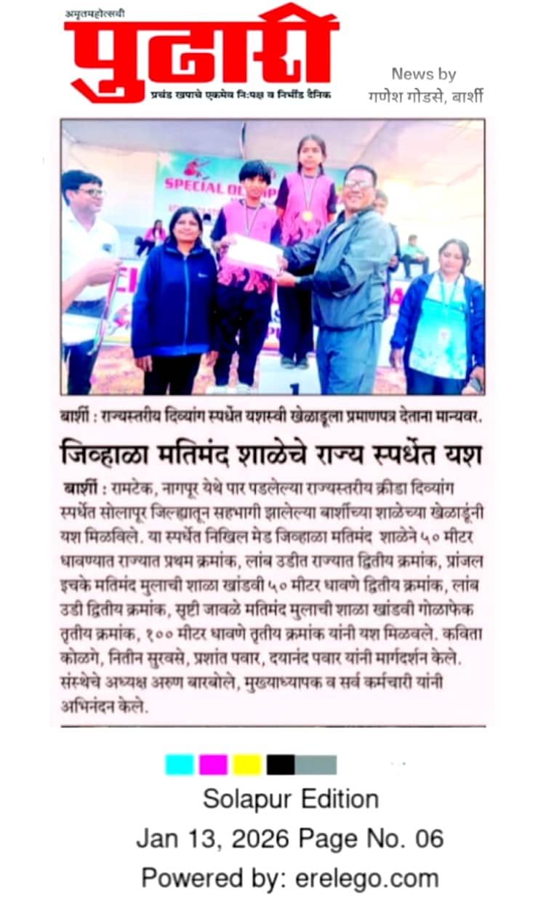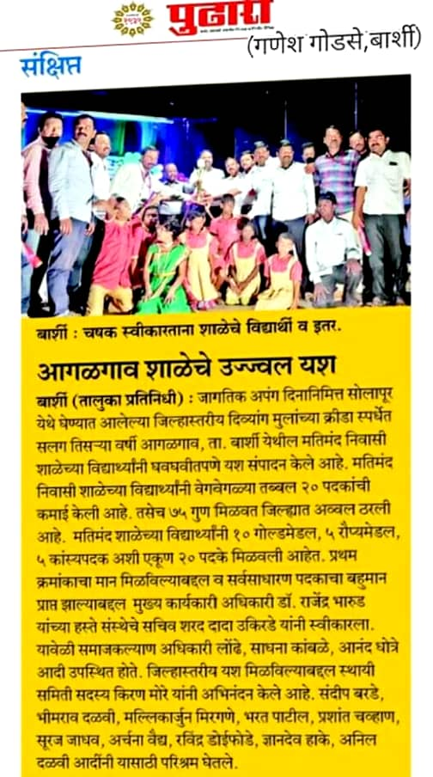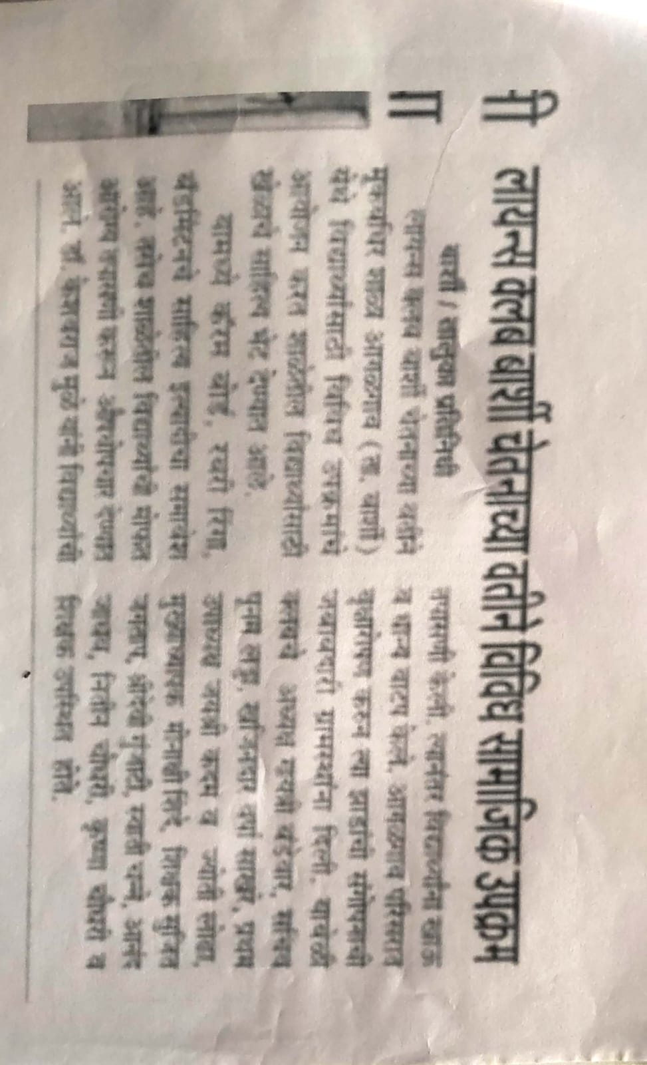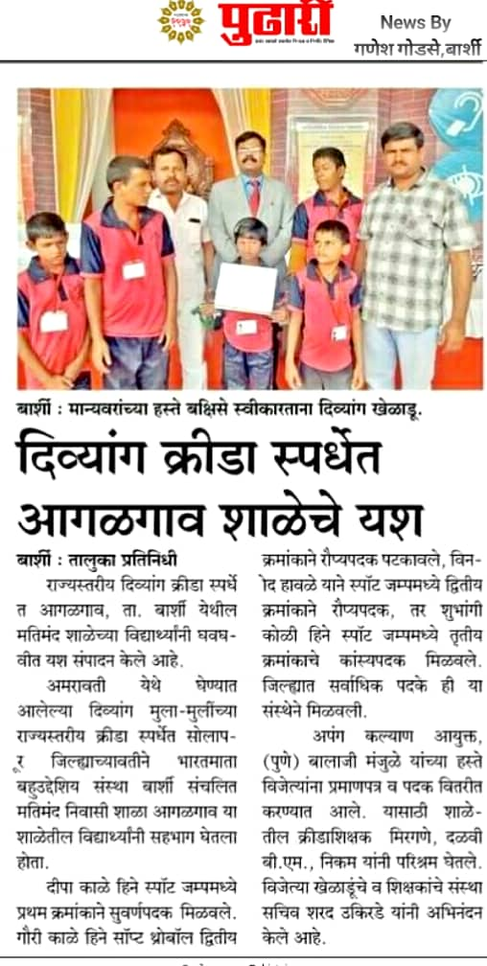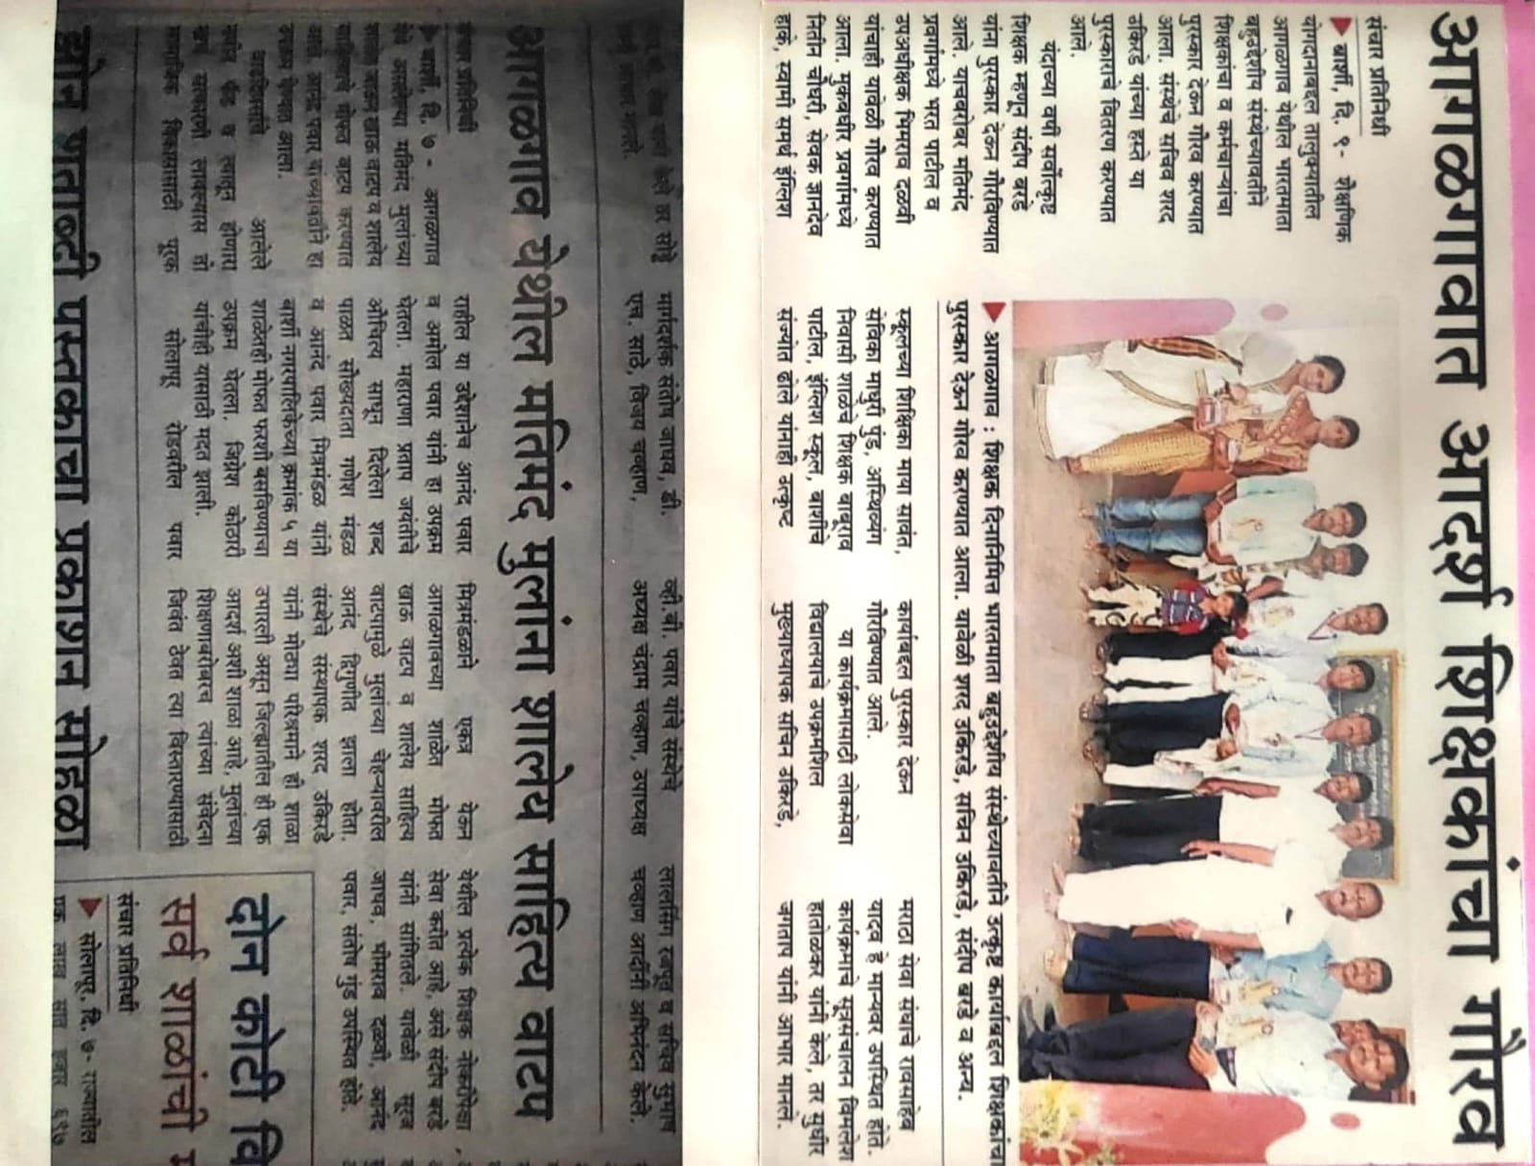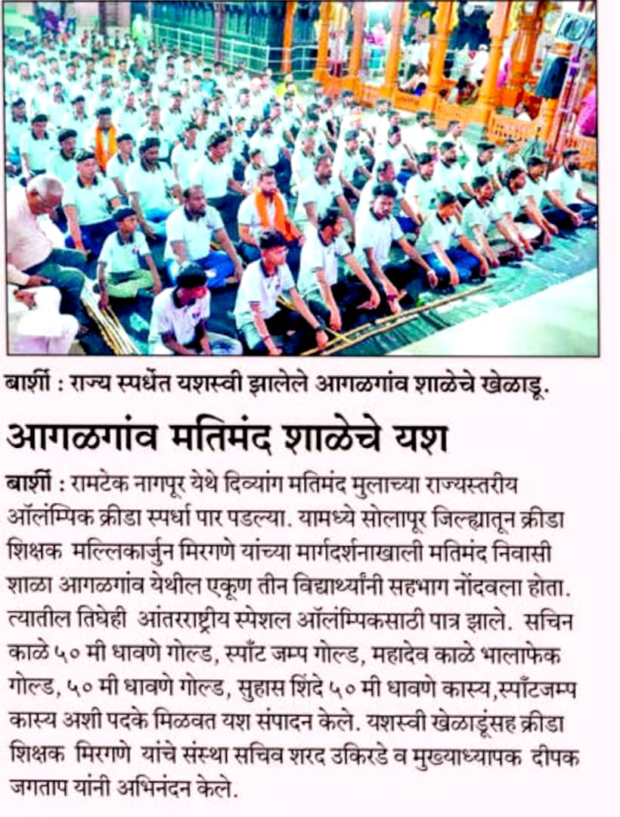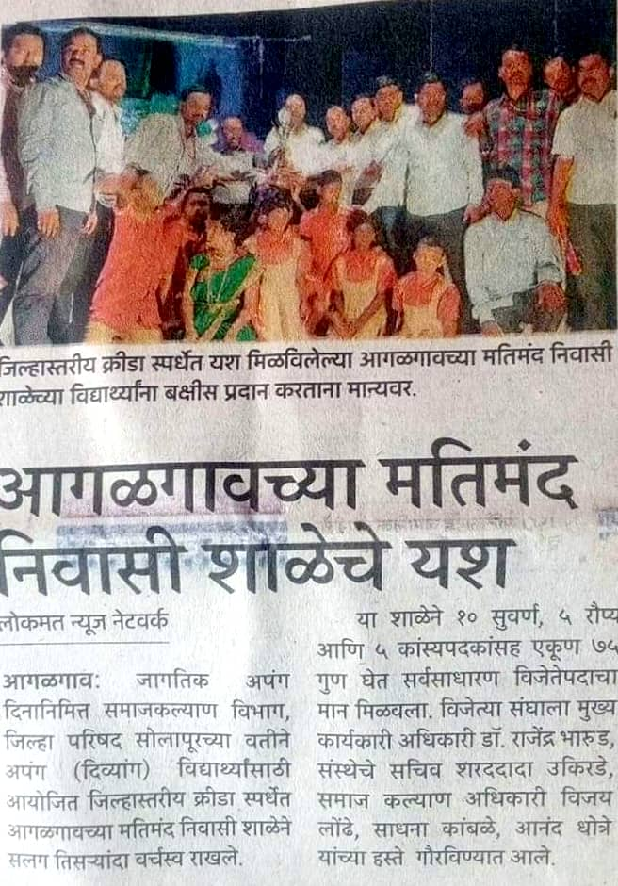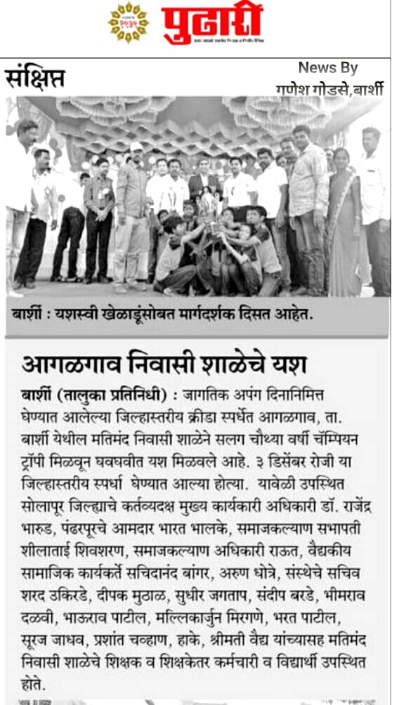
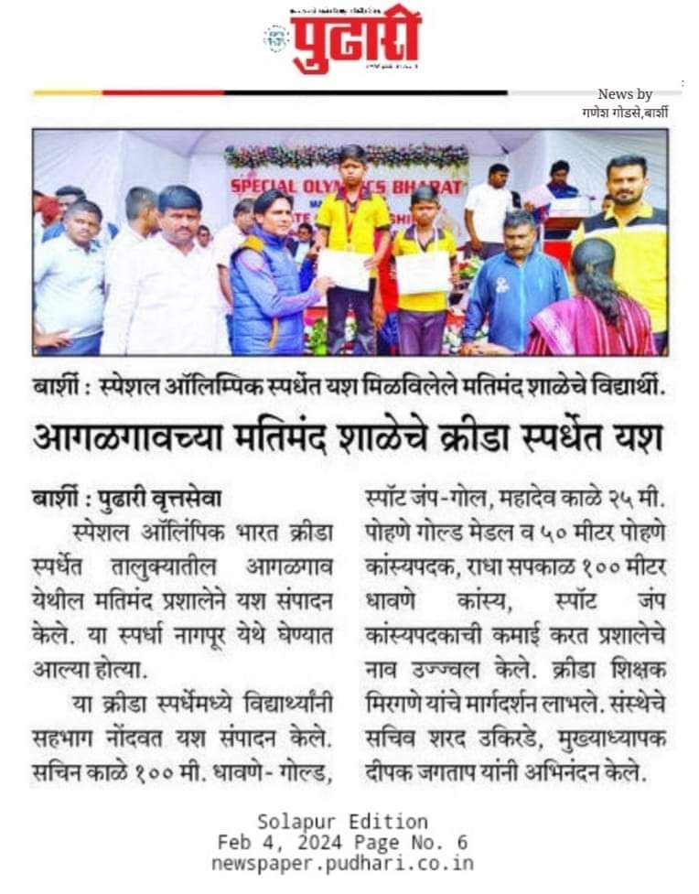
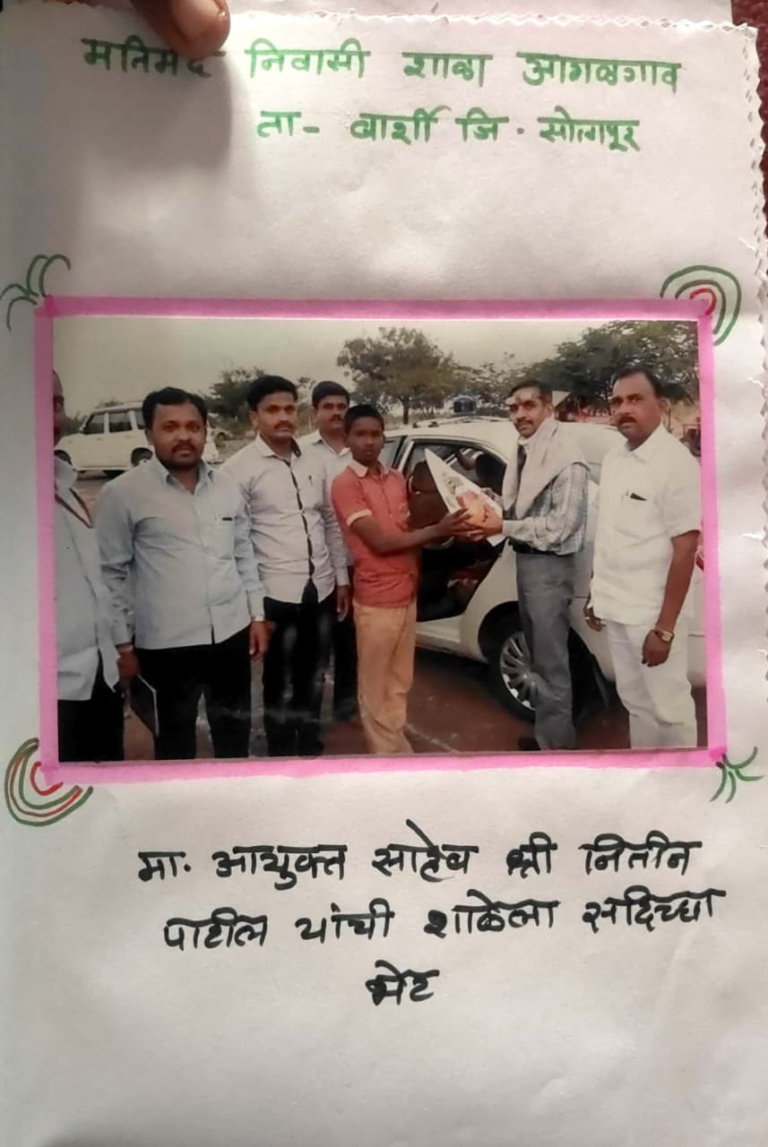
- Mukbadhir Nivasi Shala Agalgaon :- Bharatmata Bahuuddeshiya Sanstha, Barshi, established in 1993, is a special co-educational school (Grades 1-8) for hearing-impaired students. Managed by the Private Aided sector, it offers Marathi-medium instruction, a library, and a playground, located in an urban area. It provides specialized educational aids and training.
Key details regarding the institution:
Location: Agalgaon, Belgaon Road,Tal. Barshi, Solapur district, Maharashtra 413409.
Infrastructure: Rented building with 8 classrooms, electricity, and functional toilets.
Services: Focuses on educational aids, speech training, therapy, audiometry, and skill development.
Administration: The school is managed by the Indian Red Cross Society and provides services in a residential capacity.
The Bharatmata Bahuuddeshiya Sanstha, Barshi also engages in broader community service, such as conducting First Aid & CPR training workshops for professionals.
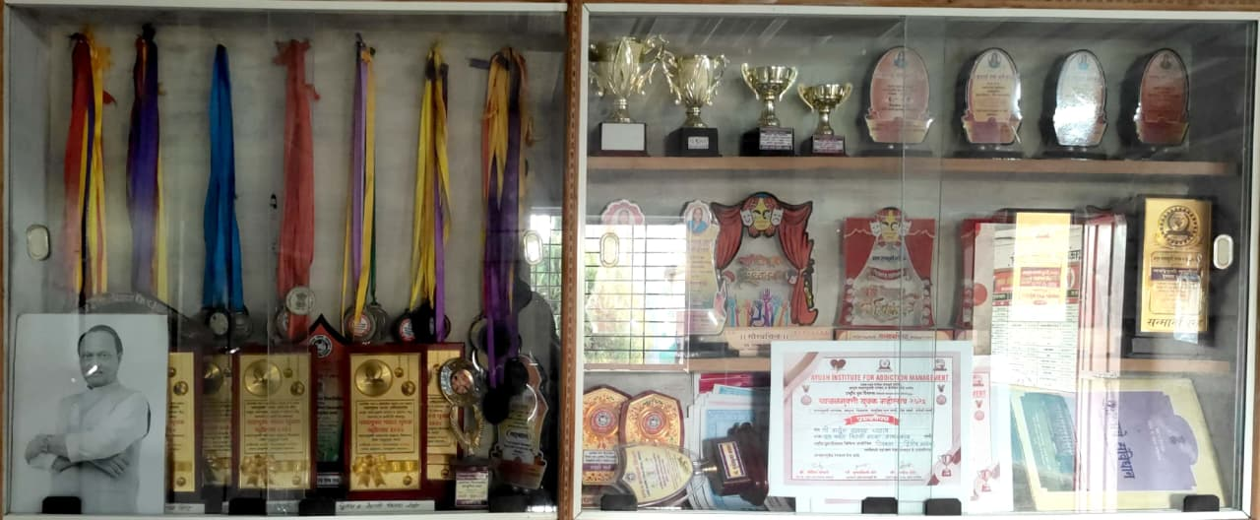
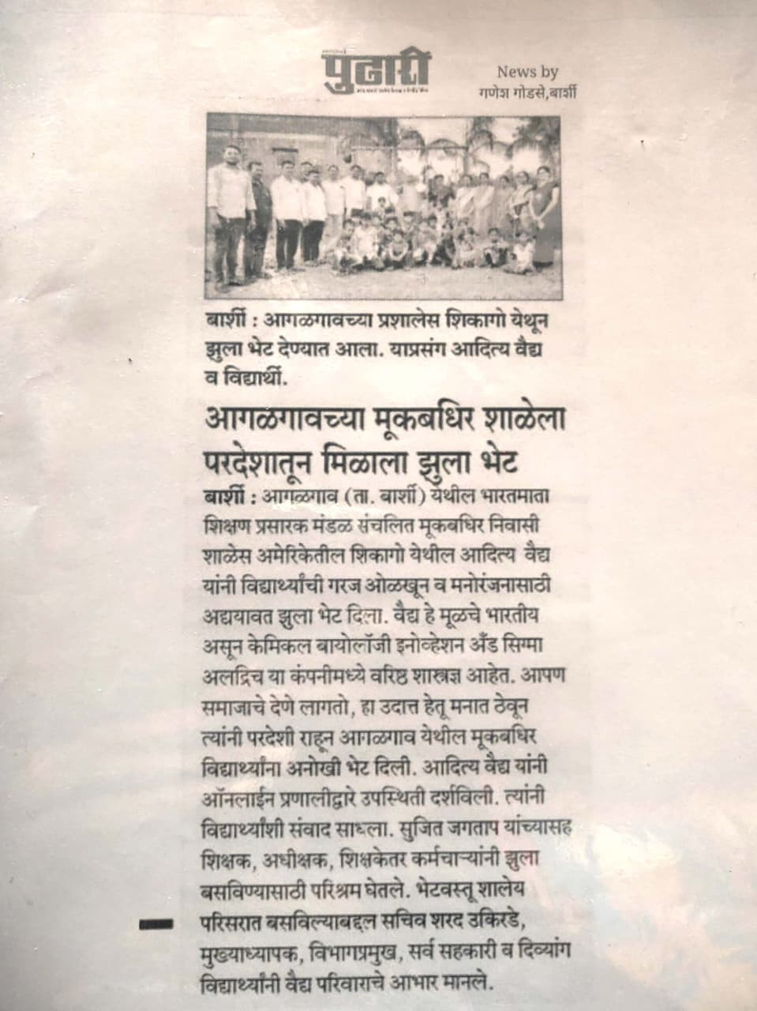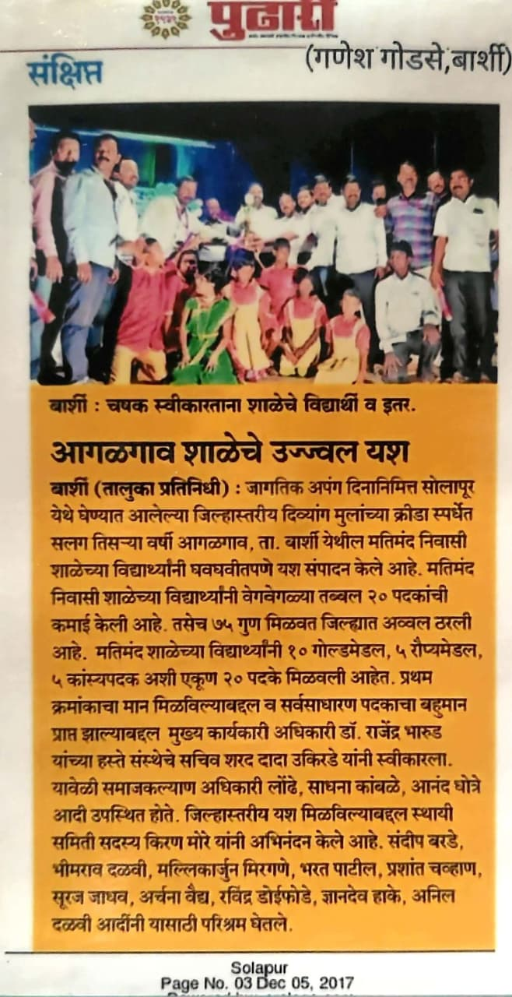
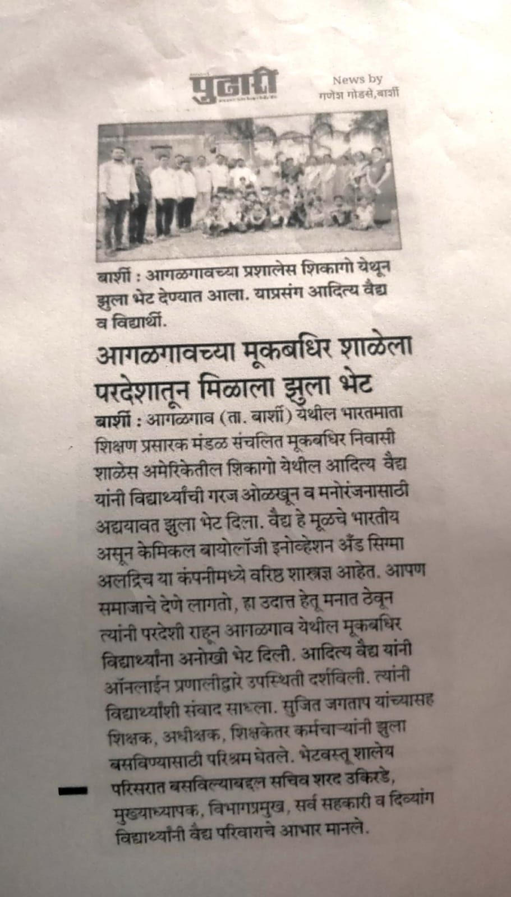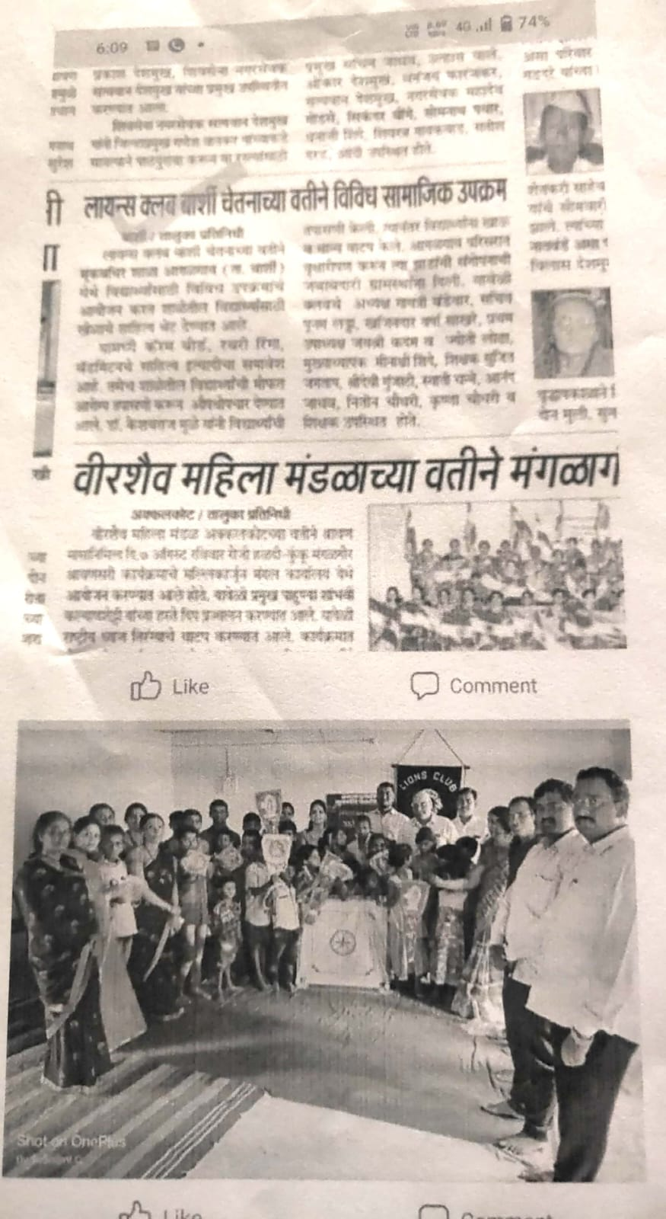
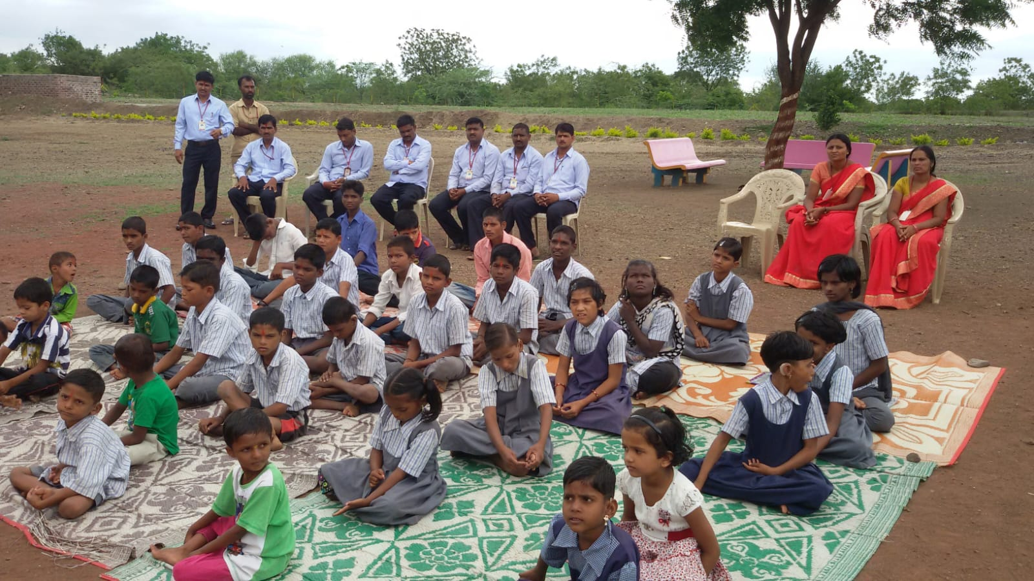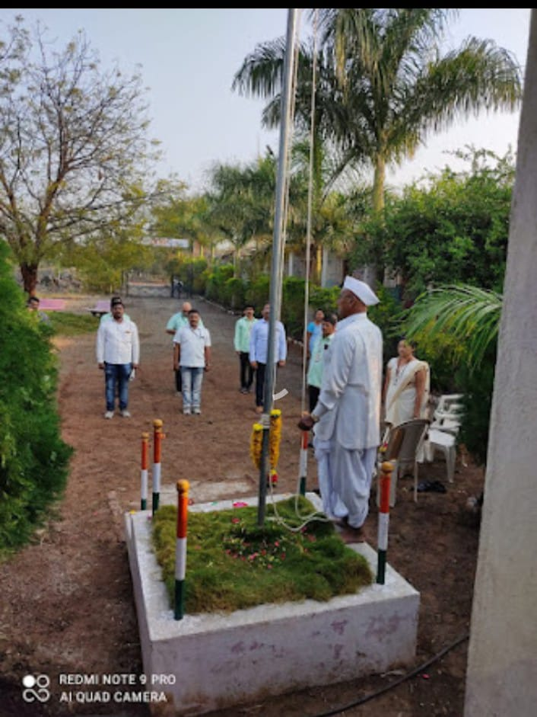
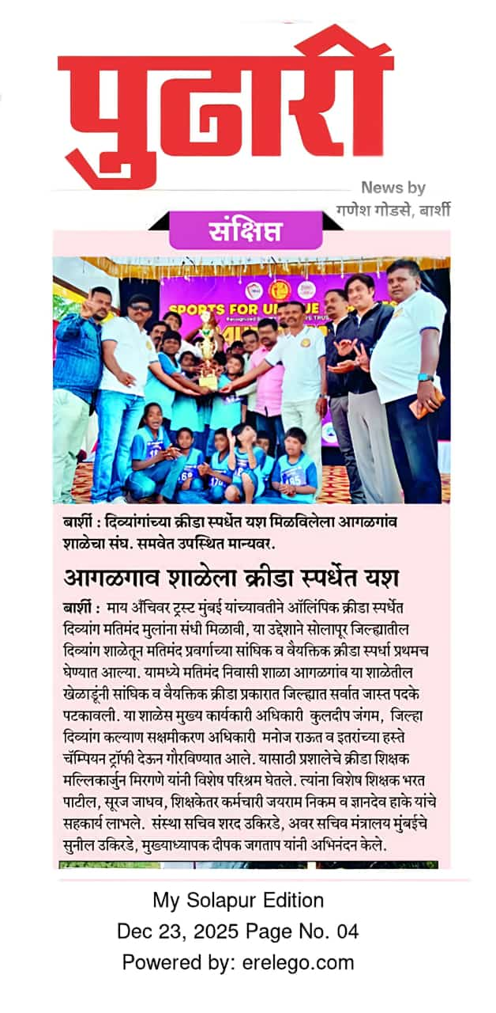

- Madhyamik Vidyalay :- it is managed by the Pvt. Aided. It is located in Rural area. It is located in BARSHI block of SOLAPUR district of Maharashtra. The school consists of Grades from 5 to 10. The school is Co-educational and it doesn't have an attached pre-primary section. The school is N/A in nature and is not using school building as a shift-school. Marathi is the medium of instructions in this school. This school is approachable by all weather road. In this school academic session starts in April.
The school has Rented building. It has got 5 classrooms for instructional purposes. All the classrooms are in good condition. It has 2 other rooms for non-teaching activities. The school has a separate room for Head master/Teacher. The school has Barbed Wire Fencing boundary wall. The school has have electric connection. The source of Drinking Water in the school is Hand Pumps and it is functional. The school has 1 boys toilet and it is functional. and 1 girls toilet and it is functional. The school has a playground. The school has a library and has 4401 books in its library. The school does not need ramp for disabled children to access classrooms. The school has 6 computers for teaching and learning purposes and all are functional. The school is not having a computer aided learning lab. The school is Provided and Prepared in School Premises providing mid-day meal.

- Swami Samarth English Medium School Barshi :- This School Of Scholars has been providing exceptional education to more than 750+ students in Barshi, Solapur, Maharashtra. Our network of 2 Units Near Barshi is committed to offering a safe and conducive learning environment that enables students to realize their full potential. SOS has emerged as one of the best CBSE School in Maharashtra by shaping young minds into confident, compassionate, and capable individuals.
Among all the good CBSE schools, SOS, part of the Meghe Group established in 2015, has been instrumental in shaping young learners' minds and empowering them to build a bright future. Our comprehensive academic curriculum is complemented by various co-curricular and extracurricular activities that support the holistic development of our students.

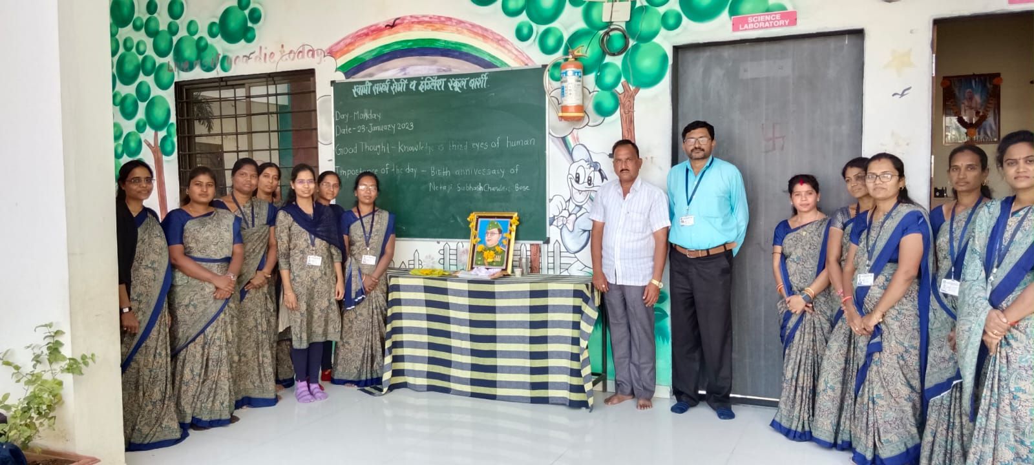

- Swami Samarth Magasvargiya Vidyarthi Vastigrah Agalgaon :- The Backward Class Student Hostel Scheme is implemented by the Government of Maharashtra through the Social Justice & Special Assistance Department. provide safe and affordable residential facilities to students from backward and socially disadvantaged communities so they can continue their education without financial hardship. Scheduled Caste (SC), VJNT (Vimukta Jati & Nomadic Tribes), SBC (Special Backward Class), OBC (Other Backward Classes), Other eligible backward categories as per government rules.
Facilities Provided - Free or subsidized accommodation, Meals (as per hostel rules), Study room facilities, Basic amenities (water, sanitation, electricity), In some cases: stipend/maintenance allowance

- Swami Samarth Magasvargiya Vidyarthi Vastigrah Barshi :- The Backward Class Student Hostel Scheme is implemented by the Government of Maharashtra through the Social Justice & Special Assistance Department. provide safe and affordable residential facilities to students from backward and socially disadvantaged communities so they can continue their education without financial hardship. Scheduled Caste (SC), VJNT (Vimukta Jati & Nomadic Tribes), SBC (Special Backward Class), OBC (Other Backward Classes), Other eligible backward categories as per government rules.
Facilities Provided - Free or subsidized accommodation, Meals (as per hostel rules), Study room facilities, Basic amenities (water, sanitation, electricity), In some cases: stipend/maintenance allowance

- Swami Samarth English Medium School Agalgaon :- SWAMI SAMARTH ENGLISH MEDIUM SCHOOL, AGALGOAN was established in 2014 and it is managed by the Pvt. Unaided. It is located in Rural area. It is located in BARSHI block of SOLAPUR district of Maharashtra. The school consists of Grades from 1 to 2. The school is Co-educational and it have an attached pre-primary section. The school is N/A in nature and is not using school building as a shift-school. English is the medium of instructions in this school. This school is approachable by all weather road. In this school academic session starts in April.
The school has Rented building. It has got 8 classrooms for instructional purposes. All the classrooms are in good condition. It has 2 other rooms for non-teaching activities. The school has a separate room for Head master/Teacher. The school has Barbed Wire Fencing boundary wall. The school has have electric connection. The source of Drinking Water in the school is None and it is functional. The school has 2 boys toilet and it is functional. and 2 girls toilet and it is functional. The school has a playground. The school has no library and has 0 books in its library. The school does not need ramp for disabled children to access classrooms. The school has 9 computers for teaching and learning purposes and all are functional. The school is not having a computer aided learning lab. The school is Not Applicable providing mid-day meal.
Web :- https://schools.org.in/solapur/27300200110/swami-samarth-english-medium-school-agalgoan.html

- Swami Samarth Balkashram /Balsangopan Kendra Barshi :- Child Care Institution (Balakashram) In Barshi, a Balakashram (बालकाश्रम) is officially known as a Child Care Institution (CCI). These institutions provide care, protection, education, and rehabilitation to children who are in need of care and protection.
Balakashrams in Maharashtra function under : Juvenile Justice (Care and Protection of Children) Act, 2015
Women and Child Development Department
Guidelines of the Central Adoption Resource Authority (for adoption-related institutions)
Children admitted in Balakashram include:
Orphan children, Abandoned children, Children of single parents unable to care, Street children, Children rescued from child labor, abuse, trafficking, Children in conflict with law (in separate observation homes)
Generally 0 to 18 years Child Care Institutions in Maharashtra
Balakashrams provide Safe shelter and accommodation
Nutritious food, Formal education (schooling), Medical care, Psychological counseling, Vocational training, Sports and recreational activities, Rehabilitation and family restoration
- Swami Samarth Nursing School :- ANM (Auxiliary Nurse Midwife) is a diploma-level nursing course focused on basic healthcare services, community health, maternal and child care. It prepares students to work as frontline healthcare providers in rural and urban health settings Usually Course Duration is 2 years including classroom study + clinical training/internship. Provide basic nursing care, Support maternal and child health services, Work in Primary Health Centres (PHCs) and community health units, Assist in health education, immunization, and first-aid care.
10+2 Passed (High School) from a recognised board. Science stream with Biology is preferred, but Arts/any stream is also accepted in Our colleges.

10. Swami Samarth Semi-English School :- Swami Samarth Semi English School in Barshi (Irle/Agalgaon area), Solapur, is a Co-educational state board school (Grades 1-12) offering, education in English, Marathi, and Hindi. It provides facilities including 8 classrooms, 9 computers, and a playground. The school is noted for having good teachers and a positive environment.
Key Details for Swami Samarth School (Barshi/Agalgaon):
Location: Irle area/Agalgaon, Barshi, Solapur, Maharashtra.
Medium: English.
Board: State Board.
Classes: 1 to 12.
Infrastructure: The school has a playground, 8 classrooms, and 9 functional computers.
Contact Information: Often found +919356001343 listed with local contact.

