Wind Turbine Predictive Maintenance Platform
Technical Briefing for Domain Experts (O&M / Reliability Engineering)

————————————————————

Prepared by: Data Engineering & Data Science Team
Date: 2026-09-08
Audience: Wind Turbine Domain Experts / O&M Engineers
Classification: Internal

In This Briefing
- Purpose, scope, and the real dataset this platform is built and validated against
- The fault taxonomy - derived from real maintenance logs, not assumed
- Detection methodology and physical rationale per asset, with real evidence charts
- The machine learning approach: classification, RUL, and trend forecasting
- Validation, data quality, and honest limitations
- How this complements existing SCADA alarms and CMMS workflows

1. Purpose, Scope & the Real Dataset
This platform turns 10-minute SCADA averages - the same data class most turbines already produce - into three outputs per component: fault classification (which component, which failure mode), Remaining Useful Life (RUL) estimation, and health trend forecasting. Target components today: Gearbox, Hydraulics, Pitch System, Generator, Transformer, Rotor Brake, and Bearing (via vibration analysis). The method is designed to extend to further components (Yaw, Converter, PLC/communications) as more labeled failure history becomes available.
It was built and validated against the public wind-turbine SCADA benchmark dataset - three real wind farms, not synthetic data:
Farm | Type | Turbines | Sensors/file | Total rows | Anomaly / Normal events
A | Onshore, Portugal (EDP) | 5 | 86 | 1,196,747 | 11 / 11
B | Offshore, Germany (anonymized) | 9 | 257 | 859,065 | 6 / 9
C | Offshore, Germany (anonymized) | 22 | 957 | 3,187,136 | 27 / 31
Total | - | 36 | - | 5,242,948 | 44 / 51

NOTE Farm C is offshore with 3-axis independent pitch control, full hydraulics, and water cooling - by far the richest instrumentation of the three, which is why most of the evidence charts in §3 are drawn from it. Farm B's sensor names are anonymized (sensor_N) in all three farms, but sensor *descriptions* remain meaningful - all component matching in this platform is done against the description text, never the raw column name.

2. Fault Taxonomy Derived From Real Maintenance Logs
Rather than assume a generic failure-mode list, all 44 real anomaly events' free-text maintenance descriptions were keyword-classified into component categories (English + German, since Farm B/C's operators write in both). Full category list, fleet-wide:
Category | Count
Hydraulics | 8
Other / unclassified | 8
Pitch / blade angle | 8
Gearbox | 5
PLC / communication / wiring | 4
Bearing | 3
Transformer | 2
Generator | 2
Converter | 2
Rotor brake | 1
Yaw | 1

HONEST FINDING Farm B splits cleanly into two real issue modes: 3 of its 6 anomaly events are genuine main/rotor bearing failures ("Rotor Bearing 2 - Damage", main-bearing standstill), now captured by the Bearing category specifically because Farm B carries real vibration sensors (see §3) that let this taxonomy extend to cover them (see the Bearing subsection of §3 for the evidence). The remaining 3 ("high temperature" x3) stay in "Other/unclassified" - generic alarms with no component-specific keyword to match, a real finding about this farm's maintenance-log detail level, not a taxonomy gap.

3. Detection Methodology & Physical Rationale per Asset
Detection never relies on a single reading. Rolling 1h/6h/24h mean AND standard deviation are computed per sensor group (a component running unusually smoothly, or unusually erratically, is as meaningful a signal as an absolute value shift). Sensors are resolved per farm by keyword-matching each farm's own feature_description.csv, not by fixed column name - the same method that already reconciles Farm A/B/C's completely incompatible schemas (86 / 257 / 957 columns).

Gearbox
Sensors used: oil temperature, oil pressure, high-speed-shaft bearing temperature
A gearbox converts low-speed, high-torque rotor motion to high-speed generator input through meshing gears under constant load. Wear, misalignment, or oil breakdown show up first as friction (heat) and lubrication irregularity (pressure), before a gear tooth actually breaks.
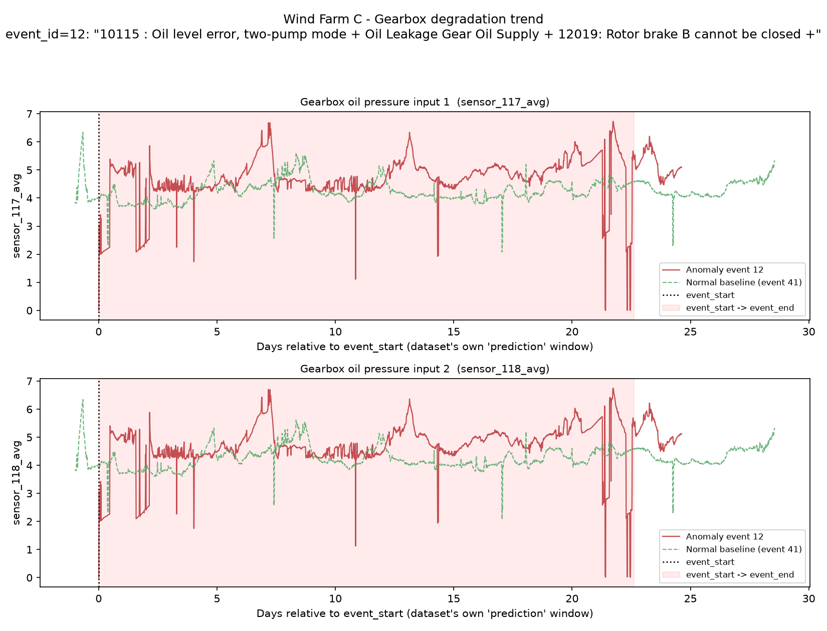
Wind Farm C, event 12 ("Oil level error, two-pump mode + Oil Leakage Gear Oil Supply...") - gearbox oil pressure.
Oil pressure runs at a visibly higher and far more erratic level (frequent sharp drop-outs) than the baseline's low-noise band across the entire ~23-day window - consistent with the "two-pump mode"/"oil leakage" wording in the real event description. The erratic-pressure signature, not just an average shift, is why rolling standard deviation is tracked alongside rolling mean.

Hydraulics
Sensors used: hydraulic oil tank temperature, oil level, pump pressure
The hydraulic system actuates pitch and braking. A leak, failing pump, or degrading accumulator makes the pump work harder and/or lose pressure, showing up as sustained elevated oil temperature or abnormal pressure well before the system fails to actuate.
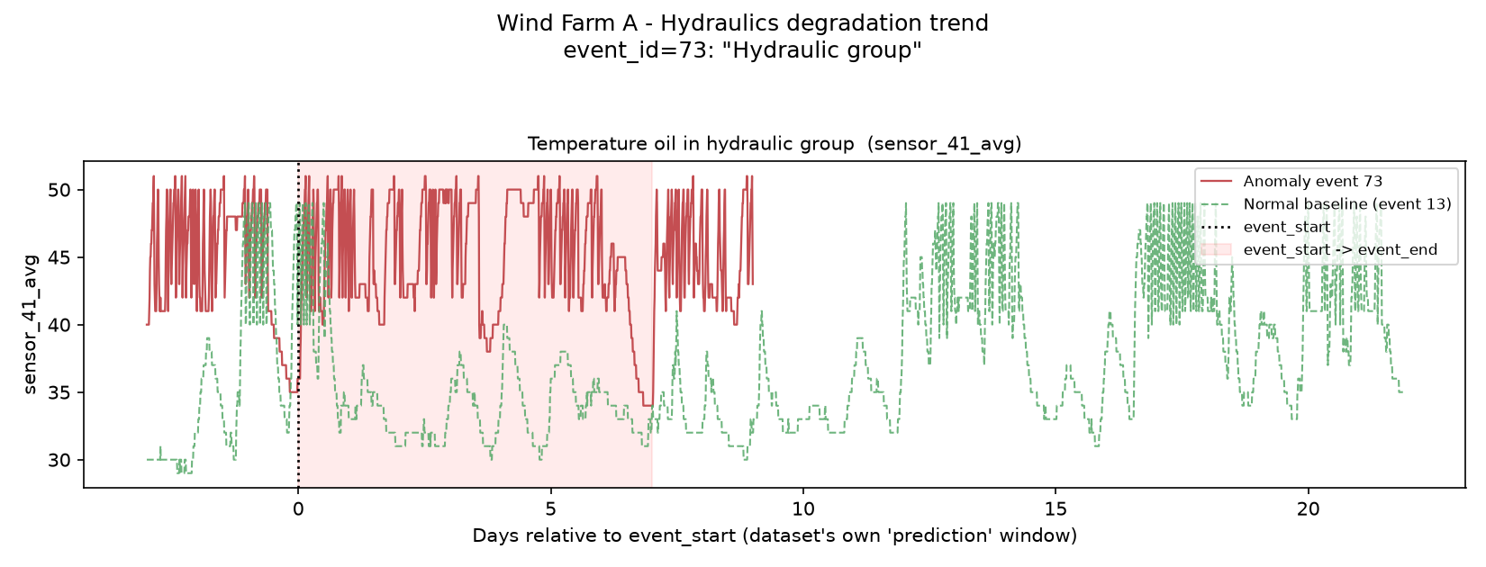
Wind Farm A, event 73 ("Hydraulic group") - hydraulic oil temperature.
The cleanest signal found in the entire EDA: oil temperature sits persistently ~10-15°C above the normal baseline for the entire pre-fault window shown, not just near event_start - a stable, early, sustained offset rather than a last-minute spike.

Pitch System
Sensors used: per-axis pitch motor temperature, axis cooling-element temperature, pitch angle
Each blade's pitch axis has its own motor, encoder, and (in Farm C's 3-axis independent design) its own cooling and control electronics. A failing axis motor or control card draws abnormal current and runs hot well before the axis stops responding ("not-ready-to-operate").
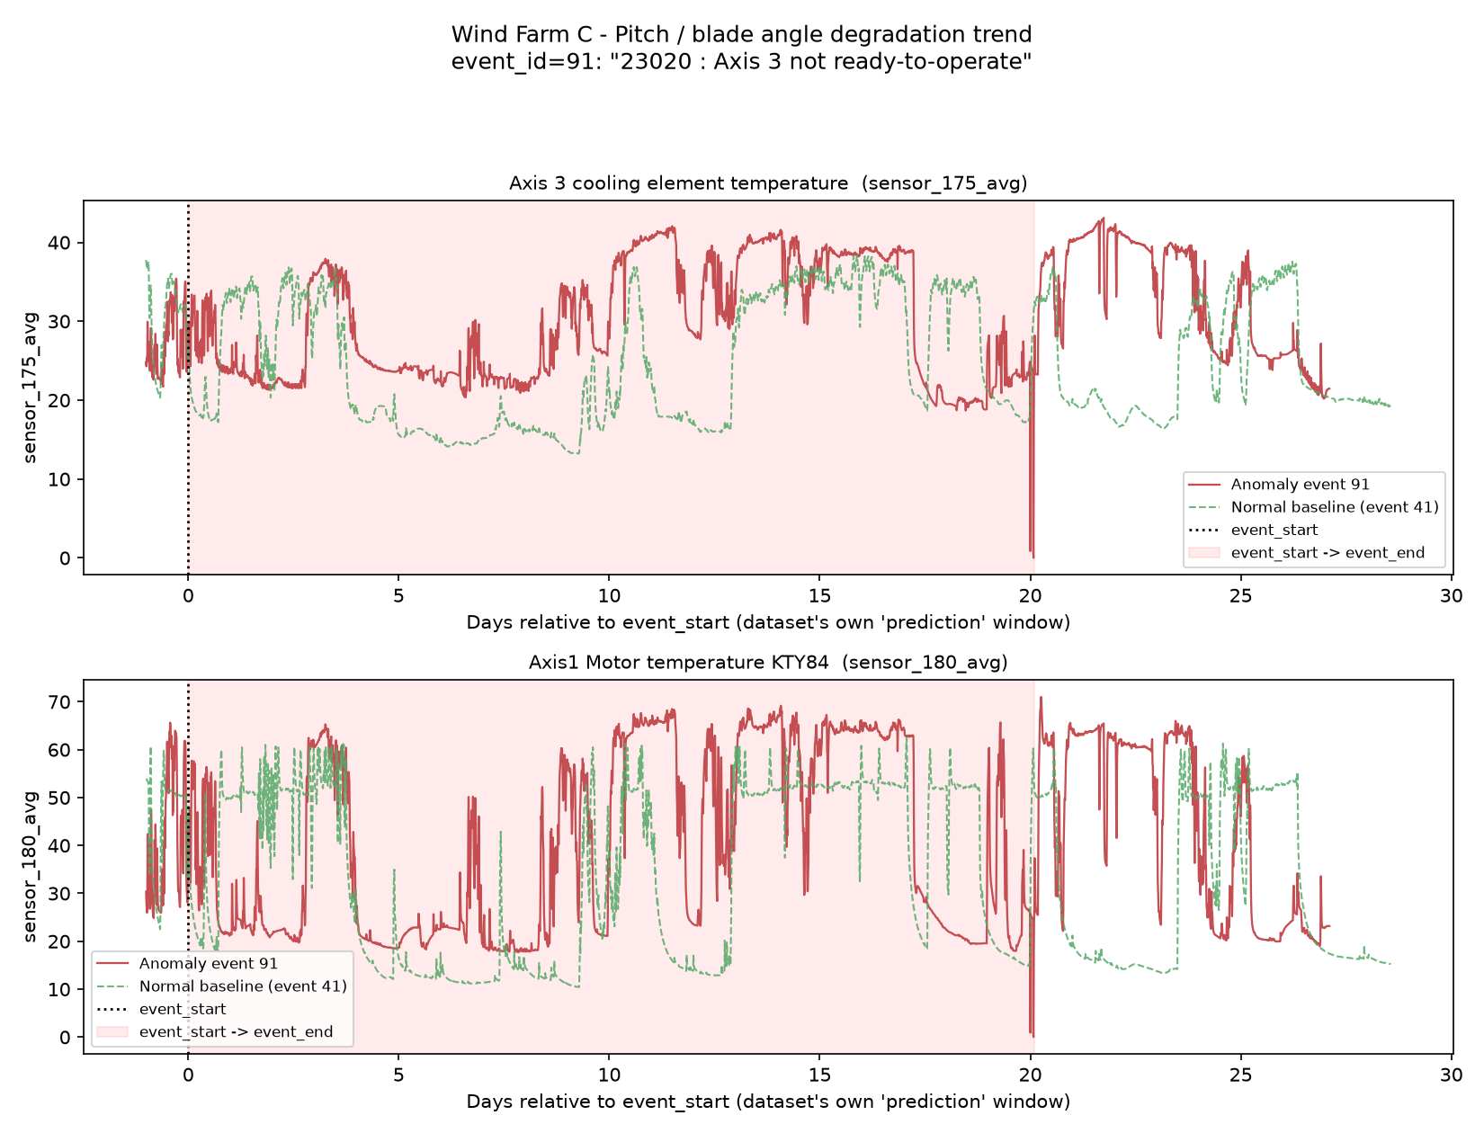
Wind Farm C, event 91 ("23020 : Axis 3 not ready-to-operate") - Axis 3 cooling element and Axis 1 motor temperature.
The rule-based sensor pick (no hand-curation) landed on Axis 3's own cooling temperature - the exact axis named in the real fault text - running ~5-10°C above baseline for most of the pre-fault window. Axis 1 motor temperature shows a similar sustained elevation, pointing to a genuine multi-day thermal precursor rather than an instantaneous trip.

Generator
Sensors used: Drive-End / Non-Drive-End bearing temperature, stator winding temperature, cooling-air-inlet temperature
Generator bearings and windings are what actually wear/degrade under continuous rotation and electrical load; bearing wear raises friction (temperature), winding insulation breakdown raises electrical resistance (also temperature).
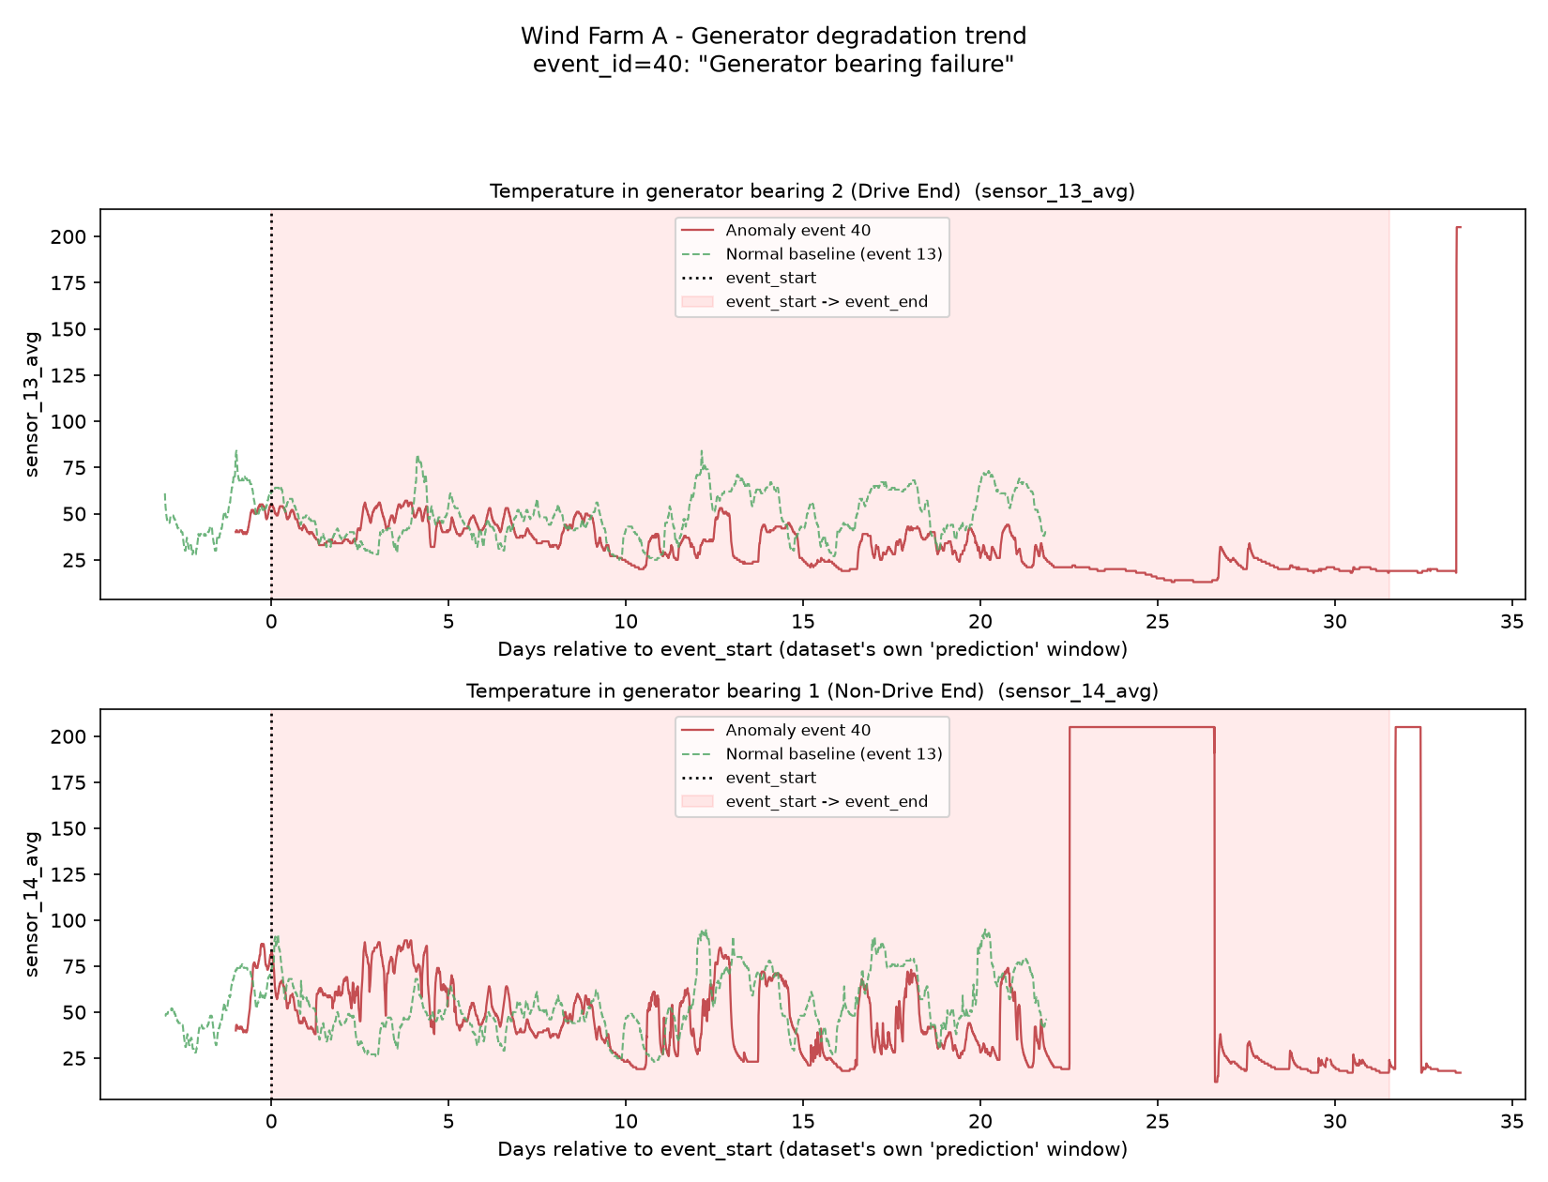
Wind Farm A, event 40 ("Generator bearing failure") - Drive-End / Non-Drive-End bearing temperature.
The one case in this whole analysis where the anomaly runs cooler and less variable than baseline for most of the window - read together with the fault, more consistent with the turbine already being throttled back (derated) in response to an early symptom than with unchecked overheating.
CAVEAT The Non-Drive-End sensor is pinned at a flat ~204 for extended stretches late in the window - almost certainly a sensor fault/dropout code, not a real physical reading. A production feature pipeline needs an explicit implausible-value filter (per-sensor plausible range from feature_description.csv's unit field), not just a missingness check - a stuck-at-a-constant value is not "missing" and will silently corrupt a rolling mean/std feature if untreated.

Transformer
Sensors used: per-phase or per-unit oil/winding temperature (granularity differs by farm)
Transformer oil is both the coolant and the electrical insulator; insulation degradation and internal electrical faults manifest as abnormal, sustained temperature rise or abnormal thermal cycling, since oil temperature directly tracks internal heat generation.
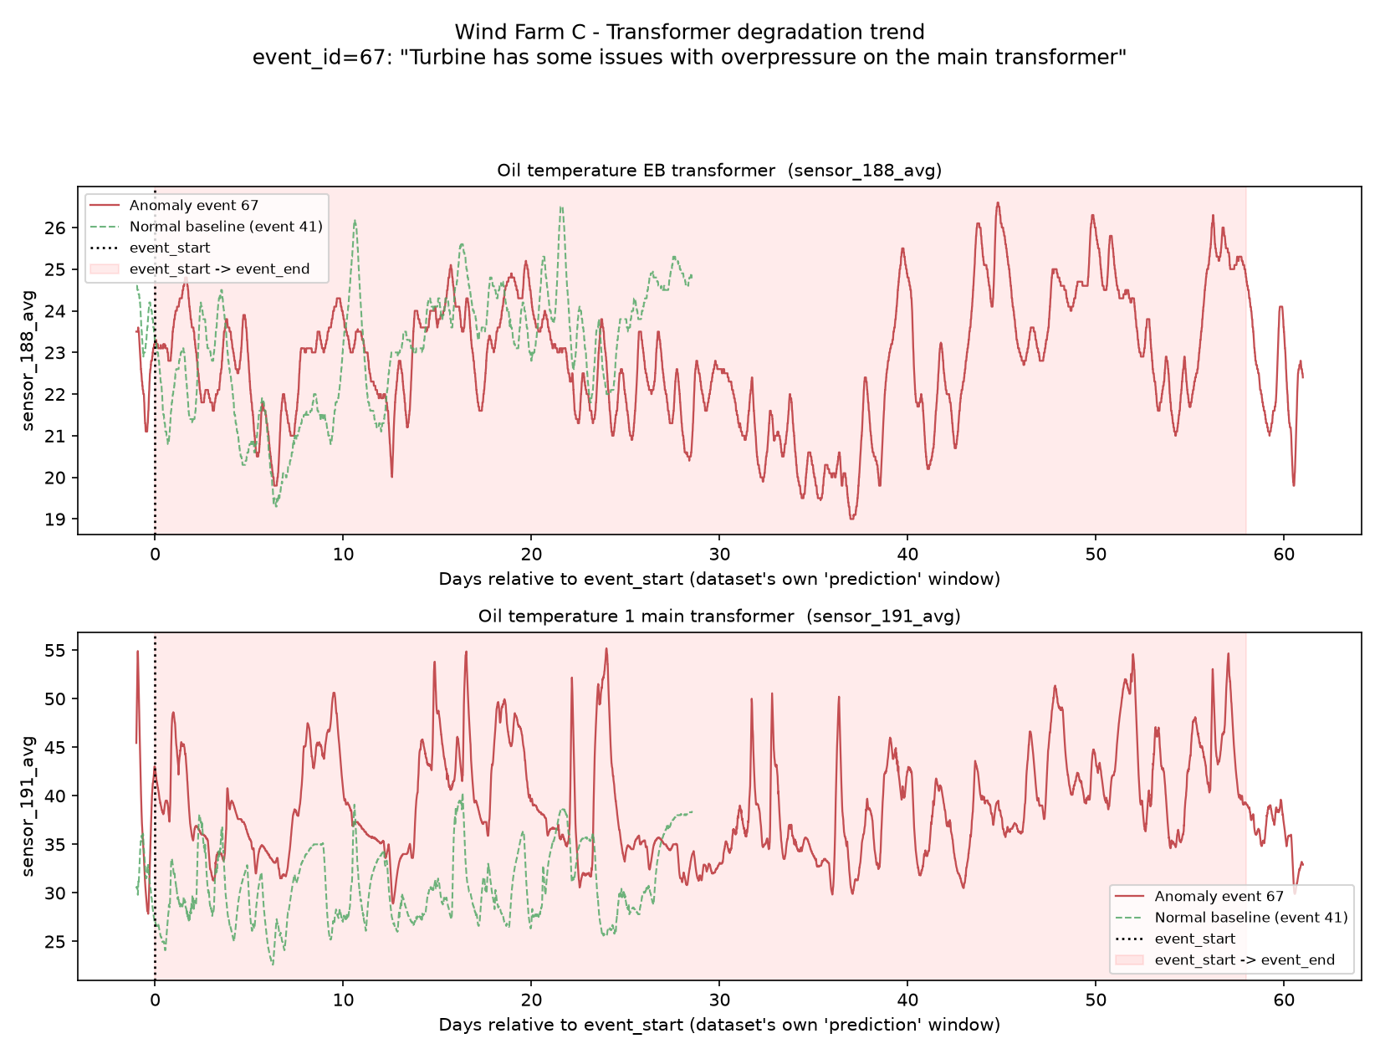
Wind Farm C, event 67 ("overpressure on the main transformer") - main transformer oil temperature.
One of the longest, cleanest early-warning offsets in the whole dataset: oil temperature runs a sustained ~10-15°C above baseline for essentially the entire ~58-day window. Note: of the two oil sensors profiled for this event, only this one is discriminative - the other ("EB transformer", a different bank) tracks the baseline closely and would be down-weighted in a production feature set. Separately, Farm A's transformer-failure event (68) shows a different precursor pattern worth knowing: reduced day/night thermal cycling during the officially logged window, then a clear thermal-runaway climb in the week immediately after the logged window ends - evidence that cycling pattern, not just absolute temperature, carries signal, and that monitoring should not stop the moment an official event window closes.

Rotor Brake
Sensors used: hydraulic brake-caliper pressure (per-caliper)
The rotor brake is hydraulically actuated. Anything disrupting its hydraulic supply or control power causes pressure to run low or erratic rather than holding its normal regulated band, before the brake fails to engage/disengage on command.
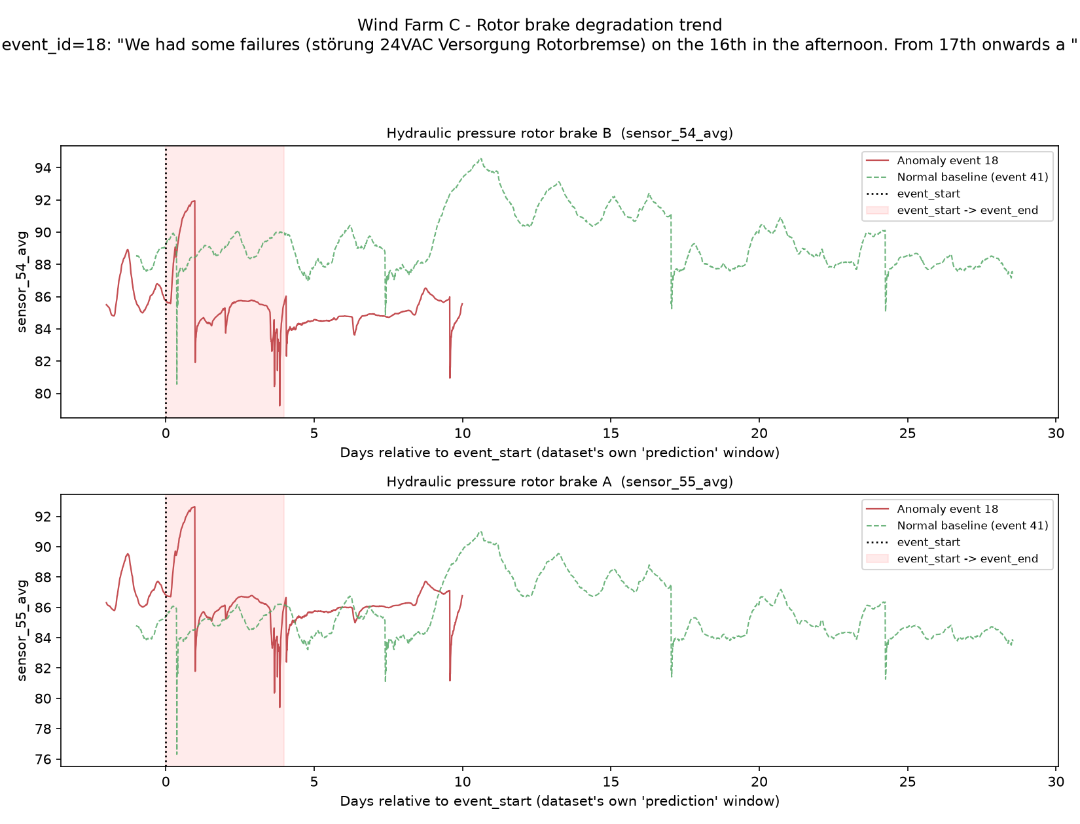
Wind Farm C, event 18 ("24VAC supply fault to rotor brake, then extended standstill") - brake caliper A/B hydraulic pressure.
Both calipers run persistently lower than baseline across the ~10 days of available pre-fault data, with sharp transient dips layered on top - consistent with a control/power-supply fault causing degraded pressure regulation rather than a single instantaneous mechanical break.
CAVEAT Rotor-brake instrumentation exists only in Farm C - Farm A and B have no rotor-brake-specific sensor at all (confirmed by manual inspection of both farms' feature_description.csv, not a matching failure). This model is necessarily Farm-C-only until other farms add the instrumentation.

Bearing (Vibration Analysis)
Sensors used: broadband vibration amplitude - drive-train/tower accelerometers (Farm B, mG), nacelle accelerometers (Farm C, m/s²)
This is the one component detected by a fundamentally different physical signal than every other asset above - motion/acceleration, not temperature or pressure. Bearing wear, imbalance, and looseness increase overall mechanical vibration energy transmitted through the structure; broadband vibration monitoring against a normal baseline is a decades-old, industry-standard condition-monitoring technique for rotating machinery (the same principle behind ISO 10816/20816 vibration severity zones), independent of knowing the exact fault mechanism.
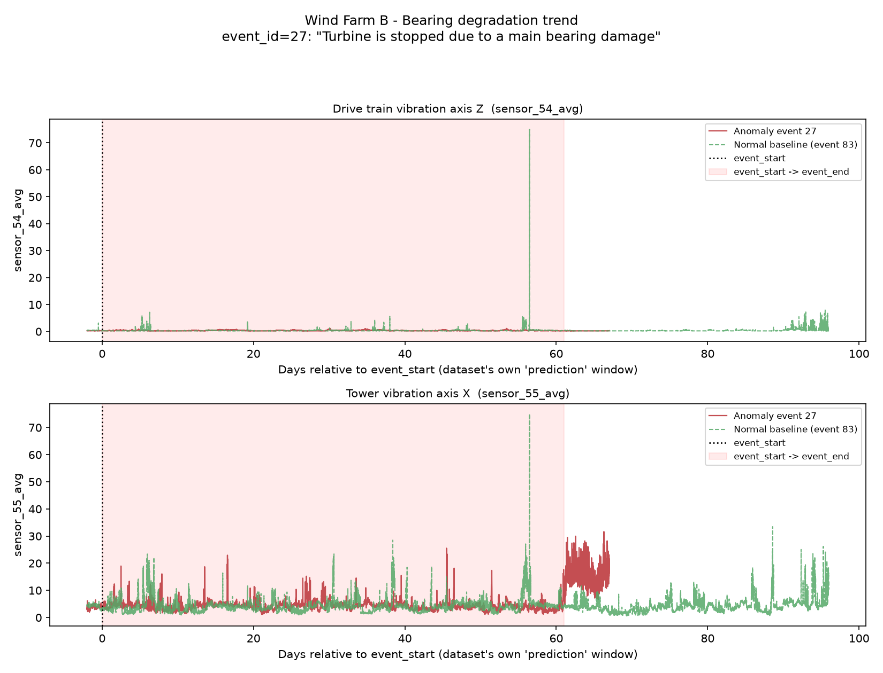
Wind Farm B, event 27 ("Turbine is stopped due to a main bearing damage") - drive-train (axis Z) and tower (axis X) vibration.
An honest mixed result, not a clean win. Drive-train vibration shows no usable separation from baseline through the pre-fault window - both series sit near zero with matching transient spikes. Tower vibration is more useful but tells a different story than the cleanest charts above: during the ~61-day labeled event window itself it overlaps the baseline's noisy range closely - no early separation. The clear signal instead appears in the week immediately after the labeled window closes, where the anomaly turbine shows a sustained, densely-elevated vibration band while the baseline stays low over the same relative period - plausibly abnormal coast-down/restart dynamics from a damaged bearing, not a multi-week advance-warning precursor the way hydraulics and transformer showed above.
CAVEAT This dataset's vibration sensors are 10-minute statistical aggregates (avg/max/min/std of overall amplitude), not raw high-frequency waveform data. A production bearing/gearbox CMS typically samples accelerometers in the kHz range and applies FFT spectral analysis to isolate characteristic fault frequencies (ball-pass frequencies outer/inner race, cage/roller frequencies, gear-mesh frequency and sidebands) to identify which specific defect mode is present. This platform's vibration component supports broadband severity trending only - spectral fault-mode diagnosis would require raw-waveform capture this dataset does not contain, a documented v2 extension.

4. Machine Learning Approach
Problem | Approach | Rationale
Fault classification | Multi-class LightGBM per component, trained on rolling Gold-layer features, MLflow-tracked (macro-F1) | Gradient-boosted trees handle the mixed numeric feature set well and train fast enough to retrain per-component as new labeled events accumulate.
RUL estimation | LightGBM quantile regression, P10/P50/P90 hours-to-failure | A single point estimate is misleading for maintenance scheduling; the uncertainty band is shown in the dashboard alongside the P50, always.
Trend forecasting | Classical (statsmodels ETS) per-asset health index, not deep learning | Deliberately classical-first: only ~44 labeled anomaly events exist fleet-wide - nowhere near enough to trust a deep sequence model's extrapolation. Noted as a v2 upgrade path once more history accumulates.

Feature engineering resolves each component's relevant sensors per farm via keyword match against that farm's feature_description.csv description column (not the anonymized sensor_name) - the same mechanism used for the taxonomy in §2 and the evidence charts in §3. RUL labels are computed as hours from each pre-event row back to that event's event_start, capped at a 720-hour (30-day) look-back horizon and deduplicated to the nearest upcoming anomaly event per row.

5. Validation, Data Quality & Honest Limitations
Data quality is genuinely strong across all three farms:
Farm | Columns | Always populated | Sparse (>5% missing) columns
A | 86 | 84/86 always populated | 0
B | 257 | 255/257 always populated | 0
C | 957 | 121/957 always populated | 0

Farm C's large "mostly populated" bucket (836 of 957 columns) is an artifact of the 5% bucketing threshold catching sub-0.02% gaps, not a real quality problem - the actual missing rate across every one of those columns tops out at 0.0136%.
LIMITATION The "derated/idle-to-downtime lead time" KPI is only computable for 2/44 anomaly events fleet-wide - Farm A and Farm C never emit status_type_id 1 (derated) or 2 (idling) at all; only Farm B does, and even there never idling. status_type_id usage is not standardized across farms, and this platform reports that honestly rather than presenting a fleet-wide lead-time number built on 2 data points.
LIMITATION Event timestamps are anonymized/shifted independently per turbine (observed years span ~2014-2029 across files) - never usable for cross-turbine or calendar-based seasonality analysis, only within-turbine relative timing and duration.

6. How This Complements Existing SCADA Alarms & CMMS
SCADA threshold alarms are reactive by design - they fire once a fixed setpoint is crossed, which several of the charts in §3 show happening well after a sustained trend shift was already visible. This platform is designed to extend the warning horizon on the same sensor stream, not replace the alarm system - both should run side by side.
A flagged component is only useful if it becomes a real maintenance action: the platform's architecture includes a relational store (assets ↔ work orders ↔ technicians) specifically so a fault classification or RUL estimate can route into an existing CMMS workflow rather than living only on a dashboard.

